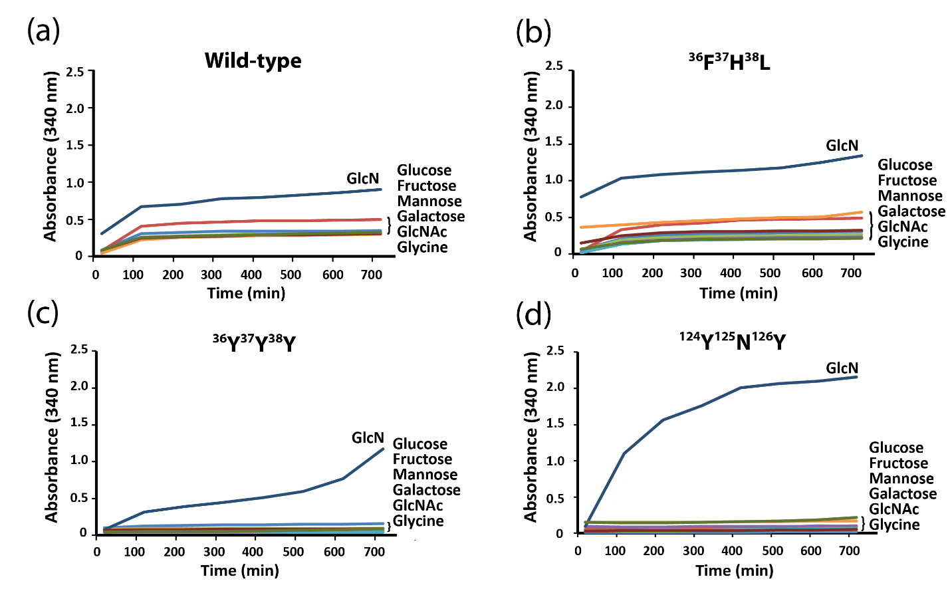

Figure S10. Protein precipitation performance in the presence of GlcN, glucose, fructose, mannose, galactose, GlcNAc, and glycine (a) Wild-type; (b) Mutant variant ³⁶F³⁷H³⁸L (c) Mutant variant ³⁶Y³⁷Y³⁸Y; (d) Mutant variant ¹²⁴Y¹²⁵N¹²⁶Y.

