**Supplementary File 1** Detailed methods for Free sulfhydryl content, Molecular flexibility, Surface hydrophobicity, X-ray diffraction (XRD), Fourier transform infrared spectroscopy (FTIR), Transmission electron microscopy (TEM), and Atomic force microscopy (AFM).

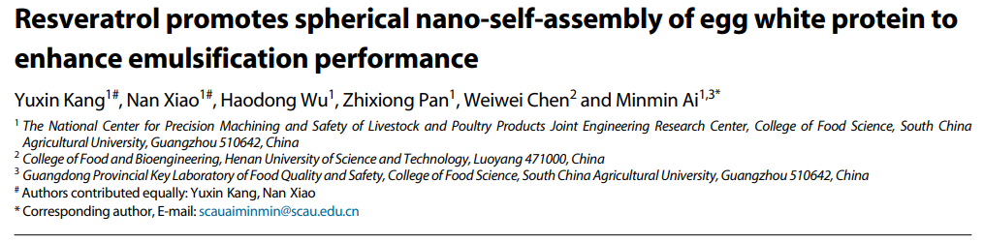**Methods**

**Free sulfhydryl content**

0.4 mL of sample was added to 2.8 mL of buffer A (pH 8.0, 0.089 M Tris, 0.09 M glycine, 0.004 M ethylenediamine tetraacetic acid, 8 M urea), and 0.2 mL of supernatant was added to 2.8 mL of buffer B (pH 8.0, 0.089 M Tris, 0.09 M glycine, 1.5 mg/mL β-Me, 0.5% sodium dodecyl sulfate, 8 M urea). The samples added to buffer A were then added to 0.02 mL Ellman reagent (pH 8.0, 0.089 M Tris, 0.09 M glycine, 4 mg/mL DTNB) and reacted in a water bath at 40 °C for 15 min. Then, the absorbance at 412 nm was measured, and the sulfhydryl content was calculated using an Ellman reaction[1].

**Molecular flexibility**

Molecular flexibility was determined by the method reported before[2]. First, 250 μL of 1 mg/mL trypsin solution (0.05 M, pH 8.0 Tris-HCl buffer) was mixed with 4 mL of 1 mg/mL protein solution and then immediately reacted in a water bath at 38 °C for 5 min. Next, 4 mL of 5.0% trichloroacetic acid was added to the protein solution to immediately stop the enzymatic reaction. Following centrifugation at 4000 × g for 10 min and the protein content of the supernatant was determined. molecular flexibility was calculated as follows:

$$Molecular flexibility (\%/min)=100×C_{S}/C_{0}×5$$

where Cs is the protein content of the supernatant, C0 is the initial protein content, and 5 is the reaction time (min).

**Surface hydrophobicity**

The surface hydrophobicity of EWP was determined according to our previous study[3] under the same experimental condition. ANS (8-anilino-1-naphthalenesulfonate) was used as a fluorescent probe. 20 μL of 8 mM solution was combined with 4 mL of 1.0 mg/mL protein and reacted in the dark. The excitation wavelength was set to 390 nm, the scanning range was set at 400-600 nm, and a fluorescent spectrophotometer (RF-5301PC, Shimadzu, Tokyo, Japan) with a slit width of 5 nm was used for the analysis. The fluorescence intensity of the spectral peak represents the surface hydrophobicity of the protein molecule.

**X-ray diffraction (XRD)**

The XRD patterns of EWP loaded with RES were analyzed with an X-ray polycrystalline powder diffractometer (Ultima IV, Rigaku, Japan) with CuKα radiation. The range was 5-80°, the scanning speed was 5°/min, and the current and voltage were 15 mA and 30 KV, respectively.

**Fourier transform infrared spectroscopy (FTIR)**

The freeze-dried EWP loaded with RES was used and its FTIR spectrum was determined over the range of 4000-500 cm-1. The secondary structure components derived from the amide I band (1700-1600 cm-1) were analyzed using PeakFit software 4.12 (SeaSolve, Framigham, MA, USA). Fourier self-deconvolution was performed between 1800 and 1600 cm-1 using Omnic 8.2 software (Thermo Electron Corporation, Madison, WI, USA), with a bandwidth of 27.2 cm-1 and a resolution enhancement parameter of 2.6.

**Transmission electron microscopy (TEM)**

The solution was diluted to 1 mg/mL and a drop of solution was dropped onto copper mesh using a rubber-tipped dropper. The sample was allowed to adsorb for 3 min and then the excess was aspirated with filter paper. The sample was then stained with 1% phosphotungstic acid and placed on the TEM carrier stage for observation (Hitachi HT7820, Tokyo, Japan) at 150 kV.

**Atomic force microscopy (AFM)**

AFM (Bruker Ltd., USA) was performed by diluting the solution to 5 ng/mL and dropping 10 μL drops onto freshly flaked mica flakes. These were naturally dried and then observed in tap mode. The height of the nanoparticle structure was analyzed using NanoScope analysis 1.5.

**References**

1. Ellman GL. 1959. Tissue sulfhydryl groups. *Archives of Biochemistry and Biophysics* 82:70-77

2. Kato A, Ibrahim HR, Watanabe H, Honma K, Kobayashi K. 1990. Structural and gelling properties of dry-heated egg white proteins. *Journal of Agricultural and Food Chemistry* 38:32-37

3. Ai M, Zhou Q, Guo S, Ling Z, Zhou L, et al. 2019. Effects of tea polyphenol and Ca(OH)2 on the intermolecular forces and mechanical, rheological, and microstructural characteristics of duck egg white gel. *Food Hydrocolloids* 94:11-19