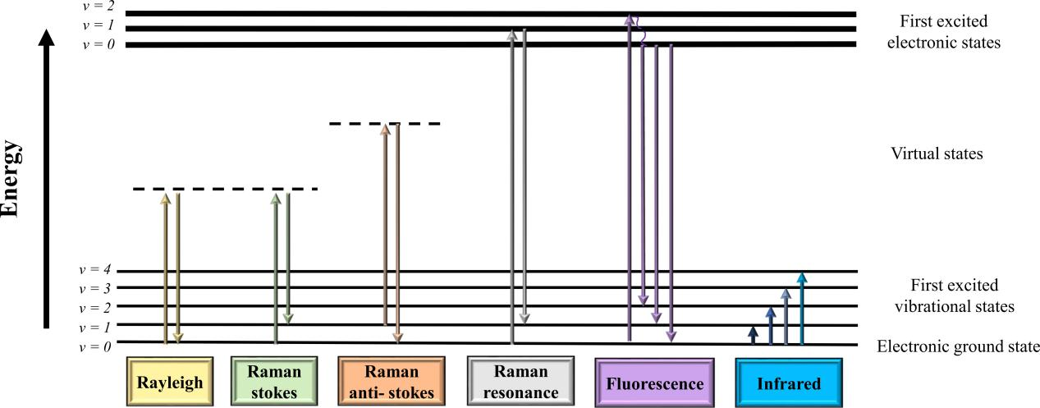

**Supplemental Figure S1.** Energy diagram of Raman and IR spectroscopy mechanisms with numbers .representing the different vibrational levels within each electronic state