**Electronic supplementary information**

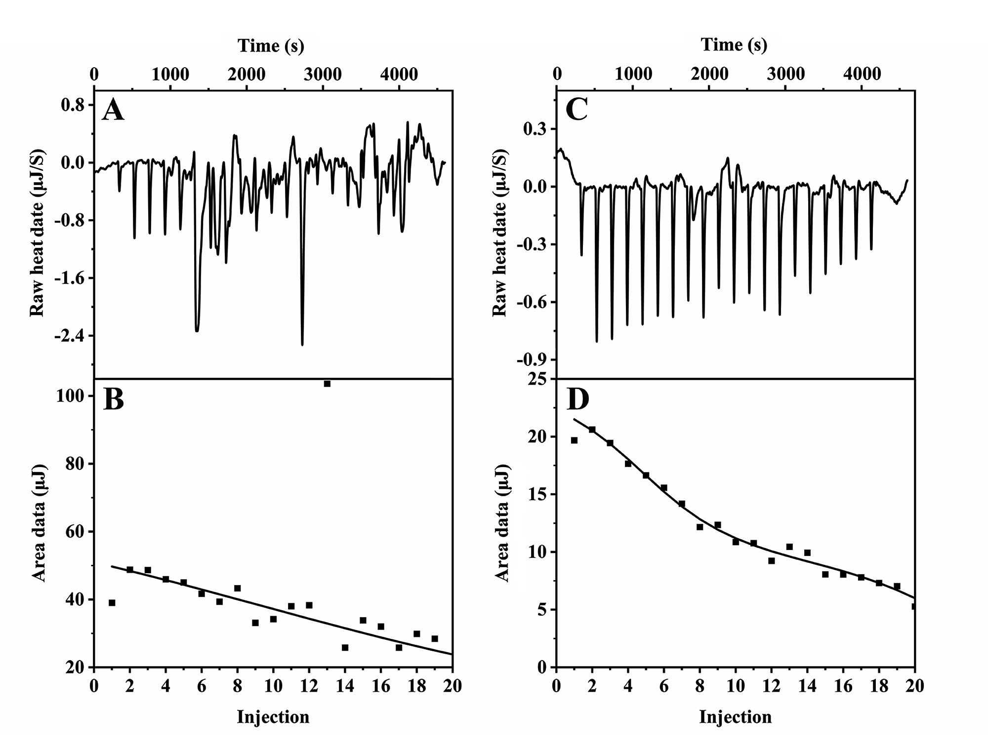

Fig. S1. ITC for the binding of CP and FP to oyster actin. (A) The raw heat data for the consecutive injections of FP solution into oyster actin solution. (B) The integrated heat data for oyster actin binding to FP at 298K, the solid line is the fitted data curve. (C) The raw heat data for the consecutive injections of CP solution into oyster actin solution. (D) The integrated heat data for oyster actin binding to CP at 298K, the solid line is the fitted data curve.