Supplementary Materials

Peatland Fire Management in Malaysia: Current Approaches and Research Needs
Dayang Nur Sakinah Musa^{1, 2}, Yunzhu Qin³, Hardawati Yahya², Shaorun Lin⁴, Mohd Zahirasri Mohd Tohir^{1,*}, Xinyan Huang^{3,*}
¹ Safety Engineering Interest Group (SEIG), Department of Chemical and Environmental Engineering, Faculty of Engineering, Universiti Putra Malaysia, 43400 UPM Serdang, Selangor, Malaysia
² International Tropical Forestry Programme, Faculty of Tropical Forestry, Universiti Malaysia Sabah, Malaysia
³Research Centre for Fire Safety Engineering, Department of Building Environment and Energy Engineering, The Hong Kong Polytechnic University, Hong Kong SAR
⁴Department of Mechanical Engineering, University of California, Berkeley, CA, USA
*Corresponding author: zahirasri@upm.edu.my (MZM Tohir); xy.huang@polyu.edu.hk (X. Huang)

- Interview session with Fire Managers

Table S1: Description of the interview analysis based on the theme.
Theme | Code | Summary
Peat Fire | Forest fire occurrences | - Representatives A: Fire occurrences during drought and worsen by el-nino cases.  - Representative B: Peat fire occurrences in Klias and Binsuluk Forest Reserves.  - Representative C: Smoke was used to indicate whether a peat fire is fully suppressed but the fire will come out again after some time (after suppression) in Sarawak.  - Representative C: Experience with peat fire in Kalimantan Barat, Indonesia.
Peat Fire | Peat fire effects | - Representatives A: Peat fire affect people, the ecosystem, and the economy  - Representative C: Had personally experienced the worst haze event in 1997/98 Kalimantan, Indonesia peatland fire when Malaysia helped Indonesia at that time to reduce the impact. This haze event, also known as transboundary haze pollution, urged the ASEAN county to sign a Transboundary Haze Pollution in 2001.  - Representative C: Heavy smoke will increase breathing difficulty, and the heat during the peat firefighting will also contribute to breathing problems and movement constraints.
Peat Fire | Fire Causes | - Representative B: Human activities such as arson, land development, open burning, hunting, and recreational activities  - Representative B: The Pandemic Covid-19 reduced the fire to 550 ha from thousands of ha in previous years. In 2021, the area burn is 100ha  - Representatives C: The human factor is believed to be the main reason for the peat fire, which is proven during the Movement Controlled Order (MCO) by the government of Malaysia as the number of fires has been reduced since the pandemic in the past 2 years. The slash-and-burn activity cannot be completely prevented and should exit as it relates to the economy.
Current approaches | Prevention/  mitigation | - Representatives A & B: Prevention/control- a fire break or fireguard to prevent fire spreading. For example canal as fire break that has been implemented in Klias and Binsuluk Forest Reserves (peat swamp forest).  - Representatives A & B: In addition to the prevention measures by the Sabah Forestry Department, they also implemented an awareness issue, especially for the people near the forest reserve, to increase awareness of the peat fire.  - Representative B: The regular awareness campaign with the local communities includes flyers and signboards (placed in a strategic area).  - Representative C: To control the peat fire, collaboration with the Forestry Department also helps monitor the forest area. Cooperation is necessary in this matter to prevent peat fire. For example, in 2017, there was an opening of the agricultural proposes that contributed to the high number of fires cumulatively. Therefore, if we can control the activities, we can control the fire and eventually increase awareness and create more champions to help control the fire.  - Representative C: The prevention measure that was introduced by the Fire & Rescue Department is a Standard Operational Procedure that must be followed by the companies or local people when doing the slash and burn. This method has reduced fire events, especially the peat fires in Sarawak.  - Representative C: A tube well with 247 units will be installed for flooding when the water table depth is lower. This ensures the water table depth is always maintained to prevent peat fire. Further research on this matter is highly recommended. Other engagements with the Institute of Peat in Sarawak to do research related to peat soil also gave information to increase the knowledge in this matter. He also mentioned that Sabah has a similar approach where 283 tube wells were installed with the same purpose (Representative B). A check dam was used to measure the water table depth. Additionally, irrigation can help in supplying the water from the nearby river to help prevent the peat from drying. Also, collaborating with the Meteorological Department to monitor the weather and potential fire area is essential.  - Representative C: Technology is very important nowadays; another method that has been implemented is patrolling using a drone.  - Representative C also encourages engagement with the local community, which is known as the Champion, to assist with fire-related issues. When discussing cross-border fire, it does not occur as the State of Sarawak creates a resilient community that understands its responsibility to protect the environment.  - As far as the Representative C is concerned, the current approach by President Jokowi of Indonesia to move the capital city from Jakarta to Kalimantan has made the community love nature, which eventually reduced the fire cases. So, it is a positive sign of reducing the fire through this method despite huge agricultural activities.
Current approaches | Suppression | - Representative B: The department uses water bombing, flooding techniques, and water pumps.  - Representative B: After applying the suppression technique, we do mopping-up to ensure the fire is fully suppressed.  - Representative A: The suitable time for suppression is 10:00 am. At 12:00 pm in Sabah, it is too hot and difficult to do suppression.  - Representative C: Regarding suppression, the fire and rescue department will use various methods, such as water bombing by using a helicopter, hand tools and a water pump.  - Representative C: As the peat fire can last from weeks to months, the firefighters only have 12 hours (6:00 am to 6:00 pm) to suppress it. It can be difficult especially when water shortage happens during the prolonged dry season.  - Representative C: Fast enforcement in the area and to make sure the peat fire is fully extinguished is significant.  - Representative A, B, C: Rain is helpful to suppress the peat fire. Peat fire can re-appear after suppression/rain.
Current approaches | Monitoring | - Representatives A: Monitoring through a Fire Danger Rating System (FDRS) was used and is currently being improved by developing a new mobile application technology. This new technology is known as the FDRS data collector, which uses a daily input of weather (humidity, rain, wind speed and temperature) for 27 districts in Sabah.  - Representative C: In the case of a hidden fire that is coming up in the dry season, the department will use a drone and thermal image to monitor the in-depth peat condition.  - Representative C: Currently, they use thermal image technology to detect and do total flooding to ensure the fire is fully suppressed. The thermal image will be available within 1-2 hours, which can be checked underground by the National Disaster Management Agency (NADMA), and we do not have to make any requests from the fire department as this matter is crucial. As the team marked the potential area and do the total flooding for the past 2 years, the fire cases have extremely reduced.
Management/  operation | Others | - Representative A: In Sabah, the Forest Fire Management Unit was established under the SFM division, SFD; it was reported in the 1980s.  - Representative C: Limiting the oil palm plantation suggested by the EU is also part of the challenge to Malaysia, as the oil palm production is strongly related to the economy of Malaysia. The palm oil industries have been monitored by the Malaysian Timber Board (MTOB) to make sure that the oil palm company follows the standard on cutting trees for opening new plantations monitored by the National Resources and Environment Board Sarawak (NREB) and, some extent by Sarawak Forest Department. They are responsible for creating the policy related to oil palm plantation
Management/  operation | Suggestion to researcher | - Representative A: As a way forward to work with researchers, collaboration in research with the objective to improve fire suppression techniques effectiveness and invent an advanced tool to put out fires, especially in the peat swamp forests as it is very difficult to mobilize the heavy equipment in the swamp area.  - Representative C: If researcher can analyze the effectiveness of the approach is much appreciated. During the suppression, firefighters will also face a few challenges. For example, heavy machinery is one of the challenges, as the peatland area is hard to access.
Management/  operation | Crews experience | - Representatives A: Strengthening: i) monitoring, ii) crew, iii) equipment, and iv) suppression techniques.  - Representative B: Sabah Forestry Department was the first in Malaysia to have its firefighters fight forest fires. We were informed that this crew was divided into Initial Attach Crew (IAC) and Forest Fire Crew (FFC). The IAC is an elite group with a total of 80 personnel. These crews are well-trained in controlling and suppressing forest fires and will be deployed as the first group to fight them. During the firefighting, these crews will be grouped into 4 people groups and follow the Incident Command System (ICS) as part of the safety measure. The ICS allows a group rotation and better logistics (4x4 vehicle) during the service. They are also very well equipped and knowledgeable on forest fire, including peatland fire, which is also part of their training. As for the equipment, the crew will have their protective equipment as PPE, gloves, and boots. Another crew that is attached to each district’s offices will support the IAC when the fire is huge and hard to control, which is known as Forest Fire Crew (FFC). The FFC is a general crew with basic fire control and suppression training. All crews will always be ready for any forest fire alarm, especially during the dry season. As the person mentioned during the session, they will also make sure all crews are in high spirits and in a good mood during the firefighting, and they will be treated with good food after each service to boost their energy and spirits.  - Representative A: Another precaution they will take during thick smoke and huge fires, especially the peat fire, is waiting for the rain to pour down.  - Representative C: As the peatland is not stable land and is hard to predict, the situation can be stressful for the firefighters. Other than that, peat fire can reduce visibility by about 70%. When water is at stake, it will make the peat suppression super challenging, and they also need a lot of water to keep them hydrated.  - Representative C: Even though the firefighters are physically healthy, the situation cannot be predicted when it comes to forest fires, especially peat fires. As the Director said, “I like to fight building fire. When it comes to forest fire, especially the peat fire, the situation is stressful”. For firefighters, a jungle or a forest is a real challenge as they must also deal with wildlife, such as snakes, and they must be mentally ready.

- Survey form for firefighters

Peatland Fire Management Survey
Project purpose: This survey tries to address the situations related to peat fires and firefighter activities. If any questions do not apply to your department, please fill in 'N/ A'.

All information that is provided will be kept confidential and will only be used for academic purposes. Please note that:
- this questionnaire should be completed by or on behalf of the firefighters who involve in fighting the fires in the peatland areas;
- the items listed as the open-ended questions should be answered in short-form answers;
- all responses to the survey are strictly confidential;
this survey will have 4 Sections: A, B, C, and D.

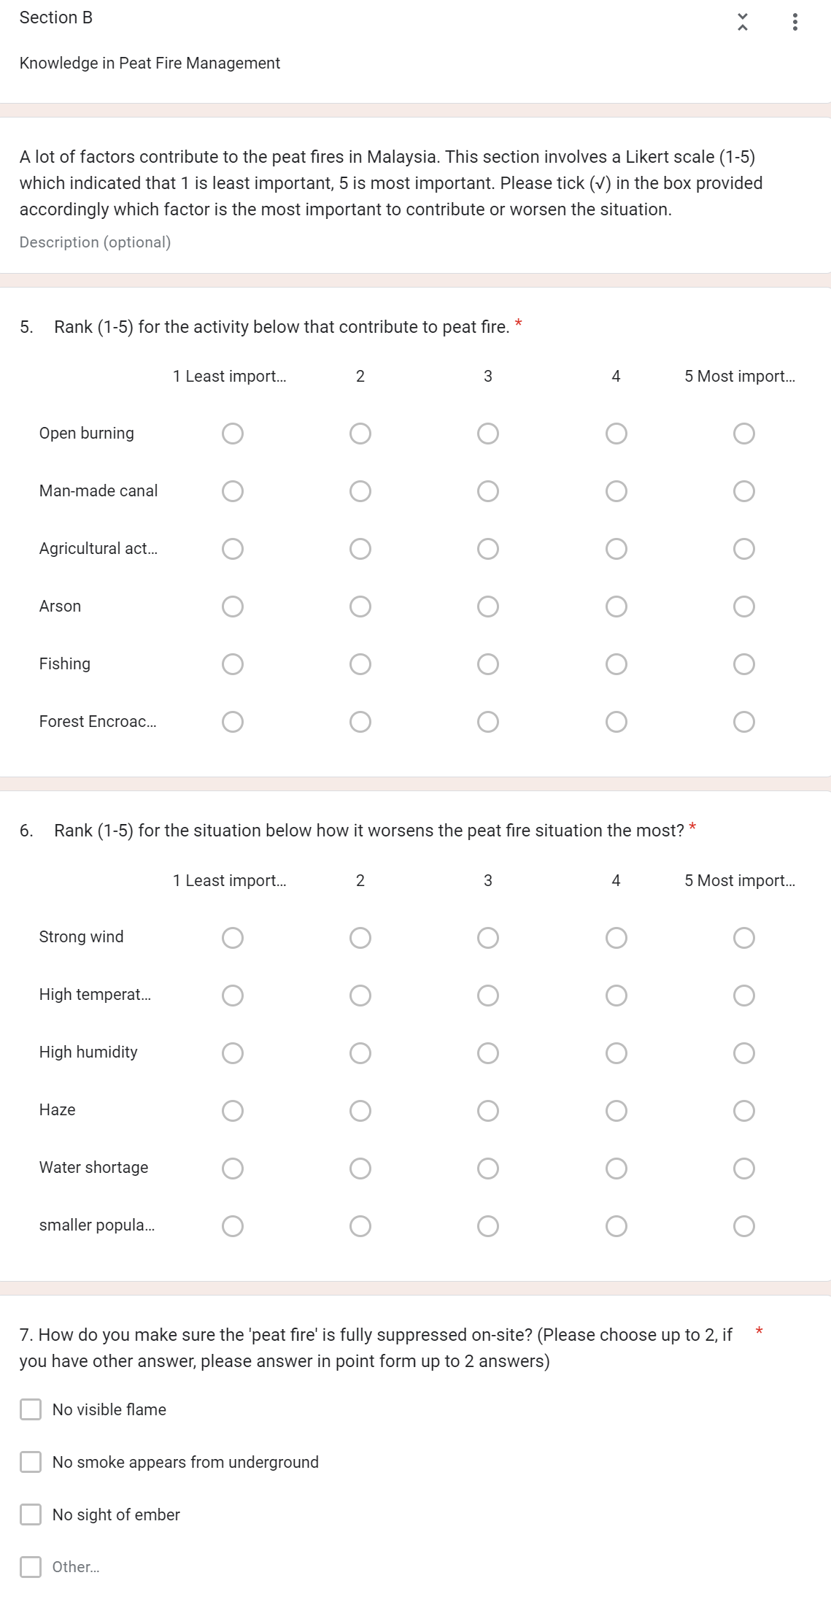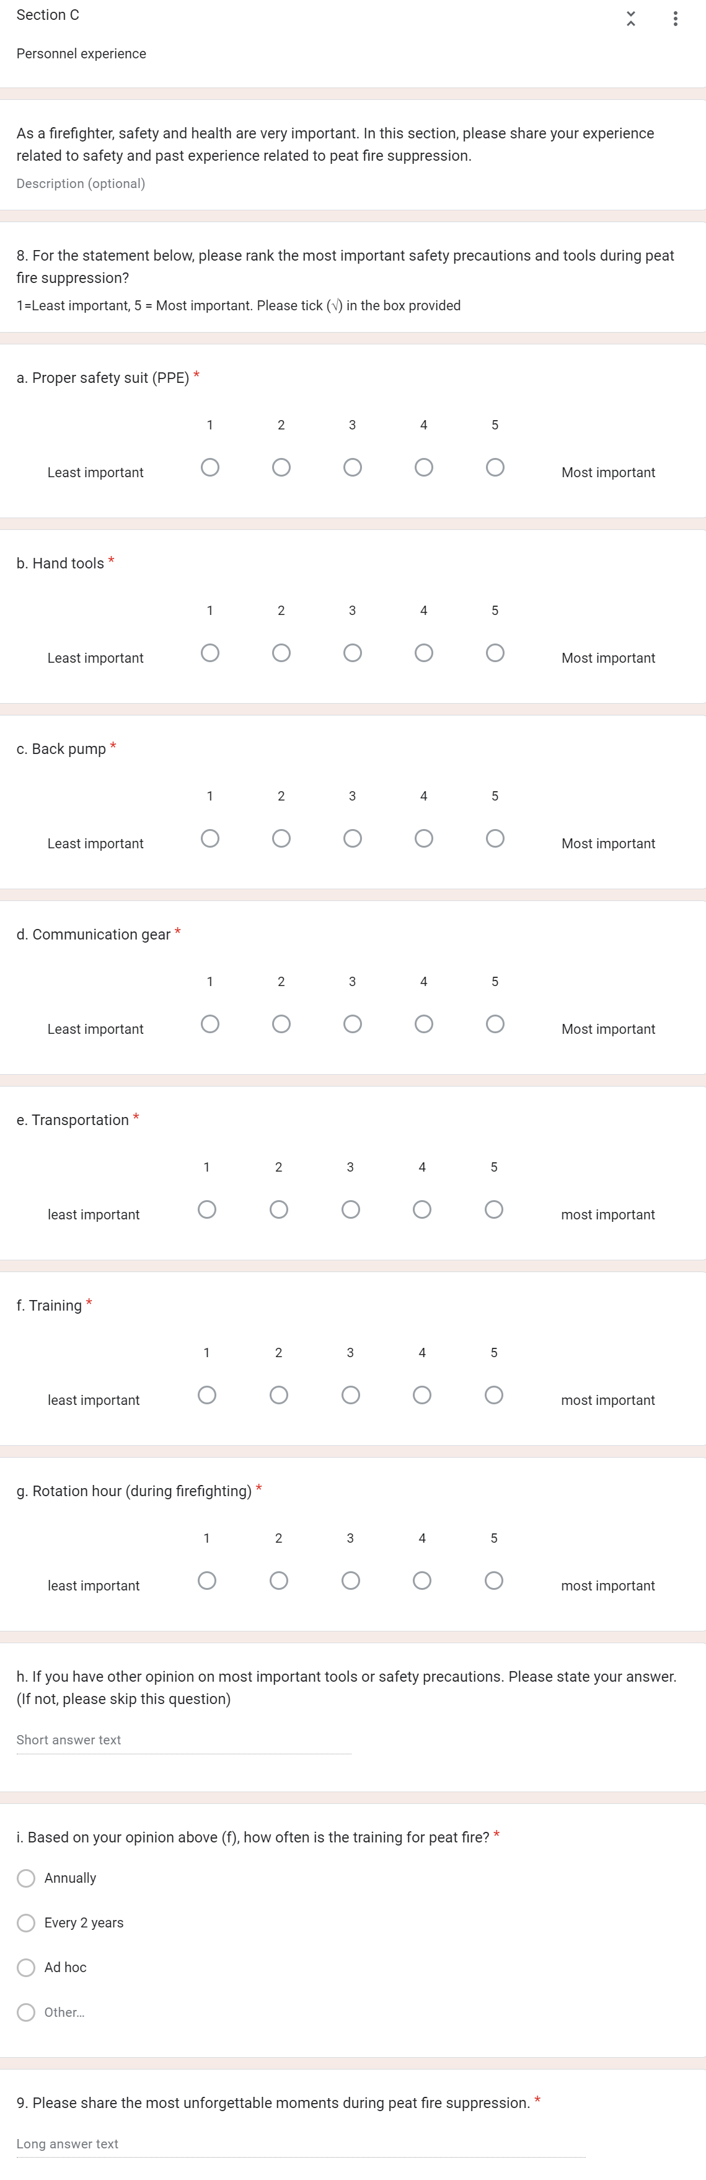

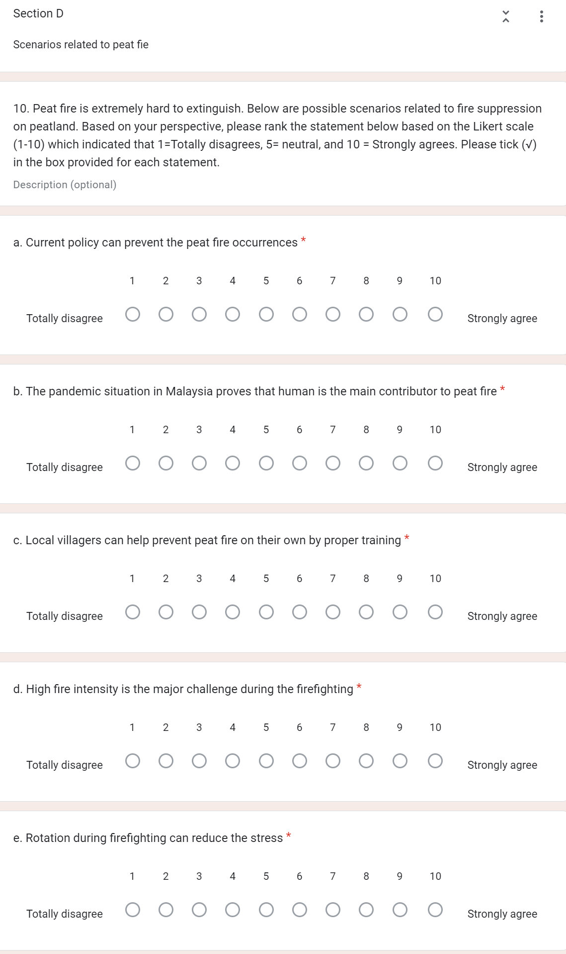

- Firefighter survey results

Table S2: Description of the survey study from the questionnaire
Description | Graph
Respondents profile
Number of respondents | 366
Age  39.3% of the firefighters age between 31 – 40 years old. | 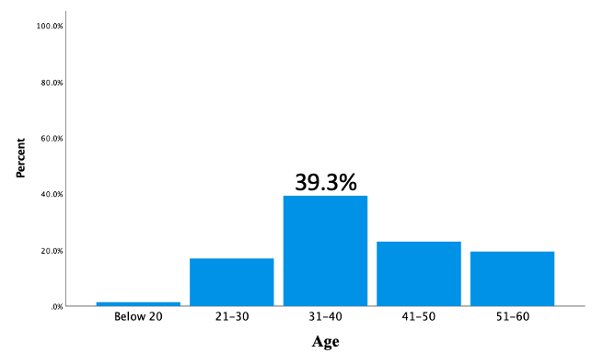
Working experience in peatland fire suppression  30.6% of the firefighters have experienced more than between 11 – 20 years. | 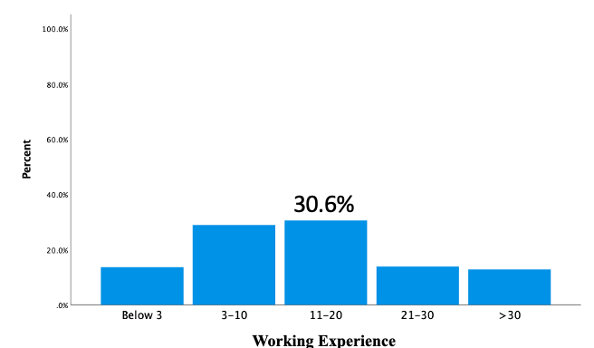
Trained in peat fire suppression  77% of the respondents were trained in peatland fire suppression, meanwhile 23% were not specifically trained for peat fire suppression. | 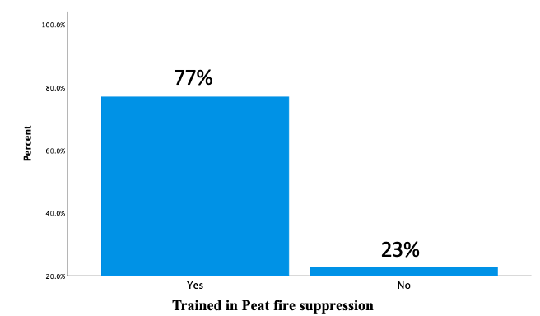
Most important contributing factor to peat fire occurrences

Likert scale
1= least important, 2= fairly important, 3=moderately important, 4=important, and 5=mostly important
a) Open burning  Respondents with majority 36.1% agreed that open burning is one of the most important factors that contributing to fire in peatland area. | 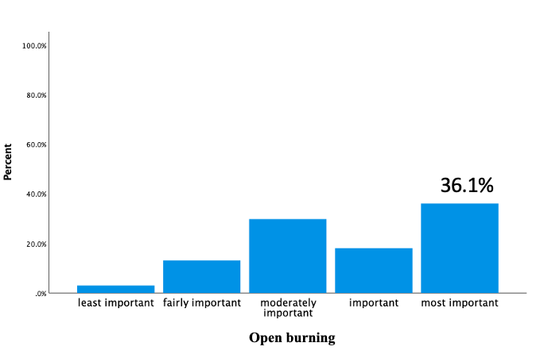
b) man-made canal in the nearby peatland area  In the case of the existence of man-made canal in the peatland area, a majority 34.4% of the respondents corresponded that it is a moderate factor that increase potential to peat fire occurrences. | 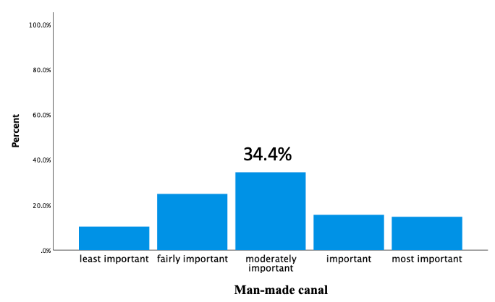
c) Agricultural activities nearby  The respondents rank agricultural activity as moderate factor that contribute to peat fire occurrence with 32.2%. | 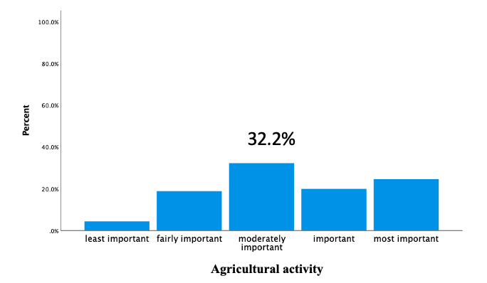
d) Arson  33.1% of the total respondents chosen arson as moderate important factor that will contribute to peat fire events. | 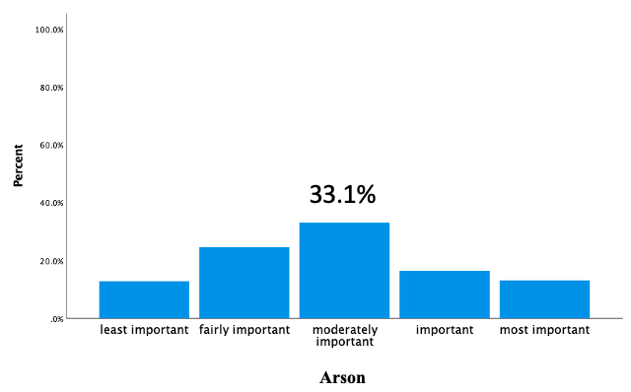
e) Fishing  Fishing activity in the peatland area indicated as least important factor contributing to peat fire by 35% of the respondents. | 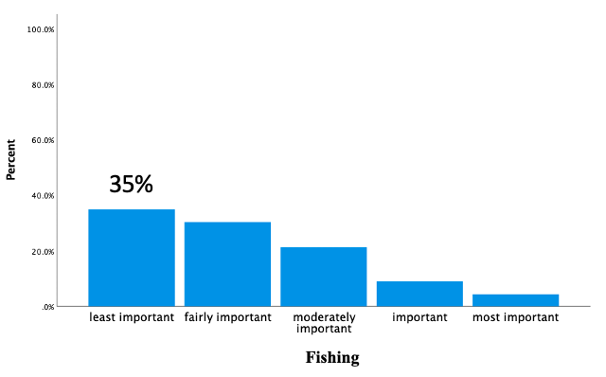
f) Forest encroachment  35.5% of the respondents point out that the forest encroachment will moderately contribute to peat fire occurrences. | 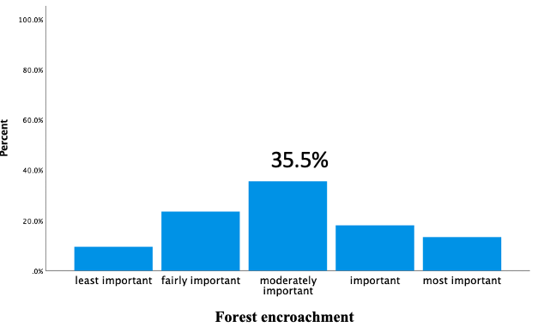
Most factor that will worsen the peat fire condition in peatland

Likert scale
1= least important, 2= fairly important, 3=moderately important, 4=important, and 5=mostly important
a) Strong wind  34.4% of the respondents agreed that strong wind is one of the most important factors that will worsen the peat fire condition | 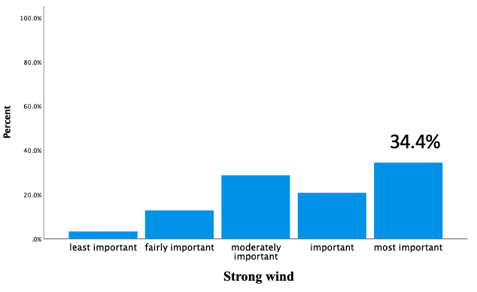
b) High temperature  High temperature also one of the most important factor according to the respondents with majority of 35.8%. | 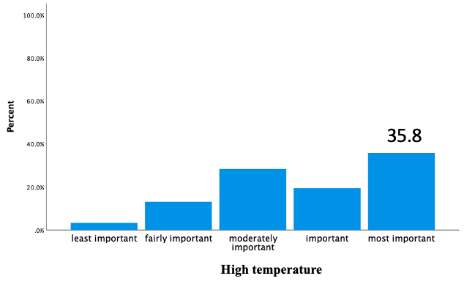
c) High humidity  Other factors such as high humidity, haze, water shortage, and smaller population in the peatland area were considered as moderate important factors by the respondents. | 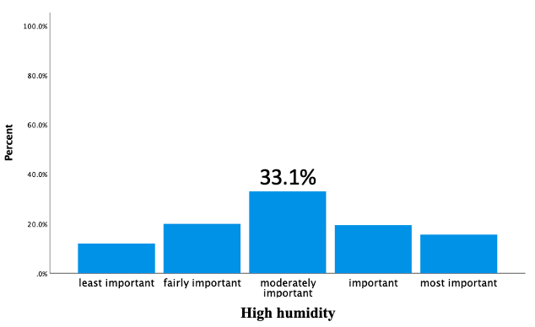
d) Haze | 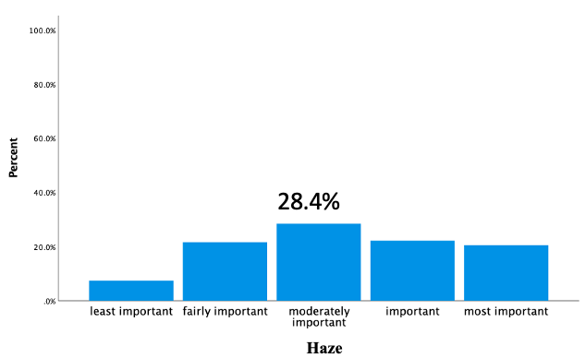
e) Water shortage | 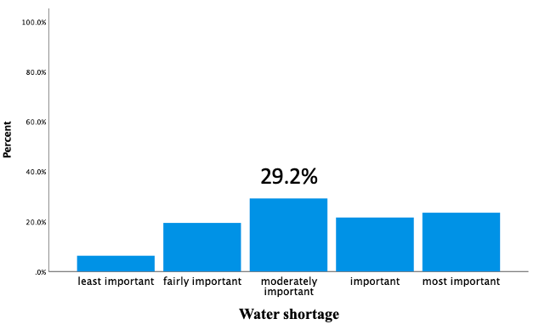
f) smaller population in the area | 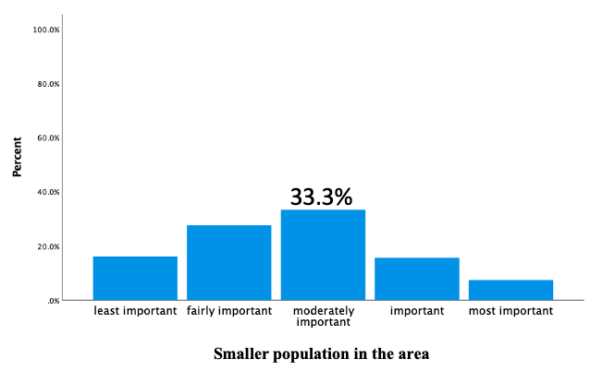
Most important safety precautions

Likert scale
1= least important, 2= fairly important, 3=moderately important, 4=important, and 5=mostly important
a) Safety suit (PPE)  Safety precautions such as proper safety suit (PPE) is considered most important safety precaution (74%). In Table 3, some respondents corresponds that not enough PPE is one of the issue during the firefighting. | 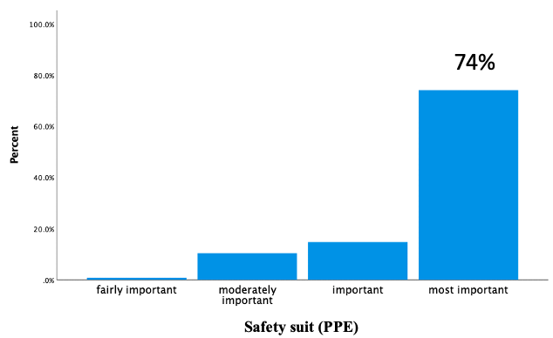
b) Hand tools  Hand tools is important to help the firefighters in peat fire suppression such as seesaw and rake, thus, 69.1% respondents agrees that hand tools can be one of the safety precaution measures. | 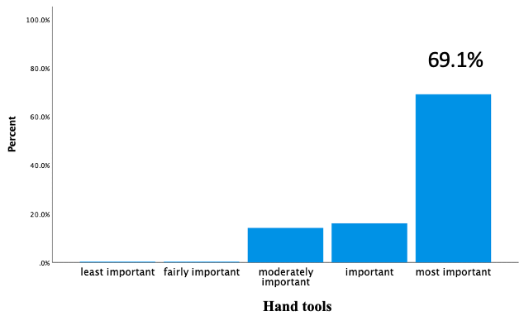
c) Water back-pump  Water-back pump is mainly used in mopping-up process after the major peat fire suppression and also considered as most important safety measures for the firefighters (65.6%). | 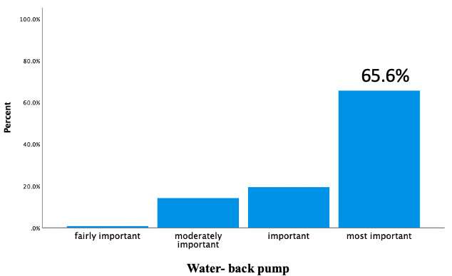
d) Communication gear  Communication is important to send order or received order. Any updates regarding the suppression procedure is very important, thus, 68% respondents point out communication gear as one of the safety measures. | 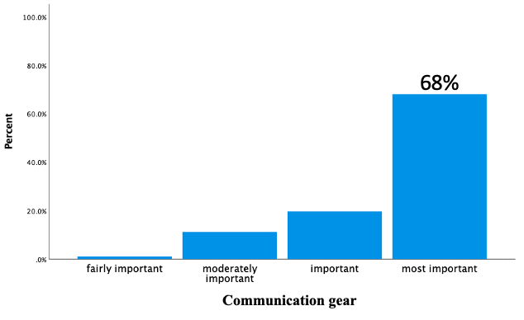
e) Transportation  73.5% of respondents correspond that transportation also important safety measures. | 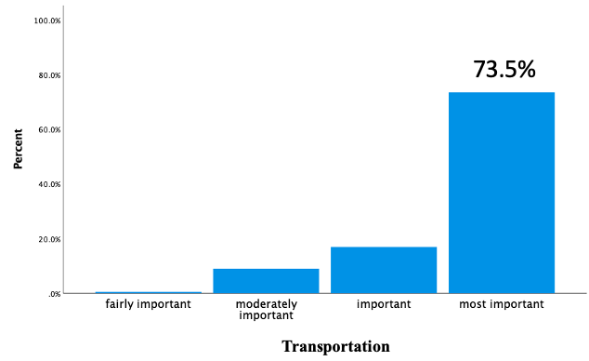
f) Training for peat fire suppression  Training is important safety measure as the peat fire is unpredictable. Thus, 71.9% of the respondents response that training is most important factor that support the safety measures. | 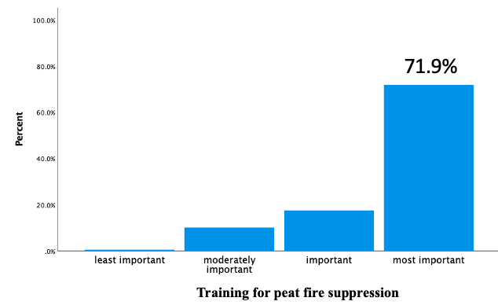
g) Rotation hour during peat fire suppression  70.2% of the respondents agree that rotation hour during peat fire suppression as one of the safety measure during firefighting. | 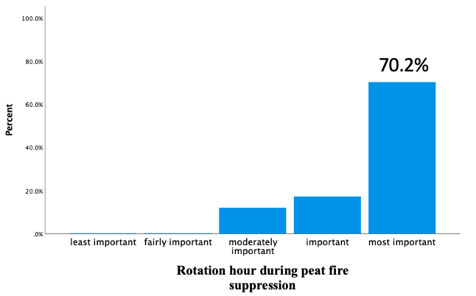
h) Training schedule  Corresponding to (f), 69.9% of the respondents actually stated that they were trained annually. | 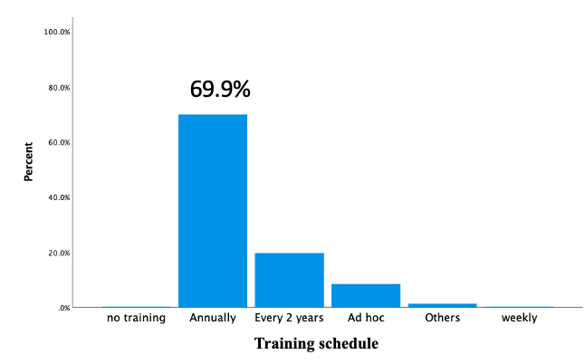
e) Indicator the peat fire underground is fully suppressed by respondents  The respondents considered the peat fire underground is fully suppressed when the there’s no smoke from underground, followed by no visible flame and no sight of ember. Additionally, the respondents also responds that they will make sure to wet the area to make sure that the fire underground is fully suppressed. | 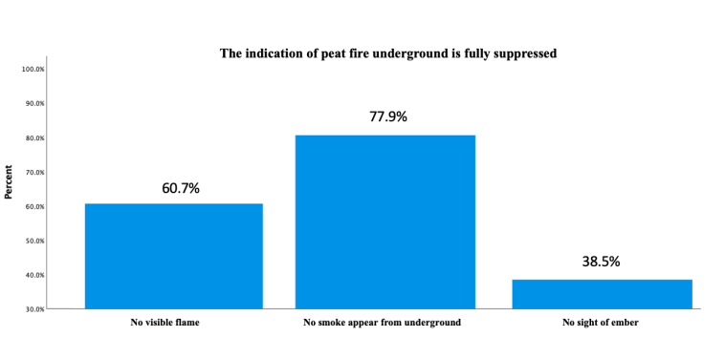

Table S3: Statement from the peat fire managers according to respondents.
Statements |  | Percentage (%)
 |  | Totally disagree | disagree | Neutral | agree | Strongly Agree
1 | Current policy can prevent the peat fire occurrences | 5.7 | 3.6 | 15.6 | 26.5 | 48.6
2 | The pandemic situation in Malaysia proves that human is the main contributor to peat fire | 3.3 | 1.9 | 14.5 | 20.5 | 59.8
3 | Local villagers can help prevent peat fire on their own by proper training | 2.2 | 1.6 | 9.6 | 19.1 | 67.5
4 | High fire intensity is the major challenge during the firefighting | 1.1 | 0.5 | 8.5 | 19.9 | 69.9
5 | Rotation during firefighting can reduce the stress | 2.2 | 1.1 | 11.7 | 12.3 | 72.7

Table S4: Unforgettable moments respondents experienced during peat fire suppression.
Code | Summary
Water shortage | - Related to water shortage during peat fire suppression. It worsens when there’s no water supply to extinguish peat fire
Past events | - Most firefighters mentioned the places the do peat fire suppression. They work at night and sleep in forest.
Physical and mental issue | - Inhale smoke, fatigue, thirsty, hard to breath, stress, heavy equipment.  - Small group to extinguish large area, losing a friend
Long operation hour | - Long operation where they don’t shower and stand-by up to 2 months
Trapped in fire | - Almost trapped during service because of huge fire and thick smoke. They share how they were surrounded by fire.
Collaboration with Indonesia | - Help in peat fire suppression in Indonesia. Most of them mentioned ‘Operation KALBAR 1997 Indonesia’
Equipment issue | - Not enough PPE for firefighters during suppression, but some firefighters think their PPE are good. Equipment to help in suppression is not enough  - Some firefighters burnt their hose during suppression
Other issues related to peat fire suppression | - Come across venomous animals and insects not enough manpower; friendship; fire in oil palm plantation; tree fall in front of them; lost communication etc.

