Enhanced nitrobenzene mineralization in a STEP system
Bin Bian^{1,2#}, Jiayue Hu^{3#*}, Xinrui Ma^{1,2}, Pengkai Wang^{1,2}, Zhan Shen⁴, Pascal E. Saikaly⁵, Ling Liu^{3*}
¹ School of Sustainable Energy and Resources, Nanjing University, Suzhou 215163, China
² Frontiers Science Center for Critical Earth Material Cycling, Nanjing University, Nanjing 210023, China
³ Department of Mechanical Engineering, Temple University, Philadelphia, PA 19122, USA
⁴ School of Electrical Engineering, Southeast University, Nanjing 210096, China
⁵Environmental Science and Engineering Program, Biological and Environmental Science and Engineering Division, King Abdullah University of Science and Technology, Thuwal 23955–6900, Saudi Arabia

*Corresponding author.
Email: Jiayue Hu, jiayue.hu0001@temple.edu;
Ling Liu, ling.liu@temple.edu.
#These authors contributed equally to this work.

Appendix S1
Chemical analysis
To investigate the degradation kinetics for NB under different solar coupling conditions (SE, SE+ST, and STEP), the changes in absorbance at a light wavelength of 267 nm was monitored, which corresponds to the UV characteristic peak of NB. The NB degradation rate could be calculated from the first-order kinetics equation as follows,
$$ln⁡(C_{0}/C_{t})=kt$$
where C₀ represents the initial concentration of NB, C_{t} is the concentration of NB after a specific duration of solar illumination, k is the degradation rate constant, and t is the time interval.
Cyclic voltammetry (CV) was conducted in a three-electrode mode at a scan rate of 5 mV/s (Metrohm, AUT86762) for the intermediate product detection during NB degradation. The as-prepared Fe(III)/TiO₂ NTs/Ti electrode served as the working electrode, while Pt as the counter electrode and Ag/AgCl as the reference electrode. 5 g/L Na₂SO₄ aqueous solution was employed as the electrolyte.
To quantify the concentration of intermediate products, liquid samples were also collected at 4 different time intervals (30 min, 60 min, 90 min, and 120 min). High-performance liquid chromatography (HPLC) equipped with a reverse C18 column (Akzo Nobel, Kromasil C18) was used for product identification and quantification at a detection wavelength of 280 nm using. The mobile phase made of 70 vol% methanol in DI for HPLC was set at a constant flow rate of 1 mL/min. The mineralized product, NO₃⁻, was detected using ionic chromatography (IC, Model 883, Metrohm AG) equipped with an anionic exchange column (6.1006.5X0 Metrosep A Supp5-150/4.0). The mobile phase for the IC analysis was Na₂CO₃/NaHCO₃ (0.45 mol/L and 0.08 mol/L, respectively), and the flow rate was maintained at 0.7 mL/min.
Energy consumption under different solar coupling conditions
Table S3 Energy input under SE, SE + ST and STEP conditions
 | Electric energy  (J/mol) | Thermal energy  (J/mol) | Total solar energy input  (J/mol)
SE | 0.4 × 10⁷ | 887 | 0.4 × 10⁷
SE + ST | 1.4 × 10⁷ | 11532 | 1.4 × 10⁷
STEP | 2.1 × 10⁷ | 11532 | 2.1 × 10⁷
Calculation of the energy
- Electric energy:
W_{e} (SE) = UIt = (1.2 V × 125829.25 × 10⁻⁶ A·s × 123.11 g/mol) / 4.4 × 10⁻⁶ g= 0.4 × 10⁷ J/mol
W_{e} (SE+ST) = UIt = (1.2 V × 423842.96 × 10⁻⁶ A·s × 123.11 g/mol) / 4.4 × 10⁻⁶ g = 1.4 × 10⁷ J/mol
W_{e} (STEP) = UIt = (1.2 V ×632343.29 × 10⁻⁶ A·s × 123.11 g/mol) / 4.4 × 10⁻⁶ g = 2.1× 10⁷ J/mol
- Thermal energy:
Q (30 ºC) = cΔT = 177.4 J/mol·K × (303.15-298.15) K = 887 J/mol
Q (90 ºC) = cΔT = 177.4 J/mol·K × (363.15-298.15) K = 11532 J/mol
- Total energy:
W (SE) = W_{e} (SE) + Q (30 ºC)= 0.42 × 10⁷ J/mol + 887 J/mol ≈ 0.4 × 10⁷ J/mol
W (SE+ST) = W_{e} (SE) + Q (90 ºC) = 1.42 × 10⁷ J/mol + 11532 J/mol ≈ 1.4 × 10⁷ J/mol
W (STEP) = W_{e} (STEP) + Q (90 ºC) = 2.12 × 10⁷ J/mol + 11532 J/mol ≈2.1 × 10⁷ J/mol

Table S1 The adsorption energy and binding energy of NB on Fe-modified anatase TiO₂ (101) surface in Fig. 3.
Configuration | Adsorption energy (eV) | Binding energy (eV)
1 | −0.3887 | −0.6009
2 | −0.3649 | −0.5967
3 | −0.3928 | −0.7111
4 | −0.5297 | −0.7879
5 | −0.6336 | −1.0312
6 | −0.2879 | −0.5048

Table S2 Apparent first-order rate constant k for nitrobenzene (NB) removal under solar-electrochemical (SE), solar-thermal-electrochemical (SE + ST), and solar thermal electrochemical photocatalytic (STEP) conditions. $R^{2}$denotes the correlation coefficient of the first-order kinetic fit.
Condition | Apparent rate constant k (min⁻¹) | Correlation coefficient, R²
SE (k₁) | 0.0006 | 0.994
SE + ST (k₂) | 0.006 | 0.954
STEP (k₃) | 0.022 | 0.964

Fig. S1 Scheme of the preparation of Fe(III)/TiO₂ NTs/Ti electrode.

Fig. S2 Schematic diagram of the in-situ micro-reactor analyzer (in-situ MRA) used for nitrobenzene (NB) degradation in the laboratory STEP configuration. STEP denotes the coupled photo–thermal–electrochemical operation mode, in which electrical bias, thermal input, and UV photo-input are supplied in the microreactor.
Fig. S3 Cross-section of Fe(III)/TiO₂ NTs layers.
Fig. S4 Electronic structure of pristine anatase TiO₂ (001) slab: (a) Band structures (The band gap is 1.41 eV.), (b) Total density of states (TDOS), and (c) Projected density of states (PDOS) of the atomic types that construct the structure. Electronic structure of Fe-modified anatase TiO₂ (001) slab: (d) Band structures (The band gap is 0.94 eV.), (e) TDOS, and (f) PDOS. Fermi level was shifted to zero. All electronic-gap values shown in the figure were calculated using GGA-PBE and are provided only for relative comparison; they should not be interpreted as experimental optical band gaps.
Fig. S5 Electronic structure of pristine anatase TiO₂. (a) Band structures. The band gap is 2.06 eV; (b) Total density of states (TDOS); (c) Projected density of states (PDOS) of the atomic types that construct the structure. Fermi level was shifted to zero. The electronic-gap value shown here is a GGA-PBE-calculated and should not be interpreted as the experimental optical band gap of anatase TiO₂.
Fig. S6 Top view of NB adsorption on Fe-modified anatase TiO₂ (101) surface. (a)–(d) Adsorption configurations of NB on Fe-substituted Ti_{5c} site. (e) and (f) Adsorption configurations of NB on O_{2c} site. Blue, red, white, brown, grey and golden spheres stand for Ti, O, H, C, N, and Fe atoms. Top: initial position, bottom: after optimization.

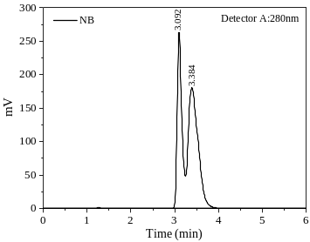
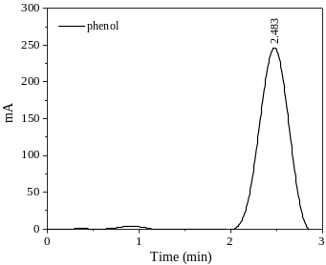
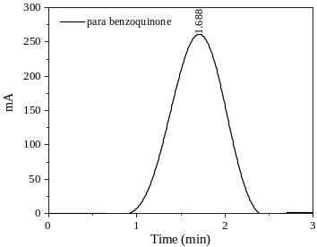
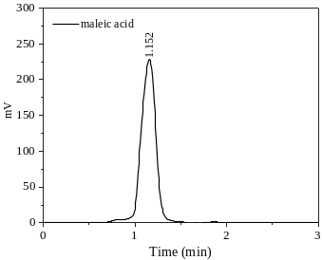
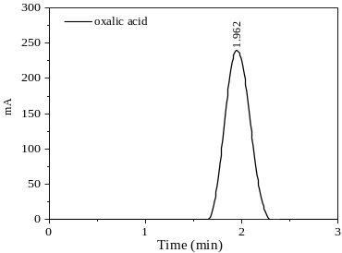
Fig. S8 High-performance liquid chromatography (HPLC) chromatograms of standard compounds used for product identification during nitrobenzene (NB) degradation: NB, phenol, para-benzoquinone (PBQ), maleic acid, and oxalic acid. The chromatograms provide retention-time references for assigning peaks in degradation samples.
Fig. S9 High-performance liquid chromatography (HPLC) chromatograms of nitrobenzene (NB) degradation samples collected after 30, 60, 90, and 120 min under SE, SE + ST, and STEP conditions. The figure compares the time evolution of NB and intermediate products, supporting the pathway assignment shown in Fig. 6 and Fig. 7.
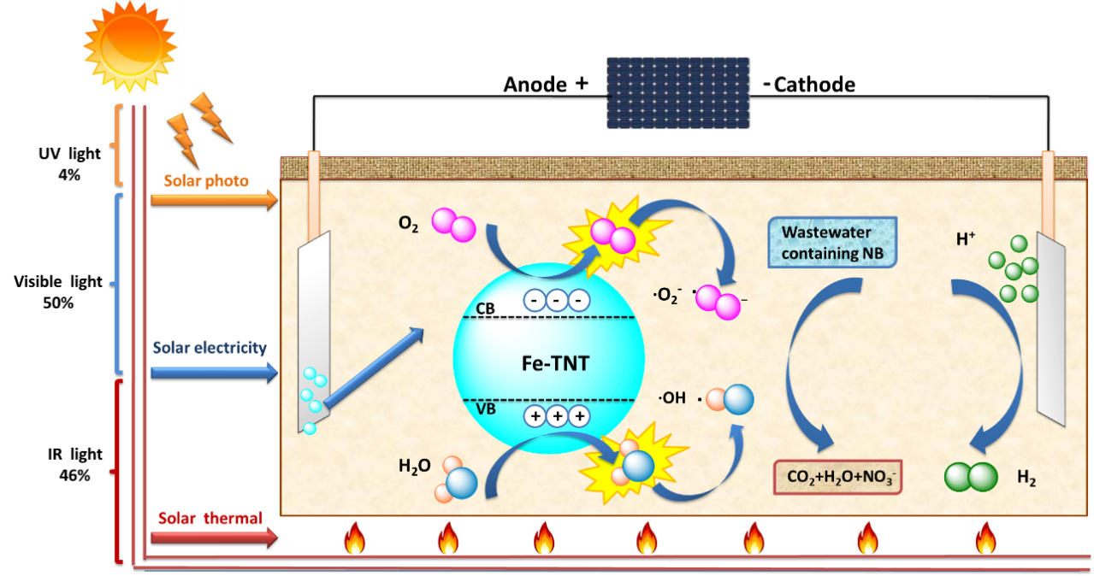
Fig. S10 Mechanism of nitrobenzene (NB) degradation and partial mineralization in the solar thermal electrochemical photocatalytic (STEP) system.
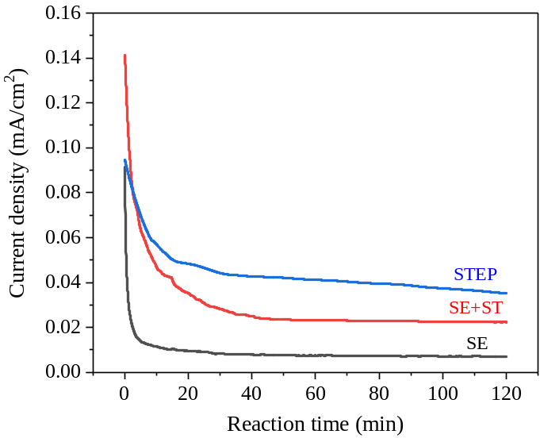
Fig. S11 Real-time current responses recorded under solar-electrochemical (SE), solar-thermal-electrochemical (SE + ST), and solar thermal electrochemical photocatalytic (STEP) conditions.
Table S2 Apparent first-order rate constant k for nitrobenzene (NB) removal under solar-electrochemical (SE), solar-thermal-electrochemical (SE+ST), and solar thermal electrochemical photocatalytic (STEP) conditions. $R^{2}$denotes the correlation coefficient of the first-order kinetic fit. The data in this table is taken from Fig. S7.
Condition | Apparent rate constant k (min⁻¹) | Correlation coefficient, R²
SE (k₁) | 0.0006 | 0.994
SE + ST (k₂) | 0.006 | 0.954
STEP (k₃) | 0.022 | 0.964
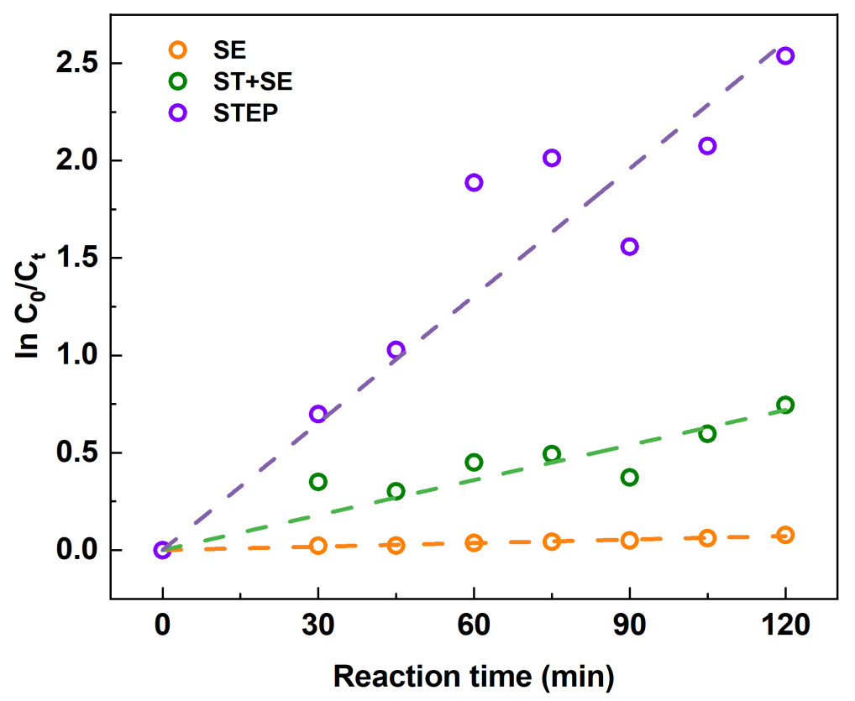
Fig. S7 Reaction rate constant evaluated from the concentration of NB at different times, compared to the initial NB concentration.

