Biological triggering waste rock-based soil system with native plant litter establishes soil microbiome and biochemical functional potential typical of Eucalyptus woodland
Fang You¹, David Parry ², Merinda Hall¹, Longbin Huang^{1*}
1. Sustainable Minerals Institute, The University of Queensland, Brisbane Qld 4072, Australia
2. Rio Tinto Aluminium, Brisbane Qld 4000, Australia
*Corresponding Author: Longbin Huang, Tel: +61 7 3346 3103, fax: +61 7 3346 4056, e-mail: l.huang@uq.edu.au
Table S1 Geochemical properties of surface soils from TLF-1A, Inoculate 1A and Reference sites.
Chemical property | TLF-1A | Inoculated-1A | Reference Site
pH ª | 6.8±0.3 | 7.0±0.1 | 6.4±0.2
Electrical conductivity(μS/cm)ª | 28.8±6.3 | 29.9±8.9 | 30.5±0.3
C:N | 19.2±6.9 | 14.6±1.7 | 16.5±1.5
Total P (g/kg) | 0.70±0.09 | 0.88±0.02 | 0.23±0.05
Total S (g/kg) | 0.42±0.18 | 0.80±0.44 | 0.19±0.08
Soluble OC (mg/kg) | 48.9±18.3 | 34.6±9.2 | 113.5±33.4
NH₄-N (mg/kg) | 3.7±4.7 | 3.6±3.5 | 21.0±16.5
NO₃-N(mg/kg) | 0.79 ±0.82 | 1.71±1.27 | 1.95±2.66
Available P (mg/kg) | 2.28±0.90 | 2.97±1.87 | 1.61±0.62
Water soluble S (mg/kg) | 4.55±3.22 | 4.08±3.16 | 2.56±0.98
a: 1:5 H₂O water extract

Table S2 Topological properties of the co-occurrence network in the surface soils of TLF-1A, Inoculated 1A, and Reference Sites
Site | Modulation | Graph density | Average  degree | Average  path length | Clustering coefficient
Archaea and bacteria
TLF-1A | 4 | 0.11 | 17.3 | 2.4 | 0.68
Inoculate 1A | 23 | 0.04 | 6.7 | 1.0 | 1.00
Reference Site | 4 | 0.09 | 18.3 | 2.1 | 0.59
Fungi
TLF-1A | 9 | 0.05 | 9.7 | 2.5 | 0.53
Inoculate 1A | 20 | 0.06 | 12.6 | 1.0 | 1.00
Reference Site | 5 | 0.05 | 11.1 | 2.6 | 0.55
*The top 250 abundant ASVs and strong correlations (P < 0.05, r > 0.6 or r < −0.6) were considered for network construction.

Table S3 Association strength of microbial families with individual site
Kingdom | Microbiomes/Families | TLF-1A | Inoculated 1A | Reference Site
Archaea | Thermoplasmata[c]:Unidentified E2 | 0.65 | 0.60 | 0.47
Archaea | Thaumarchaeota[c]:Nitrososphaeraceae | 0.44 | 0.56 | 0.70
Archaea | Thermoplasmata[c] | 0.68 | 0.54 | 0.50
Archaea | [Parvarchaea][c]:Unidentified YLA114 | 0.36 | 0.48 | 0.70
Archaea | [Parvarchaea][c]:Unidentified WCHD3-30 | 0.69 | 0.54 | 0.20
Archaea | Methanomicrobia[c]:Methanocellaceae | 0.00 | 0.00 | 0.93
Archaea | Methanomicrobia[c]:ANME-2D | 0.00 | 0.00 | 0.89
Archaea | [Micrarchaea][c]:Unidentified [Micrarchaeles] | 0.00 | 0.27 | 0.58
Archaea | MCG[c] | 0.00 | 0.00 | 0.52
Archaea | DSEG[c]:Unidentified HydGC-84-221A | 0.21 | 0.91 | 0.00
Archaea | Thaumarchaeota[c]:Cenarchaeaceae | 0.24 | 0.66 | 0.00
Archaea | DSEG[c]:Unidentified ArcA07 | 0.26 | 0.50 | 0.00
Bacteria | Thermoleophilia[c]:Gaiellaceae | 0.54 | 0.50 | 0.68
Bacteria | Planctomycetia[c]:Gemmataceae | 0.61 | 0.55 | 0.57
Bacteria | [Chloracidobacteria][c]:Unidentified RB41 | 0.66 | 0.53 | 0.53
Bacteria | Alphaproteobacteria[c]:Hyphomicrobiaceae | 0.63 | 0.53 | 0.57
Bacteria | Acidobacteria-6[c]:Unidentified iii1-15 | 0.57 | 0.57 | 0.59
Bacteria | MB-A2-108[c]:Unidentified_0319-7L14 | 0.64 | 0.58 | 0.51
Bacteria | Anaerolineae[c]:Unidentified envOPS12 | 0.59 | 0.66 | 0.48
Bacteria | Chloroflexi[c]:Unidentified [Roseiflexales] | 0.71 | 0.56 | 0.44
Bacteria | Ellin6529[c]:Unidentified Ellin6529 | 0.68 | 0.46 | 0.57
Bacteria | Planctomycetia[c]:Pirellulaceae | 0.63 | 0.60 | 0.50
Bacteria | Betaproteobacteria[c] | 0.59 | 0.58 | 0.56
Bacteria | Acidimicrobiia[c]:Unidentified Acidimicrobiales | 0.61 | 0.71 | 0.35
Bacteria | Anaerolineae[c]:A4b | 0.53 | 0.75 | 0.40
Bacteria | Actinobacteria[c]:Micromonosporaceae | 0.51 | 0.48 | 0.71
Bacteria | [Saprospirae][c]:Chitinophagaceae | 0.53 | 0.56 | 0.64
Bacteria | Alphaproteobacteria[c]:Rhodospirillaceae | 0.50 | 0.51 | 0.70
Bacteria | Phycisphaerae[c]:Unidentified WD2101 | 0.56 | 0.52 | 0.64
Bacteria | Deltaproteobacteria[c]:Syntrophobacteraceae | 0.58 | 0.48 | 0.66
Bacteria | Chloroflexi[c]:[Kouleothrixaceae] | 0.63 | 0.49 | 0.61
Bacteria | Actinobacteria[c]:Geodermatophilaceae | 0.52 | 0.39 | 0.76
Bacteria | Alphaproteobacteria[c]:Acetobacteraceae | 0.52 | 0.60 | 0.61
Bacteria | Actinobacteria[c]:Unidentified Actinomycetales | 0.41 | 0.60 | 0.69
Bacteria | Alphaproteobacteria[c]:Bradyrhizobiaceae | 0.52 | 0.48 | 0.71
Bacteria | Betaproteobacteria[c]:Unidentified Ellin6067 | 0.55 | 0.52 | 0.66
Bacteria | Deltaproteobacteria[c]:Myxococcaceae | 0.26 | 0.00 | 0.96
Bacteria | Betaproteobacteria[c]:Unidentified MND1 | 0.47 | 0.59 | 0.66
Bacteria | Betaproteobacteria[c]:Comamonadaceae | 0.50 | 0.45 | 0.74
Bacteria | Actinobacteria[c]:Pseudonocardiaceae | 0.73 | 0.54 | 0.42
Bacteria | Thermoleophilia[c]:Solirubrobacteraceae | 0.63 | 0.42 | 0.65
Bacteria | Alphaproteobacteria[c]:Unidentified Rhizobiales | 0.56 | 0.62 | 0.55
Bacteria | Gammaproteobacteria[c]:Sinobacteraceae | 0.54 | 0.65 | 0.53
Bacteria | TK10[c]:Unidentified B07_WMSP1 | 0.47 | 0.43 | 0.77
Bacteria | Nitrospira[c]:0319-6A21 | 0.51 | 0.40 | 0.76
Bacteria | Actinobacteria[c]:Streptomycetaceae | 0.49 | 0.45 | 0.75
Bacteria | Acidobacteriia[c]:Koribacteraceae | 0.49 | 0.35 | 0.80
Bacteria | Anaerolineae[c]:oc28 | 0.51 | 0.30 | 0.81
Bacteria | [Chloracidobacteria][c]:Unidentified 11-24 | 0.86 | 0.30 | 0.40
Bacteria | Anaerolineae[c]:Unidentified H39 | 0.65 | 0.68 | 0.33
Bacteria | Planctomycetia[c]:Planctomycetaceae | 0.55 | 0.77 | 0.33
Bacteria | 0319-6E2[c] | 0.43 | 0.85 | 0.31
Bacteria | OP11-4[c] | 0.54 | 0.73 | 0.41
Bacteria | TM7-1[c] | 0.55 | 0.81 | 0.19
Bacteria | Gemm-3[c] | 0.31 | 0.92 | 0.22
Bacteria | Betaproteobacteria[c]:Burkholderiaceae | 0.41 | 0.36 | 0.82
Bacteria | Ktedonobacteria[c]:Unidentified JG30-KF-AS9 | 0.30 | 0.25 | 0.88
Bacteria | Actinobacteria[c]:Kineosporiaceae | 0.21 | 0.15 | 0.97
Bacteria | Deltaproteobacteria[c]:Unidentified_Myxococcales | 0.50 | 0.51 | 0.70
Bacteria | Ktedonobacteria[c]:Thermogemmatisporaceae | 0.22 | 0.07 | 0.95
Bacteria | Chloroflexi[c]:Unidentified AKIW781 | 0.45 | 0.89 | 0.02
Bacteria | Gemm-5[c] | 0.20 | 0.97 | 0.04
Fungi | Archaeorhizomycetes[c]:Archaeorhizomycetaceae | 0.00 | 0.00 | 1.00
Fungi | Eurotiomycetes[c]:Aspergillaceae | 0.59 | 0.57 | 0.57
Fungi | Sordariomycetes[c]:Chaetomiaceae | 0.55 | 0.48 | 0.69
Fungi | Dothideomycetes[c]:Unidentified Capnodiales | 0.47 | 0.74 | 0.48
Fungi | Agaricomycetes[c]:Thelephoraceae | 0.76 | 0.08 | 0.64
Fungi | Agaricomycetes[c]:Inocybaceae | 0.77 | 0.06 | 0.62
Fungi | Dothideomycetes[c]:Botryosphaeriaceae | 0.52 | 0.12 | 0.82
Fungi | Dothideomycetes[c]:Unidentified Botryosphaeriales | 0.00 | 0.00 | 1.00
Fungi | Pezizomycetes[c]:Pyronemataceae | 0.38 | 0.82 | 0.33
Fungi | Eurotiomycetes[c]:Trichomeriaceae | 0.65 | 0.65 | 0.38
Fungi | Eurotiomycetes[c]:Herpotrichiellaceae | 0.42 | 0.82 | 0.39
Fungi | Sordariomycetes[c] | 0.41 | 0.69 | 0.60
Fungi | Eurotiomycetes[c]:Trichocomaceae | 0.45 | 0.81 | 0.39
Fungi | Agaricomycetes[c] | 0.28 | 0.48 | 0.80
Fungi | Sordariomycetes[c]:Hypocreaceae | 0.68 | 0.71 | 0.14
Fungi | Glomeromycetes[c]:Glomeraceae | 0.83 | 0.40 | 0.29
Fungi | Spizellomycetes[c]:Spizellomycetaceae | 0.83 | 0.47 | 0.18
Fungi | Agaricomycetes[c]:Agaricaceae | 0.54 | 0.57 | 0.47
Fungi | Agaricomycetes[c]:Lycoperdaceae | 0.42 | 0.82 | 0.32
Fungi | Dothideomycetes[c]:Didymosphaeriaceae | 0.30 | 0.55 | 0.77
Fungi | Dothideomycetes[c]:Unidentified Pleosporales | 0.50 | 0.72 | 0.45
Fungi | Agaricomycetes[c]:Unidentified Sebacinales | 0.51 | 0.71 | 0.41
Fungi | Dothideomycetes[c]:Mycosphaerellaceae | 0.45 | 0.66 | 0.59
Fungi | Dothideomycetes[c]:Pleosporaceae | 0.20 | 0.78 | 0.59
Fungi | Dothideomycetes[c] | 0.52 | 0.30 | 0.74
Fungi | Sordariomycetes[c]:Unidentified Sordariales | 0.44 | 0.36 | 0.77
Fungi | Sordariomycetes[c]:Nectriaceae | 0.23 | 0.47 | 0.83
Fungi | Sordariomycetes[c]:Magnaporthaceae | 0.34 | 0.65 | 0.50
Fungi | Eurotiomycetes[c]:Unidentified Chaetothyriales | 0.34 | 0.36 | 0.82
Fungi | Unidentified_Glomeromycota[c] | 0.69 | 0.20 | 0.50
Fungi | Agaricomycetes[c]:Unidentified Agaricales | 0.33 | 0.78 | 0.37
Fungi | Dothideomycetes[c]:Cucurbitariaceae | 0.16 | 0.05 | 0.93
Fungi | Dothideomycetes[c]:Didymellaceae | 0.17 | 0.22 | 0.77
Fungi | Agaricomycetes[c]:Ceratobasidiaceae | 0.50 | 0.33 | 0.46
Fungi | Agaricomycetes[c]:Unidentified Auriculariales | 0.63 | 0.24 | 0.30
Fungi | Orbiliomycetes[c]:Unidentified Orbiliales | 0.84 | 0.00 | 0.16
Fungi | Agaricomycetes[c]:Psathyrellaceae | 0.33 | 0.78 | 0.09
Fungi | Dothideomycetes[c]:Unidentified Dothideales | 0.37 | 0.91 | 0.06
Fungi | Rozellomycotina_cls_Incertae_sedis[c]:Unidentified GS11 | 0.23 | 0.96 | 0.01
Fungi | Calcarisporiellomycetes[c]:Calcarisporiellaceae | 0.43 | 0.90 | 0.00
Fungi | Agaricomycetes[c]:Pisolithaceae | 0.41 | 0.63 | 0.01
Fungi | Agaricomycetes[c]:Hydnodontaceae | 0.41 | 0.75 | 0.06
Fungi | Paraglomeromycetes[c]:Unidentified GS24 | 0.62 | 0.16 | 0.00
Fungi | Pezizomycetes[c]:Pezizaceae | 0.31 | 0.34 | 0.40
Fungi | Agaricomycetes[c]:Russulaceae | 0.16 | 0.00 | 0.71
Fungi | Agaricomycetes[c]:Amanitaceae | 0.41 | 0.00 | 0.47
Fungi | Agaricomycetes[c]:Sebacinaceae | 0.71 | 0.00 | 0.18
Fungi | Agaricomycetes[c]:Boletaceae | 0.01 | 0.00 | 0.52
Fungi | Agaricomycetes[c]:Clavulinaceae | 0.30 | 0.00 | 0.20
Fungi | Dothideomycetes[c]:Gloniaceae | 0.00 | 0.71 | 0.00
Significant differences (P < 0.05) across sites are indicated in bold. Statistical significance was determined using one-way ANOVA for taxa with homogeneous variances (Levene’s test, P > 0.05). For taxa exhibiting heteroscedasticity, Welch’s ANOVA was employed.
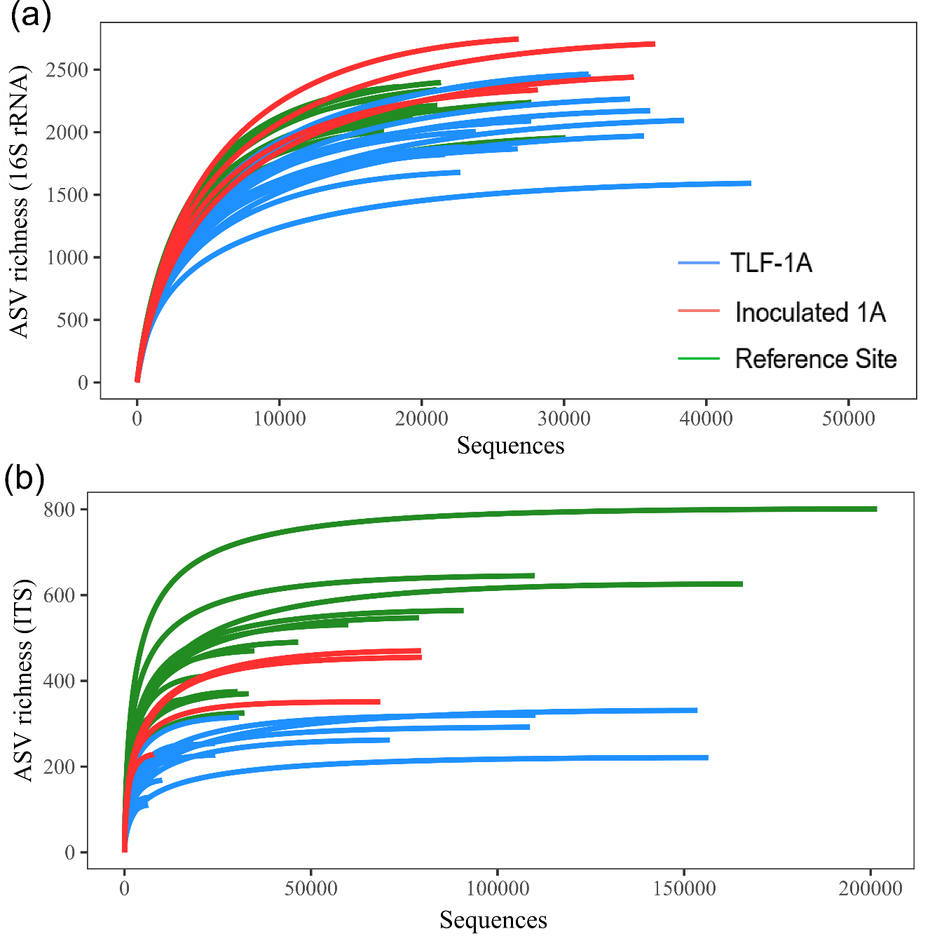
Figure S1 Rarefaction curves for the ASVs detected using (a) 16S rRNA and (b) ITS region sequences in surface soils from TLF-1A, Inoculated 1A and Reference Site.
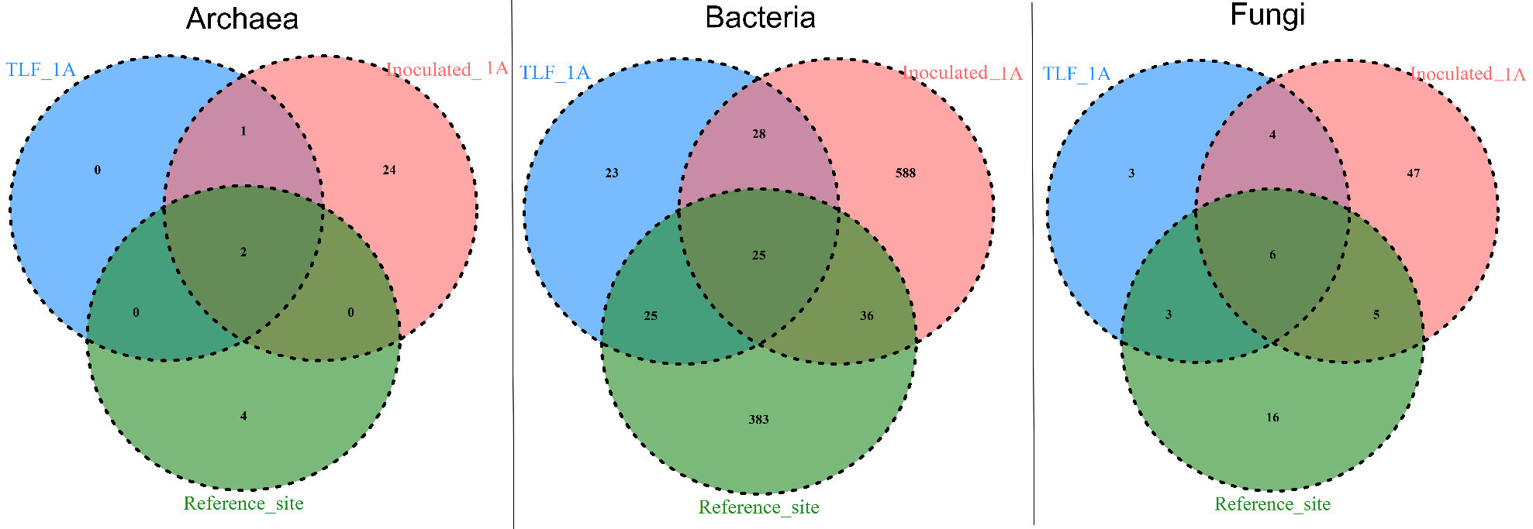
Figure S2 Venn diagram showing common core taxa detected in soil microbiomes from TLF-1A, Inoculated 1A and Reference site and the specific core taxa associated with individual sites within domains of archaea, bacteria and fungi.
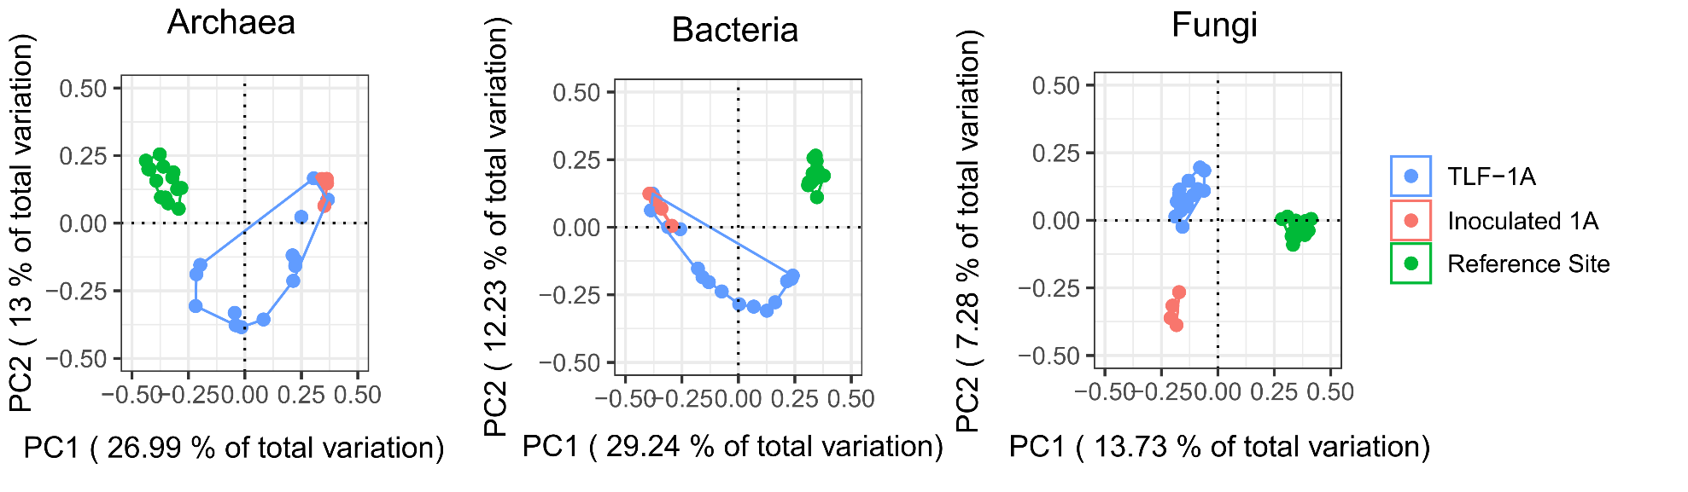
Figure S3 Unconstrained principal coordinates analysis plots illustrating the similarities in individual samples based on Bray-Curtis distance of square root transformed relative abundance of soil microbiomes from TLF-1A, Inoculated 1A and Reference Site.

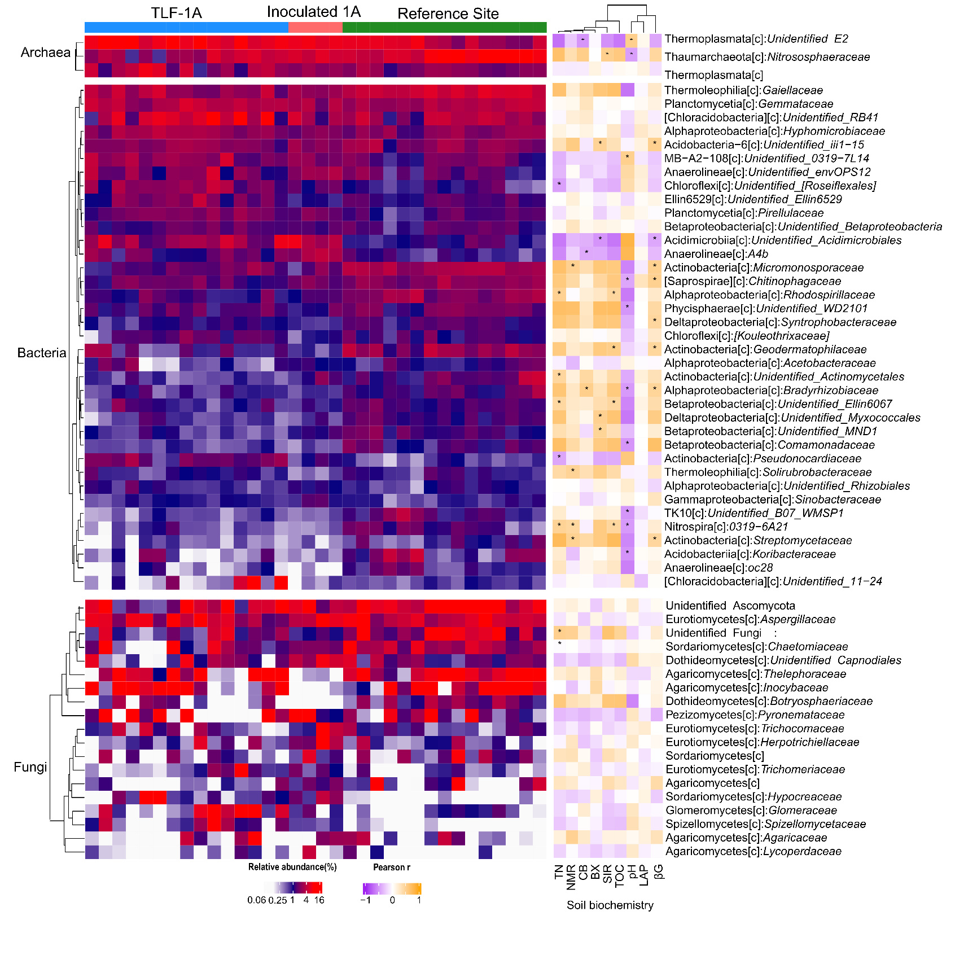
Figure S4 Heatmap of the abundant soil microbiomes at family level of archaeal, bacterial and fungal communities. Left panel displaying their relative abundance in individual samples with these families clustering result shown on the left side; middle panel illustrating the Pearson’s correlation among soil geochemical properties with their cluster results above and * indicates the significant correlations between the soil biochemistry and the corresponding family; right panel displaying the taxonomy annotation based on the blast results format as name of class[c]: family group. Abbreviations for soil biochemistry include TOC: total organic carbon; TN: total nitrogen; NMR: net N mineralization rate; SIR: sucrose induced respiration; βG:β-1,4-glucosidase activity; CB: cellobiohydrolase activity and LAP: L-leucine aminopeptidase activity.

