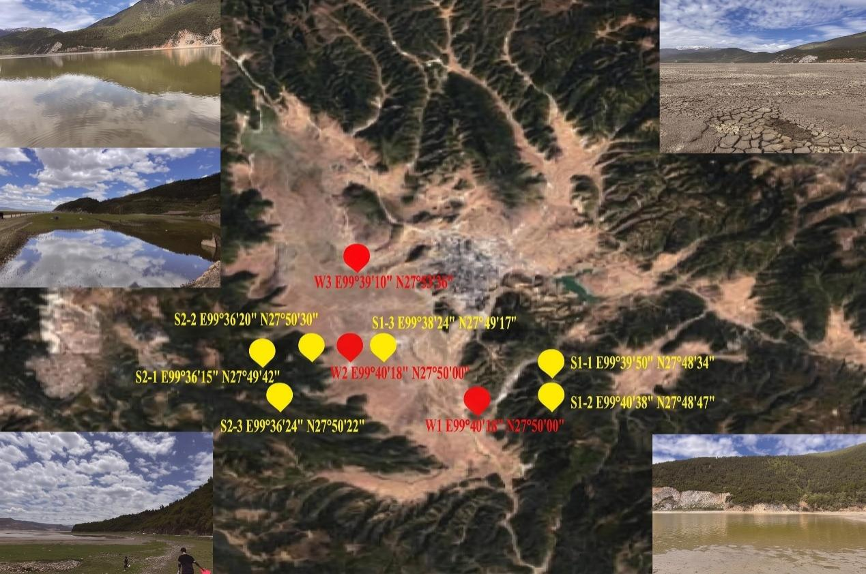
Supplementary Figure 1. Geographical satellite map of the sample collection area, including the coordinates and information from Supplementary Table 1 and landscape photos taken during sample collection.

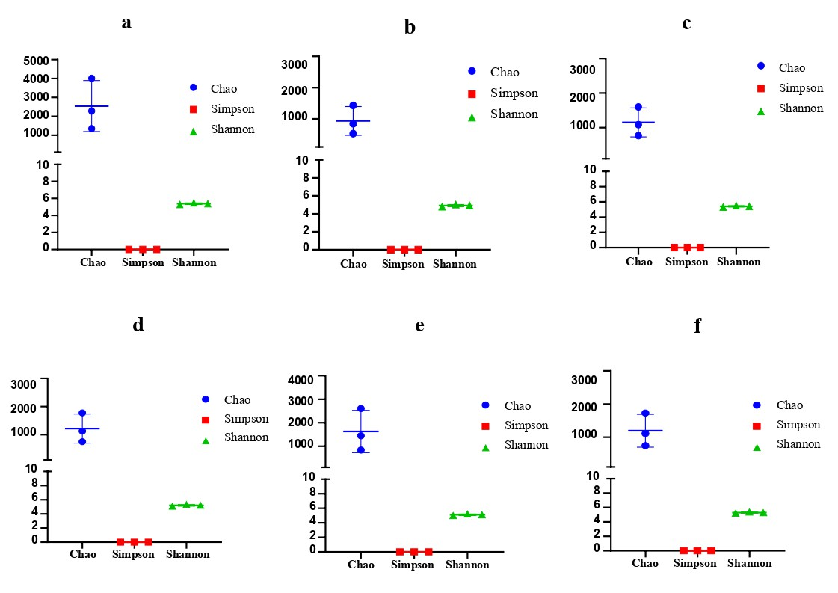
Supplementary Figure 2. Alpha diversity analysis of DNA polymerase genes from different habitats and origins. Different colors denote different genetic diversity indices. Panels a/d, b/e, and c/f correspond to PolA, PolB, and PolC family genes, respectively.

Supplementary Table 1. Geographic coordinates and physicochemical parameters of the sampling sites

Sample type | Sample number | Longitude | Latitude | Altitude (m) | pH | N | P | Zn | Mg | K | Cu
Soil | S1 | 99°39′50″ | 27°48′34″ | 3231.64 | 6.0 | 1.089 | 0.1440 | 6.020 | 54.7 | 0.587 | 24.0
Soil | S2 | 99°40′38″ | 27°48′47″ | 3220.00 | 6.0 | 0.253 | 0.0352 | 2.280 | 38.0 | 1.100 | 16.6
Soil | S3 | 99°38′24″ | 27°49′17″ | 3220.99 | 5.0 | 0.435 | 0.0880 | 3.800 | 53.4 | 0.647 | 16.9
Soil | S4 | 99°36′15″ | 27°49′42″ | 3217.65 | 5.0 | 0.358 | 0.1200 | 5.740 | 104 | 0.908 | 16.5
Soil | S5 | 99°36′20″ | 27°50′30″ | 3218.71 | 5.0 | 0.156 | 0.1080 | 3.820 | 50.8 | 0.406 | 10.3
Soil | S6 | 99°36′24″ | 27°50′22″ | 3218.88 | 5.0 | 1.156 | 0.1420 | 5.290 | 58.5 | 0.643 | 29.4
Lake water | W1 | 99°40′18″ | 27°50′00″ | 3218.00 | 6.0 | 1.350 | 0.1580 | 0.265 | 4.86 | 2.660 | 0.011
Lake water | W2 | 99°40′18″ | 27°50′00″ | 3219.00 | 6.0 | 2.670 | 1.4300 | 0.033 | 5.04 | 2.110 | 0.008
Lake water | W3 | 99°39′10″ | 27°53′36″ | 3221.00 | 6.0 | 1.340 | - | 0.912 | 4.78 | 2.660 | 0.412
“-” indicates not detected. Physicochemical parameters for soil samples (rows 1–6) are given in g/kg (N, P, K) and mg/kg (Zn, Mg, Cu), whereas those for water samples (rows 7–9) are all in mg/L.

Supplementary Table 2. DNA polymerase gene sequences retrieved from different habitats for NMDS analysis

Habitat | GenBank accession number | Sequence count | Citation
China: Wuhan, East Lake | KP775564–KP775622 | 69 | ^{[1]}
Paddy field in Northeast China | KU171876–KU172407 | 438 | ^{[2]}
Pacific Ocean | GU082222 –GU082242 | 20 | ^{[3]}
North Atlantic Ocean | GU082060–GU082110 | 40 | —
South China Sea | GU082016–GU082035 | 20 | —
Wetland in Northeast China | MH161097–MH161162 | 66 | ^{[4]}
Arctic Ocean |  | 23 | —
Indian Ocean |  | 30 | —
Taihu Lake, China |  | 16 | —
Japan: Shiga, Lake Biwa |  | 40 | —
USA: North Dakota, Cottonwood Lake Study Area, Prairie Pothole Region wetland sediments |  | 48 | —

References
[1] Wang MN, Ge XY, Wu YQ, Yang XL, Tan B, et al. 2015. Genetic diversity and temporal dynamics of phytoplankton viruses in East Lake, China. Virologica Sinica 30: 290-300 https://doi.org/10.1007/s12250-015-3603-6
[2] Wang X, Liu J, Yu Z, Jin J, Liu X, et al. 2016. Novel groups of cyanobacterial podovirus DNA polymerase (pol) genes exist in paddy waters in northeast China. FEMS Microbiology Ecology 92: fiw192 https://doi.org/10.1093/femsec/fiw192
[3] Huang S, Wilhelm SW, Jiao N, Chen F. 2010. Ubiquitous cyanobacterial podoviruses in the global oceans unveiled through viral DNA polymerase gene sequences. The ISME Journal 4: 1243-1251 https://doi.org/10.1038/ismej.2010.56
[4] Li X, Sun Y, Liu J, Yao Q, Wang G. 2019. Molecular Diversity of Cyanopodoviruses in Two Coastal Wetlands in Northeast China. Current Microbiology 76: 863-871 https://doi.org/10.1007/s00284-019-01700-0

