Supplementary Materials
for
Alkyl carbon in a hydrophobic coating enhances the chemical stability of hydrochar

List of Tables and Figures
Table S1 Most frequently employed reaction mechanisms in solid-state processes. α = fractional conversion; g(α) = integral form of the reaction model.
Fig. S1 (O+N)/C atomic ratios at different depths of leaf-derived hydrochar. CL, LL, PL, and PN denote corn leaves, lotus leaves, palm leaves, and pine needles, respectively. The suffix -H represents the corresponding hydrochar sample.
Fig. S2 Scanning electron microscopy (SEM) images of leaf-derived hydrochars before and after acetone extraction. CL-H, LL-H, PL-H, and PN-H represent untreated hydrochar derived from corn leaves, lotus leaves, palm leaves, and pine needles, respectively; the suffix -ex denotes the corresponding hydrochar sample after acetone extraction.
Fig. S3 Contact angle of hydrochar derived from different biomass before and after acetone extraction. CE, CL, LL, PL, and PN represent cellulose, corn leaves, lotus leaves, palm leaves, and pine needle biomass, respectively. Hydrochar stands for unextracted hydrochar, and Hydrochar-ex stands for acetone-extracted hydrochar. A–E show contact angles of different raw biomass materials; a–d show contact angles of various unextracted hydrochar samples; I–V show contact angles of hydrochars after acetone extraction. ** means a significant difference at p< 0.01, and ns means no significant difference, when comparing contact angles between raw biomass and matching hydrochars, and between hydrochars before and after acetone extraction.
Fig. S4 H/C and O/C atomic ratios of acetone extraction products of different hydrochars. CE-H, CL-H, LL-H, PL-H, and PN-H represent hydrochar derived from cellulose, corn leaves, lotus leaves, palm leaves, and pine needles, respectively.
Fig. S5 Thermal decomposition and kinetic fitting curves of typical leaf-derived hydrochar before and after acetone extraction. (a) TG (thermogravimetry) curves; (b) DTG (derivative thermogravimetry) curves; (c) fractional conversion curves, where α denotes fractional conversion; (d) Coats–Redfern kinetic fitting plots. In subgraph (d), g(α) = α², and T represents absolute temperature. For linear fitting in subgraph (d), k refers to the slope of fitted lines, b refers to the intercept, and R² represents the coefficient of determination. PL-H stands for unextracted palm leaf hydrochar, and PL-H-ex stands for acetone-extracted palm leaf hydrochar.
Fig. S6 Principal component analysis (PCA) of carbon loss rate and aromaticity, specific surface area (SSA), and hydrophobic intensity of hydrophobic coating. PCA is short for principal component analysis, and SSA stands for specific surface area. CE-H, CL-H, LL-H, PL-H, and PN-H represent hydrochar derived from cellulose, corn leaves, lotus leaves, palm leaves, and pine needles, respectively.
Text 1 Python code for coats–redfern kinetic calculation of hydrochar thermal decomposition.

Table S1 Most frequently employed reaction mechanisms in solid-state processes. α = fractional conversion; g(α) = integral form of the reaction model.
Reaction mechanism | Symbol | g(α)
Order of reaction
First-order | F₁ | –ln(1–α)
Second-order | F₂ | (1–α)⁻¹–1
Third-order | F₃ | [(1–α)⁻²–1]/2
Diffusion
One-way transport | D₁ | α²
Two-way transport | D₂ | (1–α)ln(1–α)+α
Three-way transport | D₃ | [1–(1–α)^{1/3}]²
Ginstling-Brounshtein equation | D₄ | (1–2α/3)–(1–α)^{2/3}
Limiting surface reaction between both phases
One dimension | R₁ | α
Two dimensions | R₂ | 1–(1–α)^{1/2}
Three dimensions | R₃ | 1–(1–α)^{1/3}
Random nucleation and nuclei growth
Two-dimensional | A₂ | [–ln(1–α)]^{1/2}
Three-dimensional | A₃ | [–ln(1–α)]^{1/3}
Exponential nucleation
Power law, n =1/2 | P₂ | α^{1/2}
Power law, n = 1/3 | P₃ | α^{1/3}
Power law, n = 1/4 | P₄ | α^{1/4}

Fig. S1 (O+N)/C atomic ratios at different depths of leaf-derived hydrochar. CL, LL, PL, and PN denote corn leaves, lotus leaves, palm leaves, and pine needles, respectively. The suffix -H represents the corresponding hydrochar sample.

Fig. S2 Scanning electron microscopy (SEM) images of leaf-derived hydrochars before and after acetone extraction. CL-H, LL-H, PL-H, and PN-H represent untreated hydrochar derived from corn leaves, lotus leaves, palm leaves, and pine needles, respectively; the suffix -ex denotes the corresponding hydrochar sample after acetone extraction.
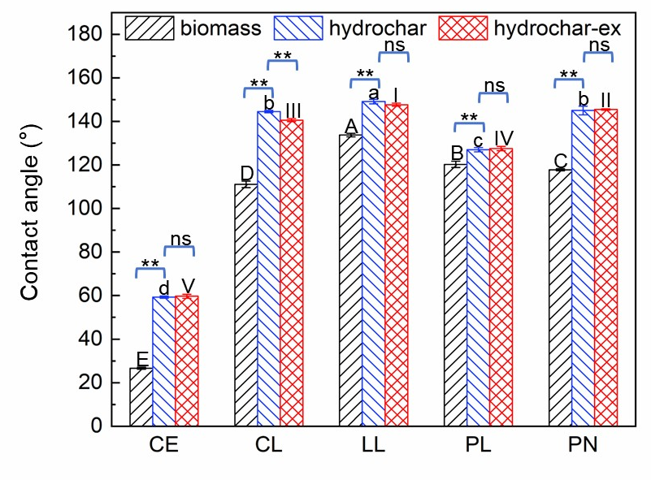
Fig. S3 Contact angle of hydrochar derived from different biomass before and after acetone extraction. CE, CL, LL, PL, and PN represent cellulose, corn leaves, lotus leaves, palm leaves, and pine needle biomass, respectively. Hydrochar stands for unextracted hydrochar, and Hydrochar-ex stands for acetone-extracted hydrochar. A–E show contact angles of different raw biomass materials; a–d show contact angles of various unextracted hydrochar samples; I–V show contact angles of hydrochars after acetone extraction. ** means a significant difference at p< 0.01, and ns means no significant difference, when comparing contact angles between raw biomass and matching hydrochars, and between hydrochars before and after acetone extraction.

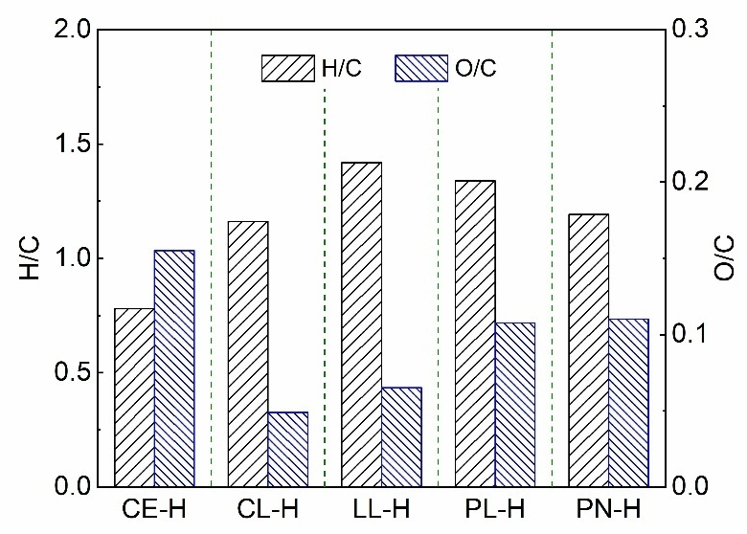

Fig. S4 H/C and O/C atomic ratios of acetone extraction products of different hydrochars. CE-H, CL-H, LL-H, PL-H, and PN-H represent hydrochar derived from cellulose, corn leaves, lotus leaves, palm leaves, and pine needles, respectively.

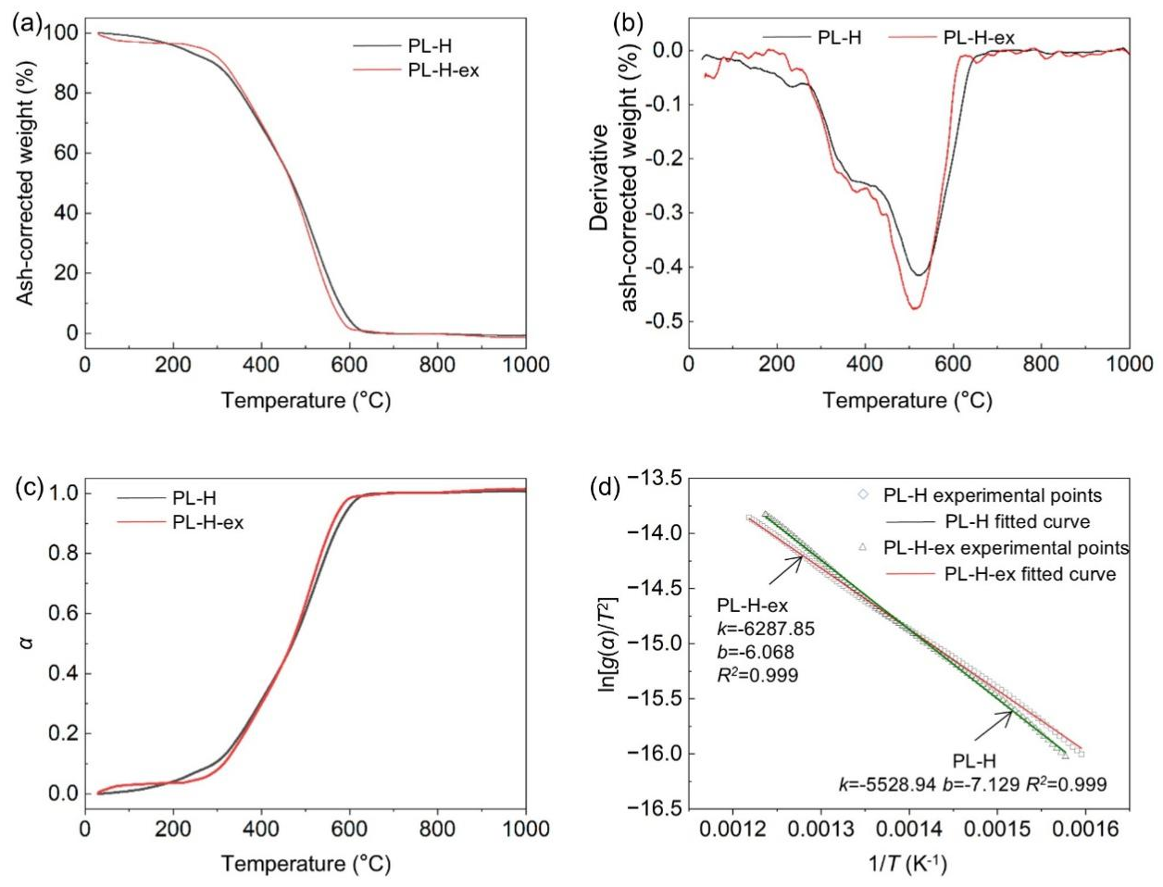
Fig. S5 Thermal decomposition and kinetic fitting curves of typical leaf-derived hydrochar before and after acetone extraction. (a) TG (thermogravimetry) curves; (b) DTG (derivative thermogravimetry) curves; (c) fractional conversion curves, where α denotes fractional conversion; (d) Coats–Redfern kinetic fitting plots. In subgraph (d), g(α) = α², and T represents absolute temperature. For linear fitting in subgraph (d), k refers to the slope of fitted lines, b refers to the intercept, and R² represents the coefficient of determination. PL-H stands for unextracted palm leaf hydrochar, and PL-H-ex stands for acetone-extracted palm leaf hydrochar.

Fig. S6 Principal component analysis (PCA) of carbon loss rate and aromaticity, specific surface area (SSA), and hydrophobic intensity of hydrophobic coating. PCA is short for principal component analysis, and SSA stands for specific surface area. CE-H, CL-H, LL-H, PL-H, and PN-H represent hydrochar derived from cellulose, corn leaves, lotus leaves, palm leaves, and pine needles, respectively.

Text 1
Python code for coats–redfern kinetic calculation of hydrochar thermal decomposition
This Python script implements the Coats–Redfern integral method for thermal decomposition kinetic analysis of the typical hydrochar sample PL-H. The supporting Excel file storing data for PL-H contains only two columns: the first column is temperature in °C with the header name “Temp”, and the second column refers to conversion degree α with the header name “Degree”. All calculations are strictly restricted within the fractional conversion range of α = 0.2–0.8, and activation energy is uniformly calculated with the unit of J/mol to prevent unit mismatch errors described in the manuscript.
This script automatically executes linear regression fitting for multiple classical solid-state reaction kinetic models. In addition to the final kinetic fitting results (i.e., R², E, and A), this code also calculates and outputs the original independent variable (x=1/T), original experimental dependent variable (y= ln[g(α)/T²]), and model-fitted theoretical y value for each reaction model. This one-to-one correspondence of experimental and theoretical data facilitates intuitive comparison, verification of fitting accuracy, and in-depth analysis of fitting deviation. Finally, the script exports a complete collation table containing all raw data and kinetic parameters for all fitted models, which enables the selection of the optimal fitting model with the highest coefficient of determination (R²).
"""
Thermal Pyrolysis Kinetic Analysis Code
Method: Coats-Redfern integral method
Applicable for kinetic parameter calculation of solid pyrolysis
Main Parameters & Units:
1. Universal gas constant R = 8.314 J/(mol·K)
2. Heating rate β = 10 K/min
3. Activation Energy E: unit = J/mol
4. Pre-exponential factor A: unit = min⁻¹
5. Temperature: Original data is Celsius (°C), converted to Kelvin (K) for calculation
6. Conversion degree α: range filtered as 0.2 < α < 0.8
Calculation Formula (Coats-Redfern):
ln[g(α) / T²] = ln(AR/(βE)) - E/(RT)
- Independent variable x = 1/T (K⁻¹)
- Dependent variable y = ln[g(α) / T²]
- Slope = -E/R → E = -Slope × R
- Intercept = ln(AR/(βE)) → A = (β * E / R) * exp(Intercept)
Output Files:
1. Kinetic_Analysis_Results.xlsx: Summary of regression and kinetic parameters
2. XY_Data_for_Plotting.xlsx: X, original Y and fitted Y for plotting (1 sheet per model)
"""
import pandas as pd
import numpy as np
from sklearn.linear_model import LinearRegression
from sklearn.metrics import r2_score
#====== Basic Physical & Experimental Parameters ======
R = 8.314 # Universal gas constant, J/(mol·K)
BETA = 10 # Heating rate, K/min
# ====== File Path Configuration ======
# Input raw data (modify the path according to your local file)
input_file = r"E:/Kinetic-Analysis/PL-H.xlsx"
# Output 1: Summary table of kinetic parameters (single sheet)
summary_result_file = r"E:/Kinetic-Analysis/Results_PL-H.xlsx"
# Output 2: Data for plotting (15 sheets, one sheet for each kinetic model)
plot_data_file = r"E:/Kinetic-Analysis/XY_Data_for_Plotting_PL-H.xlsx"
# ====== Read Raw Data & Data Filtering======
df_raw = pd.read_excel(input_file, sheet_name="Sheet1")
# Filter data: 0.2 < Conversion degree (Degree) < 0.8
df_filtered = df_raw[(df_raw["Degree"] > 0.2) & (df_raw["Degree"] < 0.8)].copy()
# Extract variables
T_celsius = df_filtered["Temp"].values # Temperature (°C)
alpha = df_filtered["Degree"].values # Conversion degree α
T_kelvin = T_celsius + 273.15 # Convert to Kelvin (K)
# ====== Define 15 Kinetics Functions g(α) ======
# Add 1e-8 to avoid log(0) and division by zero errors
g1 = -np.log(1 - alpha + 1e-8)
g2 = (1 - alpha) ** (-1) - 1
g3 = ((1 - alpha) ** (-2) - 1) / 2
g4 = alpha ** 2
g5 = (1 - alpha) * np.log(1 - alpha + 1e-8) + alpha
g6 = (1 - (1 - alpha) ** (1 / 3)) ** 2
g7 = (1 - 2 * alpha / 3) - (1 - alpha) ** (2 / 3)
g8 = alpha
g9 = 1 - (1 - alpha) ** (1 / 2)
g10 = 1 - (1 - alpha) ** (1 / 3)
g11 = (-np.log(1 - alpha + 1e-8)) ** (1 / 2)
g12 = (-np.log(1 - alpha + 1e-8)) ** (1 / 3)
g13 = alpha ** (1 / 2)
g14 = alpha ** (1 / 3)
g15 = alpha ** (1 / 4)
# Store kinetic functions and their mathematical expressions
g_function_list = [g1, g2, g3, g4, g5, g6, g7, g8, g9, g10, g11, g12, g13, g14, g15]
g_expression = [
"-ln(1-α)",
"(1-α)⁻¹-1",
"((1-α)⁻²-1)/2",
"α²",
"(1-α)ln(1-α)+α",
"(1-(1-α)^(1/3))²",
"(1-2α/3)-(1-α)^(2/3)",
"α",
"1-(1-α)^(1/2)",
"1-(1-α)^(1/3)",
"(-ln(1-α))^(1/2)",
"(-ln(1-α))^(1/3)",
"α^(1/2)",
"α^(1/3)",
"α^(1/4)"
]
# ====== Construct Independent Variable x ======
# x = 1/T (K⁻¹), no multiplication by 1000
x = 1 / T_kelvin
x_2d = x.reshape(-1, 1) # 2D array for sklearn linear regression
x_1d = x.flatten() # 1D array for writing to Excel table
# ====== Linear Regression & Parameter Calculation ======
summary_results = []
# Create multi-sheet Excel file for plotting data
with pd.ExcelWriter(plot_data_file, engine="openpyxl") as writer:
for idx, (g_func, g_expr) in enumerate(zip(g_function_list, g_expression), 1):
# Calculate original dependent variable y
y = np.log(g_func / (T_kelvin ** 2) + 1e-8)
# Linear regression fitting
lr_model = LinearRegression()
lr_model.fit(x_2d, y)
y_fitted = lr_model.predict(x_2d) # Fitted y values from regression
# Extract regression coefficients
intercept = lr_model.intercept_
slope = lr_model.coef_[0]
r_square = r2_score(y, y_fitted)
# Calculate Activation Energy E (J/mol)
E = -slope * R
# Calculate Pre-exponential factor A (min⁻¹)
# Formula matched with manuscript: A = (β * E / R) * exp(intercept)
if E > 0:
A = (BETA * E / R) * np.exp(intercept)
else:
A = np.nan # Invalid result for negative activation energy
# 1. Append data to parameter summary list
summary_results.append({
"Model_ID": f"Model_{idx}",
"Kinetic_Function": g_expr,
"Intercept": round(intercept, 6),
"Slope_(K)": round(slope, 6),
"R_squared": round(r_square, 6),
"Activation_Energy_E_(J/mol)": round(E, 2),
"Pre_exponential_Factor_A_(min^-1)": round(A, 2) if not np.isnan(A) else A
})
# 2. Write X-Y data to independent sheet (for plotting)
plot_df = pd.DataFrame({
"x (1/K)": x_1d,
"Original_y": y,
"Fitted_y": y_fitted
})
sheet_name = f"Model_{idx}"
plot_df.to_excel(writer, sheet_name=sheet_name, index=False)
# 3. Print results to console
print(f"========== Model {idx} Regression Results ==========")
print(f"Kinetic Function: {g_expr}")
print(f"Intercept: {intercept:.6f}")
print(f"Slope (K): {slope:.6f}")
print(f"R²: {r_square:.6f}")
print(f"Activation Energy E: {E:.2f} J/mol")
if np.isnan(A):
print("Pre-exponential Factor A: Invalid (Negative activation energy)\n")
else:
print(f"Pre-exponential Factor A: {A:.2f} min⁻¹\n")
# ====== Export Parameter Summary to Excel ======
summary_df = pd.DataFrame(summary_results)
summary_df.to_excel(summary_result_file, index=False)
# ====== Running Completion Prompt ======
print("=" * 70)
print("Execution completed successfully! Two Excel files have been generated:")
print(f"1. Parameter Summary: {summary_result_file}")
print(f"2. Plotting Data (Multi-sheet): {plot_data_file}")
print("=" * 70)

