Supplementary data for:
Incorporating rice straw in the form of biochar: A sustainable measure to protect humans from heavy metal exposure
Jiannan Liao^{1#}, Wenjing Ning^{1#}, Yu Gong², Wenli Tang¹*, Huan Zhong¹*
¹ School of Environment, Nanjing University, State Key Laboratory of Water Pollution Control and Green Resource Recycling, Nanjing 210023, China.
² Institute of Urban Agriculture, Chinese Academy of Agricultural Sciences, Chengdu 610299, China.
# These two authors contributed equally to this work.
Corresponding to: W. Tang (tangwenli@nju.edu.cn); H. Zhong (zhonghuan@nju.edu.cn).
1 Supplementary Text
1.1 BCR sequential extraction
Geochemical fractionation of Cd in soils was determined using the widely adopted BCR sequential extraction procedure^{[1–4]}. Cd was operationally separated into four geochemical fractions: (1) the acid-extractable fraction (F1), extracted with 0.11 M CH₃COOH, representing weakly bound Cd such as carbonate-associated Cd; (2) the reducible fraction (F2), extracted with 0.5 M NH₂OH·HCl, mainly corresponding to Cd associated with Fe/Mn oxides; (3) the oxidizable fraction (F3), obtained after digestion with 8.8 M H₂O₂ followed by extraction with 1 M CH₃COONH₄, mainly including Cd bound to soil organic matter and CdS; and (4) the residual fraction (F4), consisting of the residue remaining after the previous extraction steps and subsequently digested with aqua regia at 110 °C, representing Cd strongly incorporated into soil minerals, such as lattice-bound Cd. After each extraction step, the extract solutions were diluted with 2% HNO₃ prior to Cd analysis. The recovery of Cd for the BCR sequential extraction procedure, calculated as the total Cd extracted from the four fractions relative to the total soil Cd concentration, ranged from 90% to 119%.
1.2 CaCl₂ extracted Cd in soils
Extraction with a dilute CaCl₂ solution is commonly used to assess relatively mobile Cd fractions in soils and has also been used as an indicator of potentially available Cd in previous studies^{[5-8]}. In the present study, CaCl₂-extractable Cd was determined to evaluate the effects of different treatments on soil Cd mobility. Briefly, approximately 3 g of fresh soil was transferred into a 15-mL polypropylene centrifuge tube, followed by the addition of 10 mL of 0.01 M CaCl₂ solution^{[9,10]}. The mixtures were extracted by shaking at 25 ℃ and 260 rpm for 1 h, followed by centrifugation at 3000 rpm for 20 min. After centrifugation, the supernatants were passed through 0.45-μm membrane filters, acidified with 2% HNO₃, and subsequently analyzed for Cd concentrations.
2 Supplementary figures
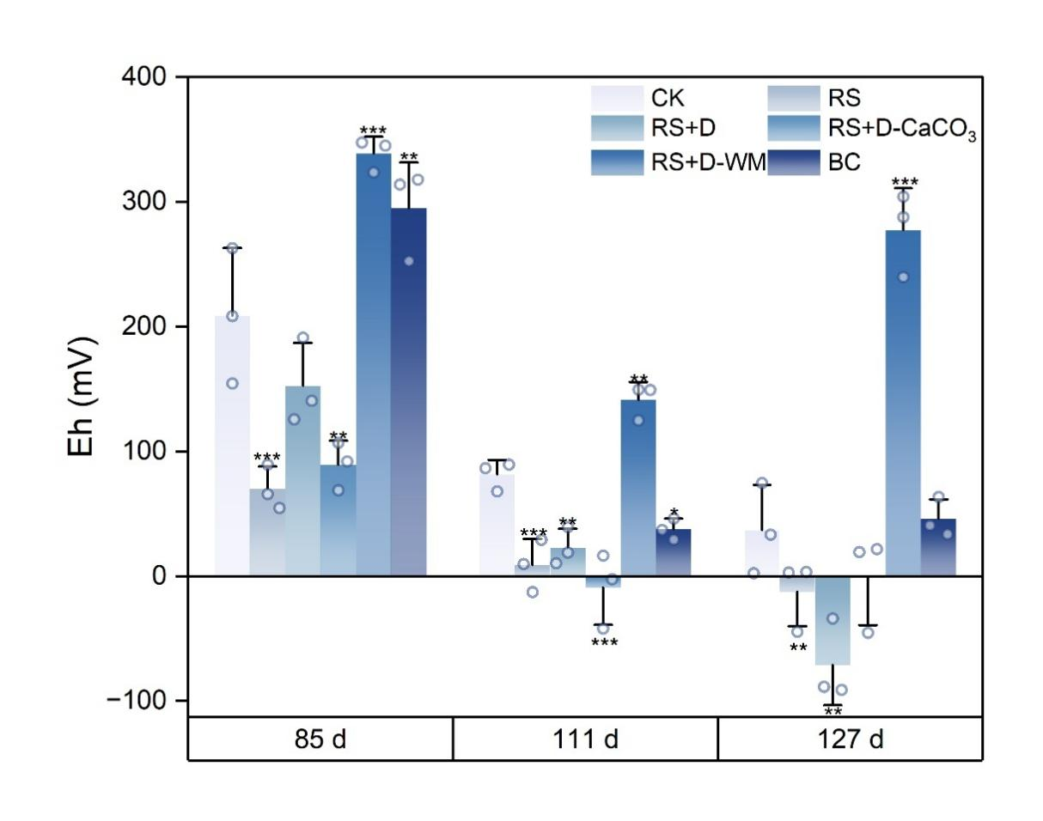
Fig. S1 Soil Eh in different treatments during the rice growth period. *, **, and *** represent a significant difference at p < 0.05, p < 0.01, and p < 0.001 compared with the control. Data are presented as mean ± SD, n = 3.
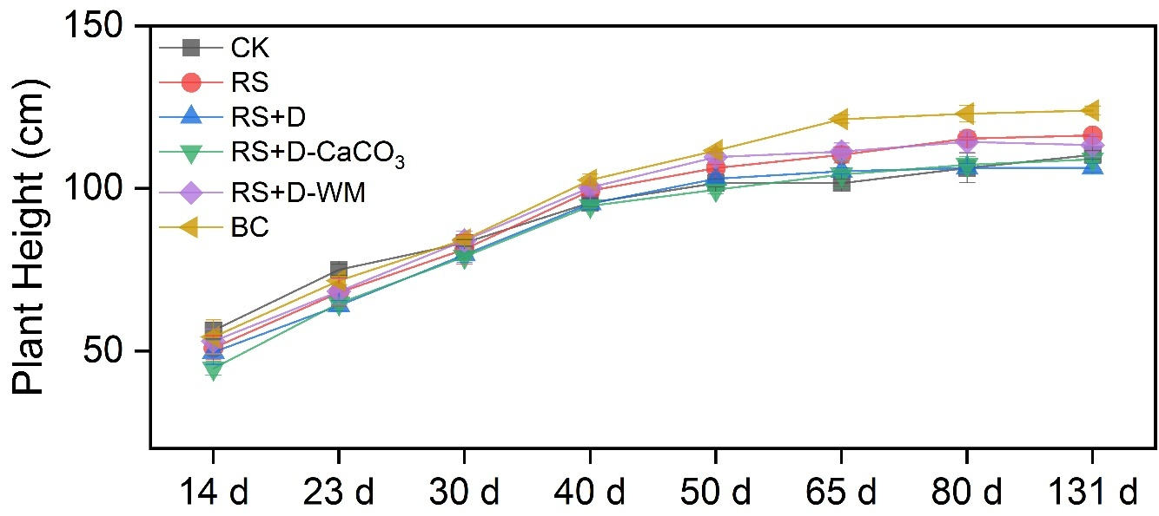
Fig. S2 Dynamics of plant heights in different treatments. Data are presented as mean ± SD, n = 3.
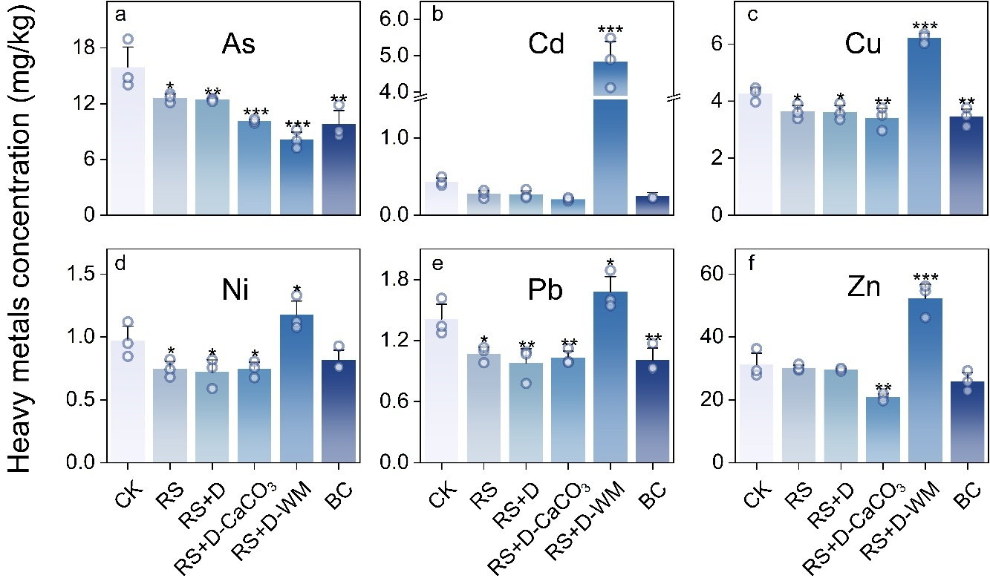
Fig. S3 Heavy metals in rice straw. *, **, and *** represent a significant difference at p < 0.05, p < 0.01, and p < 0.001 compared with the control. Data are presented as mean ± SD, n = 3.
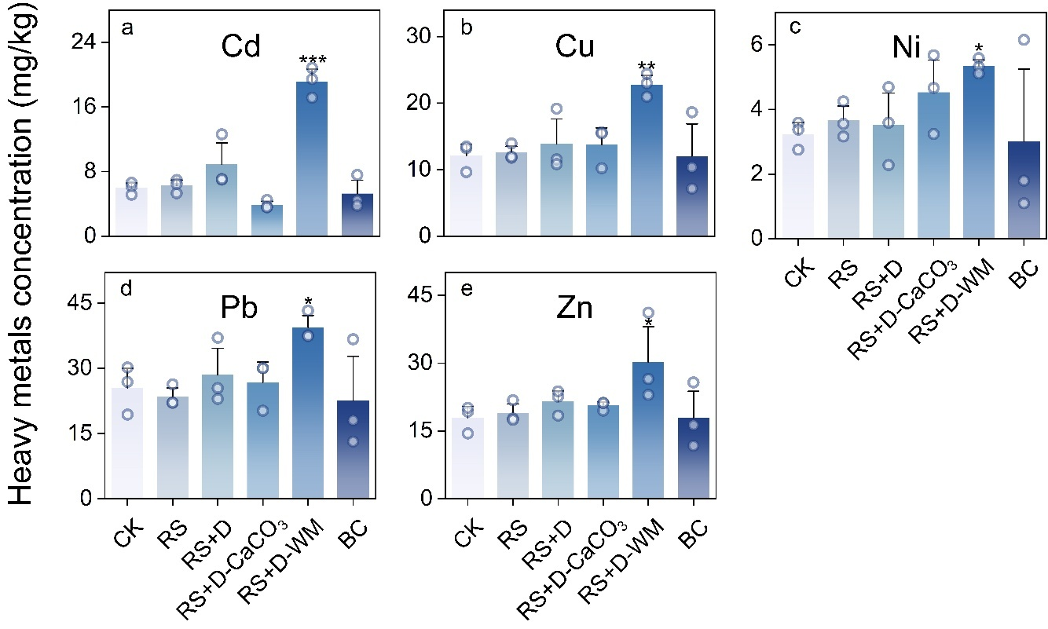
Fig. S4 Heavy metals in rice roots. *, **, and *** represent a significant difference at p < 0.05, p < 0.01, and p < 0.001 compared with the control. Data are presented as mean ± SD, n = 3.
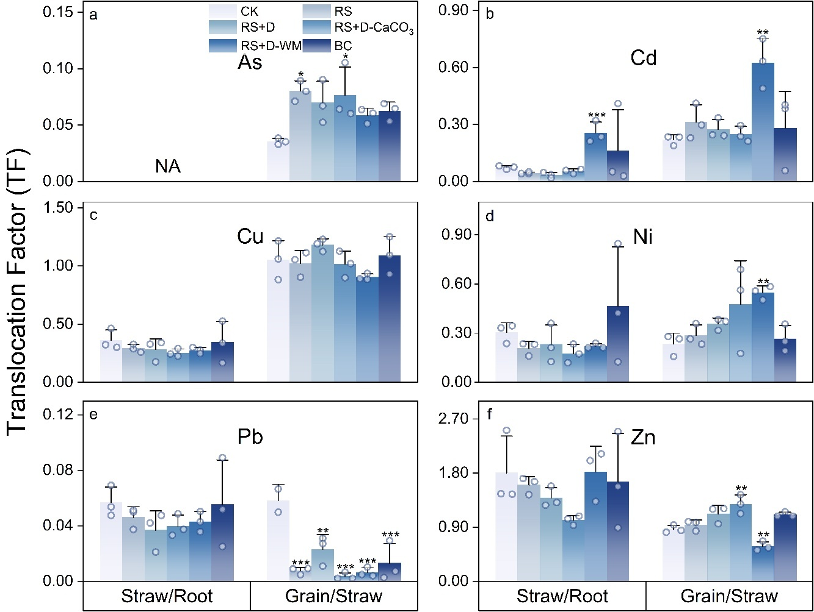
Fig. S5 Translocation factors of heavy metals from roots to straw and from straw to grains. *, **, and *** represent a significant difference at p < 0.05, p < 0.01, and p < 0.001 compared with the control. Data are presented as mean ± SD, n = 3.
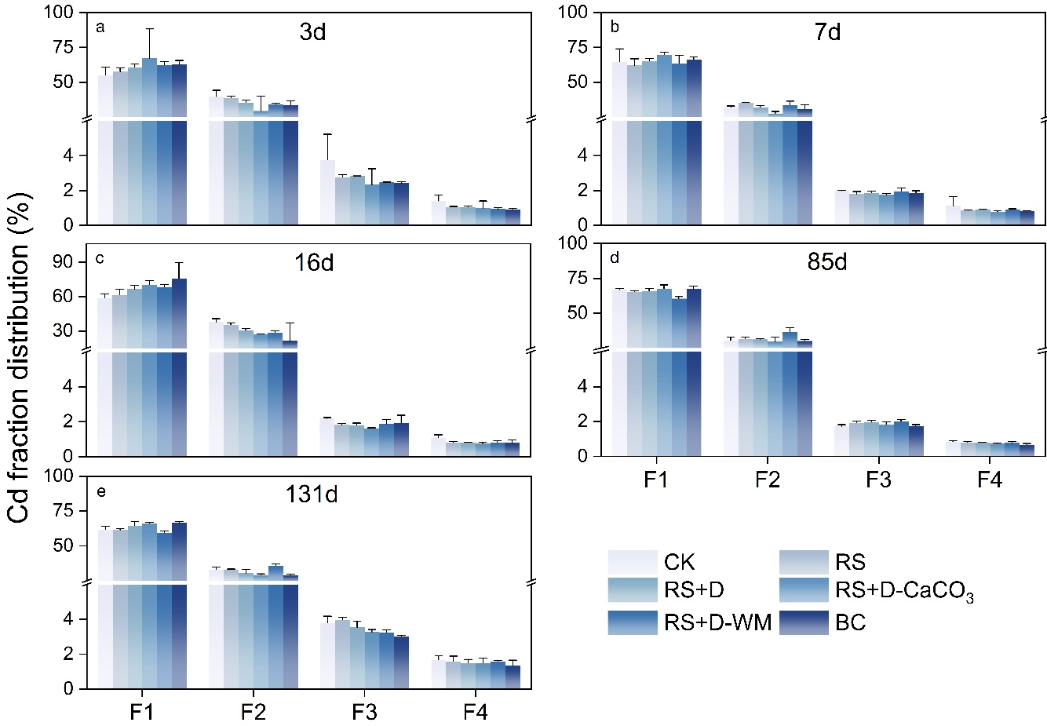
Fig. S6 BCR-extracted fractions of Cd in soils under different straw management treatments. F1, acid-extractable fraction; F2, reducible fraction; F3, oxidizable fraction; F4, residual fraction. Data are presented as mean ± SD, n = 3.
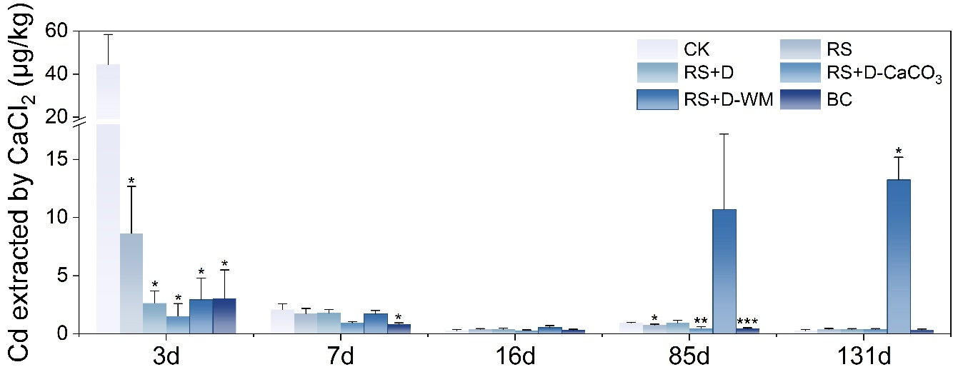
Fig. S7 CaCl₂-extractable Cd concentrations in soils under different straw management treatments. *, **, and *** represent a significant difference at p < 0.05, p < 0.01, and p < 0.001 compared with the control. Data are presented as mean ± SD, n = 3.
3 Supplementary tables
Table S1. Reported changing ratio of HM accumulation induced by straw incorporation
Metal | Changing rate (%) | Experimental condition | Reference | Metal | Changing rate (%) | Experimental condition | Reference
As | 8.7 | Pot | [11] | Cd | 1.6 | Pot | [12]
As | 1.2 | Pot | [13] | Cd | 0.7 | Pot | [12]
As | 69.5 | Pot | [13] | Cd | 5.5 | Pot | [12]
As | 0.6 | Pot | [13] | Cd | 10.7 | Pot | [12]
As | 26.2 | Pot | [13] | Cd | -29.4 | Field | [14]
As | 15.1 | Pot | [13] | Cd | 38 | Field | [15]
As | 46 | Pot | [13] | Cd | -39.3 | Field | [16]
As | 8.7 | Pot | [13] | Cd | 21.3 | Field | [17]
As | 21.7 | Pot | [13] | Cd | 31.9 | Field | [17]
As | 109.9 | Pot | [18] | Cd | 131.8 | Field | [17]
As | 6 | Pot | [19] | Cd | 75.5 | Field | [17]
Cd | 17.3 | Field | [20] | Cd | 9.6 | Field | [17]
Cd | 20.59 | Field | [20] | Cd | 28.9 | Field | [17]
Cd | 24 | Pot | [21] | Cd | 8.4 | Field | [17]
Cd | 28.6 | Pot | [21] | Cd | 93 | Field | [17]
Cd | 22.4 | Field | [22] | Cd | -8.4 | Field | [17]
Cd | -21.7 | Pot | [11] | Cd | 68.9 | Field | [17]
Cd | -14.6 | Field | [23] | Cd | 132.2 | Field | [17]
Cd | -21.6 | Field | [23] | Cd | 100.5 | Field | [17]
Cd | 28.6 | Field | [24] | Cd | 51.7 | Field | [17]
Cd | -3.6 | Field | [24] | Cd | 96.7 | Field | [17]
Cd | 41.9 | Field | [21] | Cd | 54.8 | Field | [17]
Cd | 11 | Field | [21] | Cd | 91.1 | Field | [17]
Cd | 19.7 | Field | [21] | Cu | 8.9 | Pot | [21]
Cd | 25.86 | Field | [21] | Cu | 22.1 | Pot | [21]
Cd | 17.2 | Field | [25] | Ni | -9 | Pot | [26]
Cd | 20.45 | Field | [25] | Pb | 11.3 | Pot | [21]
Cd | 18.6 | Field | [25] | Pb | 53.5 | Pot | [21]
References
[1] Chen B, Zhu Y-G. 2006. Humic Acids Increase the Phytoavailability of Cd and Pb to Wheat Plants Cultivated in Freshly Spiked, Contaminated Soil. Journal of Soils and Sediments 6:236–242 http://doi.org/10.1065/jss2006.08.178
[2] Jiang J, Xu RK, Jiang TY, Li Z. 2012. Immobilization of Cu(II), Pb(II) and Cd(II) by the addition of rice straw derived biochar to a simulated polluted Ultisol. Journal of Hazardous Materials 229:145–150 http://doi.org/10.1016/j.jhazmat.2012.05.086
[3] Kosolsaksakul P, Farmer JG, Oliver IW, Graham MC. 2014. Geochemical associations and availability of cadmium (Cd) in a paddy field system, northwestern Thailand. Environmental Pollution 187:153–161 http://doi.org/10.1016/j.envpol.2014.01.006
[4] Williams PN, Lei M, Sun G, Huang Q, Ying LU, et al. 2009. Occurrence and Partitioning of Cadmium, Arsenic and Lead in Mine Impacted Paddy Rice: Hunan, China. Environmental Science & Technology 43:637–642 http://doi.org/10.1021/es802412r
[5] Huang B, Kuo S, Bembenek R. 2004. Availability of Cadmium in some Phosphorus Fertilizers to Field-Grown Lettuce. Water, Air, and Soil Pollution 158:37–51 http://doi.org/10.1023/B:WATE.0000044832.04770.41
[6] McBride MB, Richards BK, Steenhuis T. 2004. Bioavailability and crop uptake of trace elements in soil columns amended with sewage sludge products. Plant and Soil 262:71–84 http://doi.org/10.1023/B:PLSO.0000037031.21561.34
[7] Novozamsky I, Lexmond TM, Houba VJG. 1993. A Single Extraction Procedure of Soil for Evaluation of Uptake of Some Heavy Metals by Plants. International Journal of Environmental Analytical Chemistry 51:47–58 http://doi.org/10.1080/03067319308027610
[8] Whitten M, Ritchie G. 1991. Calcium chloride extractable cadmium as an estimate of cadmium uptake by subterranean clover. Australian Journal of Soil Research 29:215–221 http://doi.org/10.1071/sr9910215
[9] Degryse F, Broos K, Smolders E, Merckx R. 2003. Soil solution concentration of Cd and Zn can be predicted with a CaCl₂ soil extract. European Journal of Soil Science 54:149–158 http://doi.org/10.1046/j.1365-2389.2003.00503.x
[10] Feng M-H, Shan X-Q, Zhang S, Wen B. 2005. A comparison of the rhizosphere-based method with DTPA, EDTA, CaCl2, and NaNO3 extraction methods for prediction of bioavailability of metals in soil to barley. Environmental Pollution 137:231–240 http://doi.org/10.1016/j.envpol.2005.02.003
[11] Liu Y, Zeng H, Zhou H, Zhang S, Tie B, et al. 2023. Variation of Cd and As accumulation in crops under oilseed rape–rice rotation system in response to different contaminated rice straw-return methods. Plant and Soil 489:309–321 http://doi.org/10.1007/s11104-023-06018-2
[12] Gao Q, Chang H, Huang T, Zhou R. 2024. Understanding the role of pig manure, rice straw, and calcium carbonate on the cadmium pollution in soil–wheat system. Soil Science Society of America Journal 88:1959–1970 http://doi.org/10.1002/saj2.20758
[13] Ma R, Shen J, Wu J, Tang Z, Shen Q, et al. 2014. Impact of agronomic practices on arsenic accumulation and speciation in rice grain. Environmental Pollution 194:217–223 http://doi.org/10.1016/j.envpol.2014.08.004
[14] Liang T, Zhou G, Chang D, Wang Y, Gao S, et al. 2022. Co-incorporation of Chinese milk vetch (Astragalus sinicus L.), rice straw, and biochar strengthens the mitigation of Cd uptake by rice (Oryza sativa L.). Science of the Total Environment 850:158060 http://doi.org/10.1016/j.scitotenv.2022.158060
[15] Rao Z-X, Huang D-Y, Wu J-S, Zhu Q-H, Zhu H-H, et al. 2018. Distribution and availability of cadmium in profile and aggregates of a paddy soil with 30-year fertilization and its impact on Cd accumulation in rice plant. Environmental Pollution 239:198–204 http://doi.org/10.1016/j.envpol.2018.04.024
[16] Wang S, Huang DY, Zhu QH, Zhu HH, Shen X. 2015. Speciation and phytoavailability of cadmium in soil treated with cadmium-contaminated rice straw. Environmental Science and Pollution Research 22:2679–2686 http://doi.org/10.1007/s11356-014-3515-2
[17] Tian B, Yang Y, Chen A, Peng L, Deng X, et al. 2025. Long-term straw removal and double-cropping system reduce soil cadmium content and uptake in rice: A four-year field analysis. Journal of Environmental Sciences 152:549–562 http://doi.org/10.1016/j.jes.2024.05.050
[18] Yang Y-P, Zhang H-M, Yuan H-Y, Duan G-L, Jin D-C, et al. 2018. Microbe mediated arsenic release from iron minerals and arsenic methylation in rhizosphere controls arsenic fate in soil-rice system after straw incorporation. Environmental Pollution 236:598–608 http://doi.org/10.1016/j.envpol.2018.01.099
[19] Yan H, Wang X, Yang Y, Duan G, Zhang H, et al. 2020. The effect of straw-returning on antimony and arsenic volatilization from paddy soil and accumulation in rice grains. Environmental Pollution 263:114581 http://doi.org/10.1016/j.envpol.2020.114581
[20] Luo S, Liu Y, Luo B, Yang Y, Li L, et al. 2023. Straw removal or non-removal affects cadmium (Cd) accumulation in soil–rice (Oryza sativa L.) system at different ambient air Cd levels. Journal of Environmental Management 344:118477 http://doi.org/10.1016/j.jenvman.2023.118477
[21] Ahmad R, Hadi F, Jan AU, Ditta A. 2022. Straw Incorporation in Contaminated Soil Enhances Drought Tolerance but Simultaneously Increases the Accumulation of Heavy Metals in Rice. Sustainability 14:10578 http://doi.org/10.3390/su141710578
[22] Li C, Wang Z-Y, Zhou H, Wen Y-L, Zeng P, et al. 2024. Effects of straw and roots removal on soil Cd availability and Cd accumulation in rice at different growth stages. Environmental Technology & Innovation 36:103768 http://doi.org/10.1016/j.eti.2024.103768
[23] Xu Y, Tang H, Liu T, Li Y, Huang X, et al. 2018. Effects of long-term fertilization practices on heavy metal cadmium accumulation in the surface soil and rice plants of double-cropping rice system in Southern China. Environmental Science and Pollution Research 25:19836–19844 http://doi.org/10.1007/s11356-018-2175-z
[24] Nie X, Duan X, Zhang M, Zhang Z, Liu D, et al. 2019. Cadmium accumulation, availability, and rice uptake in soils receiving long-term applications of chemical fertilizers and crop straw return. Environmental Science and Pollution Research 26:31243–31253 http://doi.org/10.1007/s11356-019-05998-y
[25] Yuan S, Chen P, Zhou W, Liu H, Cheng K, et al. 2024. Response characteristics of soil Cd availability to microbes in paddy soil with long-term fertilization and its impact on Cd uptake in rice. Science of the Total Environment 957:177680 http://doi.org/10.1016/j.scitotenv.2024.177680
[26] Ali U, Abdelrhman F, Bashir S, Shaaban M, Shah Z-U-H, et al. 2023. Efficacy of different amendments and residual effects on nickel toxicity and nutritional quality in wheat/rice continuous system and health risk assessment in Ultisol. Archives of Agronomy and Soil Science 69:2599–2614 http://doi.org/10.1080/03650340.2023.2169280

