Cyanobacteria-mediated carbon-nitrogen coupling promotes the enrichment of antibiotic resistance genes in the Yangtze estuarine biofilms
Xing-pan Guo^{1#}, Xiu-feng Tang^{2#}, Nazupar Sidikjan¹, Xiang-Yang Zhao², Long-ling Wang¹, Zhi Guo³, Ping Han^{4*}, Ye Huang¹, Li-jun Hou¹, Yi Yang^{1*}

¹State Key Laboratory of Estuarine and Coastal Research, Key Laboratory of Geographic Information Science (Ministry of Education); School of Geographical Sciences, East China Normal University, 500 Dongchuan Road, Shanghai 200241, China
²Jiangsu Provincial Key Lab for Organic Solid Waste Utilization, Jiangsu Collaborative Innovation Center for Solid Organic Wastes, Educational Ministry Engineering Center of Resource-saving fertilizers, Nanjing Agricultural University, Nanjing 210095, China
³School of Resources and Environmental Engineering, Hefei University of Technology, Hefei 230009, China
⁴School of Energy and Environment and State Key Laboratory of Marine Environmental Health, City University of Hong Kong, Kowloon, Hong Kong 999078, China

*Corresponding Author
Phone: 86-21-54341196; fax: 86-21-54341196; Email: pinghan@cityu.edu.hk (P. Han); yyang@geo.ecnu.edu.cn (Y. Yang)
#XP Guo and XF Tang contributed equally to this work.

Contents of the Supporting Information
1. Sample Collection
2. Ultracentrifugation of DNA
3. Bioinformatic analyses
4. The physicochemical properties in biofilm, sediment, and water samples taken along the Yangtze Estuary.
5. The abundance of the genus of microbial communities in biofilm, sediment, and water.
6. The sampling sites of metagenomic data in the East China Sea, Chinese estuaries, and the Nile River Estuary.
7. The MAG in the group of blank and ¹³C labeled in biofilm and sediment.
8. The sequences belonged to the CARD and Ncyc database.
9. The diversity and abundance of ARGs and their associated environmental factors in biofilm, sediment, and water in the Yangtze Estuary.
10. The RDA of environmental factors and ARGs.
11. The images of biofilm, sediment, and water samples (on the filters) in the eight sampling sites.
12. The cluster analysis of microbial communities (top 10 phyla) in biofilm, sediment, and water samples in the eight sampling sites along the Yangtze Estuary.
13. The abundance of the top three single ARG hosts in water, sediment, and biofilm samples.
14. The relationships between the abundance of ARGs and the total abundance of nutrient metabolism pathways in biofilm, sediment, and water samples.
15. The relative abundance of microbes using the Calvin cycle and nitrogen fixation.
16. The maps of sampling sites for collecting metagenomic data in the Chinese estuaries, East China Sea, and the Nile River Estuary.
17. The fold changes of ARGs (top 10) in control and ¹³C-groups of biofilms; the fold changes of ARGs (top 10) in control and ¹³C groups of sediments.
18. The relative abundance of rbcL labeled by ¹³C in biofilm; the relative abundance of rbcL labeled by ¹³C in sediment.
19. References
1. Sample Collection
To avoid randomness, biofilms were scraped and mixed from at least three random surfaces of submerged civil-engineered cement structures, rock, and buoys. Sediments (0.5 to 5 cm sediment depth) were collected and mixed from three sampling locations at a distance of about 10 meters using a sterilized plastic shovel. Water samples were collected from the water column above the accumulated sediments. Biofilms and sediments were placed into plastic bags, and water samples were collected into brown glass bottles. All of the samples were stored on ice and transported to the laboratory. In the laboratory, non-biofilm substances, including macroalgae, debris, and pebbles, were carefully removed with tweezers as described in our previous study.¹ Then, part of mixed biofilms and sediments were sub-packed into 1.5 mL sterile tubes, and water samples were filter-concentrated onto 0.22 µm pore-size filters (Water phase, SCBB-207, ANPEL, Shanghai, China), which were used to extract DNA for metagenomic sequencing. Other samples were freeze-dried for analysis of physical and chemical properties. Biofilms and sediments from SCK were used for the microcosm experiments. Biofilms and sediments from SCK were used in the microcosm experiments.

2. Ultracentrifugation of DNA
For the ultracentrifugation, DNA (∼3.0 μg) from a triplicate microcosm was blended together cesium chloride buffer (1.85g/mL) for storing the solution and gradient achieve 1.725 g/mL buoyant density (BD), and added into 5.1 mL tubes (Beckman Coulter, located in Pasadena, CA, USA). After achieving equilibrium and thermal sealing, ultracentrifugation was performed in a vertical rotor (Vti 65.2, Beckman) at 45000 rpm and 20 °C for 44 h. After centrifugation, approximately 360 μL of each fraction was used to generate 15 DNA gradient fractions. The BD of all DNA fractions was measured using a digital refractometer (model AR200; Leica Microsystems Inc., Buffalo Grove, IL). Subsequently, the method employed for purification of DNA fractions was based on the approach outlined in previous research,² and re-dissolved in 30 μL of Tris-EDTA buffer (TE).

3. Bioinformatic analyses
Fastp software was used to preprocess the raw data, removing adaptors and low-quality reads.³ The De Bruijn-graph-based software MEGAHIT was used to de novo assemble the above clean reads.⁴ K-mers, varying from 1/3–2/3 of read lengths, were used to build a De Bruijn graph to obtain contigs, and the generated contigs with lengths ≥500 bp were selected for further analysis. Prodigal software was used to predict open reading frames (ORFs) and translate them into amino acid sequences.⁵ MMSeqs2 software was used to change the redundant gene into a non-redundant unigene and the clustering parameters were 95% identity and 90% coverage. The ARGs were predicted by mapping sequences to the CARD database. The metabolic pathways and functional genes of C were predicated in the KEGG database. The microbial taxon was annotated by using Kaiju (http://kaiju.binf.ku.dk/).
To explore the evolutionary relationships among the studied metagenome-assembled genomes (MAGs), genome phylogenies were constructed using a concatenated alignment of conserved single-copy core genes. Whole-genome sequences were retrieved and annotated using Prokka v1.14.6. Orthologous genes were identified with Roary v3.13.0, and core genes were aligned by MAFFT v7.487. A maximum-likelihood phylogenetic tree was constructed using IQ-TREE v2.2.0, employing the best-fit substitution model determined by Bootstrap 1,000 replicates. Average Nucleotide Identity (ANI) values were calculated using FastANI v1.33 to evaluate genomic similarity among isolates. For each pairwise comparison, genome assemblies were queried against each other, and ANI values were computed based on the proportion of shared nucleotide identity in orthologous regions. An ANI threshold of 95% was applied to delineate species boundaries, consistent with established standards in microbial taxonomy.

4. The physicochemical properties in biofilm, sediment, and water samples taken along the Yangtze Estuary.
Table S1 The physicochemical properties in biofilm, sediment and water samples taken along the Yangtze Estuary.
Sampling sites | Salinity | pH | DO | TOC (%) |  | DOC (mg/L) | NO₃⁻ (mg/kg or mg/L) |  |  | NH₄⁺ (mg/kg or mg/L) |  |  | NO₂⁻ (mg/kg or mg/L) |  |  | TN (mg/kg or mg/L) |  |  | Chl-a (mg/kg or ug/L)
Sampling sites | W |  |  | B | S | W | B | S | W | B | S | W | B | S | W | B | S | W | B | S | W
XP | 0.21 | 6.59 | 7.66 | 2.45 | 0.52 | 6.25 | 8.79 | 7.4 | 9.32 | 30.53 | 36.11 | 3.62 | 0.05 | 0.08 | 0 | 1655.3 | 477 | 3.24 | 3.45 | 0.46 | 1.02
QYK | 0.27 | 7.04 | 6.87 | 0.92 | 0.54 | 6.35 | 24.46 | 6.13 | 5.54 | 16.44 | 47.71 | 50.21 | 0.06 | 0.07 | 0 | 1847.5 | 638 | 2.41 | 1.98 | 0.48 | 1.11
LHK | 0.36 | 6.88 | 5.44 | 0.86 | 0.52 | 7.15 | 31.11 | 7.16 | 16.56 | 10.40 | 53.07 | 51.34 | 0.13 | 0.05 | 0 | 1948.2 | 634 | 2.35 | 2.21 | 0.34 | 1.31
SDK | 0.36 | 6.84 | 1.32 | 2.83 | 0.39 | 7.84 | 29.59 | 6.31 | 11.05 | 227.93 | 60.82 | 8.52 | 0.16 | 0.12 | 0.002 | 2526.8 | 1124 | 6.58 | 3.76 | 0.55 | 2.18
WSK | 0.56 | 6.51 | 1.47 | 1.67 | 0.83 | 8.12 | 46.54 | 7.59 | 100.4 | 188.14 | 52.85 | 5.93 | 0.16 | 0.14 | 0.002 | 2140.1 | 1004 | 5.37 | 2.65 | 0.54 | 1.89
SCK | 0.59 | 7.03 | 1.36 | 5.58 | 0.43 | 3.35 | 59.31 | 6.57 | 21.05 | 173.10 | 61.45 | 9.47 | 0.02 | 0.09 | 0.001 | 2562.2 | 982 | 2.15 | 3.62 | 0.34 | 2.01
DZH | 1.71 | 7.13 | 2.65 | 3.67 | 0.61 | 9.56 | 36.07 | 8.1 | 9.68 | 40.02 | 43.51 | 5.93 | 0.06 | 0.08 | 0 | 1866.2 | 780 | 1.68 | 3.55 | 0.23 | 1.54
LCG | 11.93 | 6.64 | 2.35 | 10.29 | 0.14 | 8.65 | 11.81 | 6.91 | 12.33 | 66.90 | 62.44 | 8.11 | 0.03 | 0.06 | 0 | 2413.3 | 1251 | 2.65 | 4.22 | 0.21 | 1.37
Notes: B, biofilm; S, sediment; W, water.

5. The abundance of genus of microbial communities in biofilm, sediment and water.
Table S2 The abundance of genus of microbial communities in biofilm, sediment and water.
Water | Sediment | Biofilm | Genus name | Water | Sediment | Biofilm | Genus name | Water | Sediment | Biofilm | Genus name
1.6 | 3.3 | 398.5 | Acaryochloris | 41.4 | 173.1 | 5924.1 | Leptolyngbya | 14.9 | 0.7 | 60.2 | Geminocystis
0 | 0 | 35.5 | Adonisia | 0.9 | 5 | 330.9 | Leptothermofonsia | 1.1 | 1.8 | 9 | Gloeobacter
0.25 | 0.8 | 110.1 | Aetokthonos | 0.8 | 2 | 106.6 | Leptothoe | 0.4 | 3 | 82 | Gloeocapsa
56.5 | 140.1 | 203.8 | Aliterella | 1 | 1.875 | 388.7 | Limnoraphis | 0.4 | 5 | 22.8 | Gloeocapsopsis
0.4 | 2 | 517.5 | Alkalinema | 0 | 0 | 2.25 | Limnothrix | 0.3 | 5.5 | 44.6 | Gloeothece
0.8 | 3.9 | 471.4 | Allocoleopsis | 0.5 | 3.5 | 408.9 | Lusitaniella | 0.3 | 4.1 | 97 | Halomicronema
0 | 0.25 | 16.8 | Amazonocrinis | 2.3 | 5.4 | 1306.9 | Lyngbya | 0.6 | 0.8 | 32.2 | Halothece
3.4 | 4 | 72.69 | Anabaena | 0.4 | 0.6 | 34.6 | Mastigocladopsis | 0 | 0 | 2.1 | Hapalosiphon
1.8 | 0 | 17.9 | Ancylothrix | 0 | 0 | 0 | Mastigocladus | 0.1 | 0.5 | 0.2 | Hassalia
0.4 | 1.9 | 2.5 | Anthocerotibacter | 0.4 | 1.1 | 68.6 | Mastigocoleus | 0 | 0 | 3.4 | Hydrococcus
108.4 | 4.2 | 5.3 | Aphanizomenon | 11.4 | 18.5 | 1095.82 | Merismopedia | 0.125 | 0 | 58.9 | Hydrocoleum
1.9 | 0.3 | 0.4 | Aphanocapsa | 12.8 | 587.6 | 7212.5 | Microcoleus | 25.5 | 88.5 | 2787.8 | Hyella
0 | 2.9 | 18.2 | Aphanothece | 21.3 | 4.3 | 131.4 | Microcystis | 0.4 | 4 | 21.9 | Iningainema
0.3 | 1.5 | 747.3 | Argonema | 3.4 | 34.6 | 44859.3 | Microseira | 0.1 | 6.8 | 248.2 | Kamptonema
0 | 0 | 18.8 | Arthrospira | 0.5 | 2.4 | 511.2 | Moorena | 1.4 | 1.5 | 33.7 | Koinonema
0.3 | 0.6 | 3.1 | Atlanticothrix | 0.4 | 0.6 | 20.3 | Myxacorys | 0.1 | 1.5 | 167.4 | Kovacikia
0 | 0 | 1.5 | Baaleninema | 8.5 | 25.8 | 1708.9 | Myxosarcina | 0.1 | 0.4 | 11.4 | Snowella
0.3 | 2 | 25.1 | Brasilonema | 0 | 0.6 | 8.1 | Neosynechococcus | 0 | 0.8 | 9.7 | Sphaerospermopsis
8.5 | 26.5 | 730.7 | Calothrix | 2.3 | 13.8 | 110.3 | Nodosilinea | 0.4 | 3 | 82.75 | Spirulina
0 | 0 | 0.3 | Atelocyanobacterium | 0 | 0.4 | 38.9 | Nodularia | 17 | 73 | 1488.1 | Stanieria
0.4 | 8.1 | 213.4 | Chamaesiphon | 8.25 | 11.4 | 549.8 | Nostoc | 0.1 | 0.8 | 76.3 | Stenomitos
9.1 | 17.3 | 32.3 | Chlorogloea | 0.3 | 2.3 | 10.9 | Oculatella | 2.8 | 202.4 | 10952.3 | Symplocastrum
0.3 | 1.3 | 114.8 | Chlorogloeopsis | 0.1 | 0.4 | 94.9 | Okeania | 40.8 | 26 | 1975.5 | Synechococcus
4.5 | 14.8 | 1150.98 | Chondrocystis | 6.9 | 379.3 | 4974.2 | Oscillatoria | 3.4 | 15.3 | 121.8 | Synechocystis
17.1 | 132.1 | 388.5 | Chroococcidiopsis | 0 | 0 | 4.25 | Oxynema | 0.1 | 1.8 | 42.8 | Tolypothrix
0.6 | 1.8 | 11.5 | Chroococcus | 0 | 0.13 | 0.02 | Petrachloros | 8 | 0.9 | 16.6 | Trichocoleus
0.5 | 0.7 | 8.2 | Chroogloeocystis | 6.9 | 53.6 | 3201.8 | Phormidesmis | 0.4 | 51.6 | 2371.9 | Tychonema
2.9 | 30.6 | 2510.5 | Coleofasciculus | 22.6 | 21 | 1187.2 | Phormidium | 18.3 | 30.5 | 4101.2 | Waterburya
0.69 | 0.9 | 30.4 | Crinalium | 0 | 0 | 122.2 | Planktothricoides | 0 | 0 | 0.01 | Westiellopsis
0.8 | 0.38 | 65.8 | Crocosphaera | 5.4 | 23.4 | 1375.7 | Planktothrix | 0.1 | 0.3 | 27 | Woronichinia
0 | 0.3 | 0.03 | Cuspidothrix | 3.4 | 26.5 | 261.1 | Plectonema | 1.5 | 5.9 | 445.7 | Xenococcus
0 | 0.3 | 53.4 | Cyanobacterium | 49.9 | 164.4 | 8897.1 | Pleurocapsa | 4.1 | 3.1 | 527.4 | Zarconia
51.9 | 4.3 | 1.5 | Cyanobium | 3.9 | 0 | 0 | Prochlorococcus | 0.3 | 9.8 | 552.3 | Fischerella
1.4 | 4 | 3.3 | Cyanosarcina | 0 | 0.3 | 22.7 | Prochloron | 0 | 1.6 | 109.8 | Fortiea
1 | 0.4 | 40.3 | Cyanothece | 0 | 0.6 | 4.7 | Prochlorothrix | 0.1 | 0.4 | 52 | Geitlerinema
0 | 0.3 | 142.2 | Cylindrospermum | 11 | 10.9 | 227.1 | Pseudanabaena | 0.6 | 1.1 | 344.6 | Roseofilum
0 | 0 | 0.9 | Dactylococcopsis | 0 | 0.5 | 42.9 | Richelia | 0 | 0.4 | 0.5 | Rubidibacter
0 | 0.1 | 0 | Dendronalium | 0.3 | 0.1 | 16 | Rippkaea | 1.3 | 9 | 589.4 | Scytonema
0 | 0 | 1.6 | Desmonostoc | 0.1 | 5.4 | 72.92 | Rivularia | 0 | 0.4 | 26.7 | Euhalothece
0.1 | 1 | 6.9 | Dolichospermum | 0.6 | 1.8 | 23.2 | Roholtiella | 0.1 | 0.6 | 31.8 | Romeriopsis
0.9 | 8 | 87.9 | Dulcicalothrix | 1.8 | 7.8 | 320.7 | Romeria | 635.1 | 3253.6 | 161057.8 | Unclassified genus
6. The sampling sites of metagenomic data in the East China Sea, Chinese estuaries, and the Nile River Estuary.
Table S3 The sampling sites of metagenomic data in the East China Sea, Chinese estuaries, and the Nile River Estuary.
Sampling region | Sampling sites | Longitude | Latitude | Sampling types | Sampling region | Sampling sites | Longitude | Latitude | Sampling types
East China Sea | A02 | 122°21′34″ | 31°07.55″ | water, sediment | Nile River Estuary | Mz-1 | 31.39° | 31.86° | sediment
East China Sea | A01 | 122°25′28″ | 31°07′55″ | water, sediment | Nile River Estuary | Mz-2 | 31.38° | 31.89° | sediment
East China Sea | A12 | 122°21′03″ | 31°03′24″ | water, sediment | Nile River Estuary | Mz-3 | 31.32° | 31.92° | sediment
East China Sea | A13 | 122°26′58″ | 31°03′26″ | water, sediment | Nile River Estuary | Mz-5 | 31.35° | 31.95° | sediment
East China Sea | A14 | 122°29′51″ | 31°14′23″ | water, sediment | Nile River Estuary | Mz-9 | 31.29° | 32.02° | sediment
East China Sea | A15 | 122°30′04″ | 30°53′14″ | water, sediment | Nile River Estuary | Mz-11 | 31.31° | 32.06° | sediment
East China Sea | S11 | 122°15′00″ | 31°04′34″ | water, sediment | Nile River Estuary | Mz-13 | 31.31° | 32.10° | sediment
East China Sea | H11 | 122°01'43" | 31°15'46" | sediment | Nile River Estuary | Mz-15 | 31.28° | 32.17° | sediment
East China Sea | M7 | 122°09'35" | 31°10'33" | water, sediment | Nile River Estuary | Mz-16 | 31.26° | 32.19° | sediment
East China Sea | M6 | 122°08'21" | 31°12'59" | water, sediment | Nile River Estuary | Mz-17 | 31.23° | 32.20° | sediment
East China Sea | H1 | 122° 0'41" | 31°21'25" | water, sediment | Nile River Estuary | Mz-18 | 31.28° | 31.97° | sediment
East China Sea | H3 | 122° 4'52" | 31°21'24" | water, sediment | Nile River Estuary | Mz1 | 31.16° | 32.08° | sediment
East China Sea | H5 | 122° 9'2" | 31°21'30" | water, sediment | Nile River Estuary | Mz3 | 31.18° | 32.05° | sediment
East China Sea | H6 | 122°11'7" | 31°23'53" | water, sediment | Nile River Estuary | Mz8 | 31.25° | 31.85° | sediment
East China Sea | H7 | 122°12'29" | 31°20'21" | sediment | Nile River Estuary | Br-1 | 31.42° | 30.63° | sediment
East China Sea | H8 | 122°14'34" | 31°23'5" | sediemnt | Nile River Estuary | Br-3 | 31.43° | 30.68° | sediment
East China Sea | H9 | 122°15'29" | 31°18'25" | sediment | Nile River Estuary | Br-5 | 31.42° | 30.73° | sediment
East China Sea | H13 | 122° 5'54" | 31°13'37" | water, sediment | Nile River Estuary | Br-10 | 31.48° | 30.79° | sediment
Chinese estuaries | YR-1 | 121.91° | 30.95° | sediment | Nile River Estuary | Br-13 | 31.47° | 30.89° | sediment
Chinese estuaries | YR-2 | 121.51° | 31.39° | sediment | Nile River Estuary | Br-15 | 31.51° | 30.84° | sediment
Chinese estuaries | YR-3 | 121.31° | 31.52° | sediment | Nile River Estuary | Br-21 | 31.55° | 30.96° | sediment
Chinese estuaries | NLR | 109.02° | 21.62° | sediment | Nile River Estuary | Br-22 | 31.56° | 30.99° | sediment
Chinese estuaries | BCYHR | 121.04° | 32.56° | sediment | Nile River Estuary | Br-24 | 31.53° | 31.01° | sediment
Chinese estuaries | SYHR | 120.47° | 32.56° | sediment | Nile River Estuary | Br8 | 31.47° | 30.94° | sediment
Chinese estuaries | YR | 119.17° | 37.76° | sediment | Nile River Estuary | Br13 | 31.55° | 31.08° | sediment
Chinese estuaries | HHR | 117.74° | 39.09° | sediment | Nile River Estuary | Br14 | 31.41° | 30.76° | sediment
Chinese estuaries | XHR | 119.51° | 39.84° | sediment
Chinese estuaries | LHR | 121.84° | 40.83° | sediment
Chinese estuaries | HZB | 121.08° | 30.59° | sediment
Chinese estuaries | OJR | 1120.86° | 28.03° | sediment
Chinese estuaries | MJR | 119.67° | 26.04° | sediment
Chinese estuaries | JLJR | 118.02° | 24.43° | sediment
Chinese estuaries | HJR | 116.88° | 23.56° | sediment
Chinese estuaries | PR | 113.41° | 22.50° | sediment
Chinese estuaries | RDHR | 111.76° | 22.50° | sediment

7. The MAG in the group of blank and ¹³C labeled in biofilm and sediment.
Table S4 The MAG in the group of blank and ¹³C labeled in biofilm and sediment.
MAG | B-Blank | B-¹⁴C | S-Blank | S-¹⁴C | Genome Size | Mb | GC Content | Total Contigs | Contig_N50 | Completeness | Contamination | classification
mag_65 | 0.012824 | 0.037716 | 0.223279 | 0.0035 | 2509202 | 2.39 | 0.63 | 442 | 6327 | 73.79 | 3 | Thermoproteota
mag_39 | 0.002396 | 0.406799 | 0.017162 | 0.0021 | 2802533 | 2.67 | 0.68 | 149 | 31611 | 95.03 | 2.05 | Actinomycetota
mag_2 | 0.000164 | 0.000263 | 0.000321 | 0.2128 | 2107685 | 2.01 | 0.48 | 291 | 8722 | 86.37 | 3.51 | Actinomycetota
mag_26 | 0.004092 | 0.723226 | 0.016834 | 0.0009 | 3360355 | 3.20 | 0.69 | 165 | 42836 | 92.37 | 0.04 | Actinomycetota
mag_45 | 0.006439 | 0.484974 | 0.048311 | 0.0019 | 2853020 | 2.72 | 0.72 | 396 | 8620 | 84.79 | 0.32 | Actinomycetota
mag_44 | 0.001015 | 0.002835 | 0.002419 | 0.7266 | 2957536 | 2.82 | 0.56 | 31 | 147533 | 99.98 | 0.04 | Armatimonadota
mag_36 | 0.257498 | 0.001658 | 0.001855 | 0.9998 | 2885385 | 2.75 | 0.58 | 429 | 8049 | 71.65 | 0.59 | Armatimonadota
mag_59 | 4.809118 | 0.000132 | 0.026197 | 0.2574 | 7113103 | 6.78 | 0.46 | 880 | 13509 | 99.63 | 4.07 | Bacillota_A
mag_58 | 0.000718 | 4.62E-05 | 0.000306 | 1.4439 | 3342396 | 3.19 | 0.41 | 1055 | 4288 | 92.37 | 13.16 | Bacillota_A
mag_47 | 0.008261 | 0.74099 | 0.032991 | 0.0074 | 2583071 | 2.46 | 0.67 | 433 | 6701 | 77.55 | 2.42 | Bacillota_I
mag_23 | 0.001827 | 0.001126 | 0.002022 | 1.4608 | 6183631 | 5.90 | 0.54 | 121 | 155669 | 98.95 | 0.82 | Bacillota_I
mag_53 | 0.001422 | 0.003522 | 0.010409 | 1.1147 | 2724121 | 2.60 | 0.56 | 166 | 23172 | 95.09 | 1.17 | Bacteroidota
mag_30 | 3.020785 | 8.37E-05 | 0.000799 | 0.0067 | 2398971 | 2.29 | 0.31 | 93 | 47394 | 91.14 | 1.11 | Bacteroidota
mag_51 | 0.020329 | 0.01388 | 0.938087 | 0.0550 | 3713921 | 3.54 | 0.53 | 463 | 10120 | 86.41 | 1.21 | Bacteroidota
mag_50 | 0.004462 | 0.369839 | 0.109919 | 0.0016 | 2173300 | 2.07 | 0.65 | 173 | 18123 | 89.02 | 2.25 | Bacteroidota
mag_63 | 0.00021 | 0.000474 | 0.000377 | 0.2736 | 2639441 | 2.52 | 0.55 | 646 | 4101 | 67.81 | 6.14 | Bacteroidota
mag_6 | 0.001902 | 0.002238 | 0.002352 | 0.3230 | 1916221 | 1.83 | 0.5 | 206 | 14050 | 91.93 | 0.72 | Bacteroidota
mag_5 | 0.001287 | 0.283428 | 0.012462 | 0.0007 | 2605336 | 2.48 | 0.68 | 325 | 10124 | 73.52 | 0.14 | Bacteroidota
mag_25 | 0.018542 | 0.278602 | 0.271889 | 0.0154 | 2225988 | 2.12 | 0.69 | 452 | 5472 | 70.5 | 2.08 | Bacteroidota
mag_29 | 0.008795 | 0.00927 | 0.007923 | 0.7833 | 2427678 | 2.32 | 0.51 | 57 | 61822 | 96.13 | 0.19 | Bacteroidota
mag_7 | 0.299783 | 0.000176 | 0.000991 | 0.0055 | 3889501 | 3.71 | 0.52 | 1707 | 2544 | 82.28 | 7.14 | Bacteroidota
mag_24 | 0.026475 | 0.174343 | 0.340892 | 0.0459 | 2360794 | 2.25 | 0.69 | 236 | 13749 | 91.03 | 2.99 | Bacteroidota
mag_9 | 2.368047 | 8.85E-05 | 0.028589 | 0.0031 | 4401275 | 4.20 | 0.49 | 399 | 14913 | 89.58 | 0.06 | Bacteroidota
mag_42 | 0.001015 | 0.284495 | 0.007235 | 0.0006 | 2918157 | 2.78 | 0.67 | 328 | 13426 | 76.32 | 1.24 | Bdellovibrionota
mag_46 | 0.010845 | 0.389094 | 0.044155 | 0.0047 | 2967392 | 2.83 | 0.7 | 323 | 12643 | 71.72 | 0.89 | Chloroflexota
mag_20 | 0.021325 | 1.333511 | 0.095573 | 0.0180 | 4001913 | 3.82 | 0.68 | 161 | 38162 | 86.59 | 5.58 | Chloroflexota
mag_14 | 0.001705 | 0.000114 | 0.001043 | 1.6511 | 1515340 | 1.45 | 0.41 | 187 | 11178 | 75.72 | 5.62 | Chloroflexota
mag_21 | 0.010012 | 0.004507 | 0.625488 | 0.0024 | 3694010 | 3.52 | 0.48 | 213 | 23190 | 91.29 | 5.85 | Chloroflexota
mag_52 | 0.000888 | 0.000131 | 0.000994 | 2.1770 | 1625628 | 1.55 | 0.48 | 176 | 13223 | 95.67 | 5.12 | Chloroflexota
mag_62 | 0.00033 | 0.00015 | 0.000723 | 0.1585 | 1567404 | 1.49 | 0.47 | 332 | 4865 | 59.1 | 0.79 | Chloroflexota
mag_43 | 4.411197 | 0.000119 | 0.003214 | 0.0616 | 5083442 | 4.85 | 0.49 | 196 | 37110 | 91.78 | 0.01 | Chloroflexota
mag_32 | 0.006692 | 0.926365 | 0.268851 | 0.0009 | 2506084 | 2.39 | 0.71 | 122 | 31021 | 91.31 | 0.25 | Chloroflexota
mag_12 | 30.14054 | 0.000129 | 0.01023 | 0.0081 | 4995785 | 4.76 | 0.45 | 638 | 11921 | 88.98 | 0.17 | Cloacimonadota
mag_3 | 0.000435 | 4.67E-05 | 0.000486 | 0.2248 | 1182366 | 1.13 | 0.44 | 229 | 5689 | 69.76 | 2.41 | Cyanobacteriota
mag_28 | 0.00032 | 0.000763 | 0.005548 | 0.7467 | 3669567 | 3.50 | 0.53 | 401 | 11185 | 79.08 | 5.12 | Cyanobacteriota
mag_31 | 0.026047 | 0.019805 | 0.01232 | 0.7678 | 5785879 | 5.52 | 0.51 | 702 | 15923 | 95.59 | 3.81 | Cyanobacteriota
mag_1 | 1.368715 | 0.002427 | 0.023774 | 0.0488 | 6310277 | 6.02 | 0.48 | 1555 | 5780 | 97.08 | 2.57 | Cyanobacteriota
mag_54 | 0.033762 | 0.767439 | 0.037922 | 0.0532 | 2401517 | 2.29 | 0.67 | 52 | 84762 | 99.93 | 0.84 | Cyanobacteriota
mag_4 | 0.844281 | 0.000496 | 0.019094 | 0.0110 | 4380796 | 4.18 | 0.47 | 55 | 131033 | 96.08 | 0.49 | Cyanobacteriota
mag_64 | 0.649597 | 0.253033 | 0.011187 | 0.0513 | 2648743 | 2.53 | 0.66 | 528 | 5272 | 57.81 | 2.18 | Cyanobacteriota
mag_10 | 0.009879 | 0.312773 | 0.010117 | 0.0013 | 2897045 | 2.76 | 0.7 | 439 | 7915 | 86.71 | 0.9 | Cyanobacteriota
mag_37 | 0.000419 | 8.76E-05 | 0.000646 | 0.2513 | 3317739 | 3.16 | 0.43 | 288 | 16275 | 79.16 | 3.68 | Cyanobacteriota
mag_33 | 0.007489 | 2.354257 | 0.013104 | 0.0024 | 2245496 | 2.14 | 0.7 | 260 | 10622 | 80.91 | 7.8 | Cyanobacteriota
mag_48 | 0.001709 | 0.000189 | 0.000316 | 0.2216 | 3106360 | 2.96 | 0.42 | 239 | 25727 | 84.96 | 2.31 | Desulfobacterota
mag_38 | 0.790246 | 7.28E-05 | 0.002476 | 0.0006 | 5272390 | 5.03 | 0.42 | 276 | 25673 | 97.61 | 1.06 | Desulfobacterota
mag_15 | 0.400171 | 0.000375 | 0.002877 | 0.0045 | 4240307 | 4.04 | 0.48 | 714 | 6650 | 78.11 | 2.01 | Desulfobacterota
mag_40 | 0.375277 | 0.007048 | 0.026499 | 0.9938 | 2135435 | 2.04 | 0.6 | 299 | 8744 | 82.6 | 0.7 | Elusimicrobiota
mag_19 | 0.012493 | 0.637556 | 0.027663 | 0.0298 | 2718815 | 2.59 | 0.64 | 175 | 23359 | 97.66 | 2.95 | Gemmatimonadota
mag_56 | 0.000521 | 0.00034 | 0.001197 | 1.2143 | 3267205 | 3.12 | 0.41 | 174 | 28375 | 97.2 | 1.08 | Gemmatimonadota
mag_27 | 0.005007 | 0.007259 | 0.284364 | 0.0058 | 5482352 | 5.23 | 0.53 | 765 | 9116 | 91.47 | 6.4 | Gemmatimonadota
mag_16 | 0.108889 | 0.001475 | 0.001335 | 0.7195 | 2618348 | 2.50 | 0.55 | 157 | 30495 | 95.72 | 1.74 | Myxococcota
mag_35 | 0.015903 | 4.03E-05 | 0.232391 | 0.0001 | 1101108 | 1.05 | 0.34 | 210 | 5615 | 64.22 | 0.41 | Nitrospirota
mag_34 | 0.150335 | 6.33E-05 | 0.000435 | 0.1202 | 3015120 | 2.88 | 0.49 | 1456 | 2267 | 75.56 | 1.8 | Pseudomonadota
mag_49 | 0.566535 | 0.000806 | 0.001221 | 0.0021 | 4571983 | 4.36 | 0.59 | 275 | 30432 | 98.61 | 2.77 | Pseudomonadota
mag_8 | 0.000513 | 9.39E-05 | 0.000329 | 1.1209 | 1149441 | 1.10 | 0.41 | 95 | 15396 | 54.69 | 4.19 | Pseudomonadota
mag_13 | 0.001223 | 0.000338 | 0.001554 | 0.4898 | 2743650 | 2.62 | 0.46 | 191 | 22504 | 100 | 0.12 | Pseudomonadota
mag_41 | 0.0029 | 0.3536 | 0.0358 | 0.0007 | 3187150 | 3.04 | 0.58 | 202 | 22991 | 88.33 | 10.08 | Pseudomonadota
mag_55 | 0.0014 | 6.52E-05 | 0.0005 | 0.9229 | 3047719 | 2.91 | 0.41 | 458 | 7630 | 83.89 | 2.83 | Pseudomonadota
mag_22 | 0.0020 | 0.3756 | 0.0170 | 0.0011 | 4288728 | 4.09 | 0.72 | 347 | 18673 | 91.37 | 3.7 | Pseudomonadota
mag_18 | 0.3258 | 6.43E-05 | 0.0088 | 0.0389 | 3523933 | 3.36 | 0.36 | 763 | 4813 | 72.23 | 4.64 | Pseudomonadota
mag_11 | 0.5098 | 7.16E-05 | 0.0033 | 0.1797 | 3311773 | 3.16 | 0.44 | 578 | 6539 | 81.13 | 1.53 | Pseudomonadota
mag_17 | 1.6229 | 0.0007 | 0.0269 | 0.0160 | 3114659 | 2.97 | 0.36 | 721 | 6386 | 95.74 | 4 | Pseudomonadota
mag_61 | 0.0018 | 0.0007 | 0.0014 | 0.2514 | 2820838 | 2.69 | 0.57 | 269 | 15609 | 84.32 | 0.67 | Pseudomonadota
mag_60 | 0.0032 | 0.5020 | 0.0157 | 0.0015 | 3213845 | 3.06 | 0.72 | 274 | 17996 | 99.23 | 0.39 | Pseudomonadota
mag_57 | 0.0020 | 0.0005 | 0.0327 | 0.3534 | 4437949 | 4.23 | 0.49 | 148 | 59688 | 94.63 | 1.41 | Verrucomicrobiota

8. The sequences belonged to the CARD and Ncyc database.
Table S5 The sequences belonged to the CARD and Ncyc database.
QUERY_ID | CARD name | NCyc | QUERY_ID | CARD name | NCyc
gene_2467646 | LpsB | asnB | gene_1386721 | LpsB | gdh_K00262
gene_941485 | Mtub_mshA_INH | asnB | gene_1376066 | Mtub_mshA_INH | gdh_K00262
gene_2548417 | adeR | gdh_K00261 | gene_4622630 | PmrF | gdh_K00262
gene_694421 | adeR | gdh_K00261 | gene_1391288 | Efae_gshF_DAP | gdh_K15371
gene_2042822 | arlR | gdh_K00261 | gene_2470902 | cfr(B) | glsA
gene_2148819 | baeR | gdh_K00261 | gene_720674 | cfr(D) | glsA
gene_1419729 | cpxA | gdh_K00261 | gene_2221711 | cfrA | glsA
gene_327019 | Efac_liaR_DAP | gdh_K00261 | gene_87060 | cfrC | glsA
gene_2340701 | evgS | gdh_K00261 | gene_2035900 | clbB | glsA
gene_1419712 | kdpE | gdh_K00261 | gene_394917 | CRP | glsA
gene_1515992 | kdpE | gdh_K00261 | gene_2094404 | vanS_in_vanG_cl | glsA
gene_1674743 | kdpE | gdh_K00261 | gene_2030168 | Mtub_ethA_ETO | gs_K00266
gene_176435 | kdpE | gdh_K00261 | gene_1518030 | tet(47) | gs_K00266
gene_2287255 | kdpE | gdh_K00261 | gene_2159233 | tet(51) | gs_K00266
gene_2176699 | kdpE | gdh_K00261 | gene_255322 | tet(54) | gs_K00266
gene_466792 | kdpE | gdh_K00261 | gene_758702 | tet(X3) | gs_K00266
gene_3372809 | Kleb_PhoP_CST | gdh_K00261 | gene_283798 | tet(X4) | gs_K00266
gene_2533128 | mtrA | gdh_K00261 | gene_2358511 | tet(X6) | gs_K00266
gene_435598 | mtrA | gdh_K00261 | gene_2030804 | Saur_ileS_MUP | nifD
gene_2028685 | Paer_CpxR | gdh_K00261 | gene_2523434 | Saur_mupA_MUP | nifD
gene_2041450 | Paer_CpxR | gdh_K00261 | gene_2214862 | Saur_mupB_MUP | nifD
gene_2061416 | Paer_PhoP_CST | gdh_K00261 | gene_286099 | Msme_ndh_INH | nirB
gene_2307517 | Paer_PhoP_CST | gdh_K00261 | gene_2441244 | Mtub_ndh_INH | nirB
gene_1705253 | ParR | gdh_K00261 | gene_487956 | Msme_ndh_INH | nirD
gene_2500200 | ParR | gdh_K00261 | gene_877633 | NmcR | nirS
gene_1472064 | Saur_walK_DAP | gdh_K00261 | gene_512419 | Saur_walK_DAP | gdh_K00261
gene_125865 | Saur_walK_DAP | gdh_K00261 | gene_730171 | Saur_walK_DAP | gdh_K00261
gene_48335 | Saur_walK_DAP | gdh_K00261 | gene_2071020 | smeR | gdh_K00261
gene_2437571 | Saur_walK_DAP | gdh_K00261 | gene_2494504 | vanR_in_vanA_cl | gdh_K00261
gene_3370041 | Saur_walK_DAP | gdh_K00261 | gene_1635706 | vanR_in_vanB_cl | gdh_K00261
gene_42825 | Saur_walK_DAP | gdh_K00261 | gene_8964 | vanR_in_vanE_cl | gdh_K00261
gene_286883 | vanS_in_vanM_cl | gdh_K00261 | gene_2203024 | vanR_in_vanI_cl | gdh_K00261
gene_46102 | vanS_in_vanP_cl | gdh_K00261

9. The diversity and abundance of ARGs and their associated environmental factors in biofilm, sediment, and water in the Yangtze Estuary.
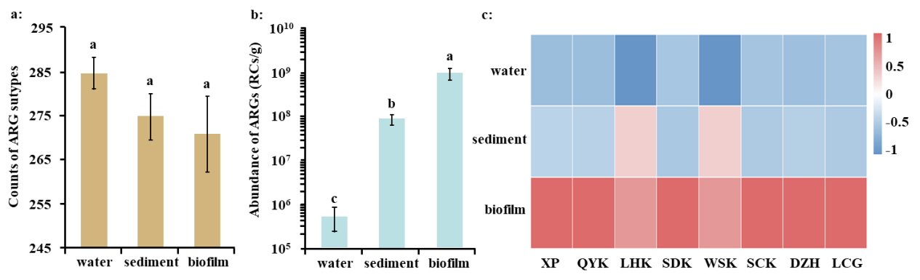
Fig. S1 The diversity and abundance of ARGs and their associated environmental factors in biofilm, sediment, and water in the Yangtze Estuary. A: the average count of ARG subtypes in biofilm, sediment, and water, B: the average abundance of ARGs (RCs/g) in biofilm, sediment, and water, C: the heatmap of ARG abundance in the eight sampling sites.

10. The RDA of environmental factors and ARGs.
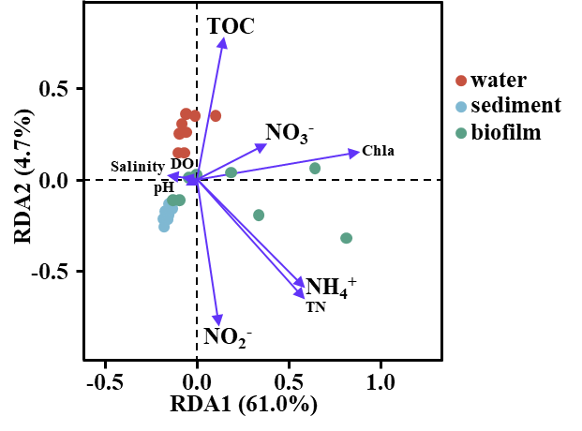
Fig. S2 The RDA of environmental factors and ARGs.

11. The images of biofilm, sediment, and water samples (on the filters) in the eight sampling sites.
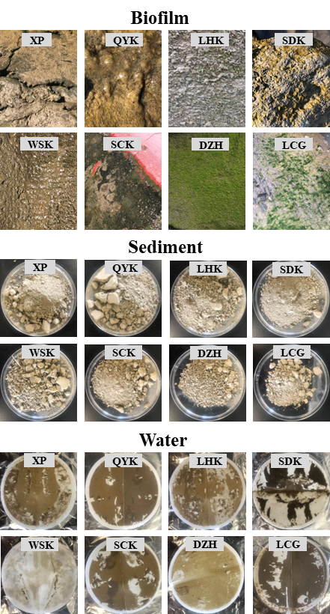
Fig. S3 The images of biofilm, sediment, and water samples (on the filters) in the eight sampling sites.

12. The cluster analysis of microbial communities (top 10 phyla) in biofilm, sediment, and water samples in the eight sampling sites along the Yangtze Estuary.
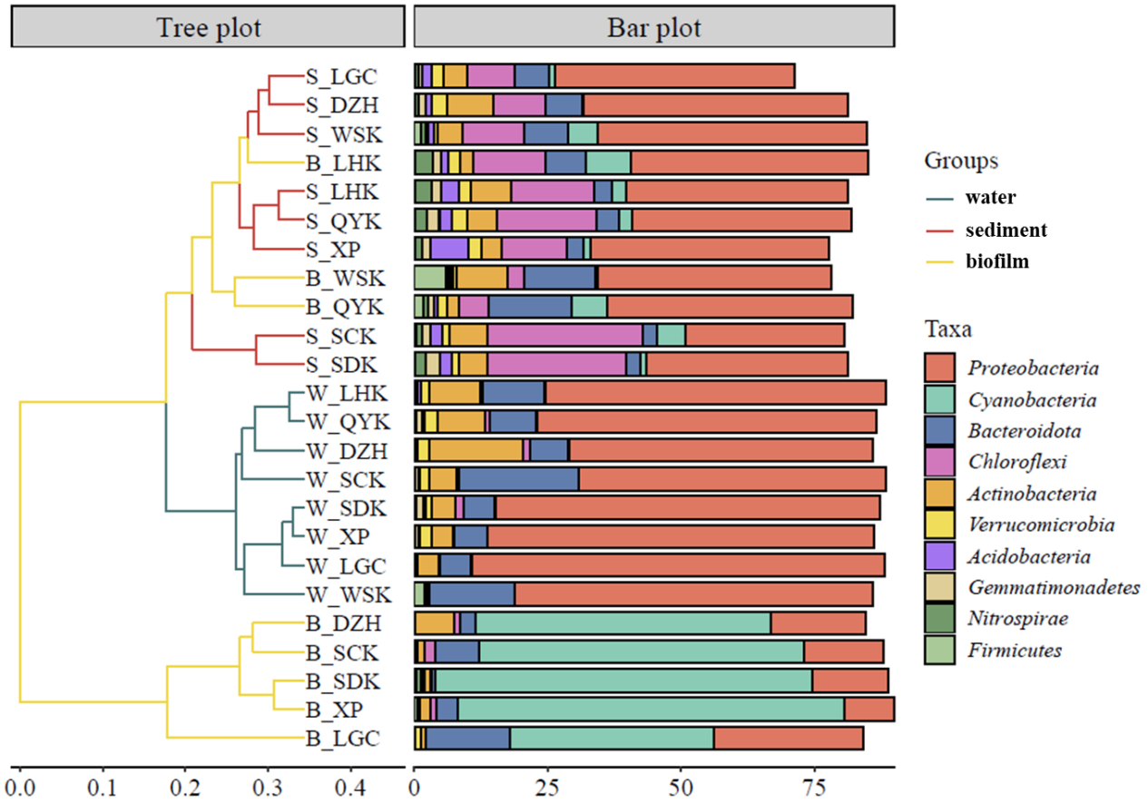
Fig. S4 The cluster analysis of microbial communities (top 10 phyla) in biofilm, sediment, and water samples in the eight sampling sites along the Yangtze Estuary.

13. The abundance of the top three single ARG hosts in water, sediment, and biofilm samples.
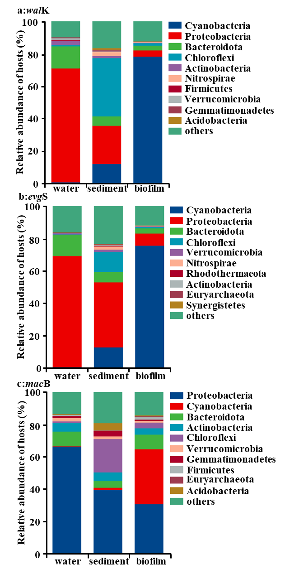
Fig. S5 The abundance of the top three single ARG hosts in water, sediment, and biofilm samples.

14. The relationships between the abundance of ARGs and the total abundance of nutrient metabolism pathways in biofilm, sediment, and water samples taken along the Yangtze Estuary.

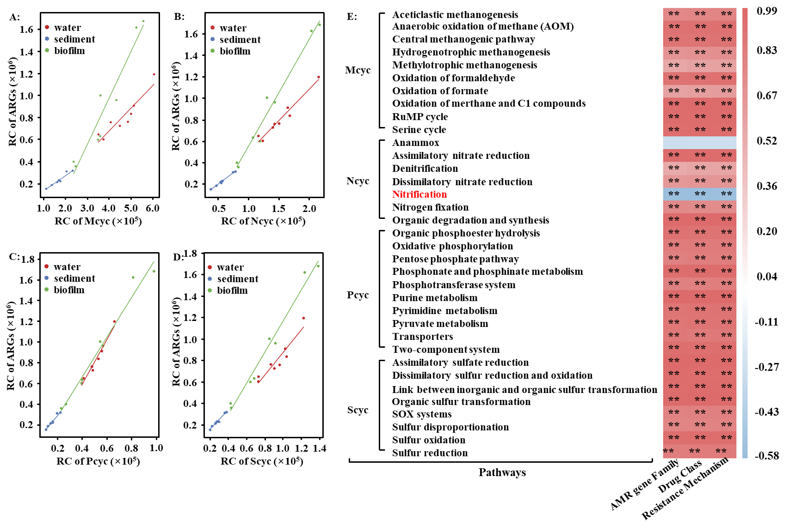 Fig.S6 The relationships between the abundance of ARGs and total abundance of nutrient metabolism pathways, including C (A), N (B), P(C), and S (D), and their individual abundances (E) in biofilm, sediment, and water samples taken along the Yangtze Estuary.

15. The relative abundance of microbes using the Calvin cycle and nitrogen fixation.
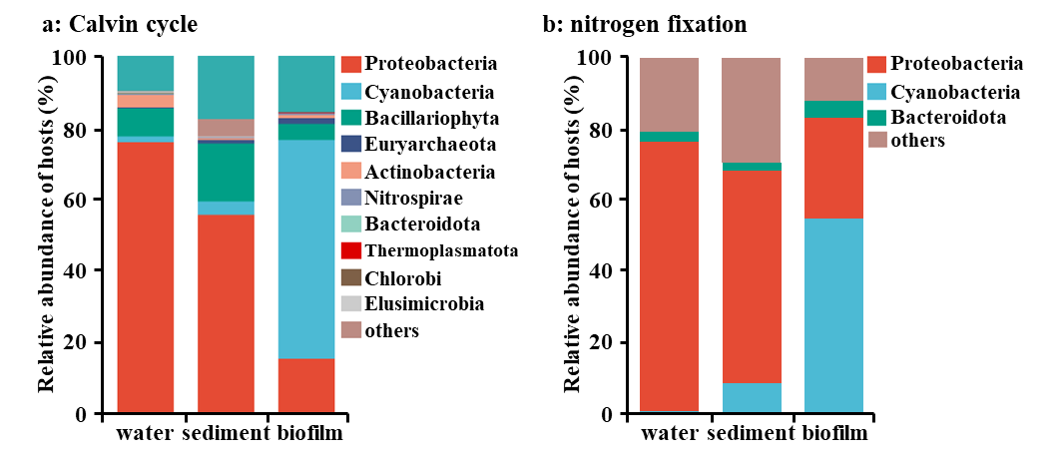
Fig. S7 The relative abundance of microbes using the Calvin cycle (a); the relative abundance of microbes in nitrogen fixation (b).

16. The maps of sampling sites for collecting metagenomic data in the Chinese estuaries, East China Sea, and the Nile River Estuary.
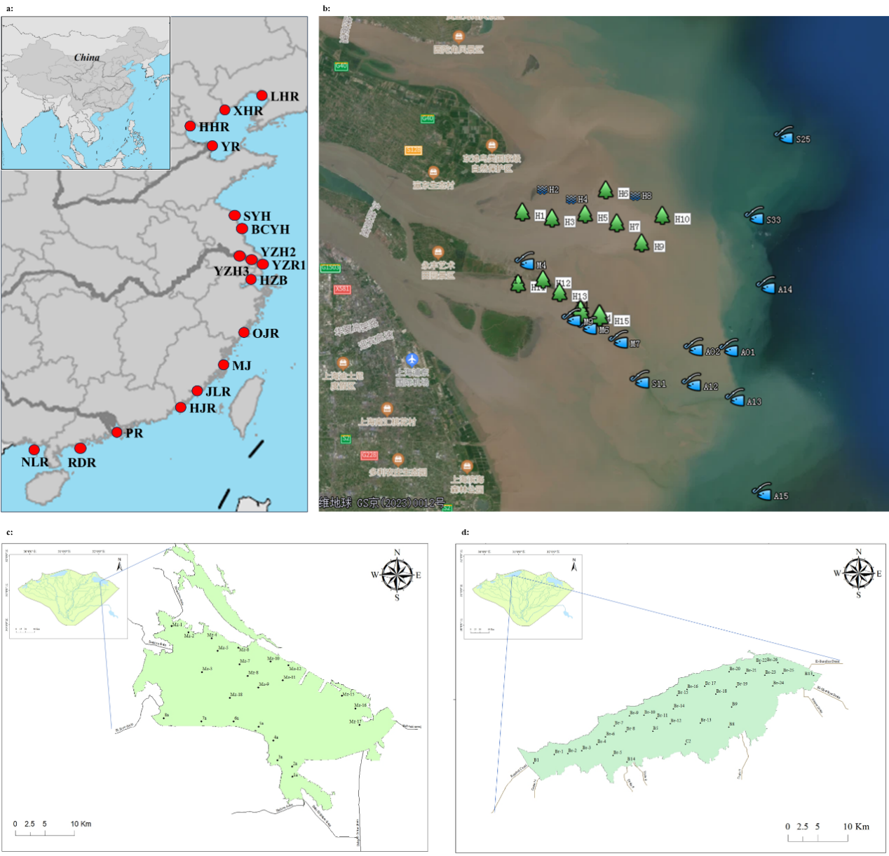
Fig. S8 The maps of sampling sites for collecting metagenomic data in the Chinese estuaries (a), East China Sea (b), and the Nile River Estuary (c and d).

17. The fold changes of ARGs (top 10) in control and ¹³C-groups of biofilms (a); the fold changes of ARGs (top 10) in control and ¹³C groups of sediments (b).

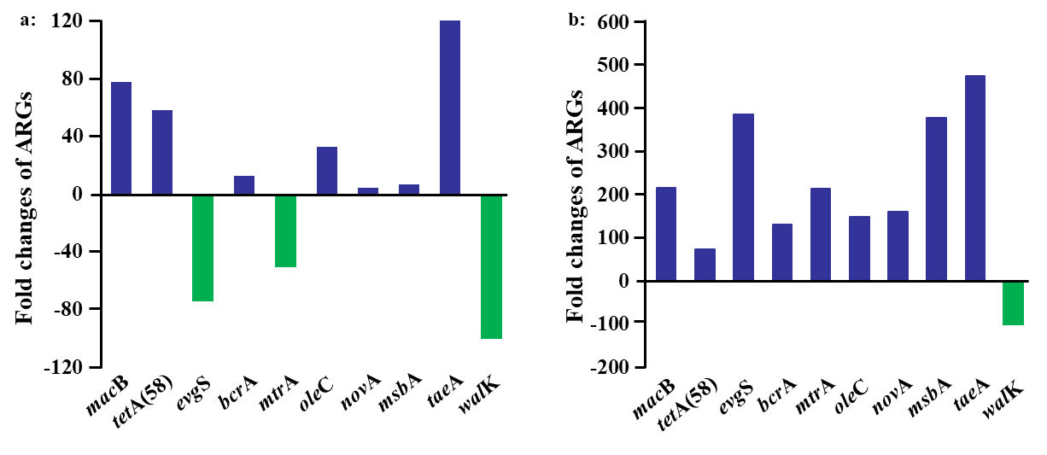
Fig. S9 The fold changes of ARGs (top 10) in control and ¹³C-groups of biofilms (a); the fold changes of ARGs (top 10) in control and ¹³C groups of sediments (b).

18. The relative abundance of rbcL labeled by ¹³C in biofilm; the relative abundance of rbcL labeled by ¹³C in sediment.
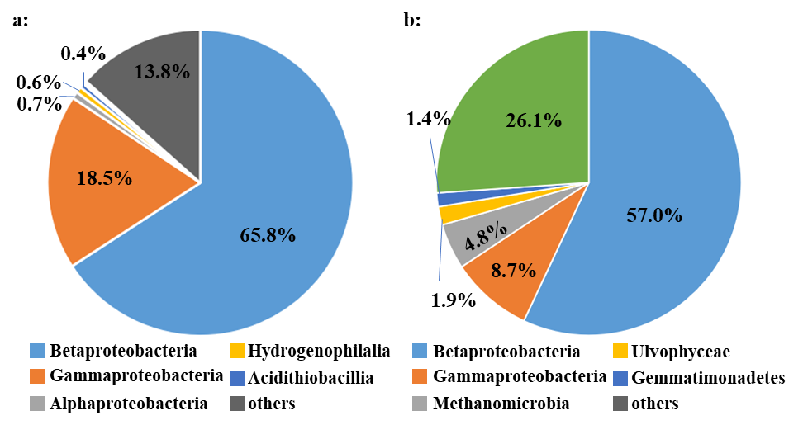
Fig. S10 The relative abundance of rbcL labeled by ¹³C in biofilm (a); the relative abundance of rbcL labeled by ¹³C in sediment (b).
19. References:
[1] Guo XP, Sha RR, Wang YC, Yan J, Peng B, et al. 2024. ZnO nanorod coatings attenuate antibiotic resistance genes (ARGs) on their surface biofilms in estuarine environment. Journal of Environmental Chemical Engineering 12, 112877 https://doi.org/10.1016/j.jece.2024.112877
[2] Tang XF, Guo XP, Kuang L, Chen XJ, Sidikjan N, et al. 2025. Comammox Nitrospira are the dominant ammonia oxidizers in the Yangtze estuarine biofilms. Water Research 273: 122969 https://doi.org/10.1016/j.watres.2024.122969
[3] Chen SF, Zhou YQ, Chen YR, Gu J. 2018. Fastp: an ultra-fast all-in-one FASTQ preprocessor. Bioinformatics 34: 884–889 https://doi.org/10.1093/bioinformatics/bty560
[4] Li DH, Liu C-M, Luo RB, Sadakane K, Lam TW. 2015. MEGAHIT: an ultra-fast single-node solution for large and complex metagenomics assembly via succinct de Bruijn graph. Bioinformatics 31: 1674–1676 https://doi.org/10.1093/bioinformatics/btv033
[5] Hyatt D, Chen GL, Locascio PF, Land ML, Larimer FW, et al. 2010. Prodigal: prokaryotic gene recognition and translation initiation site identification. BMC Bioinformatics 11: 119 https://doi.org/10.1186/1471-2105-11-119

