Appendix A. supplementary data
Table S1 Analysis of fitting effectiveness of different models for specific surface area.
Model | Sequential P-value | Lack-of-fit P-value | Adjusted R² | Predicted R² | Evaluation result
Linear | 0.4467 | < 0.0001 | -0.0101 | -0.1952 | Not Recommended
2F1 | 0.9768 | < 0.0001 | -0.2877 | -0.9614 | Not Recommended
Quadratic | < 0.0001 | 0.1086 | 0.9922 | 0.9578 | Recommended

Table S2 Comparative analysis of goodness-of-fit for different models of mesoporosity.
Model | Sequential P-value | Lack-of-fit P-value | Adjusted R² | Predicted R² | Evaluation result
Linear | 0.3694 | < 0.0001 | 0.0256 | -0.1340 | Not Recommended
2F1 | 0.9976 | < 0.0001 | -0.2614 | -0.8756 | Not Recommended
Quadratic | < 0.0001 | 0.1452 | 0.9788 | 0.8910 | Recommended

Table S3 Comparative analysis of goodness-of-fit for different models of yield.
Model | Sequential P-value | Lack-of-fit P-value | Adjusted R² | Predicted R² | Evaluation result
Linear | 0.0006 | < 0.0001 | 0.6606 | 0.5327 | Not Recommended
2F1 | 0.9950 | < 0.0001 | 0.5618 | 0.0499 | Not Recommended
Quadratic | < 0.0001 | 0.3156 | 0.9972 | 0.9882 | Recommended
Table S4 Analysis of variance table for yield of Biochar.
Item | Sum of squares | Mean square | F-value | P-value | Significance
Model | 40.82 | 4.54 | 627.46 | < 0.0001 | Highly Significant
A | 0.27 | 0.27 | 37.88 | 0.0005 | Highly Significant
B | 14.77 | 14.77 | 2043.43 | < 0.0001 | Highly Significant
C | 14.55 | 14.55 | 2013.46 | < 0.0001 | Highly Significant
AB | 0.021 | 0.021 | 2.19 | 0.1319 | Not Significant
AC | 0.027 | 0.027 | 3.77 | 0.0934 | Not Significant
BC | 0.29 | 0.29 | 40 | 0.000857 | Highly Significant
A² | 4.6 | 4.6 | 636.76 | < 0.0001 | Highly Significant
B² | 5.94 | 5.94 | 822.17 | < 0.0001 | Highly Significant
C² | 0.15 | 0.15 | 20.37 | 0.3156 | Highly Significant
Residual | 0.051 | 0.0073 | \ | \ | \
Lack-of-fit | 0.028 | 0.0093 | 1.62 | 0.3156 | Not Significant
Absolute Error | 0.023 | 0.0057 | \ | \ | \
Total | 40.87 | \ | \ | \ | \

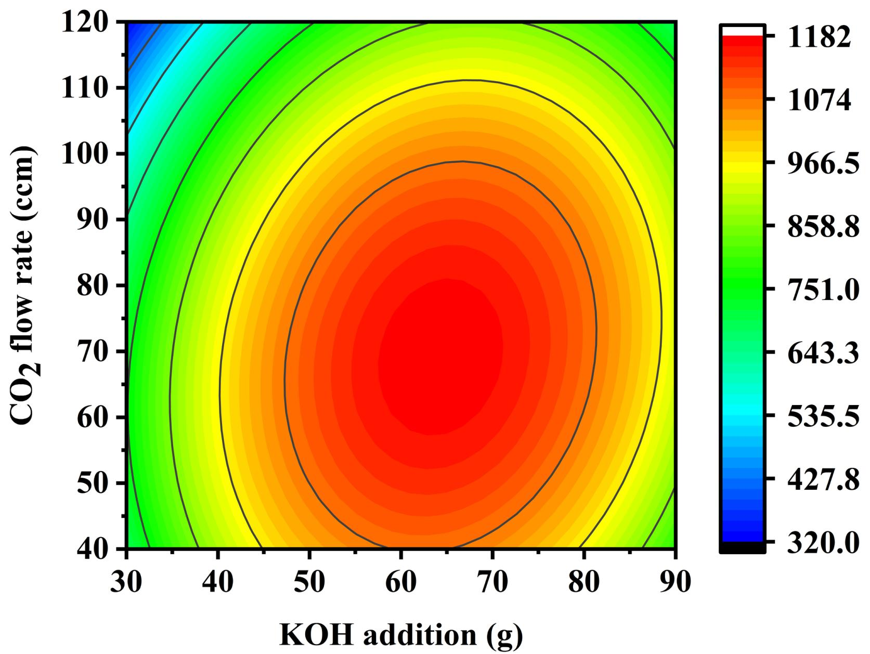 | 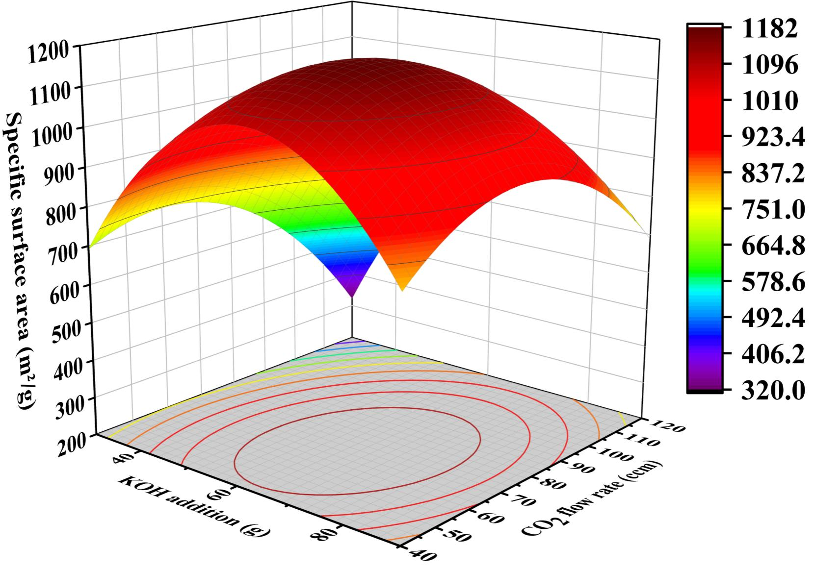
(a) KOH addition-CO₂ flow rate contour plot | (b) KOH addition-CO₂ flow rate response surface plot
Figure S1. Contour plots and response surface plots of specific surface area versus different parameters.

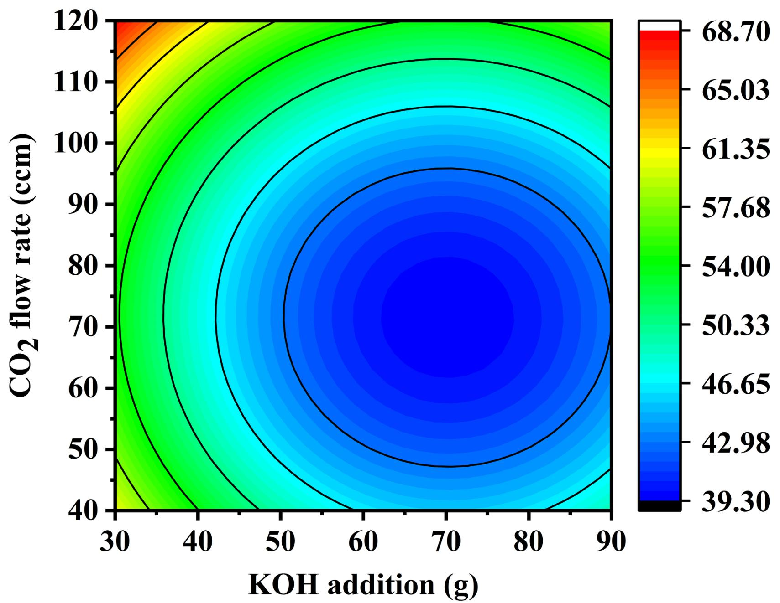 | 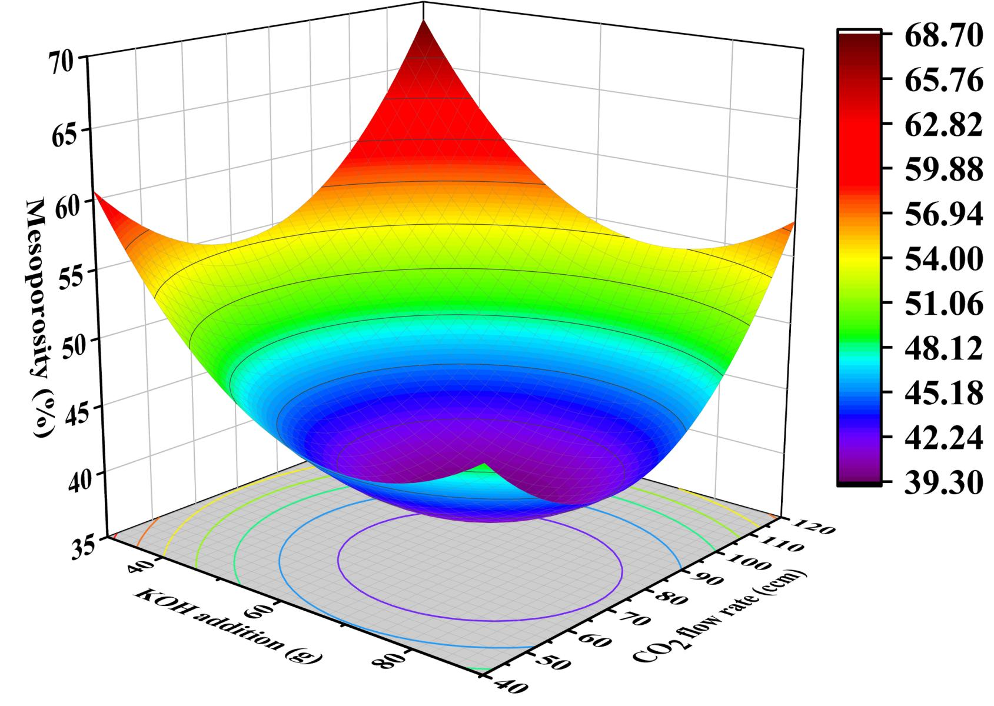
(a) KOH addition-CO₂ flow rate contour plot | (b) KOH addition-CO₂ flow rate response surface plot
Figure S2. Contour plots and response surface plots of mesoporosity versus different influencing factors.

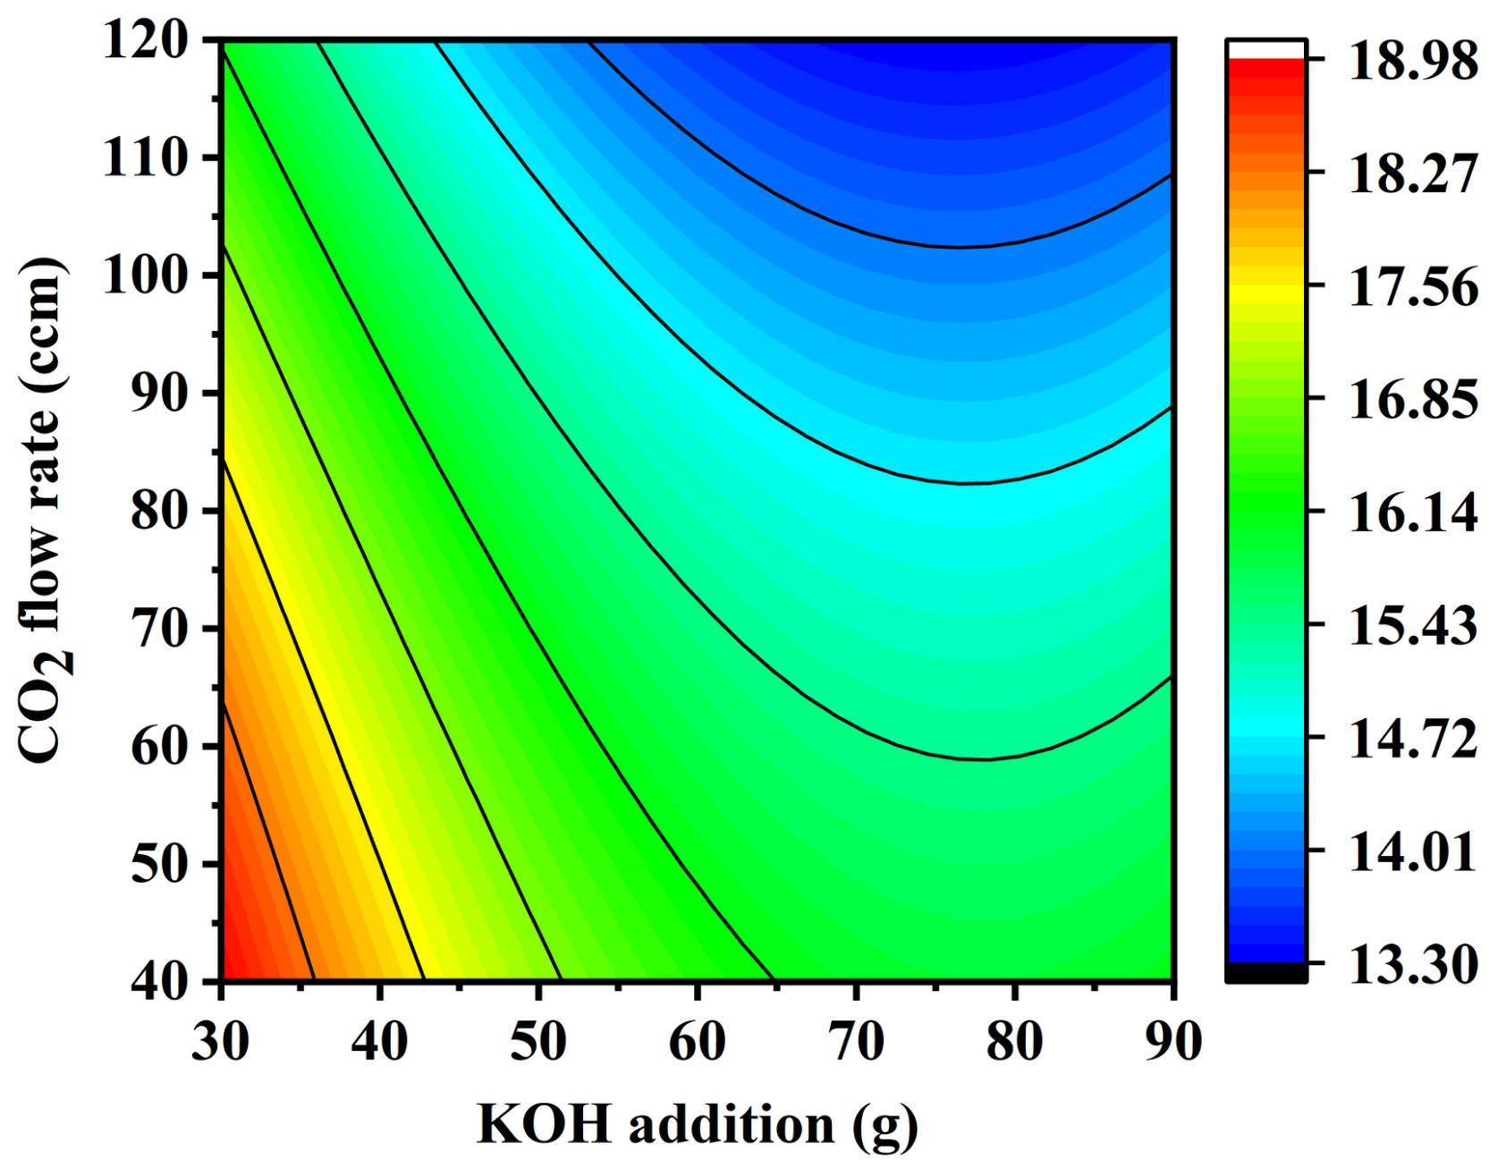 | 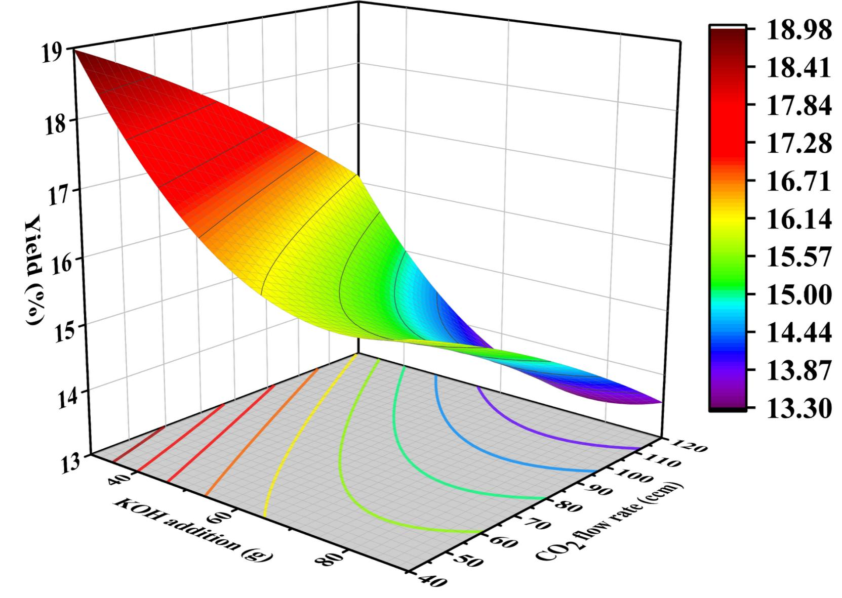
(a) KOH addition-CO₂ flow rate contour plot | (b) KOH addition-CO₂ flow rate response surface plot
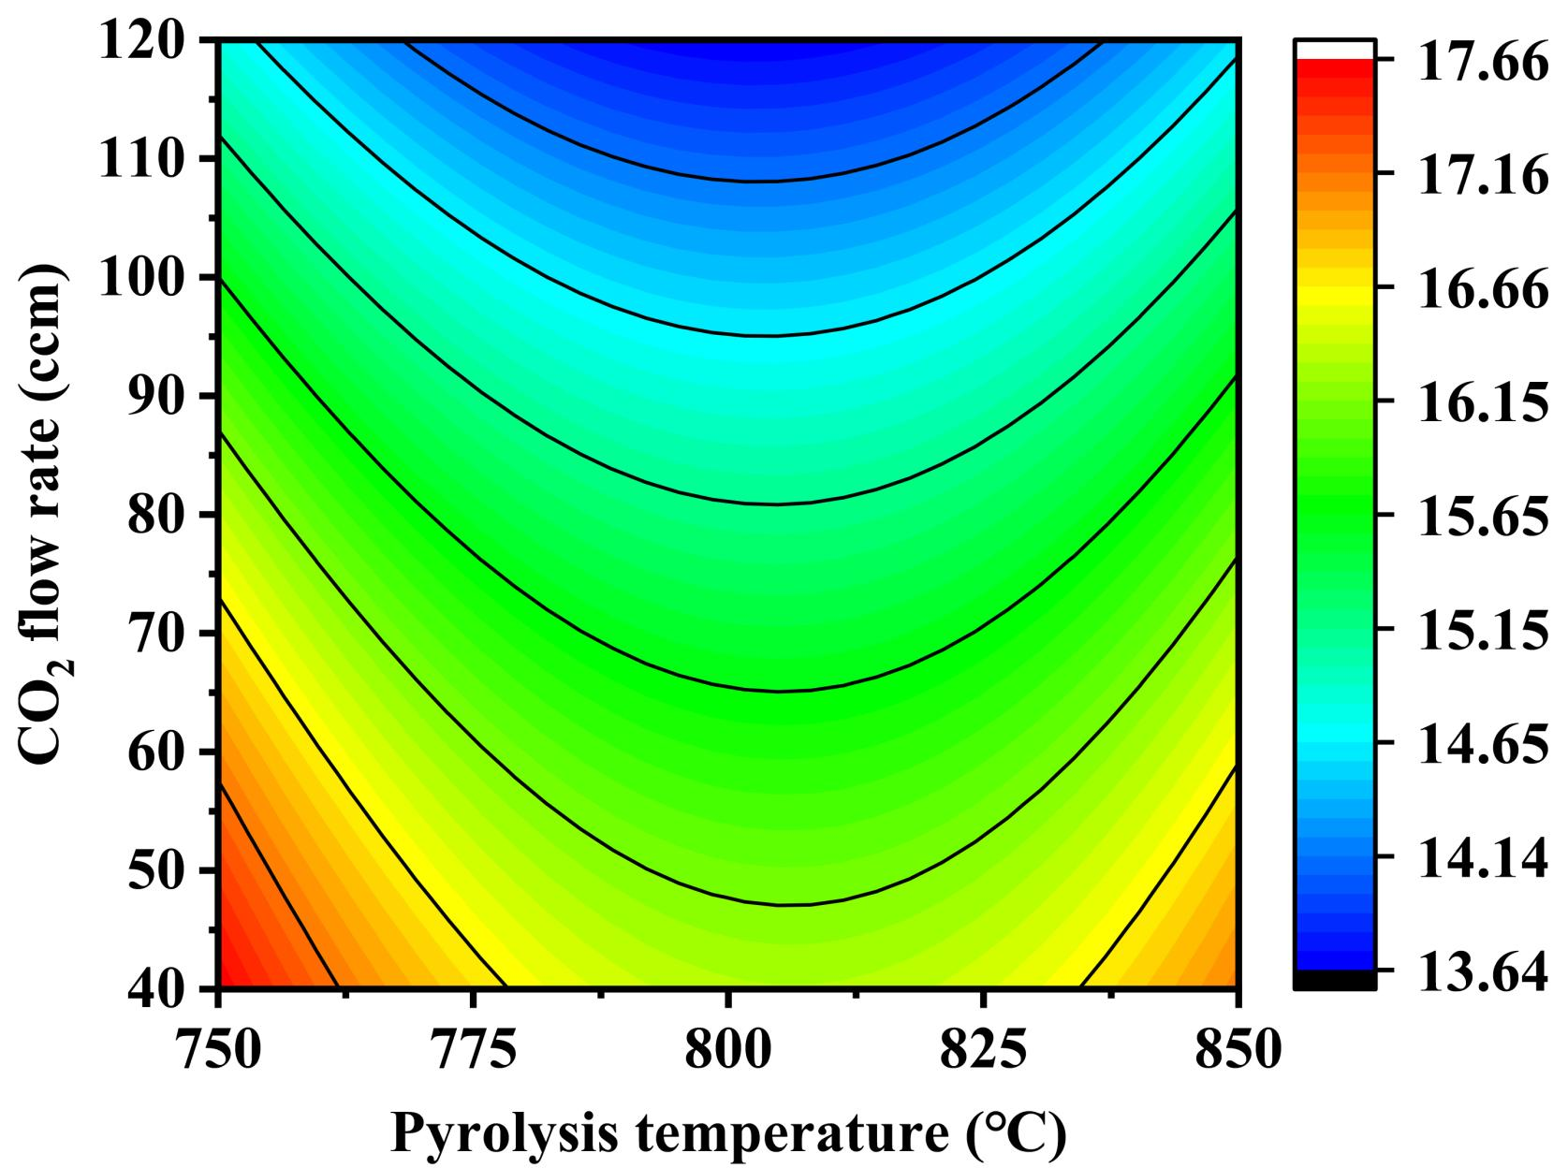 | 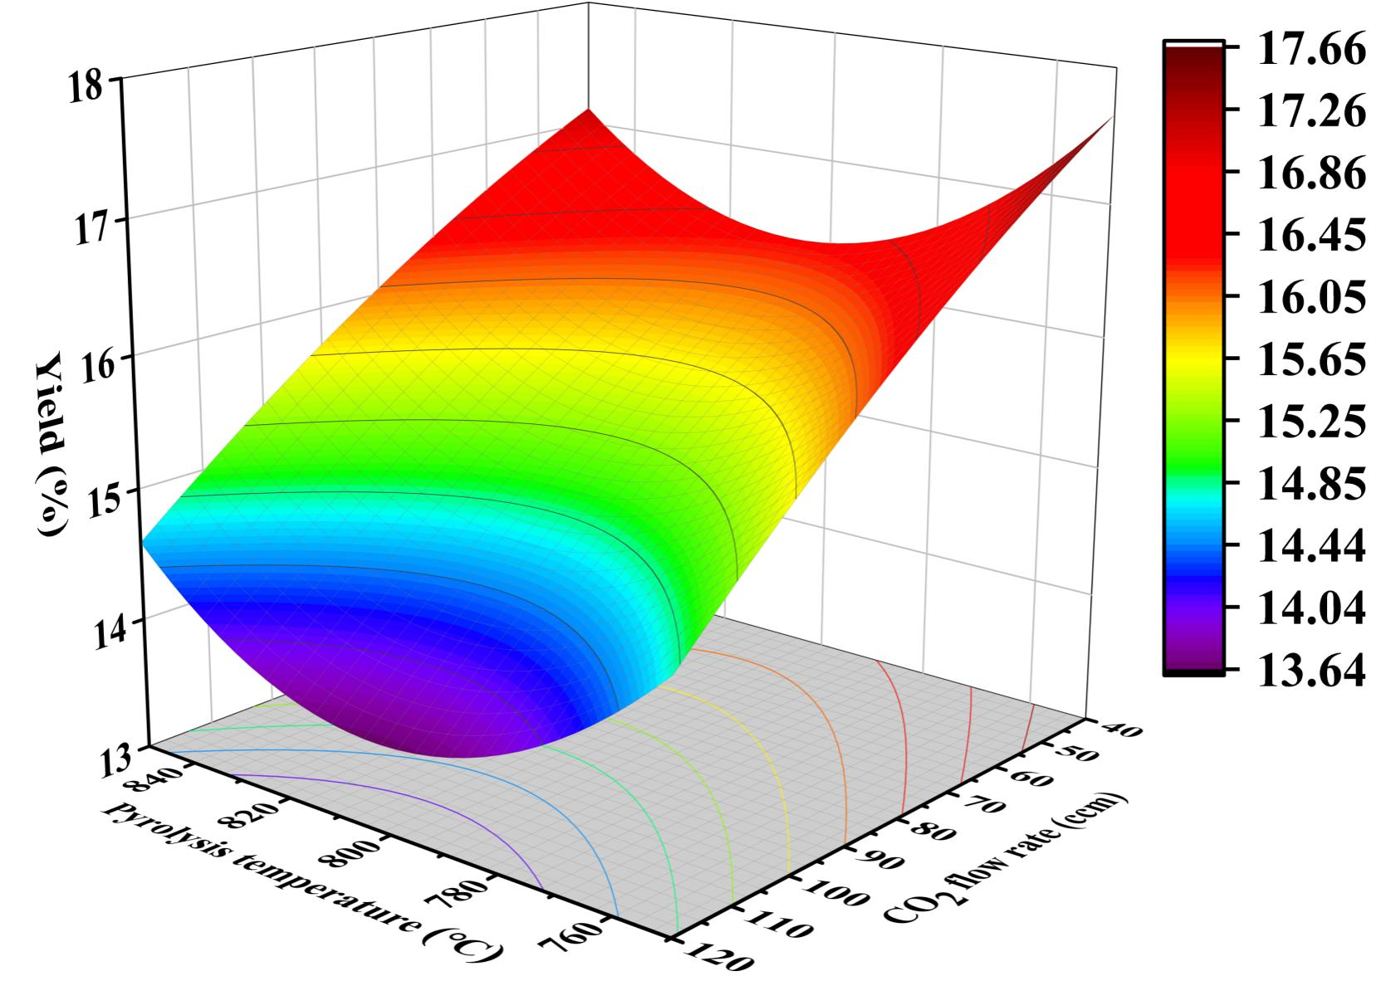
(c) Pyrolysis temperature-CO₂ flow rate contour plot | (d) Pyrolysis temperature-CO₂ flow rate response surface plot
Figure S3. Contour plots and response surface plots of biochar yield versus different parameters.

