Supplementary Information
Microplastics as emerging mediators of Cr(VI) reduction: Roles of environmentally persistent free radicals and microplastic-derived dissolved organic matter
Xinyue Wang¹, Xianjie Tang¹, Donglin Wang¹, Lingqing Gu¹, Xi Zhang¹, Yujie Tai¹, Chao Ma², Jingjie Zhang^{3,4}, Rongdi An¹, Jiunian Guan¹*
¹ School of Environment, Northeast Normal University, Changchun 130117, China
² Institute of Surface-Earth System Science, School of Earth System Science, Tianjin University, Tianjin 300072, China
³ State Key Laboratory of Black Soils Conservation and Utilization, Northeast Institute of Geography and Agroecology, Chinese Academy of Sciences, Changchun 130102, China
⁴ NUS Environmental Research Institute, National University of Singapore, Singapore 138602, Singapore
Text S1 Pseudo-first-order kinetic model for Cr(VI) photoreduction
The photoreduction of Cr(VI) by PS-MPs and PS-DOM was fitted using a pseudo-first-order kinetic model:
ln(C₀/C_{t}) = kt + b (1)
where C₀ is the initial Cr(VI) concentration (mg/L), C_{t} is the Cr(VI) concentration at time t (mg/L), k is the apparent photoreduction rate constant (h⁻¹), t is the reaction time (h), and b is the fitting constant.
Text S2 Calculation of carbonyl index
The carbonyl index (CI) was calculated to evaluate the oxidation degree of PS-MPs as follows:
CI = A(C=O)/A(ref) (2)
where A(C=O) is the integrated area of the carbonyl band and A(ref) is the integrated area of the reference band.

Text S3 PS-DOM characterization
Excitation-emission matrix fluorescence spectra of PS-DOM were obtained using a fluorescence spectrophotometer (F-2700, HITACHI, Japan). Before measurement, the samples were adjusted to DOC = 10 mg-C/L and pH = 7.0 ± 0.1. The excitation and emission wavelength ranges were 220–600 nm and 250–600 nm, respectively, with a scanning interval of 5 nm. Ultrapure water was used as the blank to remove Rayleigh scattering, and the fluorescence intensity was normalized to Raman units. Fluorescence regional integration (FRI) analysis was performed by dividing the EEM spectra into five conventional regions to quantify the relative contributions of protein-like, fulvic-like, and humic-like components in PS-DOM (Table S1).
Table S1. FRI-EEM region definition
FRI | Component | E_{x}/E_{m} (nm)
Region I | Aromatic protein I | 220–250/280–320
Region II | Aromatic protein II | 220–250/320–380
Region III | Fulvic acid-like substances | 220–250/380–550
Region IV | Tryptophan-like and tyrosine-like substances | 250–440/280–380
Region V | Humic-like substances | 250–440/380–550
PS-DOM samples were enriched and pretreated by solid-phase extraction before FT-ICR-MS analysis. The solid-phase extraction cartridges (Agilent Bond Elut PPL, 1.0 g, 6 mL) were sequentially activated with two cartridge volumes of methanol and acidified ultrapure water at pH = 2.0. DOM samples acidified to pH = 2.0 were then passed through the cartridges at a flow rate of 1–2 drops per second. The cartridges were rinsed with two cartridge volumes of acidified ultrapure water, dried under nitrogen, and eluted with two cartridge volumes of methanol. Molecular formula information of PS-DOM was obtained using electrospray ionization Fourier transform ion cyclotron resonance mass spectrometry (ESI FT-ICR-MS, Arix 2xR 7.0T, Bruker, Germany) in negative ion mode. According to the van Krevelen diagram, they were classified into seven categories (Table S2), i.e., lipid-like, protein-like, carbohydrate-like, unsaturated hydrocarbon-like, lignin-like, tannin-like, and condensed aromatic-like compounds.
Table S2. Classification method of FT-ICR-MS molecular formulas
Compound class | Abbreviation/Name | Criterion
Condensed aromatic  structure | CAS | 0.2 ≤ H/C ≤ 0.7, O/C ≤ 0.67
Lignin/RAM | Lignin | 0.7 < H/C ≤ 1.5, 0.1 ≤ O/C ≤ 0.67
Protein | Protein | 1.5 < H/C ≤ 2.2, 0.3 < O/C ≤ 0.67
Carbohydrate | HydroC | 1.5 < H/C ≤ 2.4, 0.67 ≤ O/C ≤ 1.2
Lipid | Lipid | 1.5 < H/C ≤ 2.0, O/C ≤ 0.3
Unsaturated  hydrocarbon | UnsatHydroC | 0.7 ≤ H/C ≤ 1.5, O/C ≤ 0.1
Tannin | Tannin | 0.5 ≤ H/C ≤ 1.5, 0.65 < O/C ≤ 1

Table S3. Products of photoaged PS-MPs detected by Py-GC/MS
Retention time (min) | m/z | Identified compound | Library
0.930 | 112 |  | NIST21.LIB
3.525 | 84 |  | NIST07.LIB
3.250 | 81 |  | NIST21.LIB
7.095 | 130 |  | NIST14.LIB
10.925 | 102 |  | NIST21.LIB
11.085 | 158 |  | NIST05.LIB
12.770 | 196 |  | NIST05.LIB
15.770 | 180 |  | NIST14.LIB
16.325 | 214 |  | NIST05.LIB
16.955 | 180 |  | NIST05.LIB
17.070 | 234 |  | NIST07.LIB
19.635 | 254 |  | NIST05.LIB
19.735 | 142 |  | NIST05.LIB
19.885 | 216 |  | NIST07.LIB
22.840 | 266 |  | NIST05.LIB
23.720 | 272 |  | NIST05.LIB
24.080 | 346 |  | NIST14.LIB
24.280 | 238 |  | NIST05.LIB
24.635 | 390 |  | NIST14.LIB
27.025 | 306 |  | NIST21.LIB
27.625 | 172 |  | NIST05.LIB

Table S4. Characteristic parameters of EPFRs
Photoaging time  (h) | g-factor | Linewidth  (ΔHp-p, G) | EPFR concentration  (×10¹¹ spins/g)
0 | - | - | -
6 | 2.00431 | 7.13 | 2.45
12 | 2.00438 | 7.80 | 2.87
24 | 2.00445 | 8.16 | 3.43
48 | 2.00456 | 8.20 | 4.17
96 | 2.00469 | 8.37 | 6.71

Table S5. Distribution of different components in PS-DOM based on FRI-EEM
Derivation time | I | II | III | IV | V
1 h | 32.44% | 40.79% | 20.49% | 3.06% | 3.22%
2 h | 30.27% | 33.12% | 29.17% | 2.89% | 4.56%
4 h | 27.26% | 30.52% | 32.18% | 3.05% | 6.99%
6 h | 28.36% | 31.03% | 31.09% | 3.02% | 6.50%
8 h | 25.80% | 30.31% | 33.99% | 3.04% | 6.86%
10 h | 24.70% | 28.51% | 36.33% | 3.00% | 7.46%

Table S6. Relative abundance of different compound classes identified by FT-ICR-MS
Category | Relative abundance (%)
Condensed Aromatic Structures (CAS) | 2.52
Lignin-like | 60.29
Protein-like | 10.78
Saturated Hydrocarbon-like | 3.35
Lipid-like | 1.71
Unsaturated Hydrocarbon-like | 0
Tannin-like | 21.35

Table S7. Fitting parameters of Cr(VI) photoreduction kinetics by PS-MPs
Aging time | k (h⁻¹) | Kinetic model equation | R² | p
PS-MP 0 h | 0.037 | y = 0.037x − 0.041 | 0.91 | < 0.01
PS-MP 6 h | 0.052 | y = 0.052x − 0.064 | 0.93 | < 0.01
PS-MP 12 h | 0.068 | y = 0.068x − 0.124 | 0.90 | < 0.01
PS-MP 24 h | 0.082 | y = 0.082x − 0.196 | 0.88 | < 0.05
PS-MP 48 h | 0.089 | y = 0.089x − 0.258 | 0.85 | < 0.05
PS-MP 96 h | 0.093 | y = 0.093x − 0.267 | 0.88 | < 0.05

Table S8. Comparison of Cr(VI) reduction capacity by different materials
 | Reduction capacity (mg/g) | pH | Irradiation  condition | Ref.
Humin extracted from Jiangsu Province soil | 7.7 | 2.0 | Dark | [1]
Humin extracted from Yunnan Province soil | 4.6 | 2.0 | Dark | [1]
Fallen-leaf hydrochar | 0.00 | 5.7 ± 0.1 | Dark | [2]
Fallen-leaf hydrochar | 11.00 | 5.7 ± 0.1 | Simulated solar irradiation | [2]
Fallen-leaf pyrochar | 1.80 | 5.7 ± 0.1 | Dark | [2]
Fallen-leaf pyrochar | 3.55 | 5.7 ± 0.1 | Simulated solar irradiation | [2]
Sludge biochar | 0.93 | 7.0 | Dark | [3]
Sludge biochar | 1.40 | 7.0 | Visible light | [3]
Sludge biochar | 2.14 | 7.0 | UV irradiation | [3]
PS-MPs | 7.6-17.98 | 5.0 | UV irradiation | This study
References
[1] Xu J, Dai Y, Shi Y, Zhao S, Tian H, et al. Mechanism of Cr(VI) reduction by humin: Role of environmentally persistent free radicals and reactive oxygen species. Sci Total Environ. 2020; 725:138413. https://doi.org/10.1016/j.scitotenv.2020.138413.
[2] Chen N, Cao S, Zhang L, Peng X, Wang X, et al. Structural dependent Cr(VI) adsorption and reduction of biochar: Hydrochar versus pyrochar. Sci Total Environ. 2021; 783:147084. https://doi.org/10.1016/j.scitotenv.2021.147084.
[3] Tang Z, Kong Y, Zhao S, Jia H, Vione D, et al. Enhancement of Cr(VI) decontamination by irradiated sludge biochar in neutral conditions: Evidence of a possible role of persistent free radicals. Sep Purif Technol. 2021; 277:119414. https://doi.org/10.1016/j.seppur.2021.119414.

Insert a space before "h".

Figure S1. EPR spectra of PS-MPs aged under dark conditions.

Figure S2. DOC release of PS-DOM under dark and UV irradiation conditions.

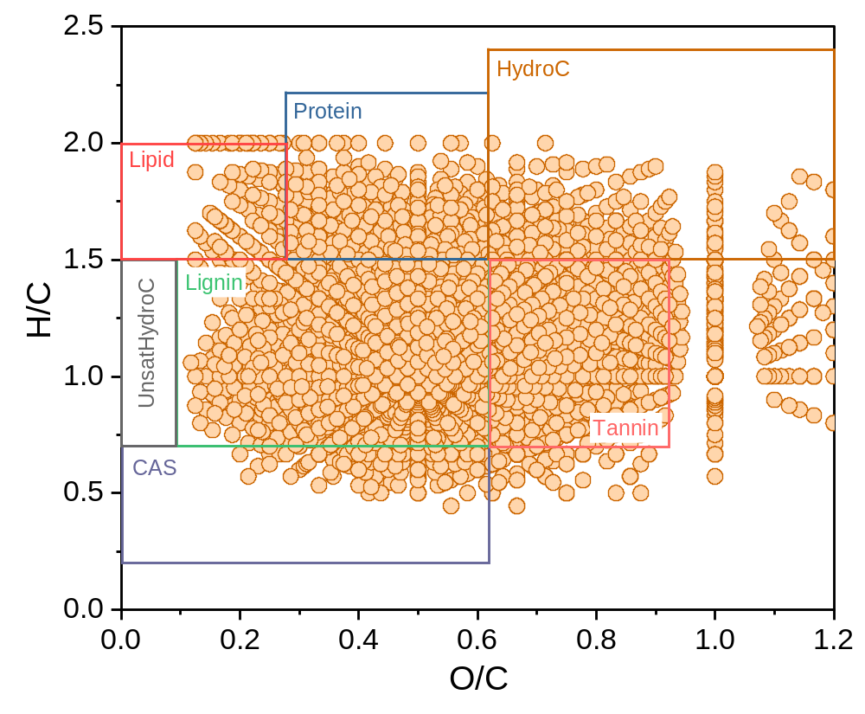
Figure S3. Van Krevelen diagram of PS-DOM based on FT-ICR-MS analysis.

Figure S4. Cr(VI) photoreduction by PS-MPs with different aging times under dark conditions.

Figure S5. Relationship between photoreduction rate constant (k) and photoaging time.

Figure S6. ESP distribution of thermal pyrolysis products in PS-MPs aged for 96 h.

* Correspondence: Jiunian Guan (guanjn461@nenu.edu.cn)

