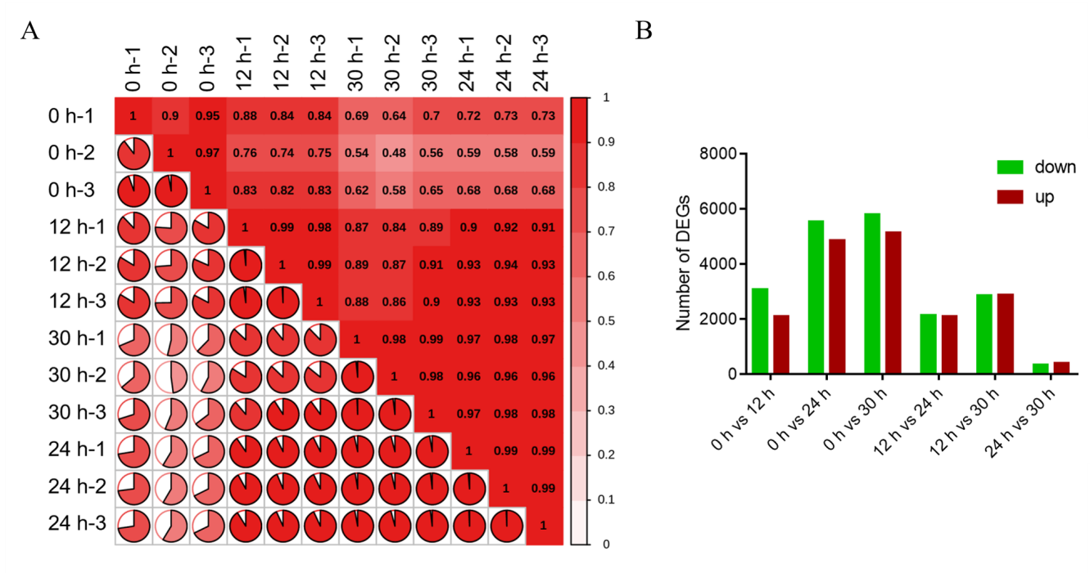
Fig. S3. Overview of RNA sequencing analysis. (A) Heatmap of correlation of gene expression levels between the samples; (B) Number statistics of up and down regulated DEGs between groups of the samples.

