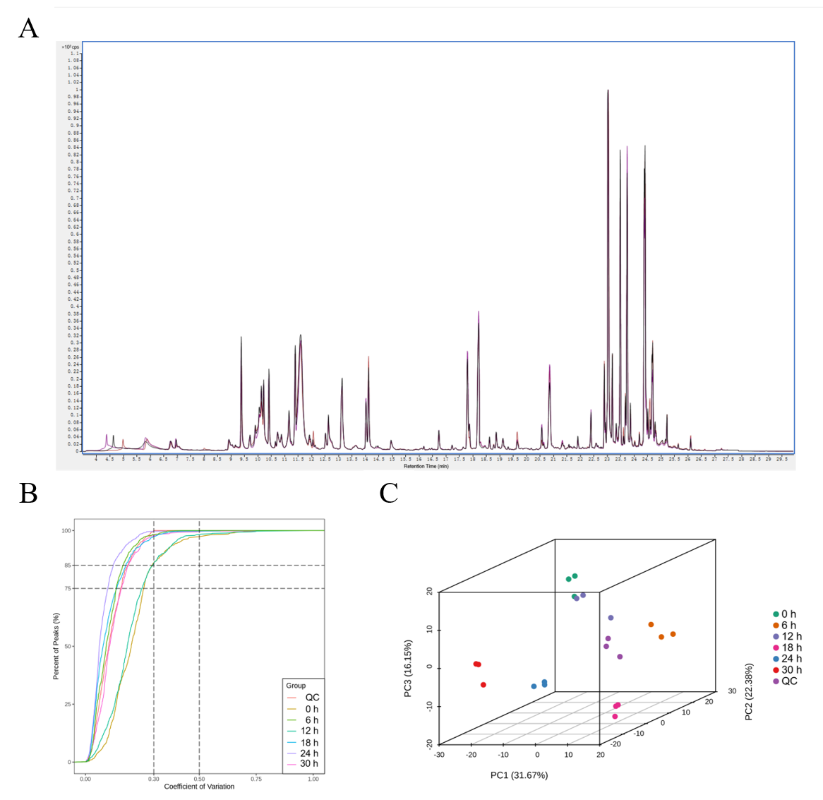
Fig. S2. Quality control of GC/MS analysis. (A) TIC overlap plot for mass spectrometric detection of the QC samples. (B) The CV distribution of samples in each group. (C) PCA scores of mass spectrometry data for each group of samples and QC samples.
Note: PC1 denoted the first principal component, PC2 denoted the second principal component, PC3 denoted the third principal component, and the percentage indicated the explanation rate of this principal component to the data set; each point in the graph depicted one sample, and the samples of the same group were represented using the same color.

