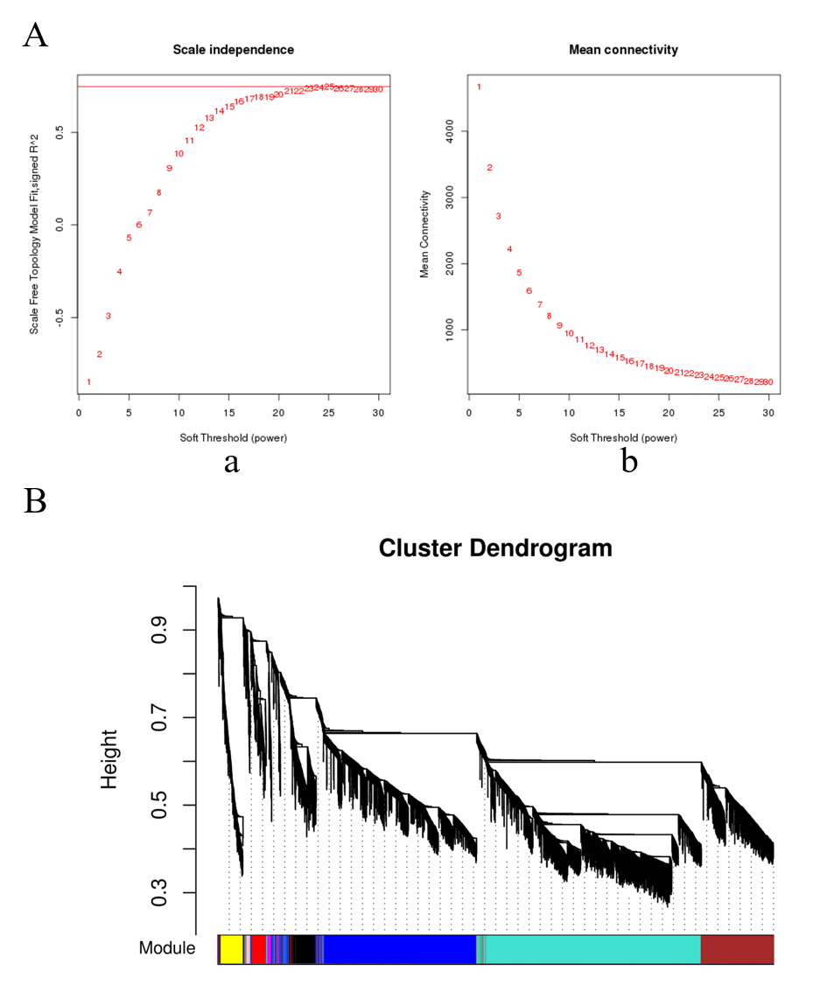
Fig. S1. Clustering dendrograms of genes and module division. (A) Analysis of network topology for various soft-thresholding powers. The scale-free fit index (y-axis) as a function of the soft-thresholding power (x-axis) (a), and the mean connectivity (degree, y-axis) as a function of the soft-thresholding power (x-axis) (b). (B) Protein clustering on TOM-based dissimilarity, module division by dynamic tree cut and different colors represent different modules.

