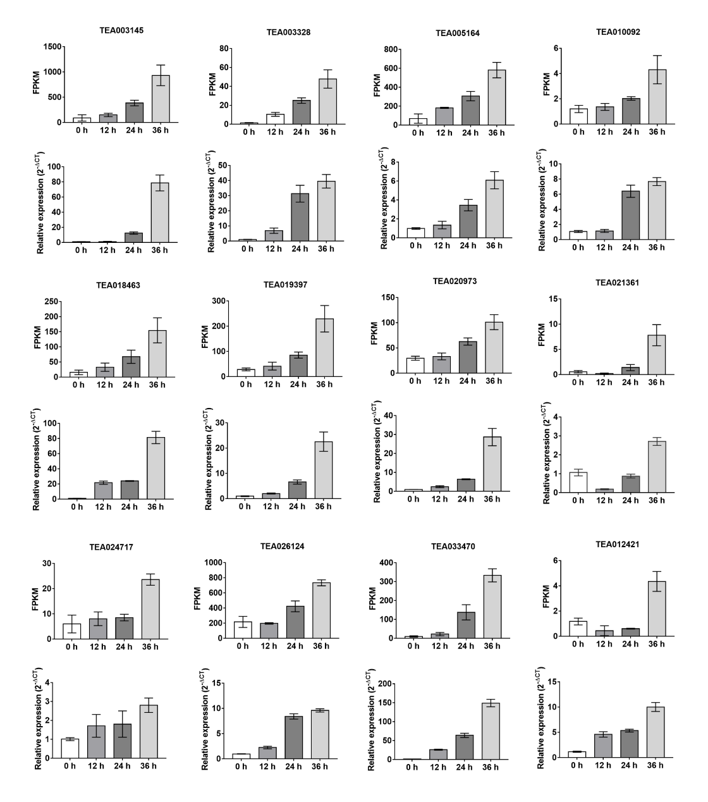
Fig. S6. The expression patterns of the 12 key hub genes identified from the co-expression networks based on RNA-seq and RT-PCR analysis. The data represent the mean + SD (n = 3).

