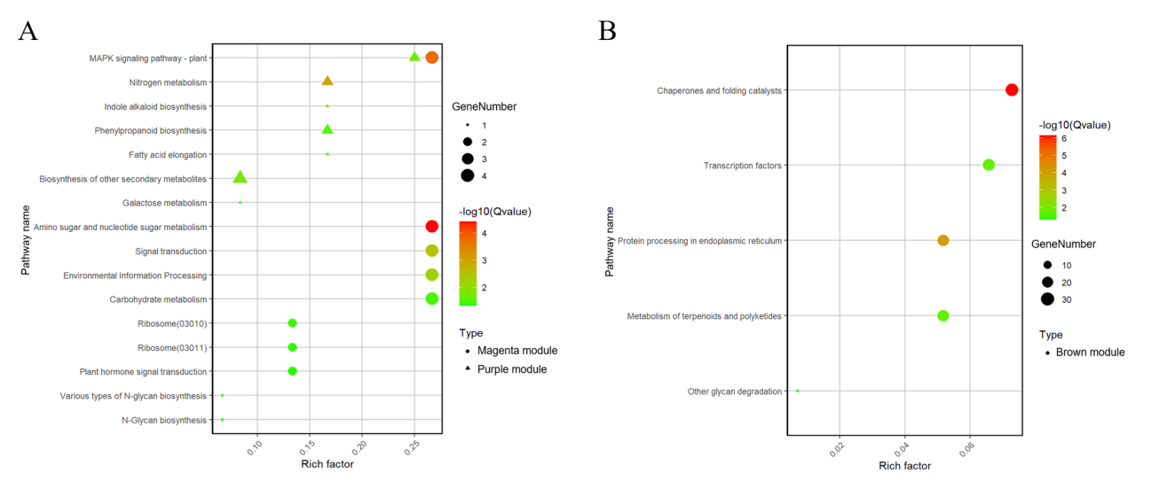
Fig. S5. The significantly enriched KEGG pathways of the genes in the magenta module & purple(A) and brown module(B).

