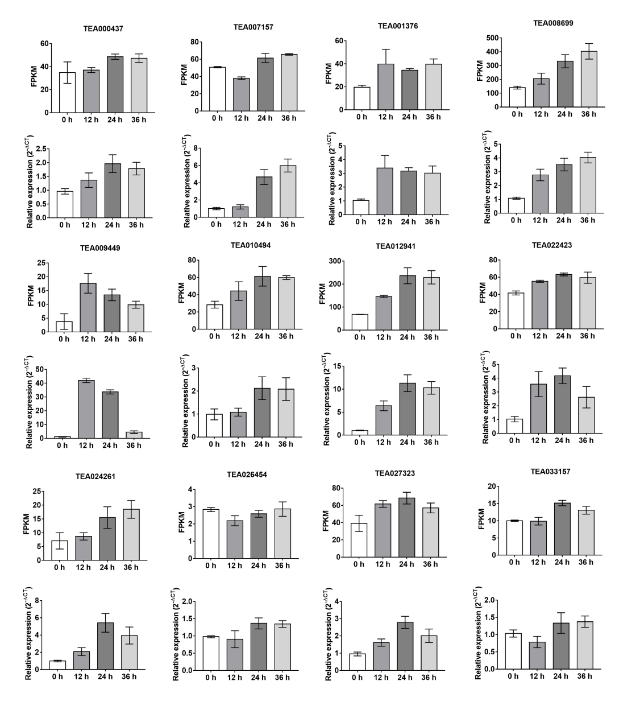
Fig. S4. The expression patterns of 12 genes in α-linolenic acid metabolism and terpenoid biosynthesis pathways based on RNA-seq and RT-PCR analysis. The data represent the mean + SD (n = 3).

