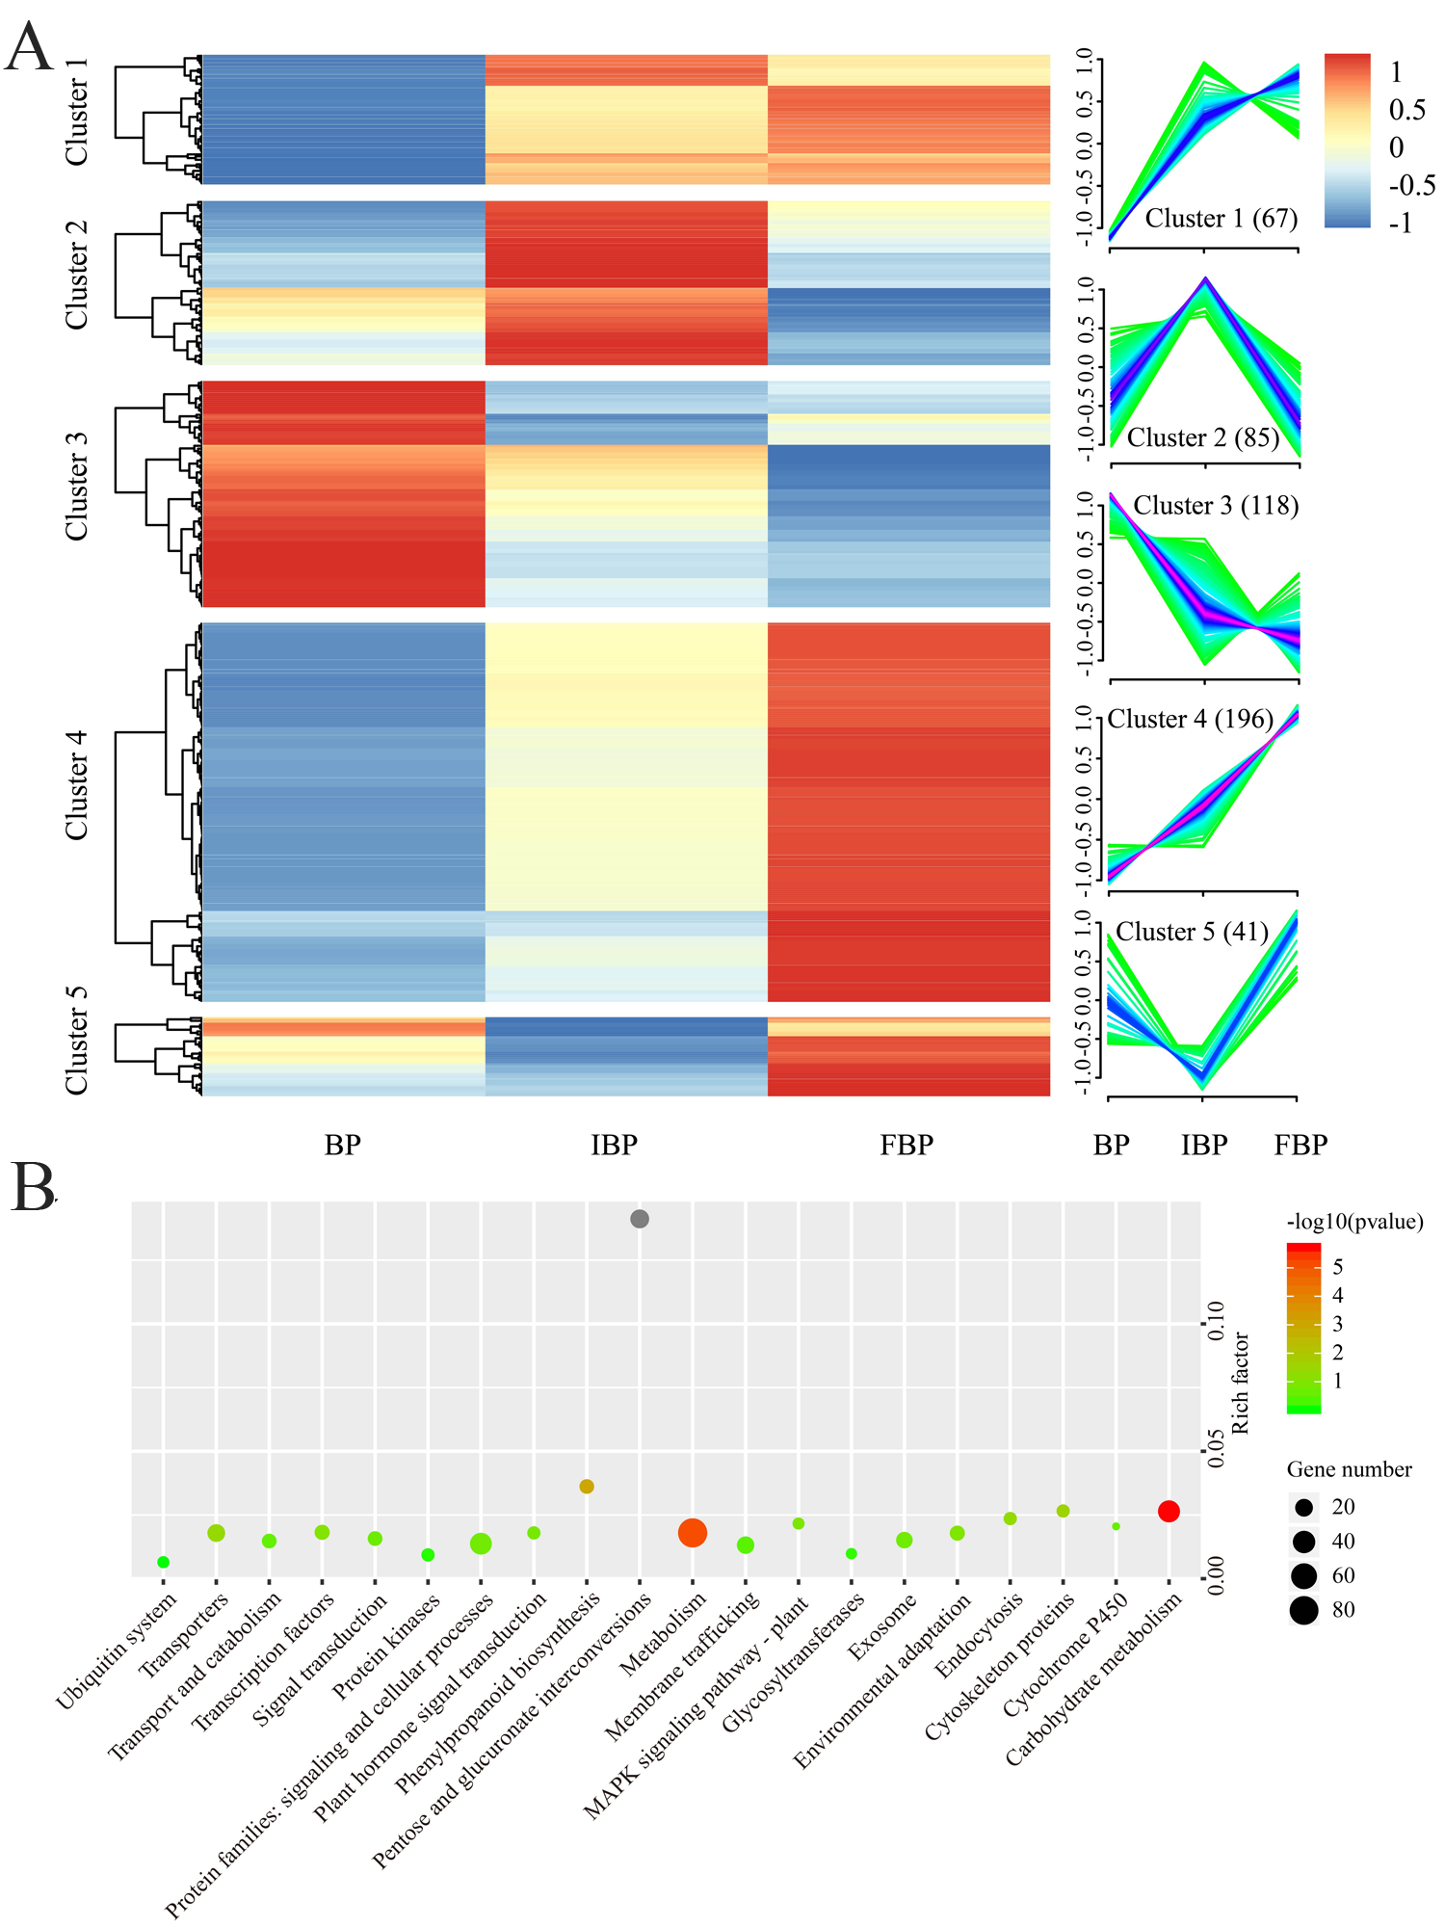
Figure S2. Cluster analysisand KEGG enrichment of DEGs. A. Cluster analysis DEGs of CKB vs BP, CKIB vs IBP, CKFB vs FBP, BP vs IBP and IBP vs FBP (p<0.01). The number in parentheses indicates the number of DEGs. B. KEGG enrichment analysis of DEGs.

