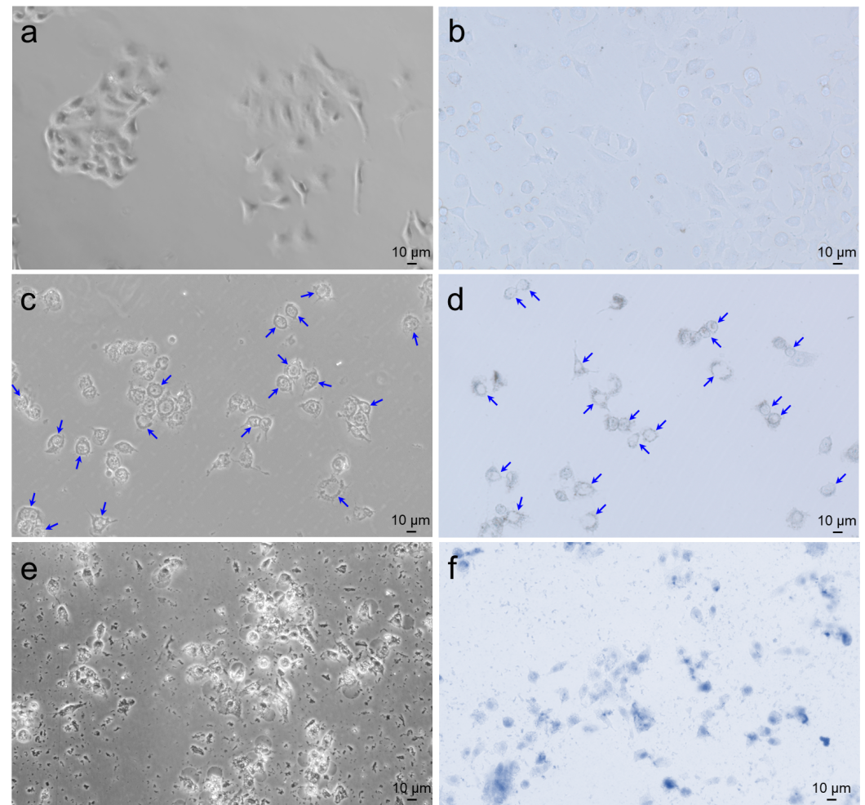

**Fig. S10.** Optical microscopic imaging of A549 cells before and after treating with polysaccharide extractives. Treatments in (a-f): control group (a), trypan blue stained control group (b), LBPS treated group (c), trypan blue stained LBPS treated group (d), TPS treated group (e), and trypan blue stained TPS treated group (f). The concentration of polysaccharide extractives for cell treatment was set as 5.0 mg/mL.