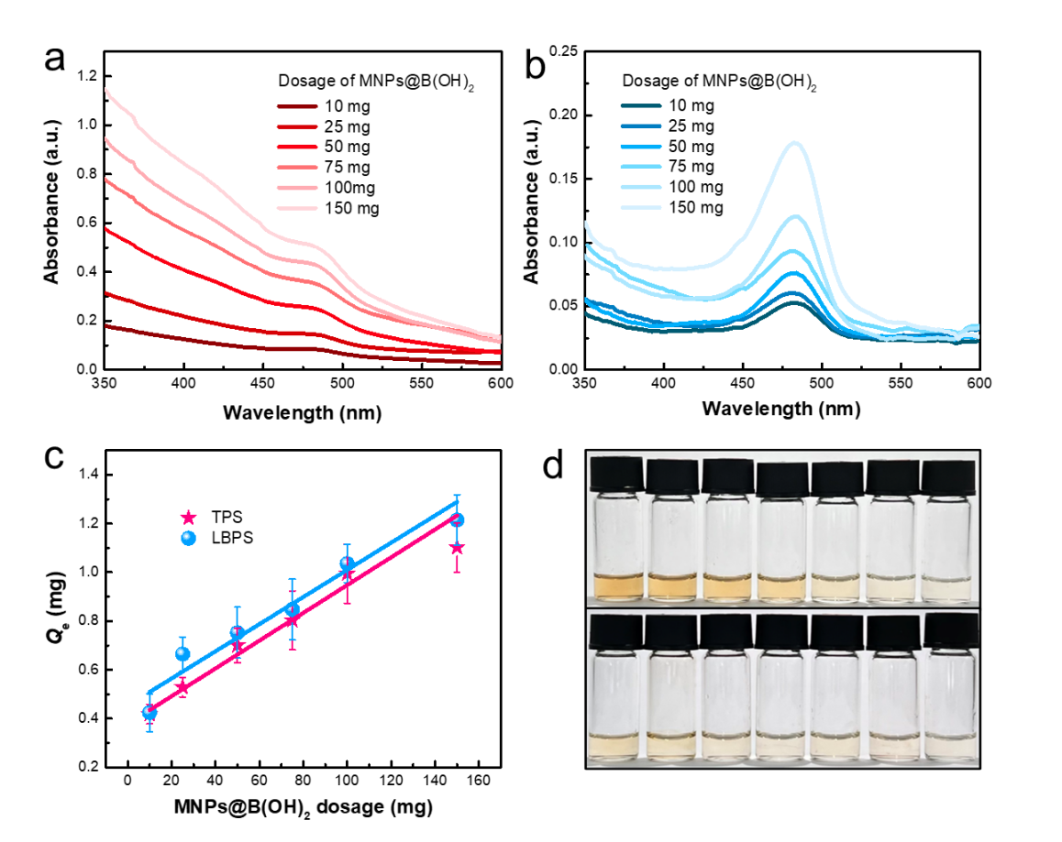

**Fig. S8.** UV-vis spectra of TPS (a) and LBPS (b) extractives from tea leaves and Lycium barbarum by MNPs@B(OH)2 with different doages; The extraction capacity of TPS and LBPS as a function of MNPs@B(OH)2 usage (c); Digital photos of TPS (top) and LBPS (bottom) extractives recorded after color development by phenol-sulfuric acid method with a decreased dosage of MNPs@B(OH)2 sorbents from left to right (d), which corresponding to the amounts used in (a-c). Linear equations in (c) were, respectively, *y*=0.0056*x*+0.4535, *R*2= 0.9392 (TPS) and *y*=0.0073*x*+0.2953, *R*2= 0.9294 (LBPS), both with a dosage gradient of MNPs@B(OH)2 ranged from 10 to 150 mg.