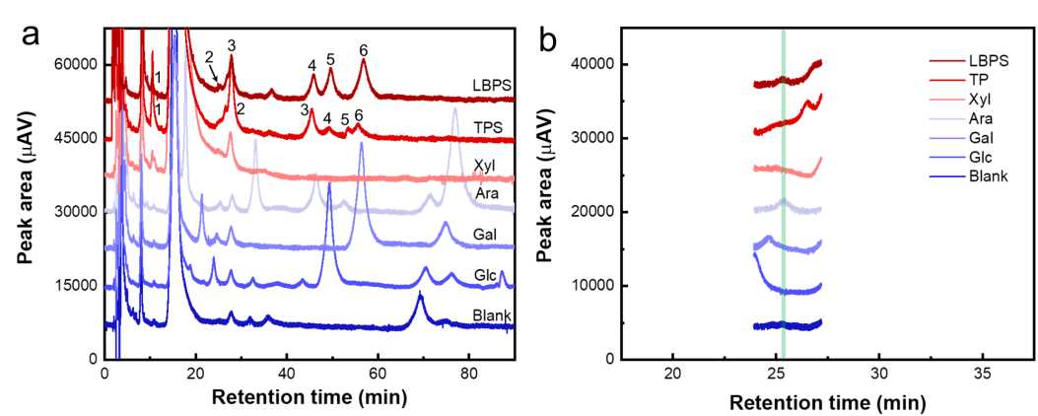

**Fig. S7.** Chromatograms of several monosaccharides and the hydrolysates of LBPS and TPS after labelling by PMP. (b) Partial enlargement of chromatographic curves for peak 2 in (a). Peaks identification for LBPS and TPS: (1, 3) xylose (Xyl); (2, 6) arabinose (Ara); (4) mannose (Man) and Ara; (5) glucose (Glc); (7) galactose (Gal).