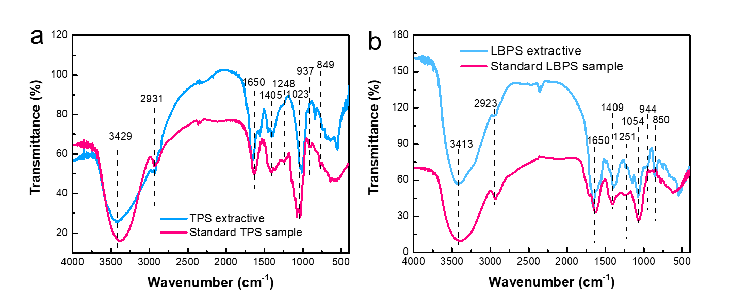

**Fig. S6.** FT-IR spectra of polysaccharide extractives (blue) and standard polysaccharide samples (red). (a) TPS; (b) LBPS.