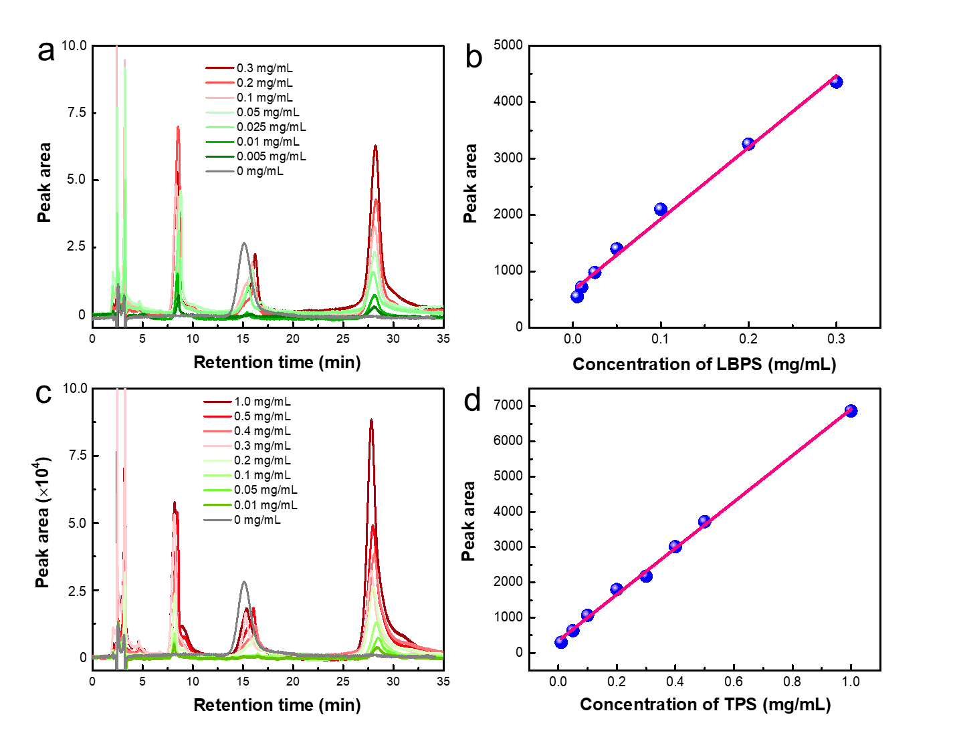

**Fig. S5.** HPLC chromatograms (a, c) of polysaccharides with different concentrations, and the standard curves (b, d) obtained by the relationship between peak area and polysaccharides concentrations. (a, b): LBPS; (c, d): TPS. Linear equations, their working parameters along with the tested purities of polysaccharides were given in Table S2.