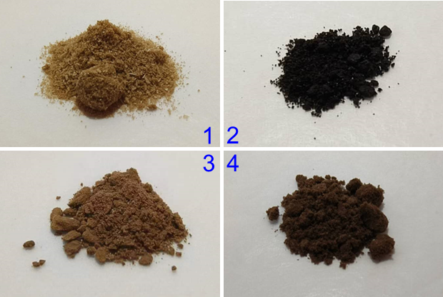

**Fig. S4.** Digital photos of standard polysaccharide samples (1, 2) and freeze-dried extractives (3, 4) of TPS (1, 3) and LBPS (2, 4) by MNPs@B(OH)2.