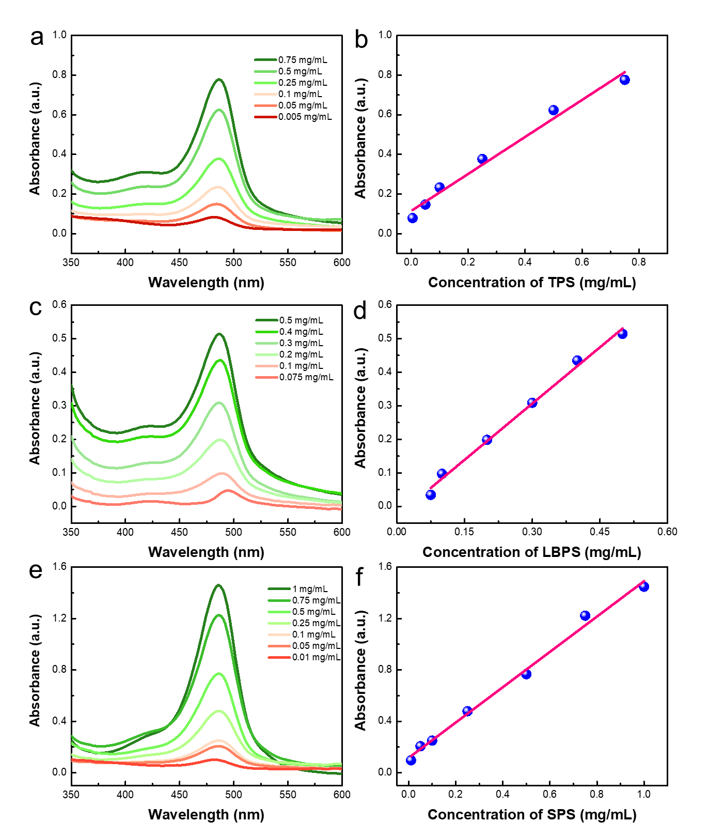

**Fig. S3.** UV-vis spectra of polysaccharides with different concentrations (a, c, e) measured after phenol-sulfuric acid chromogenesis, and the standard curves fitted by the relationship between absorbance and polysaccharides concentrations (b, d, f). The details for linear regression equation and related working parameters were listed in Table S1.