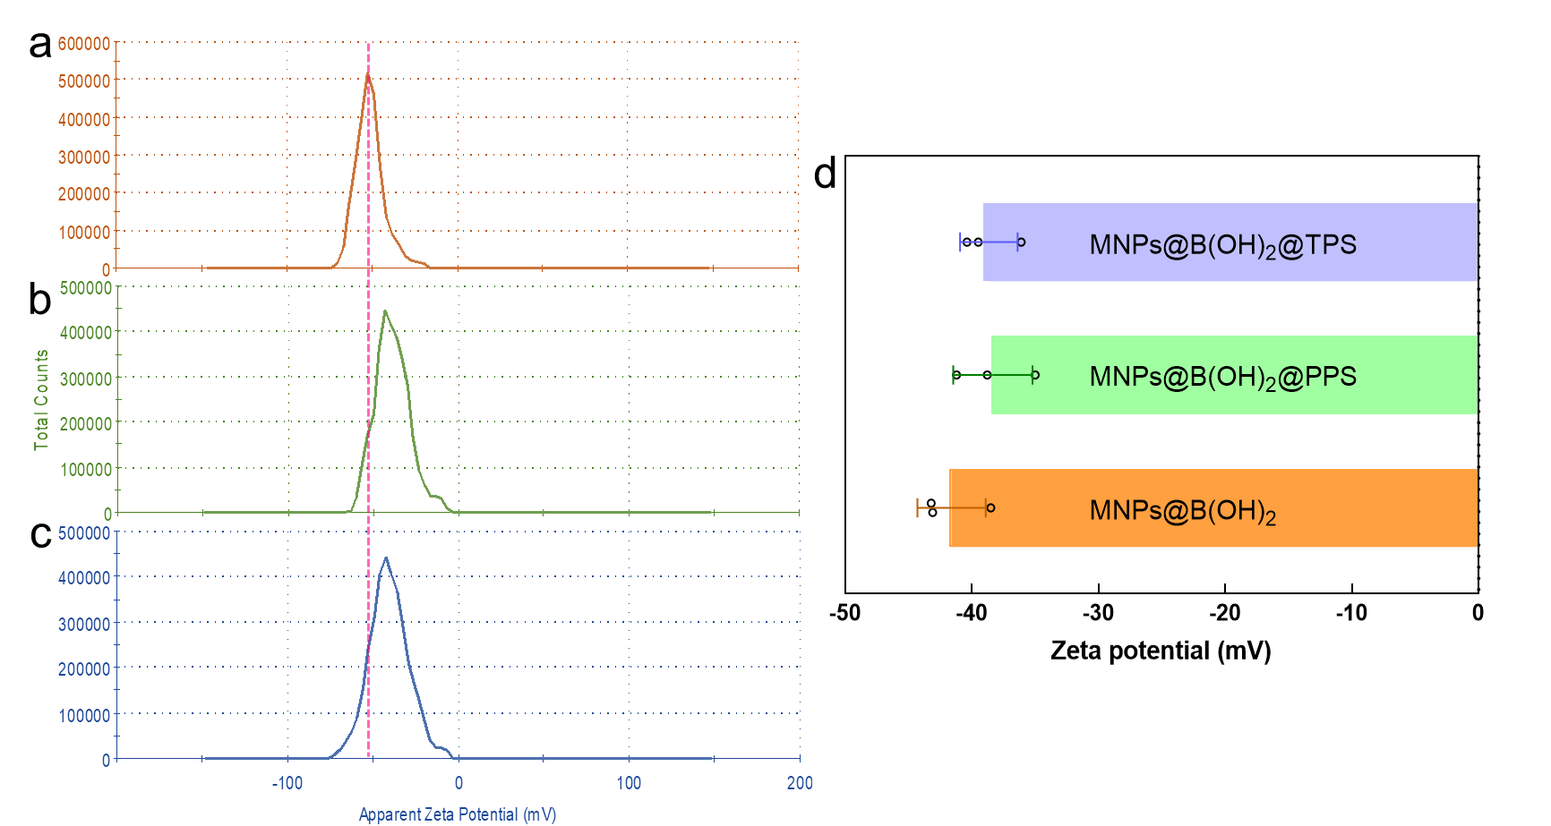

**Fig. S2.** Representative ζ potential distribution curves of MNPs@B(OH)2 (a), PPS-extracted MNPs@B(OH)2 (b), and TPS-bound MNPs@B(OH)2 (c); The quantitative comparison of their ζ potentials (d).