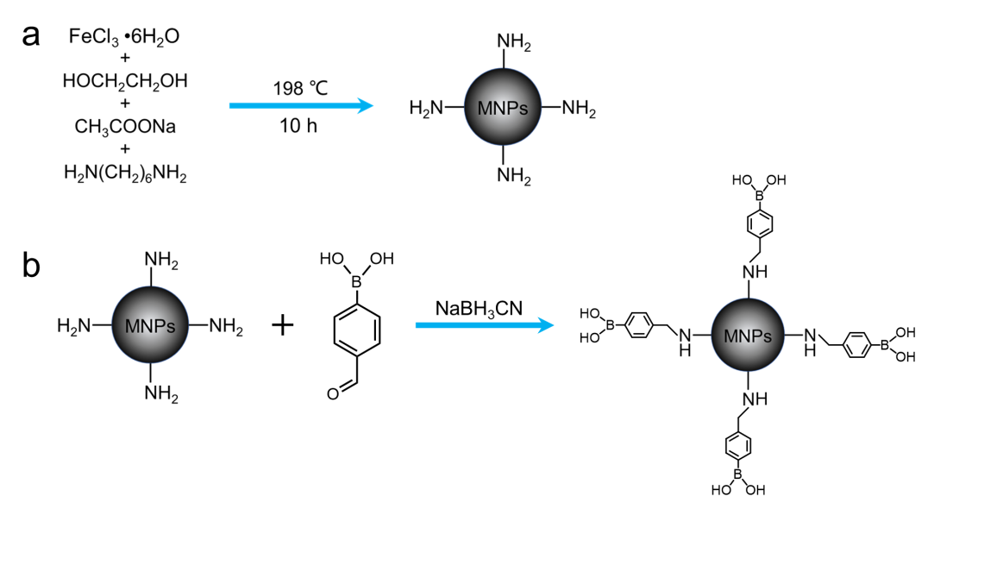

**Fig. S1.** Synthetic route of amino group-capped MNPs (a) and boronic acid-modified MNPs (b).