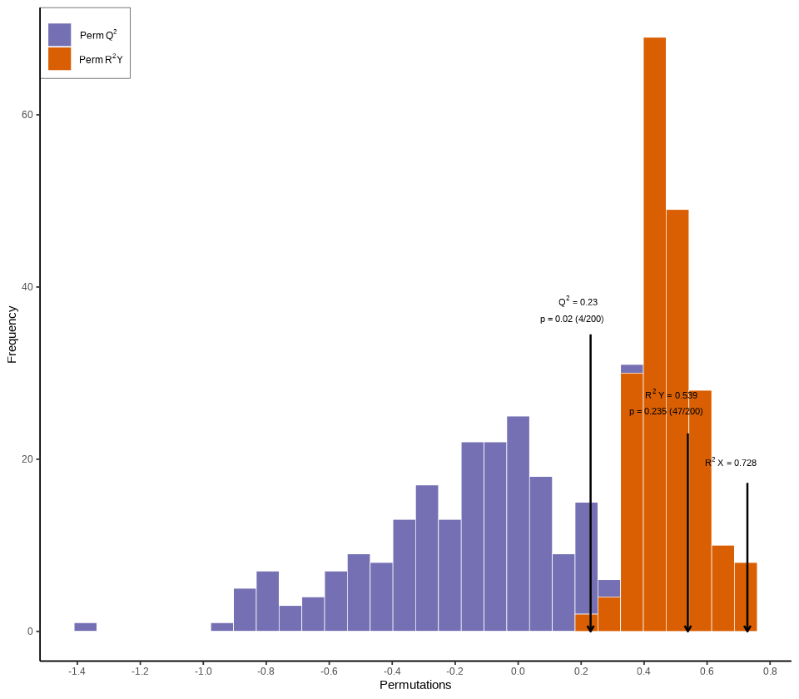

Figure 2 The permutation test diagram for model validation of OPLS-DA

The abscissa of the model validation permutation Test plot represents the accuracy of the model, the ordinate represents the frequency of the accuracy of the 200 models in the 200 permutation Test, and the arrow represents the location of the accuracy of the OPLS-DA model. R2 X and R2 Y represent the interpretation rate of the model to the X and Y matrix respectively, and Q2 represents the predictive ability of the model. In theory, the closer the value of R2 and Q2 is to 1, the better the model is, and the lower the fitting accuracy of the model is.