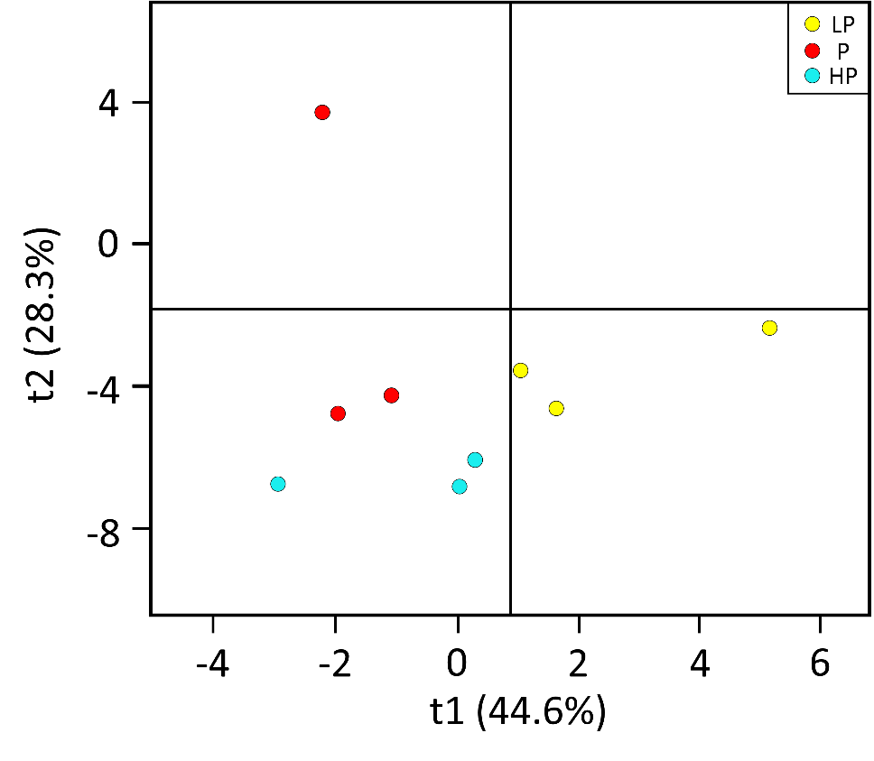

Figure 1 OPLS-DA score plot

The abscissa represents the score ( TP ) of the main components in the orthogonal process, so the difference between the groups can be seen from the direction of the abscissa.

The ordinate represents the score ( TO ) of the orthogonal component in the orthogonal process, so the difference within the group ( the difference between the samples within the group ) can be seen from the ordinate.