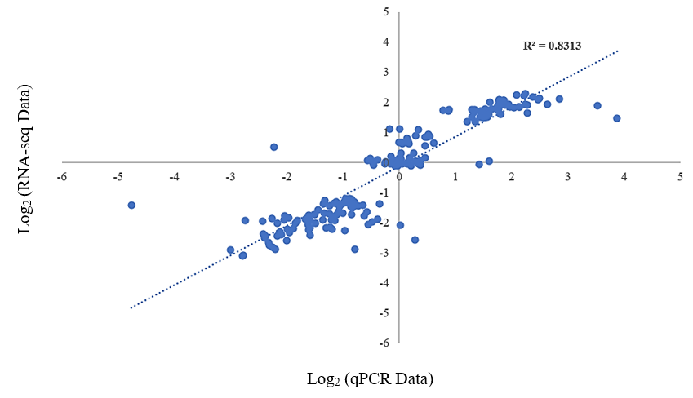
Figure S1. The correlation between RNA-Seq and qPCR data

