Contents
Figures:
Fig. S1 Heatmap depicting Kendall’s Tau-b correlations between microbial and physicochemical parameters.
Fig. S2 MAE of the RF model for fecal coliforms under grouped five-fold cross-validation.
Fig. S3 Comparison of prediction performance for the RF model of fecal coliforms on the (a) Training set and (b) Test set.
Fig. S4 MAE of the RF model for E. coli under grouped five-fold cross-validation.
Fig. S5 Comparison of prediction performance for the RF model of E. coli on the (a) Training set and (b) Test set.
Fig. S6 MAE of the RF model for E. faecalis under grouped five-fold cross-validation.
Fig. S7 Comparison of prediction performance for the RF model of E. faecalis on the (a) Training set and (b) Test set.
Fig. S8 MAE of the DT model for P. aeruginosa under grouped five-fold cross-validation.
Fig. S9 Comparison of prediction performance of the P. aeruginosa DT model on the (a) Training set and (b) Test set.
Fig. S10 MAE of the DT model for Salmonella spp. under grouped five-fold cross-validation.
Fig. S11 Comparison of prediction performance of the Salmonella spp. DT model on the (a) Training set and (b) Test set.
Fig. S12 MAE of the MLP model for Shigella spp. under grouped five-fold cross-validation.
Fig. S13 Comparison of prediction performance of the Salmonella spp. MLP model on the (a) Training set and (b) Test set.
Fig. S14 MAE of the DT model for Adenovirus under grouped five-fold cross-validation.
Fig. S15 Comparison of prediction performance of the Adenovirus DT model on the (a) Training set and (b) Test set.
Fig. S16 MAE of the RF model for Norovirus under grouped five-fold cross-validation.
Fig. S17 Comparison of prediction performance of the Norovirus RF model on the (a) Training set and (b) Test set.
Fig. S18 MAE of the RF model for Enterovirus under grouped five-fold cross-validation.
Fig. S19 Comparison of prediction performance of the Enterovirus RF model on the (a) Training set and (b) Test set.
Fig. S20 External validation of the pathogen prediction model. (a) Indicator bacteria (fecal coliforms, E. coli, E. faecalis); (b) Pathogenic bacteria (P. aeruginosa, Salmonella spp., Shigella spp.); (c) Viruses (Adenovirus, Norovirus, Enterovirus).

Tables:
Table S1 Characteristics of the oligonucleotide primers selected to target the specific waterborne bacterial pathogens chosen in this study
Table S2 TaqMan-qPCR reaction system
Table S3 The standard curves for the quantification of pathogens
Table S4 Pathogen concentration conversion relationship
Table S5 Dose-response relationships and risk characterization used in this study
Table S6 Performance evaluation of six machine learning models for fecal coliforms
Table S7 Performance evaluation of six machine learning models for E. coli
Table S8 Performance evaluation of six machine learning methods for E. faecalis
Table S9 Performance evaluation of six machine learning methods for P. aeruginosa
Table S10 Performance evaluation of six machine learning methods for Salmonella spp.
Table S11 Performance evaluation of six machine learning methods for Shigella spp.
Table S12 Performance evaluation of six machine learning methods for Adenovirus
Table S13 Performance evaluation of six machine learning methods for Norovirus
Table S14 Performance evaluation of six machine learning methods for Enterovirus
Table S15 Impact of L1-regularization-based feature selection on the performance of the RF model for fecal coliforms
Table S16 Impact of L1-regularization-based feature selection on the performance of the RF model for E. coli
Table S17 Impact of L1-regularization-based feature selection on the performance of the RF model for E. faecalis
Table S18 Impact of L1-regularization-based feature selection on the performance of the DT model for P. aeruginosa
Table S19 Impact of L1-regularization-based feature selection on the performance of the DT model for Salmonella spp.
Table S20 Impact of neuron number on the performance of the MLP model for Shigella spp.
Table S21 Impact of L1-regularization-based feature selection on the performance of the DT model for Adenovirus
Table S22 Impact of L1-regularization-based feature selection on the performance of the RF model for Norovirus
Table S23 Impact of L1-regularization-based feature selection on the performance of the RF model for Enterovirus

Fig. S1 Heatmap depicting Kendall’s Tau-b correlations between microbial and physicochemical parameters.

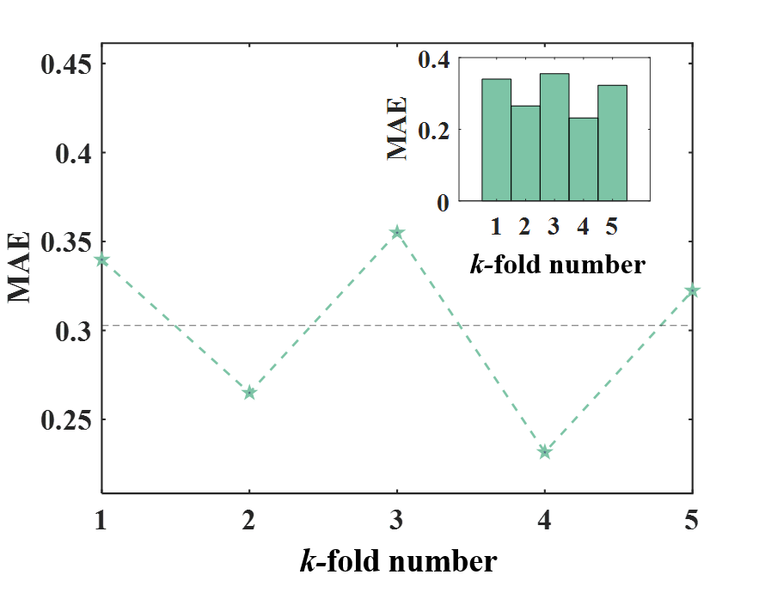
Fig. S2 MAE of the RF model for fecal coliforms under grouped five-fold cross-validation.
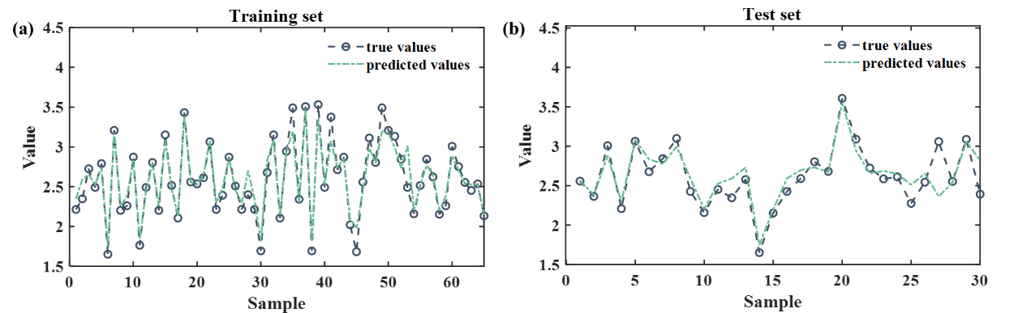
Fig. S3 Comparison of prediction performance for the RF model of fecal coliforms on the (a) Training set and (b) Test set.

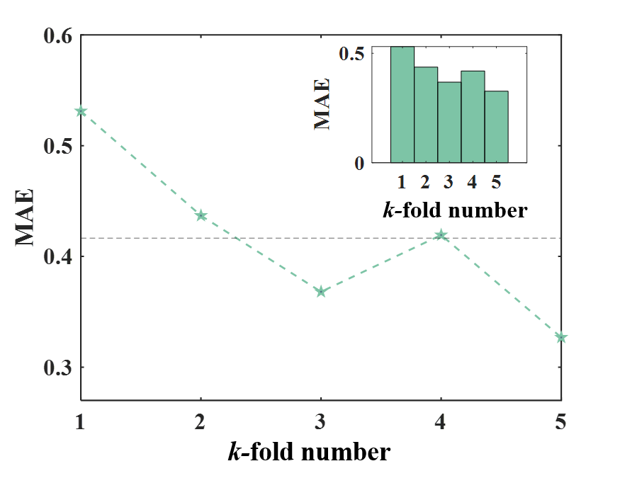
Fig. S4 MAE of the RF model for E. coli under grouped five-fold cross-validation.

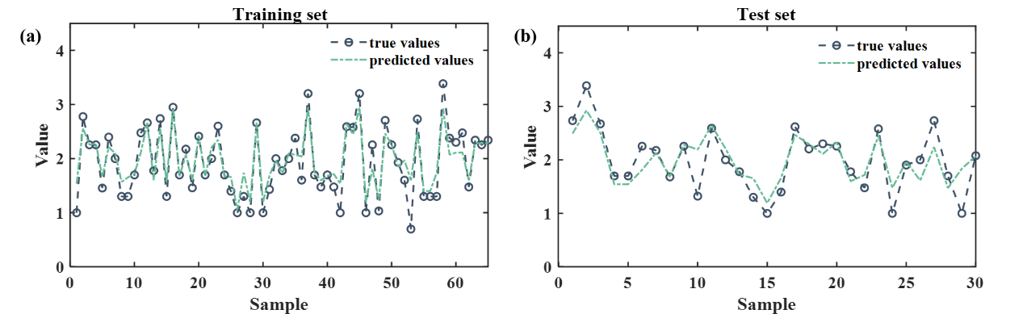Fig. S5 Comparison of prediction performance for the RF model of E. coli on the (a) Training set and (b) Test set.

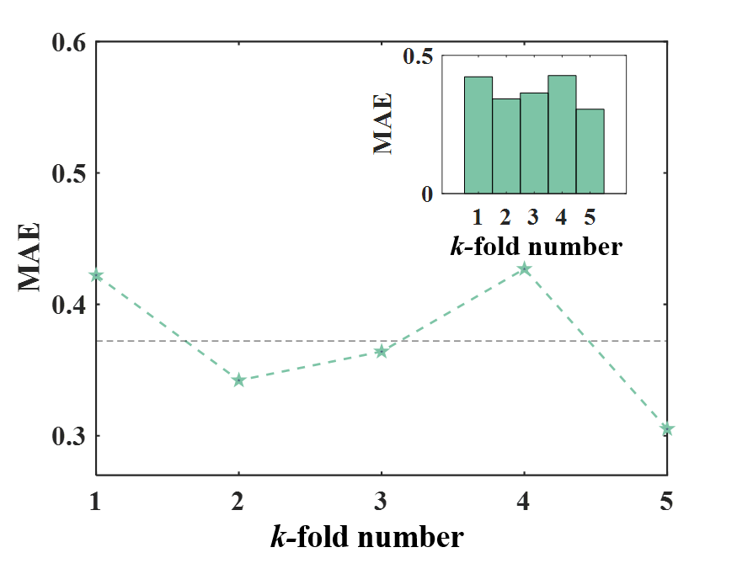
Fig. S6 MAE of the RF model for E. faecalis under grouped five-fold cross-validation.
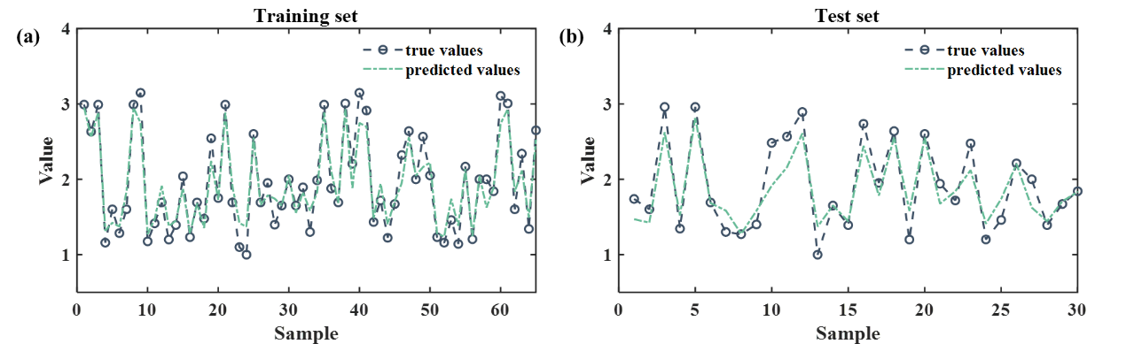
Fig. S7 Comparison of prediction performance for the RF model of E. faecalis on the (a) Training set and (b) Test set.
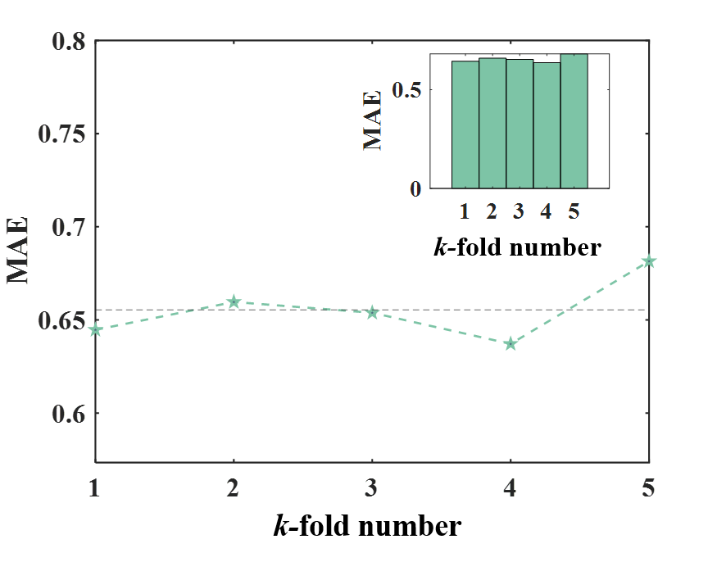
Fig. S8 MAE of the DT model for P. aeruginosa under grouped five-fold cross-validation.

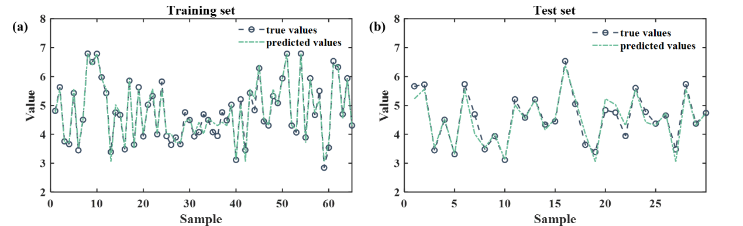
Fig. S9 Comparison of prediction performance of the P. aeruginosa DT model on the (a) Training set and (b) Test set.
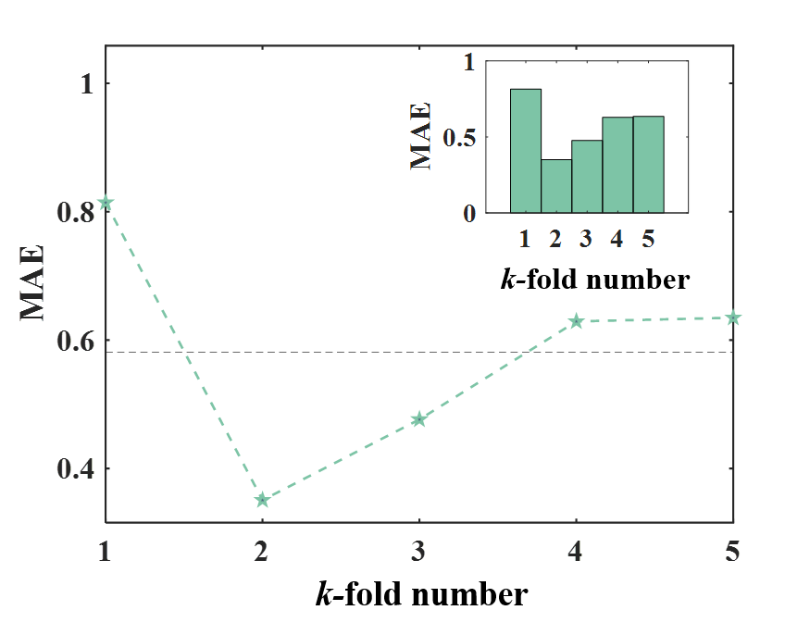
Fig. S10 MAE of the DT model for Salmonella spp. under grouped five-fold cross-validation.
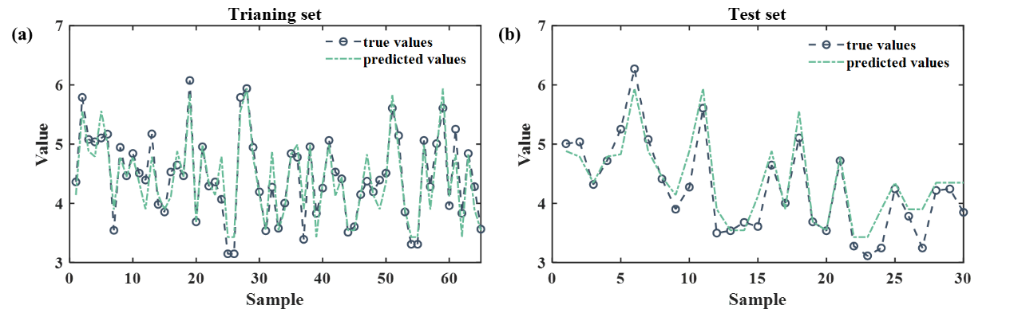
Fig. S11 Comparison of prediction performance of the Salmonella spp. DT model on the (a) Training set and (b) Test set.

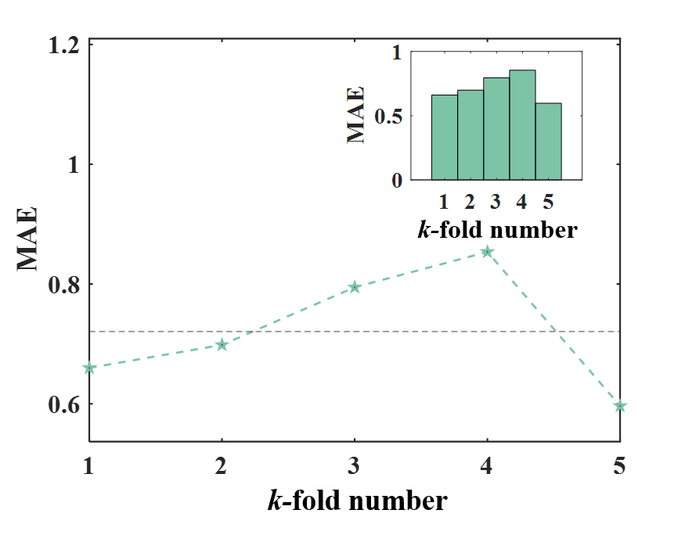
Fig. S12 MAE of the MLP model for Shigella spp. under grouped five-fold cross-validation.
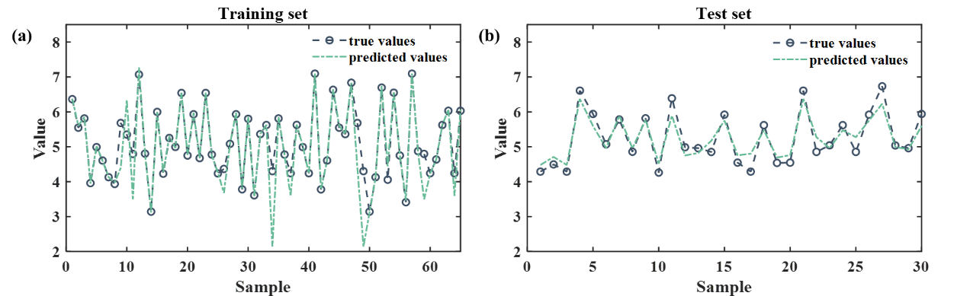
Fig. S13 Comparison of prediction performance of the Salmonella spp. MLP model on the (a) Training set and (b) Test set.
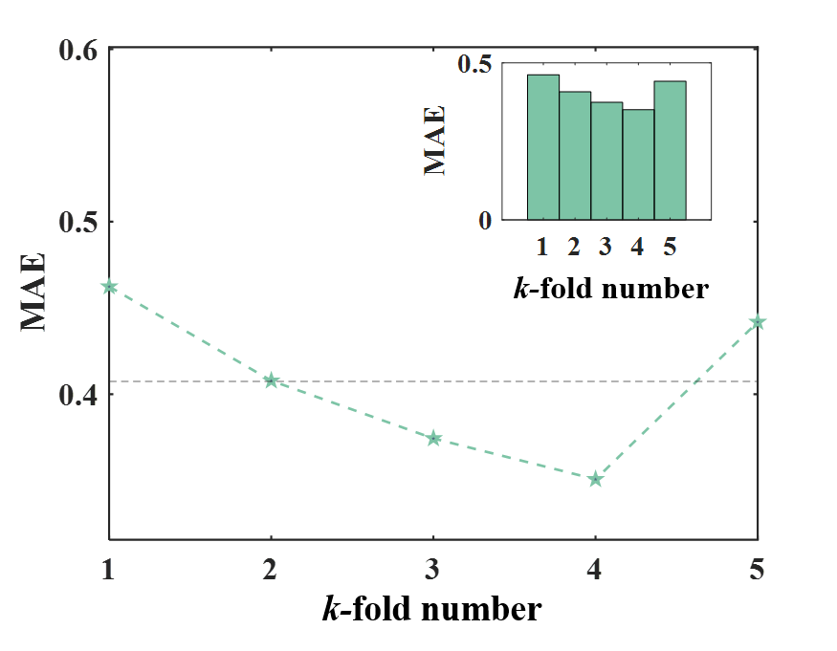
Fig. S14 MAE of the DT model for Adenovirus under grouped five-fold cross-validation.

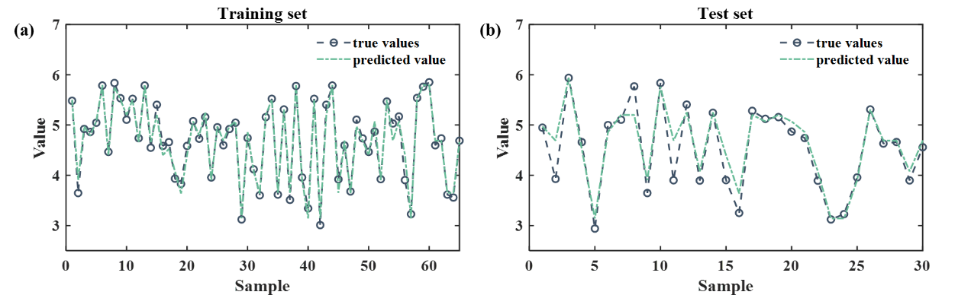
Fig. S15 Comparison of prediction performance of the Adenovirus DT model on the (a) Training set and (b) Test set.
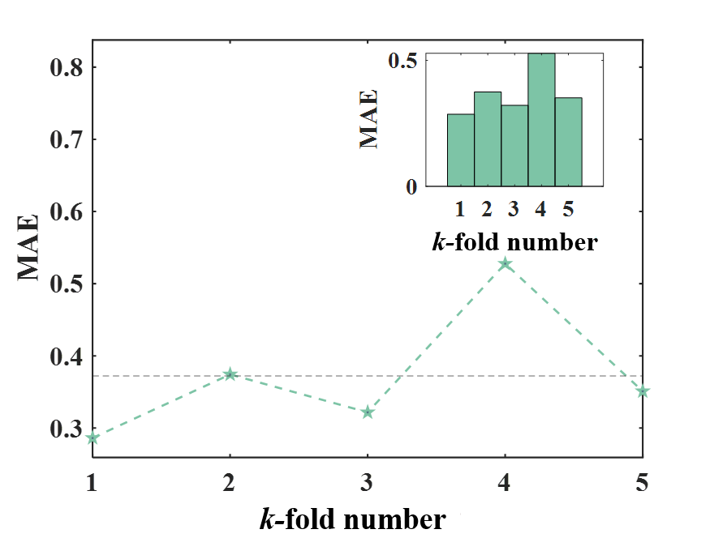
Fig. S16 MAE of the RF model for Norovirus under grouped five-fold cross-validation.
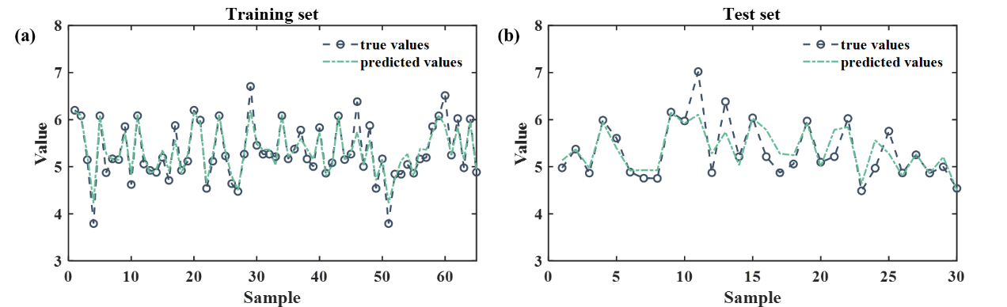
Fig. S17 Comparison of prediction performance of the Norovirus RF model on the (a) Training set and (b) Test set.

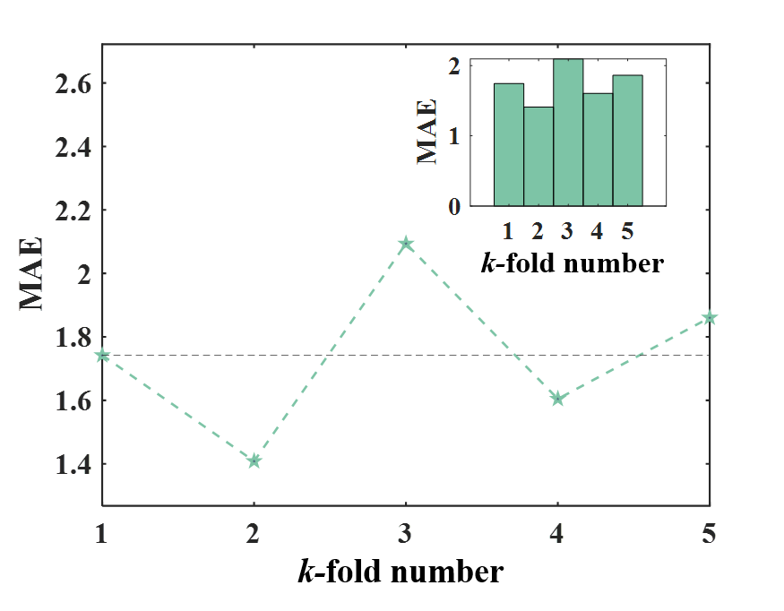
Fig. S18 MAE of the RF model for Enterovirus under grouped five-fold cross-validation.
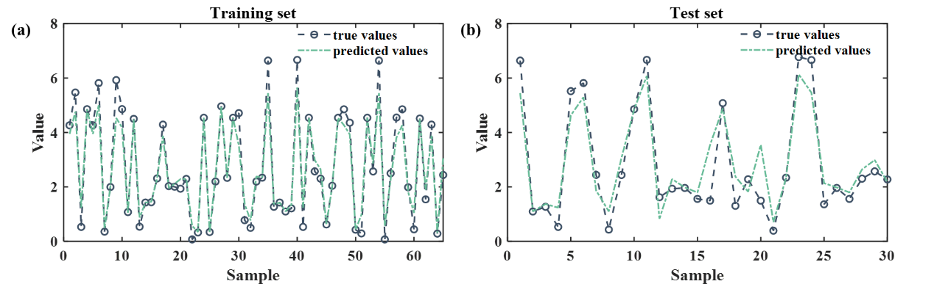
Fig. S19 Comparison of prediction performance of the Enterovirus RF model on the (a) Training set and (b) Test set.
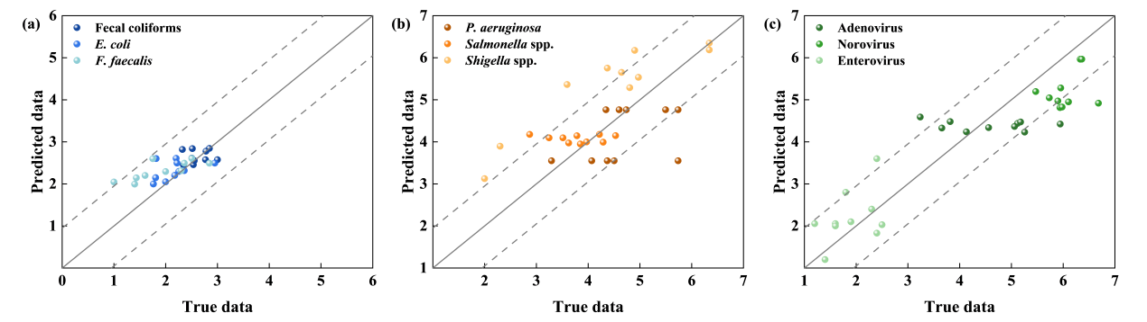
Fig. S20 External validation of the pathogen prediction model. (a) Indicator bacteria (fecal coliforms, E. coli, E. faecalis); (b) Pathogenic bacteria (P. aeruginosa, Salmonella spp., Shigella spp.); (c) Viruses (Adenovirus, Norovirus, Enterovirus).

Table S1. Characteristics of the oligonucleotide primers selected to target the specific waterborne bacterial pathogens chosen in this study
Pathogen | Target gene | Sequence (5′→3′) | Amplicon size (bp) | Reference
P. aeruginosa | oprl | F: 5’-TGCTGGTGGCACAGGACAT-3’  R: 5’-TTGTTGGTGCAGTTCCTCATTG-3’  P: FAM-CAGATGCTTTGCCTCAA- BHQ-1 | 65 | ^{[1]}
Shigella spp. | ipaH | F: 5’-CCTTTTCCGCGTTCCTTGA-3’  R: 5’-CGGAATCCGGAGGTATTGC-3’  P: FAM-CGCCTTTCCGATACCGTCTCTGCA-BHQ-1 | 67 | ^{[2]}
Salmonella spp. | invA | F: 5’-CGTTTCCTGCGGTACTGTTAATT-3’  R: 5’-AGACGGCTGGTACTGATCGATAA-3’  P: FAM-CCACGCTCTTTCGTCT-BHQ-1 | 64 | ^{[3]}
Adenovirus | - | F: 5’-AACTTTCTCTCTTAATAGACGCCCC-3’  R: 5’-TGTCCACTAGTCCAAGAGGTGC-3’  P: FAM-GCTGACACGGGCACTCTTCGC-TAMRA | 87 | ^{[4]}
Enterovirus | - | F: 5’-CCTCCGGCCCCTGAATG-3’  R: 5’-TTGGATTGGCCATCCGGT-3’  P: FAM-CCGACTACTTTGGGTGTCCGTGTTTC-TAMRA | 213 | ^{[5]}
Norovirus | - | F: 5’-ATGTTCAGATGGATGAGATTCTCAGA-3’  R: 5’-TGTGAATGAAGATGGCGTCGA-3’  P: FAM-AGCACGTGGGAGGGCGATCG-TAMRA | 106 | ^{[5]}

Table S2. TaqMan-qPCR reaction system
PCR reaction | Volume | Negative control | Final concentration (μM)
Premix Ex Taq (Probe qPCR) (μL) | 10 | 10 | 1×
Upstream primers (10 μM) | 0.4 | 0.4 | 0.2
Downstream primers (10 μM) | 0.4 | 0.4 | 0.2
Probe (10 μM) | 0.8 | 0.8 | 0.4
DNA (μL) | 2 | - | -
ddH₂O | 6.4 | 8.4 | -

Table S3. The standard curves for the quantification of pathogens
Targets | Standard curve | Linear regression coefﬁcient (R²)
rgyA | y = −3.1064x + 44.26 | 0.994
invA | y = −3.4777x + 45.71 | 0.996
ipaH | y = −3.3698x + 43.59 | 0.995
AdV | y = −3.3031x + 44.69 | 0.999
NoV | y = −3.2163x + 42.77 | 0.997
EnV | y = −3.5041x + 43.82 | 0.998

Table S4. Pathogen concentration conversion relationship
 | P. aeruginosa | Salmonella | Shigella | Adenovirus | Enterovirus | Norovirus
Unit used in clinical trials for dose-response relationships | CFU | CFU | CFU | TCID₅₀¹ | PFU² | GC³
Number of genome copies per clinical trial unit | 1 | 1 | 1 | 700 | 773 | 1
¹ TCID₅₀ = median tissue culture infectious dose.
² PFU = plaque forming unit.
³ GC = genome copies
Table S5. Dose-response relationships and risk characterization used in this study
Pathogen | Parameter value | P_{ill | inf} | Percent susceptible (S) | DALY/case | Reference
P. aeruginosa | k = 1.87×10⁻⁸ | 0.38–1.0 | 100% | 0.0455 | ^{[6, 7]}
Salmonella spp. | α = 1.75E-01S  N₅₀ = 1.11E+061 | 0.45 | 100% | 0.7 | ^{[8, 9]}
Shigella spp. | α = 2.65×10⁻¹  N₅₀ = 1.48×10³ | 0.35 | 100% | Min: 0.207; max  : 0.209; most: 0.208 | ^{[10, 11]}
Adenovirus | α = 5.11  β = 2.80 | 0.5 | 100% | Min: 0.0017; Max: 0.00196; most: 0.00151 | ^{[12, 13]}
Enterovirus | k = PERT (0.00183,0.00374,0.00562) | 0.43–0.76 | 100% | PERT (0.076,0.133,0.191) | ^{[14]}
Norovirus | α = 0.104  β = 32.3 | 0.7 | 100% | 4.6×10⁻³ | ^{[15-17]}

Table S6. Performance evaluation of six machine learning models for fecal coliforms
Model | R² (Training set) | R² (Test set) | R² (Entire dataset) | MAE (Training set) | MAE (Test set) | MAE (Entire dataset) | RMSE (Training set) | RMSE (Test set) | RMSE (Entire dataset)
MLR | 0.2812 | 0.1467 | 0.2408 | 0.3041 | 0.2832 | 0.2978 | 0.3956 | 0.3621 | 0.3856
LSBoost | 0.9981 | 0.5321 | 0.8583 | 0.0025 | 0.1698 | 0.0527 | 0.0183 | 0.2870 | 0.0989
SVM | 0.1508 | 0.0089 | 0.1082 | 0.2787 | 0.3600 | 0.3031 | 0.3917 | 0.5033 | 0.4252
DT | 0.9184 | 0.4516 | 0.7784 | 0.0843 | 0.2030 | 0.1199 | 0.1303 | 0.3115 | 0.1846
RF | 0.9072 | 0.7063 | 0.8749 | 0.0750 | 0.1267 | 0.0905 | 0.1116 | 0.2006 | 0.1383
MLP | 0.5680 | 0.0561 | 0.4144 | 0.2144 | 0.3081 | 0.2425 | 0.3076 | 0.3906 | 0.3325

Table S7. Performance evaluation of six machine learning models for E. coli
Model | R² (Training set) | R² (Test set) | R² (Entire dataset) | MAE (Training set) | MAE (Test set) | MAE (Entire dataset) | RMSE (Training set) | RMSE (Test set) | RMSE (Entire dataset)
MLR | 0.2812 | 0.1467 | 0.2408 | 0.3041 | 0.2832 | 0.2978 | 0.3956 | 0.3621 | 0.3856
LSBoost | 0.9981 | 0.5321 | 0.8583 | 0.0025 | 0.1698 | 0.0527 | 0.0183 | 0.2870 | 0.0989
SVM | 0.1508 | 0.0089 | 0.1082 | 0.2787 | 0.3600 | 0.3031 | 0.3917 | 0.5033 | 0.4252
DT | 0.9184 | 0.4516 | 0.7784 | 0.0843 | 0.2030 | 0.1199 | 0.1303 | 0.3115 | 0.1846
RF | 0.8721 | 0.7246 | 0.8278 | 0.1876 | 0.2607 | 0.2096 | 0.2346 | 0.3323 | 0.2639
MLP | 0.5680 | 0.0561 | 0.4144 | 0.2144 | 0.3081 | 0.2425 | 0.3076 | 0.3906 | 0.3325

Table S8. Performance evaluation of six machine learning methods for E. faecalis
Model | R² (Training set) | R² (Test set) | R² (Entire dataset) | MAE (Training set) | MAE (Test set) | MAE (Entire dataset) | RMSE (Training set) | RMSE (Test set) | RMSE (Entire dataset)
MLR | 0.3219 | 0.2658 | 0.3051 | 0.3552 | 0.4601 | 0.3866 | 0.4388 | 0.5603 | 0.4753
LSBoost | 0.9999 | 0.5040 | 0.8511 | 0.0000 | 0.2520 | 0.0756 | 0.0000 | 0.4605 | 0.1382
SVM | 0.2730 | 0.2199 | 0.2571 | 0.3437 | 0.4425 | 0.3733 | 0.4543 | 0.5776 | 0.4913
DT | 0.8478 | 0.3672 | 0.7036 | 0.1272 | 0.3944 | 0.2074 | 0.2079 | 0.5202 | 0.3016
RF | 0.8864 | 0.6937 | 0.8286 | 0.1566 | 0.2578 | 0.1869 | 0.1958 | 0.3206 | 0.2332
MLP | 0.8820 | 0.1603 | 0.5693 | 0.0707 | 0.4282 | 0.1780 | 0.1831 | 0.7044 | 0.3395

Table S9. Performance evaluation of six machine learning methods for P. aeruginosa
Model | R² (Training set) | R² (Test set) | R² (Entire dataset) | MAE (Training set) | MAE (Test set) | MAE (Entire dataset) | RMSE (Training set) | RMSE (Test set) | RMSE (Entire dataset)
MLR | 0.5862 | 0.2927 | 0.4982 | 0.5486 | 0.5889 | 0.5607 | 0.6866 | 0.7174 | 0.6958
LSBoost | 0.9999 | 0.6787 | 0.9035 | 0.0000 | 0.0000 | 0.0000 | 0.4445 | 0.1246 | 0.3485
SVM | 0.4861 | 0.2705 | 0.4214 | 0.5071 | 0.5576 | 0.5222 | 0.7652 | 0.7285 | 0.7542
DT | 0.9632 | 0.8911 | 0.9416 | 0.1451 | 0.2198 | 0.1675 | 0.2047 | 0.2815 | 0.2278
RF | 0.8907 | 0.7161 | 0.8383 | 0.2855 | 0.3822 | 0.3145 | 0.3529 | 0.4545 | 0.3834
MLP | 0.9305 | 0.7584 | 0.8789 | 0.1719 | 0.2641 | 0.1996 | 0.2813 | 0.4193 | 0.3227

Table S10. Performance evaluation of six machine learning methods for Salmonella spp.
Model | R² (Training set) | R² (Test set) | R² (Entire dataset) | MAE (Training set) | MAE (Test set) | MAE (Entire dataset) | RMSE (Training set) | RMSE (Test set) | RMSE (Entire dataset)
MLR | 0.3883 | 0.4551 | 0.4083 | 0.4374 | 0.4385 | 0.4377 | 0.5737 | 0.5657 | 0.5713
LSBoost | 0.9973 | 0.6786 | 0.9017 | 0.0136 | 0.1625 | 0.0582 | 0.0389 | 0.2551 | 0.1038
SVM | 0.3389 | 0.4410 | 0.3695 | 0.4130 | 0.4146 | 0.4135 | 0.5964 | 0.5729 | 0.5893
DT | 0.8860 | 0.8011 | 0.8605 | 0.1811 | 0.2649 | 0.2062 | 0.2477 | 0.3418 | 0.2759
RF | 0.8392 | 0.7889 | 0.8241 | 0.2292 | 0.3069 | 0.2525 | 0.2941 | 0.3521 | 0.3115
MLP | 0.7256 | 0.4223 | 0.6346 | 0.2045 | 0.3563 | 0.2500 | 0.3842 | 0.5825 | 0.4437

Table S11. Performance evaluation of six machine learning methods for Shigella spp.
Model | R² (Training set) | R² (Test set) | R² (Entire dataset) | MAE (Training set) | MAE (Test set) | MAE (Entire dataset) | RMSE (Training set) | RMSE (Test set) | RMSE (Entire dataset)
MLR | 0.5105 | 0.2616 | 0.4358 | 0.5778 | 0.7722 | 0.6361 | 0.7117 | 0.8756 | 0.7609
LSBoost | 0.9999 | 0.6601 | 0.8979 | 0.0000 | 0.2975 | 0.0893 | 0.0000 | 0.5941 | 0.1782
SVM | 0.4096 | 0.0983 | 0.3162 | 0.5449 | 0.7553 | 0.6080 | 0.7816 | 0.9676 | 0.8374
DT | 0.8981 | 0.5411 | 0.7910 | 0.2506 | 0.5201 | 0.3314 | 0.3247 | 0.6903 | 0.4344
RF | 0.8531 | 0.5976 | 0.7765 | 0.3117 | 0.5691 | 0.3889 | 0.3898 | 0.6464 | 0.4668
MLP | 0.8974 | 0.7717 | 0.8597 | 0.1946 | 0.3441 | 0.2394 | 0.3259 | 0.4869 | 0.3742

Table S12. Performance evaluation of six machine learning methods for Adenovirus
Model | R² (Training set) | R² (Test set) | R² (Entire dataset) | MAE (Training set) | MAE (Test set) | MAE (Entire dataset) | RMSE (Training set) | RMSE (Test set) | RMSE (Entire dataset)
MLR | 0.3043 | 0.0273 | 0.2212 | 0.5134 | 0.7053 | 0.5710 | 0.6343 | 0.8209 | 0.6903
LSBoost | 0.9439 | 0.4096 | 0.7836 | 0.0799 | 0.2219 | 0.1225 | 0.2089 | 0.3620 | 0.2548
SVM | 0.1652 | 0.0084 | 0.1182 | 0.4725 | 0.7059 | 0.5425 | 0.6948 | 0.9118 | 0.7599
DT | 0.9725 | 0.8927 | 0.9486 | 0.0916 | 0.1854 | 0.1198 | 0.1261 | 0.2795 | 0.1721
RF | 0.9265 | 0.7968 | 0.8876 | 0.1531 | 0.3134 | 0.2012 | 0.2061 | 0.3530 | 0.2502
MLP | 0.9140 | 0.5644 | 0.8091 | 0.1345 | 0.2727 | 0.1760 | 0.2231 | 0.5169 | 0.3112

Table S13. Performance evaluation of six machine learning methods for Norovirus
Model | R² (Training set) | R² (Test set) | R² (Entire dataset) | MAE (Training set) | MAE (Test set) | MAE (Entire dataset) | RMSE (Training set) | RMSE (Test set) | RMSE (Entire dataset)
MLR | 0.5225 | 0.2760 | 0.4486 | 0.3116 | 0.4197 | 0.3440 | 0.4183 | 0.5506 | 0.4580
LSBoost | 0.9999 | 0.7917 | 0.9374 | 0.0000 | 0.1394 | 0.0418 | 0.0000 | 0.2954 | 0.0886
SVM | 0.4978 | 0.1737 | 0.4006 | 0.3018 | 0.4389 | 0.3429 | 0.4289 | 0.5883 | 0.4767
DT | 0.9657 | 0.7051 | 0.8875 | 0.0742 | 0.1728 | 0.1038 | 0.1122 | 0.3515 | 0.1840
RF | 0.8850 | 0.7374 | 0.8407 | 0.1370 | 0.2424 | 0.1686 | 0.2053 | 0.3317 | 0.2432
MLP | 0.9390 | 0.6312 | 0.8467 | 0.0637 | 0.2433 | 0.1175 | 0.1494 | 0.3930 | 0.2225

Table S14. Performance evaluation of six machine learning methods for Enterovirus
Model | R² (Training set) | R² (Test set) | R² (Entire dataset) | MAE (Training set) | MAE (Test set) | MAE (Entire dataset) | RMSE (Training set) | RMSE (Test set) | RMSE (Entire dataset)
MLR | 0.7086 | (0.2062) | 0.4342 | 0.3301 | 0.6276 | 0.4193 | 0.4047 | 0.7904 | 0.5204
LSBoost | 0.9640 | 0.8145 | 0.9192 | 0.05890 | 0.2453 | 0.1149 | 0.1412 | 0.3203 | 0.1950
SVM | 0.6099 | 0.7162 | 0.6418 | 0.3004 | 0.3166 | 0.3052 | 0.4682 | 0.3834 | 0.4427
DT | 0.8587 | 0.7625 | 0.8298 | 0.1889 | 0.2274 | 0.2004 | 0.2818 | 0.3508 | 0.3025
RF | 0.8811 | 0.8473 | 0.8709 | 0.2209 | 0.2334 | 0.2246 | 0.2585 | 0.2812 | 0.2653
MLP | 0.6907 | 0.4172 | 0.6086 | 0.3138 | 0.3593 | 0.3274 | 0.4169 | 0.5494 | 0.4566

Table S15. Impact of L1-regularization-based feature selection on the performance of the RF model for fecal coliforms
Number of features | R² (Training set) | R² (Test set) | R² (Entire dataset) | MAE (Training set) | MAE (Test set) | MAE (Entire dataset) | RMSE (Training set) | RMSE (Test set) | RMSE (Entire dataset)
ck | 0.9072 | 0.7063 | 0.8749 | 0.0750 | 0.1267 | 0.0905 | 0.1116 | 0.2006 | 0.1383
12 | 0.9088 | 0.6666 | 0.8362 | 0.0903 | 0.1284 | 0.1018 | 0.1469 | 0.2137 | 0.1669
11 | 0.9183 | 0.8337 | 0.9068 | 0.0842 | 0.1316 | 0.0984 | 0.1210 | 0.1910 | 0.1420
10 | 0.9182 | 0.6290 | 0.8314 | 0.0996 | 0.1520 | 0.1153 | 0.1396 | 0.2255 | 0.1654
9 | 0.9421 | 0.6341 | 0.8497 | 0.0786 | 0.1427 | 0.0979 | 0.1165 | 0.2218 | 0.1481
8 | 0.9422 | 0.6932 | 0.8675 | 0.0776 | 0.1367 | 0.0953 | 0.1170 | 0.2018 | 0.1424
7 | 0.8849 | 0.6789 | 0.8231 | 0.1040 | 0.1412 | 0.1151 | 0.1652 | 0.2064 | 0.1775
6 | 0.8827 | 0.6837 | 0.8230 | 0.1090 | 0.1491 | 0.1210 | 0.1671 | 0.2049 | 0.1784
5 | 0.8762 | 0.6081 | 0.7958 | 0.1086 | 0.1397 | 0.1179 | 0.1749 | 0.2280 | 0.1908

Table S16. Impact of L1-regularization-based feature selection on the performance of the RF model for E. coli
Number of features | R² (Training set) | R² (Test set) | R² (Entire dataset) | MAE (Training set) | MAE (Test set) | MAE (Entire dataset) | RMSE (Training set) | RMSE (Test set) | RMSE (Entire dataset)
ck | 0.8721 | 0.7246 | 0.8278 | 0.1876 | 0.2607 | 0.2096 | 0.2346 | 0.3323 | 0.2639
12 | 0.8465 | 0.7043 | 0.8038 | 0.1973 | 0.2660 | 0.2179 | 0.2541 | 0.3472 | 0.2820
11 | 0.8552 | 0.7146 | 0.8130 | 0.1944 | 0.2677 | 0.2164 | 0.2464 | 0.3408 | 0.2747
10 | 0.8495 | 0.7780 | 0.8281 | 0.1955 | 0.2518 | 0.2124 | 0.2544 | 0.3259 | 0.2758
9 | 0.8649 | 0.6819 | 0.8100 | 0.1928 | 0.2700 | 0.2160 | 0.2409 | 0.3625 | 0.2774
8 | 0.8649 | 0.6819 | 0.8100 | 0.1928 | 0.2700 | 0.2160 | 0.2409 | 0.3625 | 0.2774
7 | 0.8780 | 0.6435 | 0.8076 | 0.1811 | 0.2684 | 0.2073 | 0.2297 | 0.3809 | 0.2751
6 | 0.8238 | 0.6587 | 0.7743 | 0.2206 | 0.2896 | 0.2413 | 0.2744 | 0.3707 | 0.3033
5 | 0.7874 | 0.6265 | 0.7391 | 0.2466 | 0.3031 | 0.2636 | 0.3091 | 0.3900 | 0.3334

Table S17. Impact of L1-regularization-based feature selection on the performance of the RF model for E. faecalis
Number of features | R² (Training set) | R² (Test set) | R² (Entire dataset) | MAE (Training set) | MAE (Test set) | MAE (Entire dataset) | RMSE (Training set) | RMSE (Test set) | RMSE (Entire dataset)
ck | 0.8864 | 0.6937 | 0.8286 | 0.1566 | 0.2578 | 0.1869 | 0.1958 | 0.3206 | 0.2332
12 | 0.8922 | 0.6878 | 0.8308 | 0.1587 | 0.2560 | 0.1879 | 0.1928 | 0.3237 | 0.2321
11 | 0.8946 | 0.7860 | 0.8620 | 0.1555 | 0.2385 | 0.1804 | 0.1927 | 0.3087 | 0.2275
10 | 0.8905 | 0.7027 | 0.8342 | 0.1588 | 0.2460 | 0.1849 | 0.1969 | 0.3144 | 0.2322
9 | 0.8778 | 0.6804 | 0.8185 | 0.1676 | 0.2572 | 0.1944 | 0.2090 | 0.3233 | 0.2433
8 | 0.8778 | 0.6804 | 0.8185 | 0.1676 | 0.2572 | 0.1944 | 0.2090 | 0.3233 | 0.2433
7 | 0.8821 | 0.6702 | 0.8185 | 0.1660 | 0.2584 | 0.1937 | 0.2080 | 0.3334 | 0.2457
6 | 0.8515 | 0.6497 | 0.7910 | 0.1809 | 0.2630 | 0.2055 | 0.2297 | 0.3398 | 0.2627
5 | 0.8566 | 0.6502 | 0.7947 | 0.1826 | 0.2621 | 0.2064 | 0.2249 | 0.3426 | 0.2602

Table S18. Impact of L1-regularization-based feature selection on the performance of the DT model for P. aeruginosa
Number of features | R² (Training set) | R² (Test set) | R² (Entire dataset) | MAE (Training set) | MAE (Test set) | MAE (Entire dataset) | RMSE (Training set) | RMSE (Test set) | RMSE (Entire dataset)
ck | 0.9632 | 0.8911 | 0.9416 | 0.1451 | 0.2198 | 0.1675 | 0.2047 | 0.2815 | 0.2278
12 | 0.9629 | 0.8908 | 0.9413 | 0.1452 | 0.2205 | 0.1678 | 0.2048 | 0.2819 | 0.2280
11 | 0.9682 | 0.9203 | 0.9538 | 0.1368 | 0.1788 | 0.1494 | 0.1884 | 0.2407 | 0.2041
10 | 0.9628 | 0.8912 | 0.9413 | 0.1419 | 0.2064 | 0.1612 | 0.2024 | 0.2813 | 0.2260
9 | 0.9384 | 0.7014 | 0.8673 | 0.1707 | 0.3312 | 0.2189 | 0.2610 | 0.4661 | 0.3225
8 | 0.9411 | 0.8556 | 0.9154 | 0.1981 | 0.2420 | 0.2113 | 0.2561 | 0.3241 | 0.2765
7 | 0.9591 | 0.8038 | 0.9125 | 0.1548 | 0.2524 | 0.1841 | 0.2134 | 0.3779 | 0.2627
6 | 0.9270 | 0.8278 | 0.8973 | 0.1953 | 0.2785 | 0.2202 | 0.2845 | 0.3540 | 0.3053
5 | 0.9270 | 0.8278 | 0.8973 | 0.1953 | 0.2785 | 0.2202 | 0.2845 | 0.3540 | 0.3053

Table S19. Impact of L1-regularization-based feature selection on the performance of the DT model for Salmonella spp.
Number of features | R² (Training set) | R² (Test set) | R² (Entire dataset) | MAE (Training set) | MAE (Test set) | MAE (Entire dataset) | RMSE (Training set) | RMSE (Test set) | RMSE (Entire dataset)
ck | 0.8860 | 0.8011 | 0.8605 | 0.1811 | 0.2649 | 0.2062 | 0.2477 | 0.3418 | 0.2759
12 | 0.8861 | 0.8158 | 0.8650 | 0.1801 | 0.2588 | 0.2037 | 0.2476 | 0.3289 | 0.2720
11 | 0.8809 | 0.8138 | 0.8608 | 0.1883 | 0.2340 | 0.2020 | 0.2537 | 0.3307 | 0.2768
10 | 0.8677 | 0.8324 | 0.8571 | 0.2053 | 0.2434 | 0.2167 | 0.2680 | 0.3138 | 0.2817
9 | 0.8837 | 0.6847 | 0.8240 | 0.1673 | 0.3079 | 0.2095 | 0.2501 | 0.4303 | 0.3041
8 | 0.8927 | 0.7775 | 0.8582 | 0.1647 | 0.2367 | 0.1863 | 0.2393 | 0.3632 | 0.2765
7 | 0.8950 | 0.7290 | 0.8452 | 0.1573 | 0.2605 | 0.1883 | 0.2375 | 0.3989 | 0.2860
6 | 0.8854 | 0.7423 | 0.8425 | 0.1738 | 0.2713 | 0.2030 | 0.2487 | 0.3909 | 0.2913
5 | 0.8433 | 0.6771 | 0.7934 | 0.2099 | 0.3296 | 0.2458 | 0.2902 | 0.4388 | 0.3348

Table S20. Impact of neuron number on the performance of the MLP model for Shigella spp.
Neuron structure | R² (Training set) | R² (Test set) | R² (Entire dataset) | MAE (Training set) | MAE (Test set) | MAE (Entire dataset) | RMSE (Training set) | RMSE (Test set) | RMSE (Entire dataset)
ck | 0.8974 | 0.7717 | 0.8597 | 0.1946 | 0.3441 | 0.2394 | 0.3259 | 0.4869 | 0.3742
[8,8] | 0.9138 | 0.5964 | 0.8186 | 0.0660 | 0.3507 | 0.1514 | 0.2987 | 0.6474 | 0.4033
[16,8] | 0.9040 | 0.4884 | 0.7793 | 0.1777 | 0.5127 | 0.2782 | 0.3153 | 0.7288 | 0.4393
[32,16] | 0.8764 | 0.4967 | 0.7625 | 0.1337 | 0.4809 | 0.2379 | 0.3576 | 0.7229 | 0.4672
[32,32] | 0.5639 | 0.0309 | 0.4040 | 0.2743 | 0.6936 | 0.4001 | 0.6718 | 1.0031 | 0.7712
[64,16] | 0.8701 | 0.6409 | 0.8013 | 0.1033 | 0.3805 | 0.1864 | 0.3666 | 0.6106 | 0.4398
[64,32] | 0.4992 | 0.5040 | 0.5006 | 0.5557 | 0.5784 | 0.5625 | 0.7199 | 0.7177 | 0.7192
[64,64] | 0.8513 | 0.8128 | 0.8398 | 0.1994 | 0.2836 | 0.2246 | 0.5073 | 0.4409 | 0.4873
[128,64] | 0.6464 | −0.9445 | 0.1691 | 0.1806 | 0.8817 | 0.3910 | 0.6049 | 1.4210 | 0.8497
[128,128] | 0.6355 | 0.2597 | 0.5228 | 0.2793 | 0.6468 | 0.3895 | 0.6141 | 0.8767 | 0.6929

Table S21. Impact of L1-regularization-based feature selection on the performance of the DT model for Adenovirus
Number of features | R² (Training set) | R² (Test set) | R² (Entire dataset) | MAE (Training set) | MAE (Test set) | MAE (Entire dataset) | RMSE (Training set) | RMSE (Test set) | RMSE (Entire dataset)
ck | 0.9725 | 0.8727 | 0.9426 | 0.0916 | 0.1854 | 0.1198 | 0.1261 | 0.2795 | 0.1721
12 | 0.9572 | 0.7571 | 0.8971 | 0.1056 | 0.2637 | 0.1530 | 0.1574 | 0.3864 | 0.2261
11 | 0.9572 | 0.7581 | 0.8975 | 0.1056 | 0.2631 | 0.1528 | 0.1574 | 0.3853 | 0.2257
10 | 0.9552 | 0.8157 | 0.9133 | 0.1110 | 0.2564 | 0.1546 | 0.1615 | 0.3363 | 0.2139
9 | 0.9570 | 0.8269 | 0.9180 | 0.1155 | 0.2598 | 0.1588 | 0.1583 | 0.3261 | 0.2086
8 | 0.9558 | 0.8242 | 0.9164 | 0.1144 | 0.2604 | 0.1582 | 0.1603 | 0.3285 | 0.2108
7 | 0.9603 | 0.7635 | 0.9012 | 0.0998 | 0.2610 | 0.1481 | 0.1523 | 0.3730 | 0.2185
6 | 0.9663 | 0.7344 | 0.8967 | 0.0922 | 0.2153 | 0.1292 | 0.1400 | 0.4040 | 0.2192
5 | 0.9276 | 0.7096 | 0.8622 | 0.1409 | 0.2663 | 0.1785 | 0.2049 | 0.4144 | 0.2678

Table S22. Impact of L1-regularization-based feature selection on the performance of the RF model for Norovirus
Number of features | R² (Training set) | R² (Test set) | R² (Entire dataset) | MAE (Training set) | MAE (Test set) | MAE (Entire dataset) | RMSE (Training set) | RMSE (Test set) | RMSE (Entire dataset)
ck | 0.8850 | 0.7374 | 0.8407 | 0.1370 | 0.2424 | 0.1686 | 0.2053 | 0.3317 | 0.2432
12 | 0.8852 | 0.7205 | 0.8358 | 0.1385 | 0.2369 | 0.1680 | 0.2082 | 0.3359 | 0.2465
11 | 0.8792 | 0.7025 | 0.8262 | 0.1374 | 0.2622 | 0.1748 | 0.2110 | 0.3530 | 0.2536
10 | 0.8845 | 0.7935 | 0.8572 | 0.1415 | 0.2174 | 0.1642 | 0.2108 | 0.3291 | 0.2463
9 | 0.8795 | 0.7312 | 0.8350 | 0.1458 | 0.2226 | 0.1688 | 0.2126 | 0.3369 | 0.2499
8 | 0.8746 | 0.7042 | 0.8234 | 0.1466 | 0.2406 | 0.1748 | 0.2202 | 0.3556 | 0.2608
7 | 0.8715 | 0.6735 | 0.8121 | 0.1488 | 0.2567 | 0.1811 | 0.2190 | 0.3693 | 0.2641
6 | 0.8618 | 0.6809 | 0.8075 | 0.1575 | 0.2555 | 0.1869 | 0.2275 | 0.3639 | 0.2684
5 | 0.8490 | 0.6831 | 0.7993 | 0.1575 | 0.2668 | 0.1903 | 0.2371 | 0.3672 | 0.2761

Table S23. Impact of L1-regularization-based feature selection on the performance of the RF model for Enterovirus
Number of features | R² (Training set) | R² (Test set) | R² (Entire dataset) | MAE (Training set) | MAE (Test set) | MAE (Entire dataset) | RMSE (Training set) | RMSE (Test set) | RMSE (Entire dataset)
ck | 0.8811 | 0.8473 | 0.8709 | 0.2209 | 0.2334 | 0.2246 | 0.2585 | 0.2812 | 0.2653
12 | 0.8811 | 0.8473 | 0.8709 | 0.2209 | 0.2334 | 0.2246 | 0.2585 | 0.2812 | 0.2653
11 | 0.8577 | 0.8256 | 0.8481 | 0.2344 | 0.2438 | 0.2372 | 0.2825 | 0.3026 | 0.2885
10 | 0.8753 | 0.8198 | 0.8586 | 0.2323 | 0.2607 | 0.2409 | 0.2675 | 0.3076 | 0.2795
9 | 0.8753 | 0.8198 | 0.8586 | 0.2323 | 0.2607 | 0.2409 | 0.2675 | 0.3076 | 0.2795
8 | 0.8674 | 0.8105 | 0.8503 | 0.2283 | 0.2483 | 0.2343 | 0.2761 | 0.3133 | 0.2872
7 | 0.8503 | 0.8452 | 0.8488 | 0.2364 | 0.2200 | 0.2315 | 0.2900 | 0.2831 | 0.2879
6 | 0.8219 | 0.8184 | 0.8208 | 0.2660 | 0.2424 | 0.2590 | 0.3200 | 0.3067 | 0.3160
5 | 0.7977 | 0.7912 | 0.7958 | 0.2762 | 0.2828 | 0.2782 | 0.3371 | 0.3289 | 0.3346

References
[1] Wang HB, Hu C, Zhang SN, Liu LZ, Xing XC. 2018. Effects of O₃/Cl₂ disinfection on corrosion and opportunistic pathogens growth in drinking water distribution systems. Journal of Environmental Sciences 73: 38-46 https://doi.org/10.1016/j.jes.2018.01.009
[2] Vu DT, Sethabutr O, Von Seidlein L, Tran VT, Do GC, et al. 2004. Detection of Shigella by a PCR assay targeting the ipaH gene suggests increased prevalence of shigellosis in Nha Trang, Vietnam. Journal of Clinical Microbiology 42: 2031-2035 https://doi.org/10.1128/jcm.42.5.2031-2035.2004
[3] Lee DY, Shannon K, Beaudette LA. 2006. Detection of bacterial pathogens oligonucleotide microarray in municipal wastewater using an ind real-time quantitative PCR. Journal of Microbiological Methods 65: 453-467 https://doi.org/10.1016/j.mimet.2005.09.008
[4] Xagoraraki I, Kuo DHW, Wong K, Wong M, Rose JB. 2007. Occurrence of human adenoviruses at two recreational beaches of the great lakes. Applied and Environmental Microbiology 73: 7874-7881 https://doi.org/10.1128/aem.01239-07
[5] Yao SJ, Liu LL, Yan CC, Zhang TY, Yu JQ, et al. 2025. Virus contamination, removal characteristics and quantitative risk assessment from drinking water source to secondary water supply system. Water Cycle 6: 95-104 https://doi.org/10.1016/j.watcyc.2024.11.004
[6] Denissen J, Reyneke B, Barnard T, Khan S, Khan W. 2023. Risk assessment of Enterococcus faecium, Klebsiella pneumoniae, and Pseudomonas aeruginosa in environmental water sources: Development of surrogate models for antibiotic resistance genes. Science of the Total Environment 901: 166217 https://doi.org/10.1016/j.scitotenv.2023.166217
[7] Havelaar AH, Kirk MD, Torgerson PR, Gibb HJ, Hald T, et al. 2015. World health organization global estimates and regional comparisons of the burden of foodborne disease in 2010. PLoS Medicine 12: e1001923 https://doi.org/10.1371/journal.pmed.1001923
[8] Westrell, T. 2004. Microbial risk assessment and its implications for risk management in urban water systems. Linköping Studies in Arts and Sciences, No. 304. Sweden: Linköping University. pp. 1–84. http://urn.kb.se/resolve?urn=urn:nbn:se:liu:diva-4880
[9] de Noordhout CM, Devleesschauwer B, Haagsma JA, Havelaar AH, Bertrand S, et al. 2017. Burden of salmonellosis, campylobacteriosis and listeriosis: a time series analysis, Belgium, 2012 to 2020. Eurosurveillance 22: 30615 https://doi.org/10.2807/1560-7917.Es.2017.22.38.30615
[10] McBride GB, Stott R, Miller W, Bambic D, Wuertz S. 2013. Discharge-based QMRA for estimation of public health risks from exposure to stormwater-borne pathogens in recreational waters in the United States. Water Research 47: 5282-5297 https://doi.org/10.1016/j.watres.2013.06.001
[11] Machdar E, van der Steen NP, Raschid-Sally L, Lens PNL. 2013. Application of quantitative microbial risk assessment to analyze the public health risk from poor drinking water quality in a low income area in Accra, Ghana. Science of the Total Environment 449: 134-142 https://doi.org/10.1016/j.scitotenv.2013.01.048
[12] Haas CN, Rose JB, Gerba C, Regli S. 1993. Risk assessment of virus in drinking water. Risk analysis : an official publication of the Society for Risk Analysis 13: 545-552 https://doi.org/10.1111/j.1539-6924.1993.tb00013.x
[13] Simhon MV, Minnery JG, Hofmann R. 2012. Adenovirus control in small drinking water systems: risks and strategies. Journal of Water Supply Research and Technology-Aqua 61: 94-102 https://doi.org/10.2166/aqua.2012.090
[14] Moazeni M, Nikaeen M, Hadi M, Moghim S, Mouhebat L, et al. 2017. Estimation of health risks caused by exposure to enteroviruses from agricultural application of wastewater effluents. Water Research 125: 104-113 https://doi.org/10.1016/j.watres.2017.08.028
[15] Atmar RL, Opekun AR, Gilger MA, Estes MK, Crawford SE, et al. 2014. Determination of the 50% Human Infectious Dose for Norwalk Virus. Journal of Infectious Diseases 209: 1016-1022 https://doi.org/10.1093/infdis/jit620
[16] Van Abel N, Schoen ME, Kissel JC, Meschke JS. 2017. Comparison of risk predicted by multiple Norovirus dose-response models and implications for quantitative microbial risk assessment. Risk Analysis 37: 245-264 https://doi.org/10.1111/risa.12616
[17] WHO. 2016. Quantitative microbial risk assessment: Application for water safety management. Geneva: World Health Organization. pp. 1–204. https://www.who.int/publications/i/item/9789241565370

