Supporting information
A global synthesis of port water microbiome biogeography and anthropogenic associations
Baoyi Lv ^{a, b}, Qitong Zhang ª, Tingxuan An ª, Shenglong Mei ª, Guolin Kan ª, Dong Wu ^{c}, Jianhong Shi ^{a *}
ª College of Ocean Science and Engineering, Shanghai Maritime University, Shanghai 201306, China
^{b} International Joint Research Center for Persistent Toxic Substances (IJRC-PTS), Shanghai Maritime University, Shanghai, 201306, China
^{c} Shanghai Engineering Research Center of Biotransformation of Organic Solid Waste, East China Normal University, Shanghai 200241, China

*Corresponding author: Jianhong Shi（shijh@shmtu.edu.cn）

The supporting materials have 52 pages (including 7 Tables and 10 Figures).

Legend of Tables
Table S1. Information on socioeconomic factors in the sampling areas.
Table S2. Detailed information on the port water sequencing data.
Table S3. Relative abundance of the top 30 phyla categorized by continent.
Table S4. Relative abundance of the top 30 phyla categorized by latitude.
Table S5. The taxonomic composition of global core bacteria in port water.
Table S6. Distinct metabolic and ecological functional groups across port water bacterial community.
Table S7. Mantel test of factors affecting bacterial community structure.

Legend of Figures
Figure S1. Geographical distribution of port water samples.
Figure S2. The DDRs based on Bray-Curtis similarity of the port water bacterial community categorized by port capacity.
Figure S3. Principal coordinate analysis based on the Bray-Curtis distance of the bacterial community in the port water.
Figure S4. Relative abundances of predominant genera across continents and latitudes.
Figure S5. Heatmap of bacterial community functional groups in the port water.
Figure S6. Phylum-level taxonomic composition of potential pathogens.
Figure S7. Venn diagram of pathogenic bacteria across continents and latitudes (a) (c). The relative abundance of zoonotic, animal, and plant pathogens in different continents and latitudes (b) (d).
Figure S8. Contributions of various environments to port water bacterial community as determined by SourceTracker.
Figure S9. The impacts of maritime activities (including Port capacity, MTI, FSS) and onshore activities (including WWD, GDP, PD, PGR) on port bacterial community.
Figure S10. ANOSIM of between-group and within-group differences.

Table S1. Information on socioeconomic factors in the sampling areas.
Port | Port Capacity  (million TEUs) | WWD (million tons) | PLSCI | GDP (billion USD) | Pop Density (people/km²) | Pop Growth Rate (%) | HDI | SDGI | EPI | MPA | FSS | MTR | Temp (°C)
Australia: Coffs Harbour | NA | 3.22 | 8.05 | 1557.20 | 3.22 | 1.37 | 0.94 | 75.90 | 74.12 | 100.00 | 16.96 | 100.00 | 23.50
Australia: Port Macquire | NA | 3.22 | 7.10 | 1326.88 | 3.22 | 1.65 | 0.94 | 75.90 | 74.12 | 100.00 | 16.96 | 100.00 | 22.40
China: Hong Kong | 20.76 | 957.32 | 1366.47 | 33234.07 | 150.44 | 0.54 | 0.77 | 67.10 | 50.74 | 89.28 | 90.52 | 50.30 | 23.90
China: Shanghai | 40.23 | 1662.87 | 1787.47 | 49183.40 | 150.44 | 0.77 | 0.77 | 67.10 | 50.74 | 89.28 | 90.52 | 50.30 | 17.70
France: Martigues | 5.62 | 5.94 | NA | 324.80 | 119.23 | 0.29 | 0.91 | 80.30 | 83.95 | 100.00 | 78.37 | 37.05 | 15.10
Germany: Wilhelmshaven | 3.90 | 10.30 | 157.53 | 252.00 | 237.85 | 0.37 | 0.95 | 81.70 | 78.37 | 100.00 | 36.89 | 58.54 | 10.00
Italy: Naples | 1.37 | NA | 136.62 | 2932.43 | 204.22 | 0.89 | 0.90 | 75.50 | 76.96 | 95.77 | 17.27 | 58.71 | 20.00
Italy: Venice | 1.61 | 3.09 | 171.89 | 5959.00 | 204.22 | 0.89 | 0.90 | 75.50 | 76.96 | 95.77 | 17.27 | 58.71 | 12.00
Netherlands: Rotterdam | 13.73 | 175.54 | 1012.11 | 71969.45 | 514.27 | 0.59 | 0.95 | 79.90 | 75.46 | 100.00 | 46.72 | 22.48 | 14.00
Singapore | 33.67 | 320.73 | 1651.95 | 32390.13 | 7805.14 | 0.09 | 0.94 | 69.00 | 64.23 | 18.50 | 68.93 | 79.09 | 27.70
South Africa: Durban | 2.70 | 17.34 | 235.18 | 5627.30 | 47.51 | 0.65 | 0.73 | NA | 44.73 | 100.00 | 62.82 | 55.66 | 20.50
South Korea: Busan | 20.47 | 160.64 | 1438.05 | 28526.80 | 527.52 | 0.45 | 0.92 | 75.50 | 62.30 | 87.48 | 92.34 | 41.87 | 15.50
USA: California Los Angeles | 9.34 | 491.19 | 305.75 | 102917.17 | 36.32 | 0.69 | 0.93 | 72.40 | 71.19 | 100.00 | 66.91 | 48.26 | 18.30
USA: California Oakland | 2.42 | 9243.41 | 336.50 | 19612.10 | 36.32 | 0.69 | 0.93 | 72.40 | 71.19 | 100.00 | 66.91 | 48.26 | 14.90
USA: Louisiana New Orleans | 1.29 | 147.98 | 251.79 | 8140.83 | 36.32 | 0.69 | 0.93 | 72.40 | 71.19 | 100.00 | 66.91 | 48.26 | 15.50
USA: Maryland Baltimore | 5.18 | 107.92 | 165.54 | 18278.43 | 36.32 | 0.69 | 0.93 | 72.40 | 71.19 | 100.00 | 66.91 | 48.26 | 13.00
USA: New York New York | 6.71 | 704.14 | 401.71 | 151772.43 | 36.32 | 0.69 | 0.93 | 72.40 | 71.19 | 100.00 | 66.91 | 48.26 | 12.10
USA: South Carolina Charleston | 2.20 | 1.45 | 302.13 | 4987.10 | 36.32 | 0.69 | 0.93 | 72.40 | 71.19 | 100.00 | 66.91 | 48.26 | 15.40
USA: Texas Galveston | 1.10 | 39.27 | NA | 11293.10 | 36.32 | 0.69 | 0.93 | 72.40 | 71.19 | 100.00 | 66.91 | 48.26 | 20.90
USA: Virginia Norfolk | 2.84 | 138.46 | 337.75 | 8629.73 | 36.32 | 0.69 | 0.93 | 72.40 | 71.19 | 100.00 | 66.91 | 48.26 | 15.70
USA: Washington Seattle | 3.67 | 12.35 | 156.10 | 33105.57 | 36.32 | 0.69 | 0.93 | 72.40 | 71.19 | 100.00 | 66.91 | 48.26 | 13.50
USA: Long Beach California | 7.54 | 3.22 | 245.83 | 5694.67 | 36.32 | 0.69 | 0.93 | 72.40 | 71.19 | 100.00 | 66.91 | 48.26 | 16.60

Table S2. Detailed information on the port water sequencing data^{[1-4]}.
SampleID | Port | Country | Continent
L0_2.338F_806R | China: Shanghai Yangshan | China | Asia
raw.split.L0.1 | China: Shanghai Yangshan | China | Asia
raw.split.L46 | China: Shanghai Yangshan | China | Asia
SRR11617753 | USA: Long Beach California | West Coast U.S | North America
SRR11617755 | China: Shanghai | China | Asia
SRR11617758 | China: Shanghai | China | Asia
SRR11617760 | China: Shanghai | China | Asia
SRR11617764 | China: Shanghai | China | Asia
SRR11617766 | China: Shanghai | China | Asia
SRR11617767 | USA: Long Beach California | West Coast U.S | North America
SRR11617770 | USA: Long Beach California | West Coast U.S | North America
SRR11617783 | South Africa: Durban | South Africa | Africa
SRR11617784 | USA: Long Beach California | West Coast U.S | North America
SRR11617785 | South Africa: Durban | South Africa | Africa
SRR11617787 | South Africa: Durban | South Africa | Africa
SRR11617789 | South Africa: Durban | South Africa | Africa
SRR11617794 | USA: Long Beach California | West Coast U.S | North America
SRR11617800 | Singapore | Singapore | Asia
SRR11617801 | Singapore | Singapore | Asia
SRR11617814 | Singapore | Singapore | Asia
SRR11617815 | USA: Long Beach California | West Coast U.S | North America
SRR11617817 | Singapore | Singapore | Asia
SRR11617818 | USA: Long Beach California | West Coast U.S | North America
SRR16681729 | Australia: Coffs Harbour | Australia | Oceania
SRR16681730 | Australia: Coffs Harbour | Australia | Oceania
SRR16681731 | Australia: Coffs Harbour | Australia | Oceania
SRR16681732 | Australia: Coffs Harbour | Australia | Oceania
SRR16681734 | Australia: Coffs Harbour | Australia | Oceania
SRR16681735 | Australia: Coffs Harbour | Australia | Oceania
SRR16681745 | Australia: Port Macquire | Australia | Oceania
SRR16681746 | Australia: Port Macquire | Australia | Oceania
SRR16681748 | Australia: Port Macquire | Australia | Oceania
SRR16681749 | Australia: Port Macquire | Australia | Oceania
SRR16681750 | Australia: Port Macquire | Australia | Oceania
SRR16681751 | Australia: Port Macquire | Australia | Oceania
SRR9049812 | Italy: Naples | Italy | Europe
SRR9050096 | Netherlands: Rotterdam | Netherlands | Europe
SRR9050095 | Netherlands: Rotterdam | Netherlands | Europe
SRR9050094 | Netherlands: Rotterdam | Netherlands | Europe
SRR9049816 | Singapore | Singapore | Asia
SRR9049817 | Singapore | Singapore | Asia
SRR9049818 | Singapore | Singapore | Asia
SRR9049819 | Singapore | Singapore | Asia
SRR9049820 | Singapore | Singapore | Asia
SRR9049821 | Singapore | Singapore | Asia
SRR9049822 | Singapore | Singapore | Asia
SRR9049823 | Singapore | Singapore | Asia
SRR9049824 | Singapore | Singapore | Asia
SRR9049825 | Singapore | Singapore | Asia
SRR9049826 | France: Martigues | France | Europe
SRR9049827 | France: Martigues | France | Europe
SRR9049828 | France: Martigues | France | Europe
SRR9049829 | France: Martigues | France | Europe
SRR9050093 | Netherlands: Rotterdam | Netherlands | Europe
SRR9050092 | Netherlands: Rotterdam | Netherlands | Europe
SRR9049832 | France: Martigues | France | Europe
SRR9049833 | France: Martigues | France | Europe
SRR9050091 | Netherlands: Rotterdam | Netherlands | Europe
SRR9050089 | Netherlands: Rotterdam | Netherlands | Europe
SRR9050088 | Netherlands: Rotterdam | Netherlands | Europe
SRR9050078 | Germany: Wilhelmshaven | Germany | Europe
SRR9050075 | Germany: Wilhelmshaven | Germany | Europe
SRR9050314 | Netherlands: Rotterdam | Netherlands | Europe
SRR9050287 | Germany: Wilhelmshaven | Germany | Europe
SRR9050286 | Germany: Wilhelmshaven | Germany | Europe
SRR9049842 | China: Hong Kong | China | Asia
SRR9049843 | China: Hong Kong | China | Asia
SRR9049844 | China: Hong Kong | China | Asia
SRR9049845 | China: Hong Kong | China | Asia
SRR9049846 | South Korea: Busan | South Korea | Asia
SRR9049847 | South Korea: Busan | South Korea | Asia
SRR9049848 | South Korea: Busan | South Korea | Asia
SRR9049849 | South Korea: Busan | South Korea | Asia
SRR9049850 | China: Hong Kong | China | Asia
SRR9049851 | China: Hong Kong | China | Asia
SRR9050285 | Germany: Wilhelmshaven | Germany | Europe
SRR9050284 | Germany: Wilhelmshaven | Germany | Europe
SRR9050283 | Germany: Wilhelmshaven | Germany | Europe
SRR9050282 | Germany: Wilhelmshaven | Germany | Europe
SRR9049856 | Italy: Venice | Italy | Europe
SRR9050281 | Germany: Wilhelmshaven | Germany | Europe
SRR9050280 | Germany: Wilhelmshaven | Germany | Europe
SRR9049860 | Italy: Venice | Italy | Europe
SRR9050279 | Germany: Wilhelmshaven | Germany | Europe
SRR9050278 | Germany: Wilhelmshaven | Germany | Europe
SRR9050257 | Germany: Wilhelmshaven | Germany | Europe
SRR9050246 | Germany: Wilhelmshaven | Germany | Europe
SRR9049865 | Germany: Wilhelmshaven | Germany | Europe
SRR9050235 | Germany: Wilhelmshaven | Germany | Europe
SRR9049867 | Italy: Naples | Italy | Europe
SRR9050234 | Germany: Wilhelmshaven | Germany | Europe
SRR9050233 | Germany: Wilhelmshaven | Germany | Europe
SRR9050231 | Germany: Wilhelmshaven | Germany | Europe
SRR9049871 | Italy: Naples | Italy | Europe
SRR9050230 | Germany: Wilhelmshaven | Germany | Europe
SRR9049873 | Singapore | Singapore | Asia
SRR9049874 | Singapore | Singapore | Asia
SRR9049875 | China: Hong Kong | China | Asia
SRR9049876 | China: Hong Kong | China | Asia
SRR9049877 | China: Hong Kong | China | Asia
SRR9049878 | China: Hong Kong | China | Asia
SRR9049879 | Singapore | Singapore | Asia
SRR9049880 | Singapore | Singapore | Asia
SRR9049881 | Singapore | Singapore | Asia
SRR9049882 | Singapore | Singapore | Asia
SRR9049883 | South Korea: Busan | South Korea | Asia
SRR9049884 | South Korea: Busan | South Korea | Asia
SRR9049885 | South Korea: Busan | South Korea | Asia
SRR9049886 | South Korea: Busan | South Korea | Asia
SRR9049887 | South Korea: Busan | South Korea | Asia
SRR9049888 | South Korea: Busan | South Korea | Asia
SRR9049889 | South Korea: Busan | South Korea | Asia
SRR9049890 | South Korea: Busan | South Korea | Asia
SRR9049891 | South Korea: Busan | South Korea | Asia
SRR9049892 | South Korea: Busan | South Korea | Asia
SRR9049893 | Italy: Venice | Italy | Europe
SRR9049894 | Italy: Venice | Italy | Europe
SRR9049895 | Italy: Venice | Italy | Europe
SRR9049896 | Italy: Venice | Italy | Europe
SRR9049897 | Italy: Venice | Italy | Europe
SRR9049898 | Italy: Venice | Italy | Europe
SRR9049899 | Italy: Venice | Italy | Europe
SRR9049900 | Italy: Venice | Italy | Europe
SRR9049901 | Italy: Naples | Italy | Europe
SRR9049902 | Italy: Naples | Italy | Europe
SRR9049903 | Italy: Venice | Italy | Europe
SRR9049904 | Italy: Venice | Italy | Europe
SRR9049905 | Italy: Naples | Italy | Europe
SRR9049907 | Italy: Naples | Italy | Europe
SRR9049908 | Italy: Naples | Italy | Europe
SRR9049909 | South Korea: Busan | South Korea | Asia
SRR9049910 | South Korea: Busan | South Korea | Asia
SRR9049911 | South Korea: Busan | South Korea | Asia
SRR9049912 | South Korea: Busan | South Korea | Asia
SRR9049913 | Italy: Venice | Italy | Europe
SRR9049914 | Italy: Venice | Italy | Europe
SRR9049915 | South Korea: Busan | South Korea | Asia
SRR9049916 | South Korea: Busan | South Korea | Asia
SRR9049917 | Italy: Venice | Italy | Europe
SRR9049918 | Italy: Venice | Italy | Europe
SRR9049919 | Italy: Venice | Italy | Europe
SRR9049920 | Italy: Venice | Italy | Europe
SRR9049921 | France: Martigues | France | Europe
SRR9049922 | Italy: Venice | Italy | Europe
SRR9049923 | Italy: Venice | Italy | Europe
SRR9049924 | Italy: Venice | Italy | Europe
SRR9049925 | France: Martigues | France | Europe
SRR9049926 | France: Martigues | France | Europe
SRR9049927 | France: Martigues | France | Europe
SRR9049928 | France: Martigues | France | Europe
SRR9049929 | France: Martigues | France | Europe
SRR9049930 | France: Martigues | France | Europe
SRR9049931 | France: Martigues | France | Europe
SRR9049932 | France: Martigues | France | Europe
SRR9049933 | France: Martigues | France | Europe
SRR9049935 | France: Martigues | France | Europe
SRR9049936 | France: Martigues | France | Europe
SRR9050229 | Germany: Wilhelmshaven | Germany | Europe
SRR9050228 | Germany: Wilhelmshaven | Germany | Europe
SRR9049939 | France: Martigues | France | Europe
SRR9050227 | Germany: Wilhelmshaven | Germany | Europe
SRR9050226 | Germany: Wilhelmshaven | Germany | Europe
SRR9049942 | France: Martigues | France | Europe
SRR9050225 | Germany: Wilhelmshaven | Germany | Europe
SRR9050223 | Netherlands: Rotterdam | Netherlands | Europe
SRR9050222 | Netherlands: Rotterdam | Netherlands | Europe
SRR9050221 | Netherlands: Rotterdam | Netherlands | Europe
SRR9050220 | Netherlands: Rotterdam | Netherlands | Europe
SRR9049948 | China: Hong Kong | China | Asia
SRR9049949 | Italy: Naples | Italy | Europe
SRR9049951 | Italy: Naples | Italy | Europe
SRR9049952 | Italy: Naples | Italy | Europe
SRR9049953 | Italy: Naples | Italy | Europe
SRR9049954 | Italy: Naples | Italy | Europe
SRR9049955 | Italy: Naples | Italy | Europe
SRR9049956 | Italy: Naples | Italy | Europe
SRR9049957 | Italy: Naples | Italy | Europe
SRR9049958 | Italy: Naples | Italy | Europe
SRR9049959 | Singapore | Singapore | Asia
SRR9049960 | Singapore | Singapore | Asia
SRR9049961 | Singapore | Singapore | Asia
SRR9049962 | Singapore | Singapore | Asia
SRR9049963 | Singapore | Singapore | Asia
SRR9049966 | Singapore | Singapore | Asia
SRR9049967 | Singapore | Singapore | Asia
SRR9049969 | France: Martigues | France | Europe
SRR9049970 | France: Martigues | France | Europe
SRR9050219 | Netherlands: Rotterdam | Netherlands | Europe
SRR9050218 | Netherlands: Rotterdam | Netherlands | Europe
SRR9049973 | France: Martigues | France | Europe
SRR9049974 | France: Martigues | France | Europe
SRR9049975 | France: Martigues | France | Europe
SRR9049976 | France: Martigues | France | Europe
SRR9050217 | Netherlands: Rotterdam | Netherlands | Europe
SRR9050216 | Netherlands: Rotterdam | Netherlands | Europe
SRR9050215 | Netherlands: Rotterdam | Netherlands | Europe
SRR9050014 | Netherlands: Rotterdam | Netherlands | Europe
SRR9050012 | Netherlands: Rotterdam | Netherlands | Europe
SRR9050011 | Netherlands: Rotterdam | Netherlands | Europe
SRR9049985 | China: Hong Kong | China | Asia
SRR9049986 | China: Hong Kong | China | Asia
SRR9049987 | China: Hong Kong | China | Asia
SRR9049988 | China: Hong Kong | China | Asia
SRR9049989 | China: Hong Kong | China | Asia
SRR9049990 | China: Hong Kong | China | Asia
SRR9049991 | China: Hong Kong | China | Asia
SRR9049992 | China: Hong Kong | China | Asia
SRR9049993 | China: Hong Kong | China | Asia
SRR9049994 | China: Hong Kong | China | Asia
SRR9049995 | Italy: Venice | Italy | Europe
SRR9049996 | Italy: Venice | Italy | Europe
SRR9049997 | Italy: Venice | Italy | Europe
SRR9049999 | Italy: Venice | Italy | Europe
SRR9050000 | Italy: Venice | Italy | Europe
SRR9050001 | Italy: Venice | Italy | Europe
SRR9050002 | Italy: Venice | Italy | Europe
SRR9050003 | Italy: Naples | Italy | Europe
SRR9050004 | Italy: Naples | Italy | Europe
SRR9050174 | Netherlands: Rotterdam | Netherlands | Europe
SRR9050010 | Netherlands: Rotterdam | Netherlands | Europe
SRR9050009 | Netherlands: Rotterdam | Netherlands | Europe
SRR9050153 | Germany: Wilhelmshaven | Germany | Europe
SRR9050152 | Germany: Wilhelmshaven | Germany | Europe
SRR9050151 | Germany: Wilhelmshaven | Germany | Europe
SRR9050150 | Germany: Wilhelmshaven | Germany | Europe
SRR9050008 | Netherlands: Rotterdam | Netherlands | Europe
SRR9050149 | Germany: Wilhelmshaven | Germany | Europe
SRR9050015 | Italy: Naples | Italy | Europe
SRR9050017 | Italy: Naples | Italy | Europe
SRR9050018 | Italy: Naples | Italy | Europe
SRR9050019 | China: Hong Kong | China | Asia
SRR9050020 | China: Hong Kong | China | Asia
SRR9050021 | China: Hong Kong | China | Asia
SRR9050022 | China: Hong Kong | China | Asia
SRR9050023 | China: Hong Kong | China | Asia
SRR9050024 | China: Hong Kong | China | Asia
SRR9050025 | China: Hong Kong | China | Asia
SRR9050026 | China: Hong Kong | China | Asia
SRR9050027 | China: Hong Kong | China | Asia
SRR9050028 | China: Hong Kong | China | Asia
SRR9050029 | South Korea: Busan | South Korea | Asia
SRR9050030 | South Korea: Busan | South Korea | Asia
SRR9050031 | South Korea: Busan | South Korea | Asia
SRR9050032 | South Korea: Busan | South Korea | Asia
SRR9050033 | South Korea: Busan | South Korea | Asia
SRR9050034 | South Korea: Busan | South Korea | Asia
SRR9050035 | South Korea: Busan | South Korea | Asia
SRR9050036 | South Korea: Busan | South Korea | Asia
SRR9050037 | South Korea: Busan | South Korea | Asia
SRR9050038 | South Korea: Busan | South Korea | Asia
SRR9050040 | Italy: Naples | Italy | Europe
SRR9050041 | Italy: Venice | Italy | Europe
SRR9050042 | Italy: Venice | Italy | Europe
SRR9050043 | Italy: Venice | Italy | Europe
SRR9050044 | Italy: Venice | Italy | Europe
SRR9050045 | Italy: Venice | Italy | Europe
SRR9050046 | Italy: Venice | Italy | Europe
SRR9050047 | Italy: Venice | Italy | Europe
SRR9050048 | Italy: Venice | Italy | Europe
SRR9050049 | Italy: Naples | Italy | Europe
SRR9050050 | Italy: Naples | Italy | Europe
SRR9050051 | Italy: Naples | Italy | Europe
SRR9050052 | Italy: Naples | Italy | Europe
SRR9050053 | Italy: Naples | Italy | Europe
SRR9050054 | Italy: Naples | Italy | Europe
SRR9050055 | Singapore | Singapore | Asia
SRR9050056 | France: Martigues | France | Europe
SRR9050057 | Singapore | Singapore | Asia
SRR9050058 | Singapore | Singapore | Asia
SRR9050059 | Singapore | Singapore | Asia
SRR9050060 | Singapore | Singapore | Asia
SRR9050061 | Singapore | Singapore | Asia
SRR9050062 | Singapore | Singapore | Asia
SRR9050063 | Singapore | Singapore | Asia
SRR9050064 | Singapore | Singapore | Asia
SRR9050065 | Italy: Venice | Italy | Europe
SRR9050066 | Italy: Venice | Italy | Europe
SRR9050067 | Italy: Venice | Italy | Europe
SRR9050068 | Italy: Venice | Italy | Europe
SRR9050069 | Italy: Venice | Italy | Europe
SRR9050070 | Italy: Venice | Italy | Europe
SRR9050071 | Italy: Venice | Italy | Europe
SRR9050072 | Italy: Venice | Italy | Europe
SRR9050073 | Italy: Venice | Italy | Europe
SRR9050074 | Italy: Venice | Italy | Europe
SRR9050148 | Germany: Wilhelmshaven | Germany | Europe
SRR9050076 | China: Hong Kong | China | Asia
SRR9050077 | China: Hong Kong | China | Asia
SRR9050147 | Germany: Wilhelmshaven | Germany | Europe
SRR9050079 | China: Hong Kong | China | Asia
SRR9050080 | China: Hong Kong | China | Asia
SRR9050081 | China: Hong Kong | China | Asia
SRR9050082 | China: Hong Kong | China | Asia
SRR9050084 | China: Hong Kong | China | Asia
SRR9050085 | Germany: Wilhelmshaven | Germany | Europe
SRR9050086 | China: Hong Kong | China | Asia
SRR9050087 | South Korea: Busan | South Korea | Asia
SRR9050146 | Germany: Wilhelmshaven | Germany | Europe
SRR9050145 | Germany: Wilhelmshaven | Germany | Europe
SRR9050090 | South Korea: Busan | South Korea | Asia
SRR9050007 | Netherlands: Rotterdam | Netherlands | Europe
SRR9050006 | Netherlands: Rotterdam | Netherlands | Europe
SRR9050005 | Netherlands: Rotterdam | Netherlands | Europe
SRR9050110 | Netherlands: Rotterdam | Netherlands | Europe
SRR9050108 | Germany: Wilhelmshaven | Germany | Europe
SRR9050105 | Germany: Wilhelmshaven | Germany | Europe
SRR9050104 | Germany: Wilhelmshaven | Germany | Europe
SRR9050103 | Germany: Wilhelmshaven | Germany | Europe
SRR9050102 | Germany: Wilhelmshaven | Germany | Europe
SRR9050101 | Germany: Wilhelmshaven | Germany | Europe
SRR9050100 | Germany: Wilhelmshaven | Germany | Europe
SRR9050099 | Germany: Wilhelmshaven | Germany | Europe
SRR9050098 | Netherlands: Rotterdam | Netherlands | Europe
SRR9050097 | Netherlands: Rotterdam | Netherlands | Europe
SRR9049983 | Netherlands: Rotterdam | Netherlands | Europe
SRR9049982 | Netherlands: Rotterdam | Netherlands | Europe
SRR9050109 | France: Martigues | France | Europe
SRR9049981 | Netherlands: Rotterdam | Netherlands | Europe
SRR9050112 | France: Martigues | France | Europe
SRR9050113 | France: Martigues | France | Europe
SRR9050114 | Singapore | Singapore | Asia
SRR9050115 | Singapore | Singapore | Asia
SRR9050116 | Singapore | Singapore | Asia
SRR9050117 | Singapore | Singapore | Asia
SRR9050118 | Singapore | Singapore | Asia
SRR9050119 | Singapore | Singapore | Asia
SRR9050120 | Singapore | Singapore | Asia
SRR9050121 | Singapore | Singapore | Asia
SRR9050122 | Singapore | Singapore | Asia
SRR9050123 | Singapore | Singapore | Asia
SRR9050124 | South Korea: Busan | South Korea | Asia
SRR9050125 | South Korea: Busan | South Korea | Asia
SRR9050126 | South Korea: Busan | South Korea | Asia
SRR9050127 | South Korea: Busan | South Korea | Asia
SRR9050128 | South Korea: Busan | South Korea | Asia
SRR9050129 | South Korea: Busan | South Korea | Asia
SRR9050130 | South Korea: Busan | South Korea | Asia
SRR9050131 | South Korea: Busan | South Korea | Asia
SRR9050132 | South Korea: Busan | South Korea | Asia
SRR9050133 | South Korea: Busan | South Korea | Asia
SRR9050134 | Italy: Venice | Italy | Europe
SRR9050135 | Italy: Venice | Italy | Europe
SRR9050136 | Italy: Venice | Italy | Europe
SRR9050137 | Italy: Venice | Italy | Europe
SRR9050138 | Italy: Venice | Italy | Europe
SRR9050139 | Italy: Venice | Italy | Europe
SRR9050140 | Italy: Venice | Italy | Europe
SRR9050141 | Italy: Venice | Italy | Europe
SRR9050142 | Italy: Venice | Italy | Europe
SRR9050143 | Italy: Venice | Italy | Europe
SRR9050144 | Netherlands: Rotterdam | Netherlands | Europe
SRR9049980 | Netherlands: Rotterdam | Netherlands | Europe
SRR9049872 | Germany: Wilhelmshaven | Germany | Europe
SRR9049870 | Germany: Wilhelmshaven | Germany | Europe
SRR9049869 | Germany: Wilhelmshaven | Germany | Europe
SRR9049868 | Germany: Wilhelmshaven | Germany | Europe
SRR9049866 | Germany: Wilhelmshaven | Germany | Europe
SRR9049864 | Germany: Wilhelmshaven | Germany | Europe
SRR9049863 | Germany: Wilhelmshaven | Germany | Europe
SRR9049862 | Netherlands: Rotterdam | Netherlands | Europe
SRR9050154 | France: Martigues | France | Europe
SRR9050155 | France: Martigues | France | Europe
SRR9050156 | France: Martigues | France | Europe
SRR9050157 | France: Martigues | France | Europe
SRR9050158 | France: Martigues | France | Europe
SRR9050159 | France: Martigues | France | Europe
SRR9050160 | France: Martigues | France | Europe
SRR9050161 | France: Martigues | France | Europe
SRR9050162 | France: Martigues | France | Europe
SRR9050163 | France: Martigues | France | Europe
SRR9050164 | China: Hong Kong | China | Asia
SRR9050165 | China: Hong Kong | China | Asia
SRR9050166 | China: Hong Kong | China | Asia
SRR9050167 | China: Hong Kong | China | Asia
SRR9050168 | China: Hong Kong | China | Asia
SRR9050169 | China: Hong Kong | China | Asia
SRR9050170 | China: Hong Kong | China | Asia
SRR9050171 | China: Hong Kong | China | Asia
SRR9050172 | China: Hong Kong | China | Asia
SRR9050173 | China: Hong Kong | China | Asia
SRR9049861 | Netherlands: Rotterdam | Netherlands | Europe
SRR9050175 | Italy: Naples | Italy | Europe
SRR9050176 | Italy: Naples | Italy | Europe
SRR9050177 | Italy: Naples | Italy | Europe
SRR9050178 | Italy: Naples | Italy | Europe
SRR9050179 | Italy: Naples | Italy | Europe
SRR9050180 | Italy: Naples | Italy | Europe
SRR9050181 | Italy: Naples | Italy | Europe
SRR9050182 | Italy: Naples | Italy | Europe
SRR9050183 | Italy: Naples | Italy | Europe
SRR9050184 | Italy: Naples | Italy | Europe
SRR9050185 | Singapore | Singapore | Asia
SRR9050186 | Singapore | Singapore | Asia
SRR9050187 | Singapore | Singapore | Asia
SRR9050188 | Singapore | Singapore | Asia
SRR9050189 | Singapore | Singapore | Asia
SRR9050190 | Singapore | Singapore | Asia
SRR9050191 | Singapore | Singapore | Asia
SRR9050192 | Singapore | Singapore | Asia
SRR9050193 | Singapore | Singapore | Asia
SRR9050194 | Singapore | Singapore | Asia
SRR9050195 | France: Martigues | France | Europe
SRR9050196 | France: Martigues | France | Europe
SRR9050197 | France: Martigues | France | Europe
SRR9050198 | France: Martigues | France | Europe
SRR9050199 | France: Martigues | France | Europe
SRR9050200 | France: Martigues | France | Europe
SRR9050201 | France: Martigues | France | Europe
SRR9050202 | France: Martigues | France | Europe
SRR9050203 | France: Martigues | France | Europe
SRR9050204 | France: Martigues | France | Europe
SRR9050206 | China: Hong Kong | China | Asia
SRR9050207 | China: Hong Kong | China | Asia
SRR9050208 | China: Hong Kong | China | Asia
SRR9050209 | China: Hong Kong | China | Asia
SRR9050210 | China: Hong Kong | China | Asia
SRR9050211 | China: Hong Kong | China | Asia
SRR9050212 | China: Hong Kong | China | Asia
SRR9050213 | China: Hong Kong | China | Asia
SRR9049859 | Netherlands: Rotterdam | Netherlands | Europe
SRR9049858 | Netherlands: Rotterdam | Netherlands | Europe
SRR9049855 | Netherlands: Rotterdam | Netherlands | Europe
SRR9049854 | Netherlands: Rotterdam | Netherlands | Europe
SRR9049853 | Netherlands: Rotterdam | Netherlands | Europe
SRR9049852 | Netherlands: Rotterdam | Netherlands | Europe
SRR9049841 | Netherlands: Rotterdam | Netherlands | Europe
SRR9049840 | Netherlands: Rotterdam | Netherlands | Europe
SRR9049839 | Netherlands: Rotterdam | Netherlands | Europe
SRR9049838 | Netherlands: Rotterdam | Netherlands | Europe
SRR9049837 | Netherlands: Rotterdam | Netherlands | Europe
SRR9049836 | Netherlands: Rotterdam | Netherlands | Europe
SRR9049835 | Netherlands: Rotterdam | Netherlands | Europe
SRR9049834 | Netherlands: Rotterdam | Netherlands | Europe
SRR9049831 | Netherlands: Rotterdam | Netherlands | Europe
SRR9049830 | Netherlands: Rotterdam | Netherlands | Europe
SRR9050232 | Germany: Wilhelmshaven | Germany | Europe
SRR9049815 | Netherlands: Rotterdam | Netherlands | Europe
SRR9049814 | Netherlands: Rotterdam | Netherlands | Europe
SRR9049813 | Netherlands: Rotterdam | Netherlands | Europe
SRR9050236 | Singapore | Singapore | Asia
SRR9050237 | Singapore | Singapore | Asia
SRR9050238 | Singapore | Singapore | Asia
SRR9050239 | Singapore | Singapore | Asia
SRR9050240 | Singapore | Singapore | Asia
SRR9050241 | Singapore | Singapore | Asia
SRR9050242 | Singapore | Singapore | Asia
SRR9050243 | Singapore | Singapore | Asia
SRR9050244 | Singapore | Singapore | Asia
SRR9050245 | Singapore | Singapore | Asia
SRR9049979 | Netherlands: Rotterdam | Netherlands | Europe
SRR9050247 | South Korea: Busan | South Korea | Asia
SRR9050248 | South Korea: Busan | South Korea | Asia
SRR9050249 | South Korea: Busan | South Korea | Asia
SRR9050250 | South Korea: Busan | South Korea | Asia
SRR9050251 | South Korea: Busan | South Korea | Asia
SRR9050252 | South Korea: Busan | South Korea | Asia
SRR9050253 | South Korea: Busan | South Korea | Asia
SRR9050254 | South Korea: Busan | South Korea | Asia
SRR9050256 | South Korea: Busan | South Korea | Asia
SRR9049977 | Netherlands: Rotterdam | Netherlands | Europe
SRR9050258 | Italy: Naples | Italy | Europe
SRR9050260 | Italy: Naples | Italy | Europe
SRR9050261 | Italy: Naples | Italy | Europe
SRR9050262 | Italy: Naples | Italy | Europe
SRR9050263 | Italy: Naples | Italy | Europe
SRR9050264 | Italy: Naples | Italy | Europe
SRR9050265 | Italy: Naples | Italy | Europe
SRR9050266 | Italy: Naples | Italy | Europe
SRR9050268 | France: Martigues | France | Europe
SRR9050269 | France: Martigues | France | Europe
SRR9050270 | France: Martigues | France | Europe
SRR9050271 | France: Martigues | France | Europe
SRR9050272 | France: Martigues | France | Europe
SRR9050273 | France: Martigues | France | Europe
SRR9050274 | France: Martigues | France | Europe
SRR9050275 | France: Martigues | France | Europe
SRR9050276 | France: Martigues | France | Europe
SRR9050277 | France: Martigues | France | Europe
SRR9049972 | Netherlands: Rotterdam | Netherlands | Europe
SRR9049971 | Netherlands: Rotterdam | Netherlands | Europe
SRR9049947 | Germany: Wilhelmshaven | Germany | Europe
SRR9049946 | Germany: Wilhelmshaven | Germany | Europe
SRR9049945 | Germany: Wilhelmshaven | Germany | Europe
SRR9049944 | Germany: Wilhelmshaven | Germany | Europe
SRR9049943 | Germany: Wilhelmshaven | Germany | Europe
SRR9049941 | Germany: Wilhelmshaven | Germany | Europe
SRR9049940 | Germany: Wilhelmshaven | Germany | Europe
SRR9049938 | Germany: Wilhelmshaven | Germany | Europe
SRR9050288 | China: Hong Kong | China | Asia
SRR9050289 | China: Hong Kong | China | Asia
SRR9050291 | China: Hong Kong | China | Asia
SRR9050292 | China: Hong Kong | China | Asia
SRR9050293 | China: Hong Kong | China | Asia
SRR9050294 | China: Hong Kong | China | Asia
SRR9050295 | China: Hong Kong | China | Asia
SRR9050296 | China: Hong Kong | China | Asia
SRR9050298 | South Korea: Busan | South Korea | Asia
SRR9050299 | South Korea: Busan | South Korea | Asia
SRR9050300 | South Korea: Busan | South Korea | Asia
SRR9050301 | South Korea: Busan | South Korea | Asia
SRR9050302 | South Korea: Busan | South Korea | Asia
SRR9050303 | South Korea: Busan | South Korea | Asia
SRR9050304 | South Korea: Busan | South Korea | Asia
SRR9050305 | South Korea: Busan | South Korea | Asia
SRR9050306 | South Korea: Busan | South Korea | Asia
SRR9050307 | South Korea: Busan | South Korea | Asia
SRR9050308 | South Korea: Busan | South Korea | Asia
SRR9050309 | South Korea: Busan | South Korea | Asia
SRR9050310 | Italy: Naples | Italy | Europe
SRR9050311 | Italy: Naples | Italy | Europe
SRR9050312 | Italy: Naples | Italy | Europe
SRR9050313 | Italy: Naples | Italy | Europe
SRR9049937 | Germany: Wilhelmshaven | Germany | Europe
SRR9053019 | USA: Texas Galveston | East Coast U.S | North America
SRR9053020 | USA: Texas Galveston | East Coast U.S | North America
SRR9053022 | USA: New York New York | East Coast U.S | North America
SRR9053023 | USA: Texas Galveston | East Coast U.S | North America
SRR9053025 | USA: New York New York | East Coast U.S | North America
SRR9053027 | USA: New York New York | East Coast U.S | North America
SRR9053036 | USA: New York New York | East Coast U.S | North America
SRR9053039 | USA: Virginia Norfolk | East Coast U.S | North America
SRR9053040 | USA: New York New York | East Coast U.S | North America
SRR9053041 | USA: New York New York | East Coast U.S | North America
SRR9053043 | USA: Virginia Norfolk | East Coast U.S | North America
SRR9053053 | USA: Louisiana New Orleans | East Coast U.S | North America
SRR9053054 | USA: Louisiana New Orleans | East Coast U.S | North America
SRR9053057 | USA: Maryland Baltimore | East Coast U.S | North America
SRR9053058 | USA: Maryland Baltimore | East Coast U.S | North America
SRR9053059 | USA: Louisiana New Orleans | East Coast U.S | North America
SRR9053060 | USA: Louisiana New Orleans | East Coast U.S | North America
SRR9053063 | USA: Texas Galveston | East Coast U.S | North America
SRR9053065 | USA: South Carolina Charleston | East Coast U.S | North America
SRR9053066 | USA: South Carolina Charleston | East Coast U.S | North America
SRR9053067 | USA: South Carolina Charleston | East Coast U.S | North America
SRR9053068 | USA: South Carolina Charleston | East Coast U.S | North America
SRR9053070 | USA: South Carolina Charleston | East Coast U.S | North America
SRR9053071 | USA: South Carolina Charleston | East Coast U.S | North America
SRR9053072 | USA: South Carolina Charleston | East Coast U.S | North America
SRR9053073 | USA: South Carolina Charleston | East Coast U.S | North America
SRR9053074 | USA: South Carolina Charleston | East Coast U.S | North America
SRR9053075 | USA: New York New York | East Coast U.S | North America
SRR9053076 | USA: New York New York | East Coast U.S | North America
SRR9053077 | USA: New York New York | East Coast U.S | North America
SRR9053078 | USA: New York New York | East Coast U.S | North America
SRR9053079 | USA: New York New York | East Coast U.S | North America
SRR9053080 | USA: California Los Angeles | West Coast U.S | North America
SRR9053081 | USA: California Los Angeles | West Coast U.S | North America
SRR9053082 | USA: South Carolina Charleston | East Coast U.S | North America
SRR9053083 | USA: California Los Angeles | West Coast U.S | North America
SRR9053084 | USA: California Los Angeles | West Coast U.S | North America
SRR9053085 | USA: California Los Angeles | West Coast U.S | North America
SRR9053086 | USA: California Los Angeles | West Coast U.S | North America
SRR9053087 | USA: California Los Angeles | West Coast U.S | North America
SRR9053089 | USA: California Los Angeles | West Coast U.S | North America
SRR9053090 | USA: Maryland Baltimore | East Coast U.S | North America
SRR9053094 | USA: Maryland Baltimore | East Coast U.S | North America
SRR9053095 | USA: Maryland Baltimore | East Coast U.S | North America
SRR9053096 | USA: New York New York | East Coast U.S | North America
SRR9053097 | USA: Texas Galveston | East Coast U.S | North America
SRR9053098 | USA: New York New York | East Coast U.S | North America
SRR9053099 | USA: Louisiana New Orleans | East Coast U.S | North America
SRR9053100 | USA: Louisiana New Orleans | East Coast U.S | North America
SRR9053101 | USA: New York New York | East Coast U.S | North America
SRR9053102 | USA: New York New York | East Coast U.S | North America
SRR9053103 | USA: New York New York | East Coast U.S | North America
SRR9053104 | USA: New York New York | East Coast U.S | North America
SRR9053105 | USA: New York New York | East Coast U.S | North America
SRR9053106 | USA: New York New York | East Coast U.S | North America
SRR9053113 | USA: Texas Galveston | East Coast U.S | North America
SRR9053117 | USA: California Los Angeles | West Coast U.S | North America
SRR9053118 | USA: California Los Angeles | West Coast U.S | North America
SRR9053121 | USA: South Carolina Charleston | East Coast U.S | North America
SRR9053122 | USA: South Carolina Charleston | East Coast U.S | North America
SRR9053127 | USA: South Carolina Charleston | East Coast U.S | North America
SRR9053128 | USA: South Carolina Charleston | East Coast U.S | North America
SRR9053129 | USA: South Carolina Charleston | East Coast U.S | North America
SRR9053130 | USA: South Carolina Charleston | East Coast U.S | North America
SRR9053131 | USA: South Carolina Charleston | East Coast U.S | North America
SRR9053132 | USA: South Carolina Charleston | East Coast U.S | North America
SRR9053133 | USA: South Carolina Charleston | East Coast U.S | North America
SRR9053134 | USA: South Carolina Charleston | East Coast U.S | North America
SRR9053145 | USA: New York New York | East Coast U.S | North America
SRR9053147 | USA: New York New York | East Coast U.S | North America
SRR9053148 | USA: Washington Seattle | West Coast U.S | North America
SRR9053149 | USA: Washington Seattle | West Coast U.S | North America
SRR9053150 | USA: Washington Seattle | West Coast U.S | North America
SRR9053151 | USA: Washington Seattle | West Coast U.S | North America
SRR9053152 | USA: California Los Angeles | West Coast U.S | North America
SRR9053153 | USA: California Los Angeles | West Coast U.S | North America
SRR9053154 | USA: Washington Seattle | West Coast U.S | North America
SRR9053155 | USA: Washington Seattle | West Coast U.S | North America
SRR9053156 | USA: California Los Angeles | West Coast U.S | North America
SRR9053158 | USA: California Los Angeles | West Coast U.S | North America
SRR9053160 | USA: California Los Angeles | West Coast U.S | North America
SRR9053161 | USA: California Los Angeles | West Coast U.S | North America
SRR9053162 | USA: California Los Angeles | West Coast U.S | North America
SRR9053163 | USA: California Los Angeles | West Coast U.S | North America
SRR9053164 | USA: Louisiana New Orleans | East Coast U.S | North America
SRR9053165 | USA: California Oakland | West Coast U.S | North America
SRR9053167 | USA: Louisiana New Orleans | East Coast U.S | North America
SRR9053168 | USA: Louisiana New Orleans | East Coast U.S | North America
SRR9053169 | USA: New York New York | East Coast U.S | North America
SRR9053170 | USA: New York New York | East Coast U.S | North America
SRR9053171 | USA: Louisiana New Orleans | East Coast U.S | North America
SRR9053172 | USA: Louisiana New Orleans | East Coast U.S | North America
SRR9053173 | USA: Louisiana New Orleans | East Coast U.S | North America
SRR9053174 | USA: Louisiana New Orleans | East Coast U.S | North America
SRR9053175 | USA: New York New York | East Coast U.S | North America
SRR9053176 | USA: New York New York | East Coast U.S | North America
SRR9053177 | USA: New York New York | East Coast U.S | North America
SRR9053178 | USA: New York New York | East Coast U.S | North America
SRR9053179 | USA: New York New York | East Coast U.S | North America
SRR9053180 | USA: New York New York | East Coast U.S | North America
SRR9053181 | USA: New York New York | East Coast U.S | North America
SRR9053182 | USA: New York New York | East Coast U.S | North America
SRR9053183 | USA: New York New York | East Coast U.S | North America
SRR9053192 | USA: Texas Galveston | East Coast U.S | North America
SRR9053195 | USA: Texas Galveston | East Coast U.S | North America
SRR9053206 | USA: New York New York | East Coast U.S | North America
SRR9053207 | USA: Texas Galveston | East Coast U.S | North America
SRR9053208 | USA: Texas Galveston | East Coast U.S | North America
SRR9053209 | USA: South Carolina Charleston | East Coast U.S | North America
SRR9053210 | USA: South Carolina Charleston | East Coast U.S | North America
SRR9053211 | USA: Texas Galveston | East Coast U.S | North America
SRR9053212 | USA: Texas Galveston | East Coast U.S | North America
SRR9053213 | USA: Texas Galveston | East Coast U.S | North America
SRR9053214 | USA: Texas Galveston | East Coast U.S | North America
SRR9053215 | USA: Texas Galveston | East Coast U.S | North America
SRR9053216 | USA: Texas Galveston | East Coast U.S | North America
SRR9053217 | USA: Maryland Baltimore | East Coast U.S | North America
SRR9053218 | USA: South Carolina Charleston | East Coast U.S | North America
SRR9053219 | USA: South Carolina Charleston | East Coast U.S | North America
SRR9053220 | USA: South Carolina Charleston | East Coast U.S | North America
SRR9053221 | USA: Washington Seattle | West Coast U.S | North America
SRR9053222 | USA: South Carolina Charleston | East Coast U.S | North America
SRR9053223 | USA: South Carolina Charleston | East Coast U.S | North America
SRR9053224 | USA: South Carolina Charleston | East Coast U.S | North America
SRR9053225 | USA: Washington Seattle | West Coast U.S | North America
SRR9053226 | USA: Washington Seattle | West Coast U.S | North America
SRR9053227 | USA: Washington Seattle | West Coast U.S | North America
SRR9053228 | USA: Washington Seattle | West Coast U.S | North America
SRR9053229 | USA: Washington Seattle | West Coast U.S | North America
SRR9053230 | USA: Washington Seattle | West Coast U.S | North America
SRR9053231 | USA: Washington Seattle | West Coast U.S | North America
SRR9053232 | USA: Washington Seattle | West Coast U.S | North America
SRR9053233 | USA: Washington Seattle | West Coast U.S | North America
SRR9053234 | USA: Washington Seattle | West Coast U.S | North America
SRR9053235 | USA: Washington Seattle | West Coast U.S | North America
SRR9053239 | USA: California Oakland | West Coast U.S | North America
SRR9053240 | USA: California Oakland | West Coast U.S | North America
SRR9053241 | USA: California Oakland | West Coast U.S | North America
SRR9053242 | USA: California Oakland | West Coast U.S | North America
SRR9053243 | USA: California Oakland | West Coast U.S | North America
SRR9053244 | USA: California Oakland | West Coast U.S | North America
SRR9053245 | USA: California Oakland | West Coast U.S | North America
SRR9053246 | USA: Texas Galveston | East Coast U.S | North America
SRR9053247 | USA: Texas Galveston | East Coast U.S | North America
SRR9053248 | USA: Texas Galveston | East Coast U.S | North America
SRR9053249 | USA: Texas Galveston | East Coast U.S | North America
SRR9053250 | USA: Texas Galveston | East Coast U.S | North America
SRR9053251 | USA: Texas Galveston | East Coast U.S | North America
SRR9053252 | USA: Virginia Norfolk | East Coast U.S | North America
SRR9053253 | USA: Virginia Norfolk | East Coast U.S | North America
SRR9053254 | USA: Virginia Norfolk | East Coast U.S | North America
SRR9053255 | USA: Virginia Norfolk | East Coast U.S | North America
SRR9053256 | USA: Virginia Norfolk | East Coast U.S | North America
SRR9053257 | USA: Virginia Norfolk | East Coast U.S | North America
SRR9053258 | USA: Washington Seattle | West Coast U.S | North America
SRR9053259 | USA: Virginia Norfolk | East Coast U.S | North America
SRR9053260 | USA: Virginia Norfolk | East Coast U.S | North America
SRR9053261 | USA: Virginia Norfolk | East Coast U.S | North America
SRR9053262 | USA: Washington Seattle | West Coast U.S | North America
SRR9053263 | USA: California Oakland | West Coast U.S | North America
SRR9053264 | USA: California Oakland | West Coast U.S | North America
SRR9053265 | USA: California Oakland | West Coast U.S | North America
SRR9053266 | USA: California Oakland | West Coast U.S | North America
SRR9053267 | USA: California Oakland | West Coast U.S | North America
SRR9053268 | USA: California Oakland | West Coast U.S | North America
SRR9053269 | USA: California Oakland | West Coast U.S | North America
SRR9053270 | USA: California Oakland | West Coast U.S | North America
SRR9053271 | USA: California Oakland | West Coast U.S | North America
SRR9053272 | USA: California Oakland | West Coast U.S | North America
SRR9053274 | USA: Louisiana New Orleans | East Coast U.S | North America
SRR9053278 | USA: California Oakland | West Coast U.S | North America
SRR9053279 | USA: California Oakland | West Coast U.S | North America
SRR9053280 | USA: California Oakland | West Coast U.S | North America
SRR9053281 | USA: California Oakland | West Coast U.S | North America
SRR9053282 | USA: California Oakland | West Coast U.S | North America
SRR9053283 | USA: California Oakland | West Coast U.S | North America
SRR9053284 | USA: California Oakland | West Coast U.S | North America
SRR9053285 | USA: California Oakland | West Coast U.S | North America
SRR9053286 | USA: California Oakland | West Coast U.S | North America
SRR9053287 | USA: South Carolina Charleston | East Coast U.S | North America
SRR9053288 | USA: California Oakland | West Coast U.S | North America
SRR9053289 | USA: Texas Galveston | East Coast U.S | North America
SRR9053317 | USA: California Los Angeles | West Coast U.S | North America
SRR9053318 | USA: Virginia Norfolk | East Coast U.S | North America
SRR9053319 | USA: Virginia Norfolk | East Coast U.S | North America
SRR9053320 | USA: Virginia Norfolk | East Coast U.S | North America
SRR9053321 | USA: Virginia Norfolk | East Coast U.S | North America
SRR9053322 | USA: Virginia Norfolk | East Coast U.S | North America
SRR9053331 | USA: New York New York | East Coast U.S | North America
SRR9053332 | USA: Texas Galveston | East Coast U.S | North America
SRR9053333 | USA: Virginia Norfolk | East Coast U.S | North America
SRR9053334 | USA: Virginia Norfolk | East Coast U.S | North America
SRR9053335 | USA: Virginia Norfolk | East Coast U.S | North America
SRR9053336 | USA: Virginia Norfolk | East Coast U.S | North America
SRR9053339 | USA: Texas Galveston | East Coast U.S | North America
SRR9053340 | USA: Texas Galveston | East Coast U.S | North America
SRR9053341 | USA: Texas Galveston | East Coast U.S | North America
SRR9053348 | USA: New York New York | East Coast U.S | North America
SRR9053359 | USA: Louisiana New Orleans | East Coast U.S | North America
SRR9053360 | USA: Louisiana New Orleans | East Coast U.S | North America
SRR9053361 | USA: Louisiana New Orleans | East Coast U.S | North America
SRR9053362 | USA: Louisiana New Orleans | East Coast U.S | North America
SRR9053363 | USA: Louisiana New Orleans | East Coast U.S | North America
SRR9053364 | USA: Louisiana New Orleans | East Coast U.S | North America
SRR9053365 | USA: Louisiana New Orleans | East Coast U.S | North America
SRR9053366 | USA: Louisiana New Orleans | East Coast U.S | North America
SRR9053367 | USA: Louisiana New Orleans | East Coast U.S | North America
SRR9053368 | USA: Louisiana New Orleans | East Coast U.S | North America
SRR9053369 | USA: South Carolina Charleston | East Coast U.S | North America
SRR9053370 | USA: South Carolina Charleston | East Coast U.S | North America
SRR9053371 | USA: South Carolina Charleston | East Coast U.S | North America
SRR9053372 | USA: South Carolina Charleston | East Coast U.S | North America
SRR9053373 | USA: South Carolina Charleston | East Coast U.S | North America
SRR9053374 | USA: South Carolina Charleston | East Coast U.S | North America
SRR9053375 | USA: South Carolina Charleston | East Coast U.S | North America
SRR9053376 | USA: South Carolina Charleston | East Coast U.S | North America
SRR9053377 | USA: Louisiana New Orleans | East Coast U.S | North America
SRR9053378 | USA: Louisiana New Orleans | East Coast U.S | North America
SRR9053379 | USA: South Carolina Charleston | East Coast U.S | North America
SRR9053380 | USA: South Carolina Charleston | East Coast U.S | North America
SRR9053381 | USA: Louisiana New Orleans | East Coast U.S | North America
SRR9053382 | USA: Louisiana New Orleans | East Coast U.S | North America
SRR9053384 | USA: Louisiana New Orleans | East Coast U.S | North America
SRR9053385 | USA: Maryland Baltimore | East Coast U.S | North America
SRR9053386 | USA: Maryland Baltimore | East Coast U.S | North America
SRR9053387 | USA: Maryland Baltimore | East Coast U.S | North America
SRR9053388 | USA: Maryland Baltimore | East Coast U.S | North America
SRR9053389 | USA: Maryland Baltimore | East Coast U.S | North America
SRR9053390 | USA: Maryland Baltimore | East Coast U.S | North America
SRR9053391 | USA: Maryland Baltimore | East Coast U.S | North America
SRR9053392 | USA: Maryland Baltimore | East Coast U.S | North America
SRR9053393 | USA: California Los Angeles | West Coast U.S | North America
SRR9053394 | USA: California Los Angeles | West Coast U.S | North America
SRR9053395 | USA: California Los Angeles | West Coast U.S | North America
SRR9053396 | USA: Maryland Baltimore | East Coast U.S | North America
SRR9053397 | USA: California Los Angeles | West Coast U.S | North America
SRR9053398 | USA: California Los Angeles | West Coast U.S | North America
SRR9053399 | USA: California Los Angeles | West Coast U.S | North America
SRR9053400 | USA: California Los Angeles | West Coast U.S | North America
SRR9053401 | USA: Maryland Baltimore | East Coast U.S | North America
SRR9053402 | USA: Texas Galveston | East Coast U.S | North America
SRR9053403 | USA: Texas Galveston | East Coast U.S | North America
SRR9053404 | USA: Texas Galveston | East Coast U.S | North America
SRR9053405 | USA: South Carolina Charleston | East Coast U.S | North America
SRR9053406 | USA: South Carolina Charleston | East Coast U.S | North America
SRR9053407 | USA: Maryland Baltimore | East Coast U.S | North America
SRR9053409 | USA: South Carolina Charleston | East Coast U.S | North America
SRR9053410 | USA: South Carolina Charleston | East Coast U.S | North America
SRR9053411 | USA: South Carolina Charleston | East Coast U.S | North America
SRR9053412 | USA: South Carolina Charleston | East Coast U.S | North America
SRR9053413 | USA: Maryland Baltimore | East Coast U.S | North America
SRR9053415 | USA: South Carolina Charleston | East Coast U.S | North America
SRR9053417 | USA: Maryland Baltimore | East Coast U.S | North America
SRR9053428 | USA: Louisiana New Orleans | East Coast U.S | North America
SRR9053429 | USA: Louisiana New Orleans | East Coast U.S | North America
SRR9053430 | USA: Louisiana New Orleans | East Coast U.S | North America
SRR9053431 | USA: South Carolina Charleston | East Coast U.S | North America
SRR9053432 | USA: Louisiana New Orleans | East Coast U.S | North America
SRR9053433 | USA: California Oakland | West Coast U.S | North America
SRR9053435 | USA: California Oakland | West Coast U.S | North America
SRR9053436 | USA: California Oakland | West Coast U.S | North America
SRR9053437 | USA: California Oakland | West Coast U.S | North America
SRR9053438 | USA: California Oakland | West Coast U.S | North America
SRR9053439 | USA: California Oakland | West Coast U.S | North America
SRR9053440 | USA: California Oakland | West Coast U.S | North America
SRR9053441 | USA: Louisiana New Orleans | East Coast U.S | North America
SRR9053442 | USA: Louisiana New Orleans | East Coast U.S | North America
SRR9053443 | USA: Texas Galveston | East Coast U.S | North America
SRR9053446 | USA: California Oakland | West Coast U.S | North America
SRR9053447 | USA: California Oakland | West Coast U.S | North America
SRR9053449 | USA: Virginia Norfolk | East Coast U.S | North America
SRR9053450 | USA: Virginia Norfolk | East Coast U.S | North America
SRR9053451 | USA: Virginia Norfolk | East Coast U.S | North America
SRR9053452 | USA: Virginia Norfolk | East Coast U.S | North America
SRR9053453 | USA: Virginia Norfolk | East Coast U.S | North America
SRR9053454 | USA: Virginia Norfolk | East Coast U.S | North America
SRR9053455 | USA: Virginia Norfolk | East Coast U.S | North America
SRR9053456 | USA: Virginia Norfolk | East Coast U.S | North America
SRR9053457 | USA: Virginia Norfolk | East Coast U.S | North America
SRR9053458 | USA: Virginia Norfolk | East Coast U.S | North America
SRR9053463 | USA: Texas Galveston | East Coast U.S | North America
SRR9053464 | USA: Texas Galveston | East Coast U.S | North America
SRR9053465 | USA: New York New York | East Coast U.S | North America
SRR9053466 | USA: Texas Galveston | East Coast U.S | North America
SRR9053467 | USA: Maryland Baltimore | East Coast U.S | North America
SRR9053471 | USA: New York New York | East Coast U.S | North America
SRR9053472 | USA: New York New York | East Coast U.S | North America
SRR9053473 | USA: New York New York | East Coast U.S | North America
SRR9053474 | USA: New York New York | East Coast U.S | North America
SRR9053475 | USA: Louisiana New Orleans | East Coast U.S | North America
SRR9053476 | USA: New York New York | East Coast U.S | North America
SRR9053477 | USA: Louisiana New Orleans | East Coast U.S | North America
SRR9053479 | USA: Texas Galveston | East Coast U.S | North America
SRR9053481 | USA: Maryland Baltimore | East Coast U.S | North America
SRR9053482 | USA: South Carolina Charleston | East Coast U.S | North America
SRR9053483 | USA: California Los Angeles | West Coast U.S | North America
SRR9053485 | USA: New York New York | East Coast U.S | North America
SRR9053486 | USA: New York New York | East Coast U.S | North America
SRR9053487 | USA: New York New York | East Coast U.S | North America
SRR9053488 | USA: New York New York | East Coast U.S | North America
SRR9053489 | USA: Washington Seattle | West Coast U.S | North America
SRR9053490 | USA: New York New York | East Coast U.S | North America
SRR9053511 | USA: California Los Angeles | West Coast U.S | North America
SRR9053512 | USA: Washington Seattle | West Coast U.S | North America
SRR9053523 | USA: Virginia Norfolk | East Coast U.S | North America
SRR9053524 | USA: Texas Galveston | East Coast U.S | North America
SRR9053525 | USA: Texas Galveston | East Coast U.S | North America
SRR9053526 | USA: Texas Galveston | East Coast U.S | North America
SRR9053527 | USA: Texas Galveston | East Coast U.S | North America
SRR9053528 | USA: Maryland Baltimore | East Coast U.S | North America
SRR9053529 | USA: Maryland Baltimore | East Coast U.S | North America
SRR9053530 | USA: Texas Galveston | East Coast U.S | North America
SRR9053531 | USA: Texas Galveston | East Coast U.S | North America
SRR9053532 | USA: Maryland Baltimore | East Coast U.S | North America
SRR9053533 | USA: Maryland Baltimore | East Coast U.S | North America
SRR9053534 | USA: Maryland Baltimore | East Coast U.S | North America
SRR9053535 | USA: Maryland Baltimore | East Coast U.S | North America
SRR9053536 | USA: Maryland Baltimore | East Coast U.S | North America
SRR9053537 | USA: Maryland Baltimore | East Coast U.S | North America
SRR9053538 | USA: Maryland Baltimore | East Coast U.S | North America
SRR9053539 | USA: Maryland Baltimore | East Coast U.S | North America
SRR9053542 | USA: Washington Seattle | West Coast U.S | North America
SRR9053543 | USA: Washington Seattle | West Coast U.S | North America
SRR9053544 | USA: Washington Seattle | West Coast U.S | North America
SRR9053545 | USA: Washington Seattle | West Coast U.S | North America
SRR9053546 | USA: Washington Seattle | West Coast U.S | North America
SRR9053547 | USA: Washington Seattle | West Coast U.S | North America
SRR9053548 | USA: Washington Seattle | West Coast U.S | North America
SRR9053549 | USA: Washington Seattle | West Coast U.S | North America
SRR9053550 | USA: Washington Seattle | West Coast U.S | North America
SRR9053551 | USA: Washington Seattle | West Coast U.S | North America
SRR9053552 | USA: California Los Angeles | West Coast U.S | North America
SRR9053553 | USA: California Los Angeles | West Coast U.S | North America
SRR9053554 | USA: California Los Angeles | West Coast U.S | North America
SRR9053558 | USA: California Los Angeles | West Coast U.S | North America
SRR9053559 | USA: California Los Angeles | West Coast U.S | North America
SRR9053560 | USA: Texas Galveston | East Coast U.S | North America
SRR9053561 | USA: Texas Galveston | East Coast U.S | North America
SRR9053562 | USA: Texas Galveston | East Coast U.S | North America
SRR9053563 | USA: Texas Galveston | East Coast U.S | North America
SRR9053564 | USA: California Los Angeles | West Coast U.S | North America
SRR9053565 | USA: California Los Angeles | West Coast U.S | North America
SRR9053567 | USA: Texas Galveston | East Coast U.S | North America
SRR9053576 | USA: Louisiana New Orleans | East Coast U.S | North America
SRR9053577 | USA: Louisiana New Orleans | East Coast U.S | North America
SRR9053578 | USA: Louisiana New Orleans | East Coast U.S | North America
SRR9053579 | USA: Louisiana New Orleans | East Coast U.S | North America
SRR9053582 | USA: Louisiana New Orleans | East Coast U.S | North America
SRR9053583 | USA: Louisiana New Orleans | East Coast U.S | North America
SRR9053585 | USA: Texas Galveston | East Coast U.S | North America
SRR9053587 | USA: Texas Galveston | East Coast U.S | North America
SRR9053588 | USA: California Los Angeles | West Coast U.S | North America
SRR9053589 | USA: California Los Angeles | West Coast U.S | North America
SRR9053590 | USA: Louisiana New Orleans | East Coast U.S | North America
SRR9053591 | USA: Washington Seattle | West Coast U.S | North America
SRR9053592 | USA: Texas Galveston | East Coast U.S | North America
SRR9053594 | USA: New York New York | East Coast U.S | North America
SRR9053595 | USA: Maryland Baltimore | East Coast U.S | North America
SRR9053597 | USA: Maryland Baltimore | East Coast U.S | North America
SRR9053598 | USA: Maryland Baltimore | East Coast U.S | North America
SRR9053606 | USA: California Oakland | West Coast U.S | North America
SRR9053607 | USA: California Oakland | West Coast U.S | North America
SRR9053608 | USA: California Oakland | West Coast U.S | North America
SRR9053609 | USA: California Oakland | West Coast U.S | North America
SRR9053610 | USA: California Oakland | West Coast U.S | North America
SRR9053611 | USA: California Oakland | West Coast U.S | North America
SRR9053616 | USA: Virginia Norfolk | East Coast U.S | North America
SRR9053618 | USA: Texas Galveston | East Coast U.S | North America
SRR9053619 | USA: California Oakland | West Coast U.S | North America
SRR9053620 | USA: South Carolina Charleston | East Coast U.S | North America
SRR9053621 | USA: California Oakland | West Coast U.S | North America
SRR9053622 | USA: Washington Seattle | West Coast U.S | North America
SRR9053623 | USA: Washington Seattle | West Coast U.S | North America
SRR9053624 | USA: Washington Seattle | West Coast U.S | North America
SRR9053625 | USA: California Los Angeles | West Coast U.S | North America
SRR9053626 | USA: Washington Seattle | West Coast U.S | North America
SRR9053627 | USA: Washington Seattle | West Coast U.S | North America
SRR9053628 | USA: Washington Seattle | West Coast U.S | North America
SRR9053629 | USA: Washington Seattle | West Coast U.S | North America
SRR9053630 | USA: Washington Seattle | West Coast U.S | North America
SRR9053631 | USA: California Los Angeles | West Coast U.S | North America
SRR9053633 | USA: California Los Angeles | West Coast U.S | North America
SRR9053634 | USA: California Los Angeles | West Coast U.S | North America
SRR9053636 | USA: California Los Angeles | West Coast U.S | North America
SRR9053637 | USA: California Los Angeles | West Coast U.S | North America
SRR9053638 | USA: Virginia Norfolk | East Coast U.S | North America
SRR9053639 | USA: Virginia Norfolk | East Coast U.S | North America
SRR9053640 | USA: Virginia Norfolk | East Coast U.S | North America
SRR9053641 | USA: Virginia Norfolk | East Coast U.S | North America
SRR9053642 | USA: Virginia Norfolk | East Coast U.S | North America
SRR9053643 | USA: Virginia Norfolk | East Coast U.S | North America
SRR9053644 | USA: Virginia Norfolk | East Coast U.S | North America
SRR9053645 | USA: Virginia Norfolk | East Coast U.S | North America
SRR9053646 | USA: California Oakland | West Coast U.S | North America
SRR9053648 | USA: Virginia Norfolk | East Coast U.S | North America
SRR9053649 | USA: California Oakland | West Coast U.S | North America
SRR9053650 | USA: Texas Galveston | East Coast U.S | North America
SRR9053651 | USA: New York New York | East Coast U.S | North America
SRR9053652 | USA: New York New York | East Coast U.S | North America
SRR9053653 | USA: New York New York | East Coast U.S | North America
SRR9053654 | USA: New York New York | East Coast U.S | North America
SRR9053655 | USA: New York New York | East Coast U.S | North America
SRR9053656 | USA: New York New York | East Coast U.S | North America
SRR9053658 | USA: New York New York | East Coast U.S | North America
SRR9053659 | USA: New York New York | East Coast U.S | North America
SRR9053660 | USA: New York New York | East Coast U.S | North America
SRR9053661 | USA: New York New York | East Coast U.S | North America
SRR9053685 | USA: Maryland Baltimore | East Coast U.S | North America
SRR9053686 | USA: Maryland Baltimore | East Coast U.S | North America
SRR9053688 | USA: Louisiana New Orleans | East Coast U.S | North America
SRR9053690 | USA: Maryland Baltimore | East Coast U.S | North America
SRR9053691 | USA: Maryland Baltimore | East Coast U.S | North America
SRR9053692 | USA: Maryland Baltimore | East Coast U.S | North America
SRR9053693 | USA: Maryland Baltimore | East Coast U.S | North America
SRR9053694 | USA: Maryland Baltimore | East Coast U.S | North America
SRR9053695 | USA: Maryland Baltimore | East Coast U.S | North America
SRR9053696 | USA: Maryland Baltimore | East Coast U.S | North America
SRR9053697 | USA: Maryland Baltimore | East Coast U.S | North America
SRR9053698 | USA: Louisiana New Orleans | East Coast U.S | North America
SRR9053699 | USA: Louisiana New Orleans | East Coast U.S | North America
SRR9053700 | USA: Louisiana New Orleans | East Coast U.S | North America
SRR9053701 | USA: Louisiana New Orleans | East Coast U.S | North America
SRR9053702 | USA: Louisiana New Orleans | East Coast U.S | North America
SRR9053703 | USA: Louisiana New Orleans | East Coast U.S | North America
SRR9053704 | USA: Maryland Baltimore | East Coast U.S | North America
SRR9053705 | USA: Maryland Baltimore | East Coast U.S | North America
SRR9053706 | USA: Washington Seattle | West Coast U.S | North America
SRR9053707 | USA: Washington Seattle | West Coast U.S | North America
SRR9053708 | USA: Washington Seattle | West Coast U.S | North America
SRR9053709 | USA: Washington Seattle | West Coast U.S | North America
SRR9053710 | USA: Washington Seattle | West Coast U.S | North America
SRR9053711 | USA: Washington Seattle | West Coast U.S | North America
SRR9053712 | USA: California Los Angeles | West Coast U.S | North America
SRR9053713 | USA: Washington Seattle | West Coast U.S | North America
SRR9053714 | USA: California Los Angeles | West Coast U.S | North America
SRR9053715 | USA: California Los Angeles | West Coast U.S | North America
SRR9053716 | USA: California Los Angeles | West Coast U.S | North America
SRR9053717 | USA: California Los Angeles | West Coast U.S | North America
SRR9053718 | USA: California Los Angeles | West Coast U.S | North America
SRR9053719 | USA: California Los Angeles | West Coast U.S | North America
SRR9053720 | USA: California Los Angeles | West Coast U.S | North America
SRR9053721 | USA: California Los Angeles | West Coast U.S | North America
SRR9053730 | USA: Texas Galveston | East Coast U.S | North America
SRR9053732 | USA: Virginia Norfolk | East Coast U.S | North America
SRR9053733 | USA: Virginia Norfolk | East Coast U.S | North America
SRR9053736 | USA: Maryland Baltimore | East Coast U.S | North America
SRR9053752 | USA: Louisiana New Orleans | East Coast U.S | North America
SRR9053753 | USA: California Oakland | West Coast U.S | North America
SRR9053754 | USA: California Oakland | West Coast U.S | North America
SRR9053755 | USA: Louisiana New Orleans | East Coast U.S | North America
SRR9053756 | USA: California Oakland | West Coast U.S | North America
SRR9053757 | USA: California Oakland | West Coast U.S | North America
SRR9053758 | USA: California Oakland | West Coast U.S | North America
SRR9053759 | USA: California Oakland | West Coast U.S | North America
SRR9053760 | USA: California Oakland | West Coast U.S | North America
SRR9053761 | USA: California Oakland | West Coast U.S | North America
SRR9053762 | USA: California Oakland | West Coast U.S | North America
SRR9053763 | USA: California Oakland | West Coast U.S | North America
SRR9053764 | USA: New York New York | East Coast U.S | North America
SRR9053767 | USA: Virginia Norfolk | East Coast U.S | North America
SRR9053768 | USA: Virginia Norfolk | East Coast U.S | North America
SRR9053769 | USA: Virginia Norfolk | East Coast U.S | North America
SRR9053770 | USA: Virginia Norfolk | East Coast U.S | North America
SRR9053771 | USA: Virginia Norfolk | East Coast U.S | North America
SRR9053772 | USA: Virginia Norfolk | East Coast U.S | North America
SRR9053773 | USA: Virginia Norfolk | East Coast U.S | North America
SRR9053774 | USA: Virginia Norfolk | East Coast U.S | North America
SRR9053775 | USA: Virginia Norfolk | East Coast U.S | North America
SRR9053776 | USA: Virginia Norfolk | East Coast U.S | North America
SRR9053777 | USA: Louisiana New Orleans | East Coast U.S | North America
SRR9053778 | USA: Louisiana New Orleans | East Coast U.S | North America
SRR9053779 | USA: Louisiana New Orleans | East Coast U.S | North America
SRR9053781 | USA: Louisiana New Orleans | East Coast U.S | North America
SRR9053786 | USA: Louisiana New Orleans | East Coast U.S | North America
SRR9053787 | USA: Maryland Baltimore | East Coast U.S | North America
SRR9053788 | USA: Louisiana New Orleans | East Coast U.S | North America
SRR9053789 | USA: Maryland Baltimore | East Coast U.S | North America
SRR9053790 | USA: Washington Seattle | West Coast U.S | North America
SRR9053791 | USA: California Los Angeles | West Coast U.S | North America
SRR9053792 | USA: New York New York | East Coast U.S | North America
SRR9053793 | USA: New York New York | East Coast U.S | North America
SRR9053794 | USA: New York New York | East Coast U.S | North America
SRR9053795 | USA: New York New York | East Coast U.S | North America
SRR9053798 | USA: New York New York | East Coast U.S | North America
SRR9053799 | USA: New York New York | East Coast U.S | North America
SRR9053808 | USA: South Carolina Charleston | East Coast U.S | North America
SRR9053809 | USA: South Carolina Charleston | East Coast U.S | North America
SRR9053810 | USA: South Carolina Charleston | East Coast U.S | North America
SRR9053811 | USA: South Carolina Charleston | East Coast U.S | North America
SRR9053812 | USA: South Carolina Charleston | East Coast U.S | North America
SRR9053813 | USA: South Carolina Charleston | East Coast U.S | North America
SRR9053815 | USA: South Carolina Charleston | East Coast U.S | North America
SRR9053816 | USA: South Carolina Charleston | East Coast U.S | North America
SRR9053817 | USA: South Carolina Charleston | East Coast U.S | North America
SRR9053838 | USA: Louisiana New Orleans | East Coast U.S | North America
SRR9053841 | USA: Maryland Baltimore | East Coast U.S | North America
SRR9053842 | USA: Maryland Baltimore | East Coast U.S | North America
SRR9053843 | USA: Maryland Baltimore | East Coast U.S | North America
SRR9053844 | USA: Maryland Baltimore | East Coast U.S | North America
SRR9053845 | USA: Maryland Baltimore | East Coast U.S | North America
SRR9053846 | USA: Maryland Baltimore | East Coast U.S | North America
SRR9053847 | USA: Maryland Baltimore | East Coast U.S | North America
SRR9053848 | USA: Maryland Baltimore | East Coast U.S | North America
SRR9053849 | USA: Maryland Baltimore | East Coast U.S | North America
SRR9053850 | USA: Maryland Baltimore | East Coast U.S | North America
SRR9053851 | USA: Washington Seattle | West Coast U.S | North America
SRR9053852 | USA: Washington Seattle | West Coast U.S | North America
SRR9053853 | USA: Washington Seattle | West Coast U.S | North America
SRR9053854 | USA: Washington Seattle | West Coast U.S | North America
SRR9053855 | USA: Washington Seattle | West Coast U.S | North America
SRR9053856 | USA: Washington Seattle | West Coast U.S | North America
SRR9053857 | USA: Washington Seattle | West Coast U.S | North America
SRR9053858 | USA: Washington Seattle | West Coast U.S | North America
SRR9053859 | USA: Washington Seattle | West Coast U.S | North America
SRR9053860 | USA: Washington Seattle | West Coast U.S | North America
SRR9053861 | USA: California Los Angeles | West Coast U.S | North America
SRR9053862 | USA: California Los Angeles | West Coast U.S | North America
SRR9053863 | USA: California Los Angeles | West Coast U.S | North America
SRR9053864 | USA: California Los Angeles | West Coast U.S | North America
SRR9053865 | USA: California Los Angeles | West Coast U.S | North America
SRR9053866 | USA: California Los Angeles | West Coast U.S | North America
SRR9053868 | USA: California Los Angeles | West Coast U.S | North America
SRR9053869 | USA: Louisiana New Orleans | East Coast U.S | North America
SRR9053870 | USA: South Carolina Charleston | East Coast U.S | North America
SRR9053871 | USA: California Los Angeles | West Coast U.S | North America
SRR9053872 | USA: California Los Angeles | West Coast U.S | North America
SRR9053883 | USA: Virginia Norfolk | East Coast U.S | North America
SRR9053884 | USA: Virginia Norfolk | East Coast U.S | North America
SRR9053885 | USA: Virginia Norfolk | East Coast U.S | North America
SRR9053886 | USA: Virginia Norfolk | East Coast U.S | North America
SRR9053887 | USA: Virginia Norfolk | East Coast U.S | North America
SRR9053888 | USA: Virginia Norfolk | East Coast U.S | North America

Table S3. Relative abundance of the top 30 phyla categorized by continent.
Phylum | Africa (%) | Asia (%) | Europe (%) | North America (%) | Oceania (%)
Proteobacteria | 0.51329 | 0.51608 | 0.39273 | 0.32197 | 0.39148
Bacteroidota | 0.20711 | 0.20327 | 0.31335 | 0.20219 | 0.32147
Cyanobacteria | 0.15093 | 0.18721 | 0.19214 | 0.26925 | 0.16773
Actinobacteriota | 0.06224 | 0.03798 | 0.05005 | 0.10109 | 0.01422
Verrucomicrobiota | 0.01200 | 0.01234 | 0.01254 | 0.06595 | 0.00680
Planctomycetota | 0.00513 | 0.00745 | 0.02749 | 0.01723 | 0.08190
Firmicutes | 0.00688 | 0.01288 | 0.00470 | 0.00183 | 0.00291
Marinimicrobia (SAR406 clade) | 0.01014 | 0.00949 | 0.00048 | 0.00275 | 0.00085
Acidobacteriota | 0.00047 | 0.00081 | 0.00009 | 0.00597 | 0.00019
Bdellovibrionota | 0.00711 | 0.00126 | 0.00099 | 0.00272 | 0.00132
SAR324 clade (Marine group B) | 0.00082 | 0.00262 | 0.00002 | 0.00275 | 0.00031
Chloroflexi | 0.00070 | 0.00138 | 0.00140 | 0.00232 | 0.00047
Desulfobacterota | 0.00233 | 0.00067 | 0.00158 | 0.00077 | 0.00175
Campilobacterota | 0.01072 | 0.00283 | 0.00042 | 7.01E-05 | 0.00288
Gemmatimonadota | 0.00058 | 0.00025 | 0.00033 | 0.00090 | 0
Myxococcota | 0.00035 | 0.00016 | 7.80E-05 | 0.00054 | 0.00016
Nitrospinota | 0 | 0.00032 | 4.55E-05 | 0.00049 | 0
Nitrospirota | 0 | 0.00026 | 0.00048 | 0.00024 | 0
Patescibacteria | 0.00734 | 0.00080 | 1.30E-05 | 6.66E-05 | 0.00443
Armatimonadota | 0.00012 | 5.88E-05 | 0.00049 | 4.03E-05 | 0
WPS-2 | 0.00012 | 0.00048 | 0 | 6.75E-05 | 0
Fusobacteriota | 0.00012 | 0.00010 | 0.00023 | 3.07E-05 | 0.00054
Dadabacteria | 0.00082 | 0.00044 | 3.25E-05 | 1.40E-05 | 0
PAUC34f | 0.00012 | 2.59E-05 | 0 | 0.00019 | 0
Hydrogenedentes | 0 | 2.12E-05 | 0 | 0.00018 | 0
RCP2-54 | 0 | 0.00012 | 0 | 0.00014 | 0
Deinococcota | 0 | 1.41E-05 | 0.00010 | 0.00011 | 0
Margulisbacteria | 1.49E-05 | 2.44E-05 | 0 | 0.00023 | 0.00023
Latescibacterota | 4.47E-05 | 8.13E-06 | 0.00015 | 0 | 7.76E-05
Spirochaetota | 1.58E-05 | 0 | 0.00023 | 0 | 0.00014

Table S4. Relative abundance of the top 30 phyla categorized by latitude.
Phylum | High (%) | Mid (%) | Low (%)
Proteobacteria | 0.41176 | 0.43335 | 0.46273
Bacteroidota | 0.39649 | 0.30028 | 0.16229
Actinobacteriota | 0.11449 | 0.05807 | 0.13952
Cyanobacteria | 0.00348 | 0.11833 | 0.12520
Planctomycetota | 0.02516 | 0.04901 | 0.05077
Verrucomicrobiota | 0.03184 | 0.02598 | 0.00911
Firmicutes | 0.00275 | 0.00288 | 0.01295
Acidobacteriota | 0.00026 | 7.04E-05 | 0.01485
Marinimicrobia (SAR406 clade) | 0.00062 | 0.00366 | 0.00636
Chloroflexi | 0.00405 | 0.00061 | 0.00467
Bdellovibrionota | 0.00160 | 0.00222 | 0.00263
SAR324 clade (Marine group B) | 0 | 0.00217 | 0.00326
Desulfobacterota | 0.00338 | 0.00093 | 0.00044
Gemmatimonadota | 0.00100 | 0.00049 | 0.00106
Nitrospinota | 0.00136 | 0.00022 | 0.00015
Nitrospirota | 0.00014 | 9.34E-06 | 0.00121
Armatimonadota | 0.00115 | 0 | 0
Myxococcota | 0.00023 | 0.00031 | 0.00059
Campilobacterota | 1.56E-05 | 0.00030 | 0.00049
WPS-2 | 0 | 6.79E-05 | 0.00042
Hydrogenedentes | 0 | 0.00010 | 0.00019
Patescibacteria | 1.05E-05 | 0.00011 | 0.00016
PAUC34f | 0 | 0.00014 | 0.00013
Dadabacteria | 0 | 0.00010 | 0.00016
RCP2-54 | 0 | 0.00011 | 0.00014
Deinococcota | 2.09E-05 | 0.00011 | 0.00010
Fusobacteriota | 0 | 0.00016 | 2.20E-06
Dependentiae | 8.37E-05 | 1.53E-05 | 5.29E-05
Latescibacterota | 2.09E-05 | 4.25E-06 | 0.00011
Spirochaetota | 0 | 2.12E-05 | 0.00011

Table S5. The taxonomic composition of global core bacteria in port water.
Phylum | Class | Order | Family | Genus | Mean abundance (%)
Proteobacteria | Alphaproteobacteria | SAR11 clade | SAR11 clade | SAR11 subclade IIIa | 7.26
Bacteroidota | Bacteroidia | Flavobacteriales | Flavobacteriaceae | NS5 marine group | 3.75
Actinobacteriota | Acidimicrobiia | Actinomarinales | Actinomarinaceae | Candidatus Actinomarina | 2.04
Proteobacteria | Gammaproteobacteria | SAR86 clade | SAR86 clade | SAR86 clade | 1.81
Bacteroidota | Bacteroidia | Flavobacteriales | Flavobacteriaceae | NS4 marine group | 1.58
Bacteroidota | Bacteroidia | Sphingobacteriales | NS11-12 marine group | NS11-12 marine group | 1.31
Bacteroidota | Bacteroidia | Flavobacteriales | Crocinitomicaceae | Fluviicola | 1.29
Proteobacteria | Alphaproteobacteria | SAR11 clade | Clade III | Clade III | 1.01
Proteobacteria | Gammaproteobacteria | Oceanospirillales | Pseudohongiellaceae | Pseudohongiella | 0.98
Proteobacteria | Alphaproteobacteria | Puniceispirillales | SAR116 clade | SAR116 clade | 0.92
Proteobacteria | Gammaproteobacteria | Cellvibrionales | Halieaceae | OM60(NOR5) clade | 0.84
Proteobacteria | Alphaproteobacteria | Puniceispirillales | SAR116 clade | Candidatus Puniceispirillum | 0.66

Table S6. Distinct metabolic and ecological functional groups across port water bacterial community.
Function | Africa | Asia | Europe | North America | Oceania
chemoheterotrophy | 480945 | 421394 | 1123719 | 435257 | 262514
aerobic chemoheterotrophy | 451684 | 391689 | 1046130 | 397826 | 187477
chloroplasts | 170844 | 189648 | 766937 | 528097 | 361059
phototrophy | 133257 | 146181 | 272849 | 62182 | 741976
photoautotrophy | 132505 | 145877 | 271974 | 62168 | 741936
photosynthetic cyanobacteria | 132026 | 144755 | 270589 | 61991 | 741459
oxygenic photoautotrophy | 132026 | 144755 | 270589 | 61991 | 741459
hydrocarbon degradation | 42467 | 44796 | 102621 | 964 | 10354
methylotrophy | 20319 | 18532 | 56805 | 35071 | 64901
methanol oxidation | 7808 | 12516 | 55332 | 34908 | 64621
nitrate reduction | 27797 | 22337 | 72410 | 29226 | 6730
fermentation | 30454 | 25844 | 52019 | 25540 | 11017
animal parasites or symbionts | 12042 | 23307 | 24835 | 13270 | 4873
human associated | 11245 | 21111 | 22387 | 12972 | 3559
human pathogens all | 10459 | 20152 | 22078 | 12955 | 3537
human pathogens pneumonia | 8531 | 17050 | 20323 | 12841 | 1702
dark oxidation of sulfur compounds | 2631 | 7822 | 22550 | 16133 | 7131
nitrate respiration | 5013 | 9012 | 29109 | 5992 | 4995
nitrogen respiration | 5013 | 9012 | 29109 | 5992 | 4995
aromatic compound degradation | 9927 | 13660 | 24620 | 225 | 4331
aliphatic non methane hydrocarbon degradation | 6867 | 9181 | 13447 | 778 | 8513
intracellular parasites | 7414 | 7458 | 7677 | 1972 | 6139
dark sulfide oxidation | 502 | 7301 | 16298 | 3256 | 183
predatory or exoparasitic | 1561 | 8385 | 5494 | 782 | 6279
methanotrophy | 12511 | 6016 | 1473 | 163 | 280
aromatic hydrocarbon degradation | 707 | 6278 | 11110 | 97 | 985
dark sulfur oxidation | 568 | 368 | 2825 | 11843 | 30
dark sulfite oxidation | 568 | 368 | 2825 | 11843 | 20
dark thiosulfate oxidation | 1561 | 133 | 3427 | 1034 | 6928
cellulolysis | 1107 | 189 | 9465 | 438 | 138
nitrogen fixation | 8754 | 436 | 392 | 1009 | 367
nitrite respiration | 305 | 630 | 6922 | 147 | 929
nitrate denitrification | 224 | 561 | 6240 | 53 | 124
denitrification | 224 | 561 | 6240 | 53 | 124
dark hydrogen oxidation | 1348 | 2045 | 1419 | 39 | 1729
oil bioremediation | 0 | 88 | 5602 | 0 | 0
ureolysis | 1018 | 107 | 577 | 464 | 1490
anoxygenic photoautotrophy | 479 | 1122 | 1385 | 177 | 477
anoxygenic photoautotrophy S oxidizing | 479 | 1079 | 1370 | 177 | 477
chlorate reducers | 2967 | 226 | 75 | 0 | 0
human gut | 808 | 927 | 567 | 111 | 766
mammal gut | 808 | 927 | 567 | 111 | 766
nonphotosynthetic cyanobacteria | 225 | 368 | 439 | 27 | 1026
photoheterotrophy | 762 | 347 | 890 | 14 | 58
respiration of sulfur compounds | 805 | 710 | 493 | 0 | 21
nitrification | 1219 | 0 | 201 | 51 | 155
aerobic nitrite oxidation | 1219 | 0 | 201 | 41 | 0
fumarate respiration | 49 | 14 | 291 | 94 | 926
human pathogens diarrhea | 85 | 0 | 258 | 94 | 744
nitrite ammonification | 8 | 14 | 270 | 94 | 744
human pathogens gastroenteritis | 8 | 0 | 258 | 94 | 744
thiosulfate respiration | 315 | 397 | 227 | 0 | 17
sulfate respiration | 230 | 252 | 292 | 0 | 4
xylanolysis | 291 | 345 | 20 | 5 | 7
sulfur respiration | 274 | 117 | 0 | 0 | 0
chitinolysis | 170 | 75 | 103 | 0 | 0
iron respiration | 88 | 0 | 49 | 0 | 192
plastic degradation | 0 | 138 | 143 | 0 | 0
methanogenesis | 127 | 38 | 16 | 42 | 0
human pathogens nosocomia | 0 | 108 | 102 | 0 | 0
dark iron oxidation | 0 | 94 | 107 | 0 | 0
manganese oxidation | 0 | 95 | 102 | 0 | 0
sulfite respiration | 56 | 56 | 63 | 0 | 0
aerobic ammonia oxidation | 0 | 0 | 0 | 10 | 155
reductive acetogenesis | 33 | 26 | 72 | 0 | 10
human pathogens meningitis | 124 | 16 | 0 | 0 | 0
manganese respiration | 35 | 0 | 14 | 0 | 0
plant pathogen | 0 | 16 | 27 | 0 | 0
knallgas bacteria | 0 | 0 | 21 | 12 | 0
arsenate respiration | 0 | 14 | 12 | 0 | 0
aerobic anoxygenic phototrophy | 0 | 0 | 0 | 14 | 0

Table S7. Mantel test of factors affecting bacterial community structure.
Factors | R² | p-value
pH | 0.0458 | 0.004
Diss oxygen | 0.0607 | 0.001
Salinity | 0.1092 | 0.001
Temperature | 0.1519 | 0.001
WWD | 0.0976 | 0.001
Port Capacity | 0.3172 | 0.001

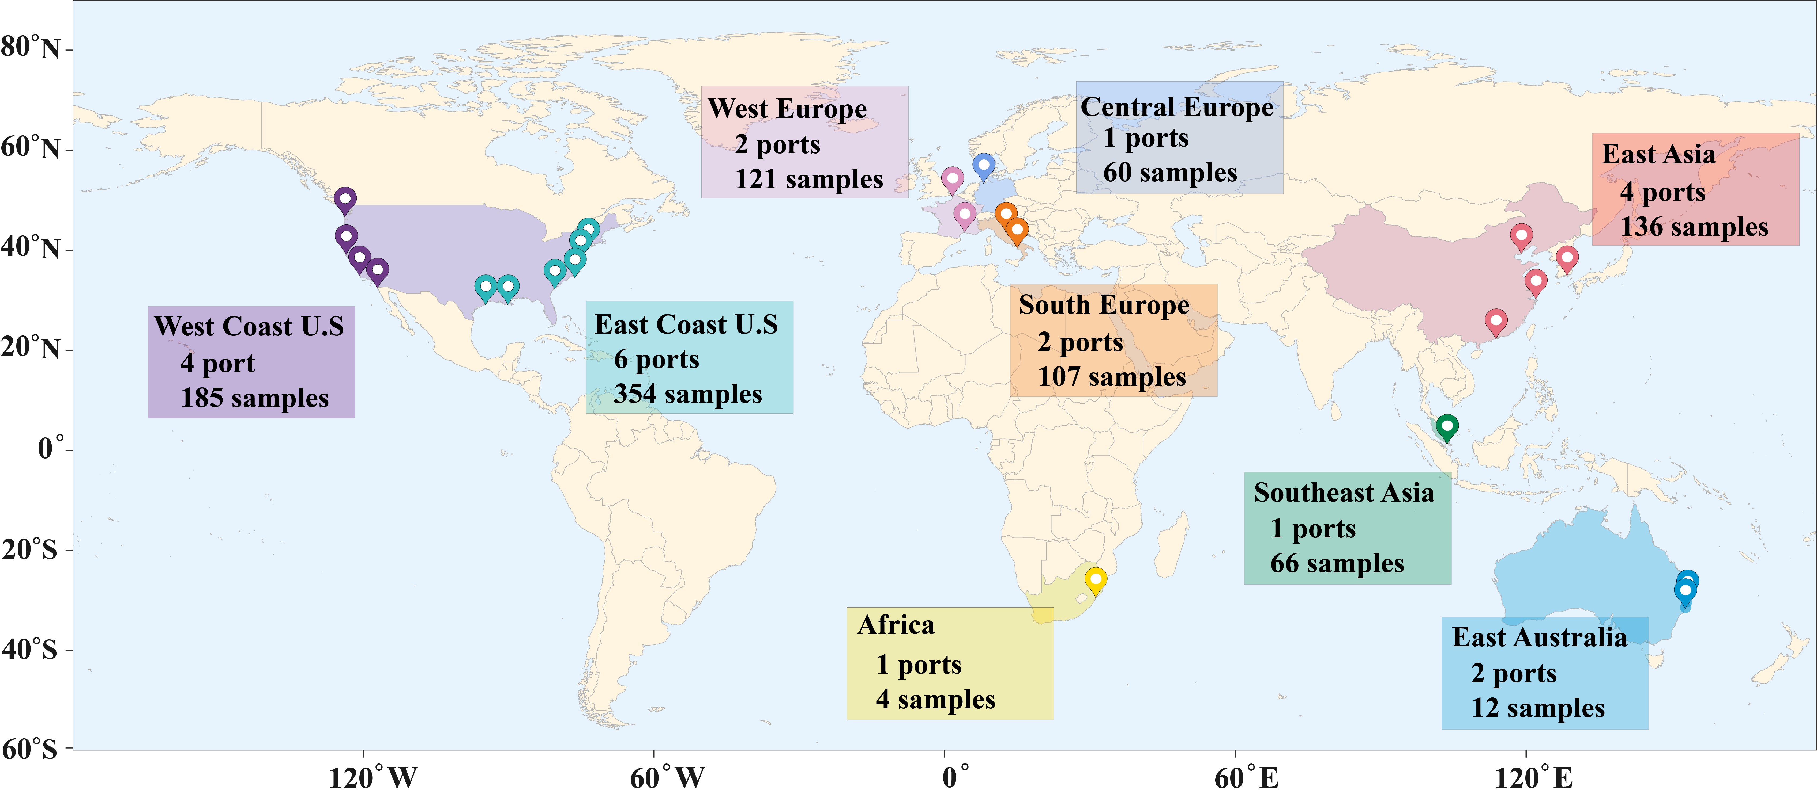
Fig. S1. Geographical distribution of port water samples.

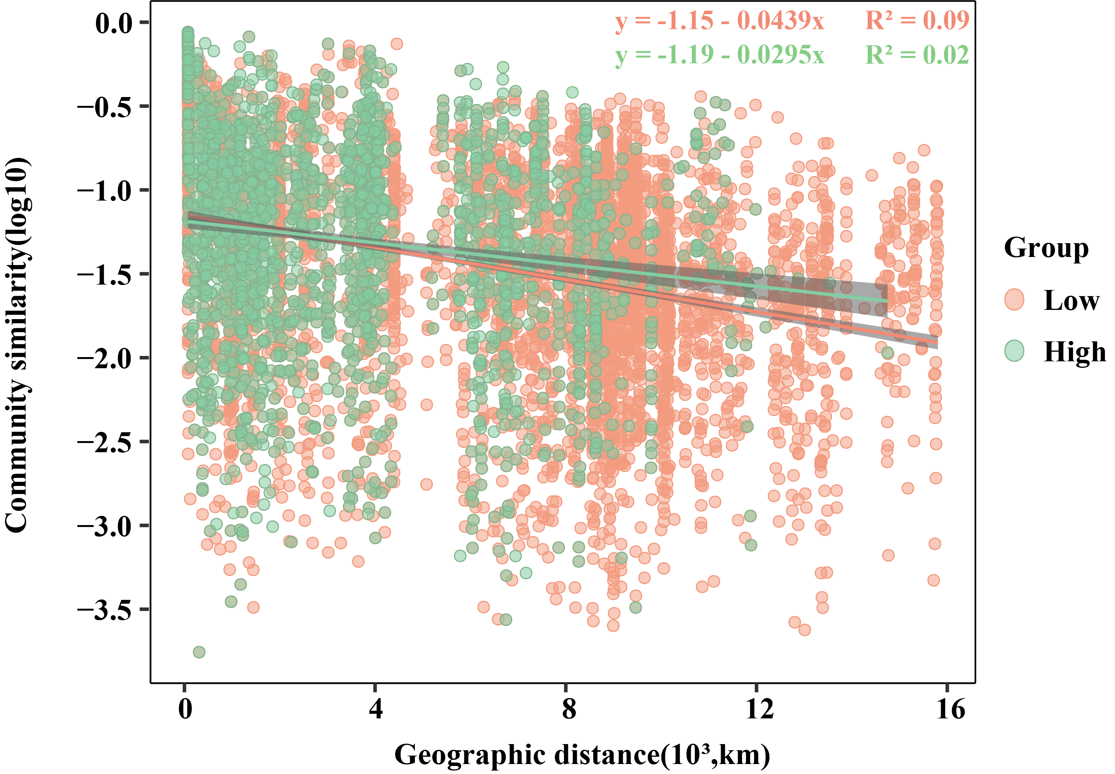
Fig. S2. The DDRs based on Bray-Curtis similarity of the port water bacterial community categorized by port capacity.

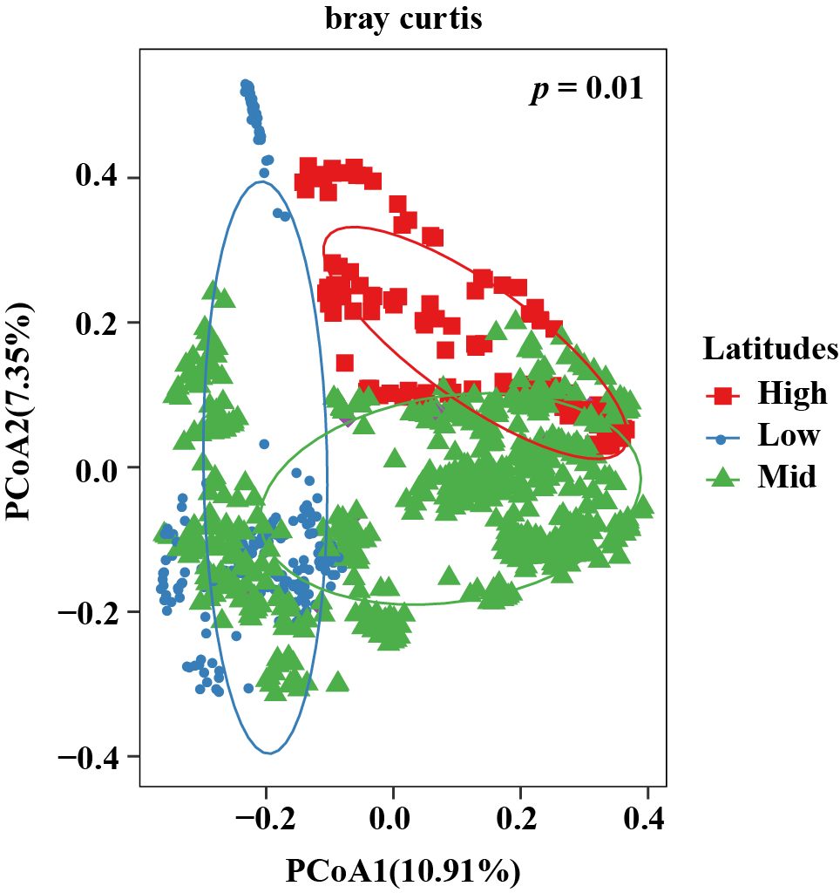
Fig. S3. Principal coordinate analysis based on the Bray-Curtis distance of the bacterial community in the port water.

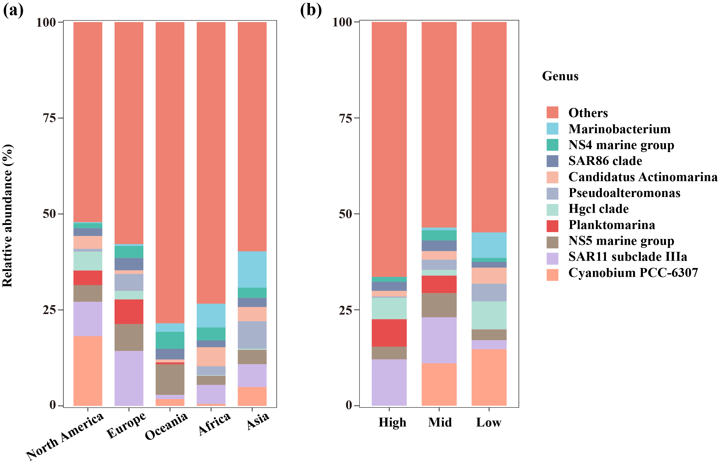
Fig. S4. Relative abundances of predominant genera across continents and latitudes.

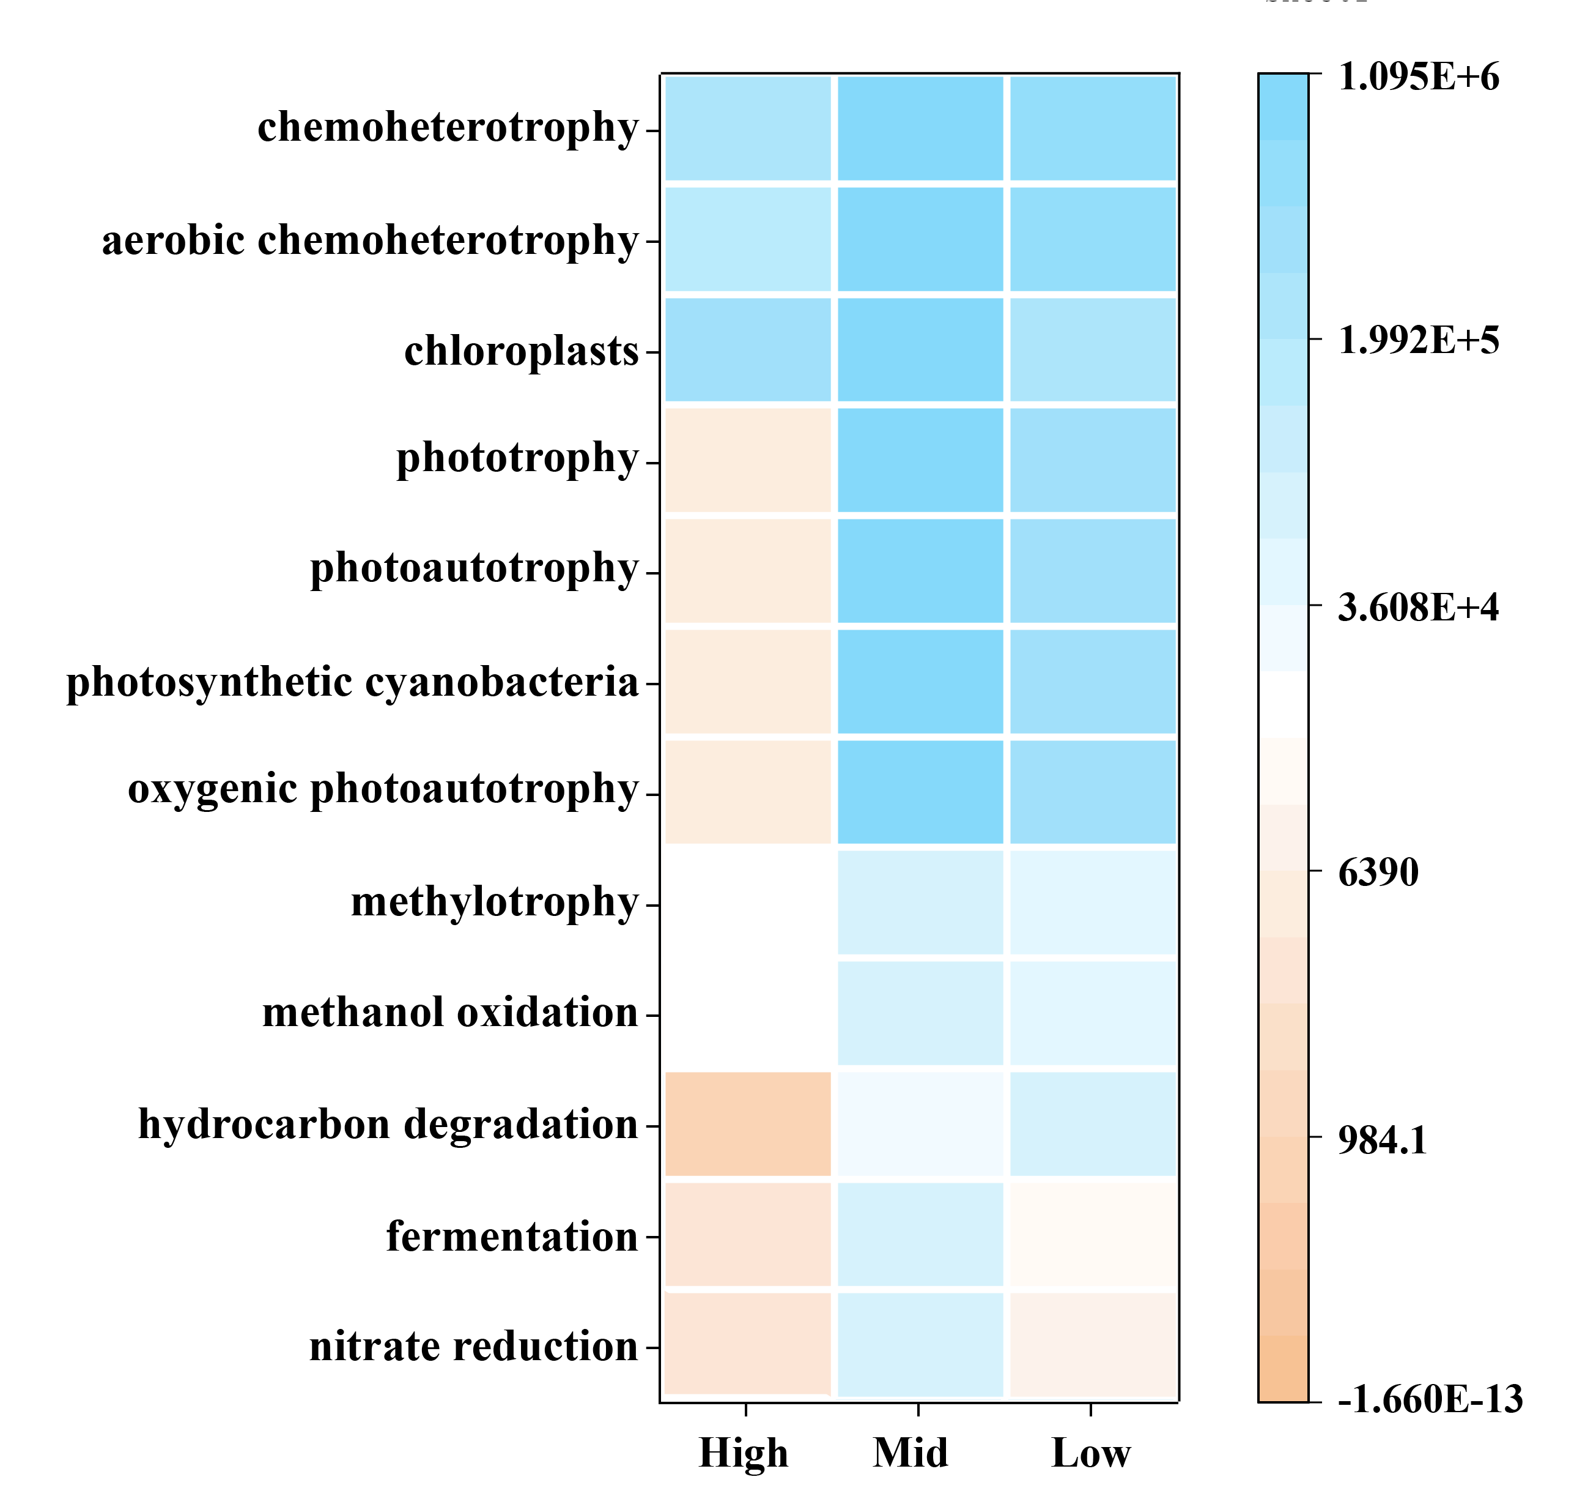
Fig. S5. Heatmap of bacterial community functional groups in the port water.

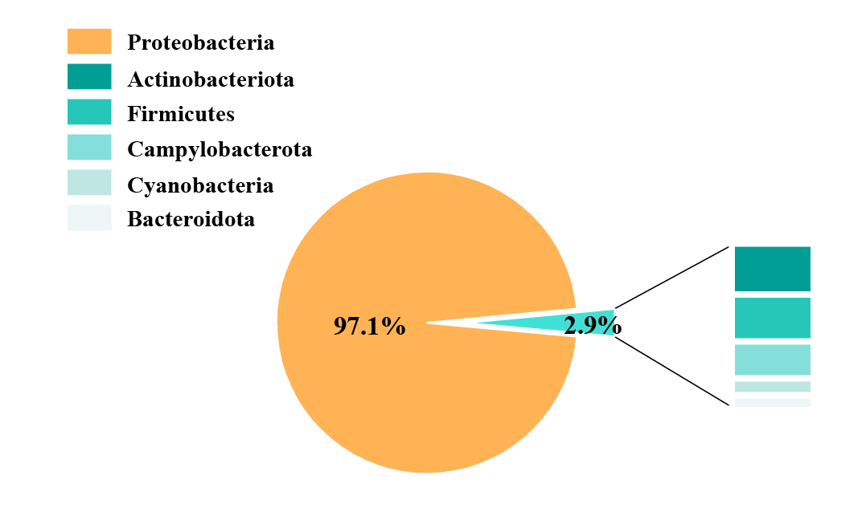
Fig. S6. Phylum-level taxonomic composition of potential pathogens.
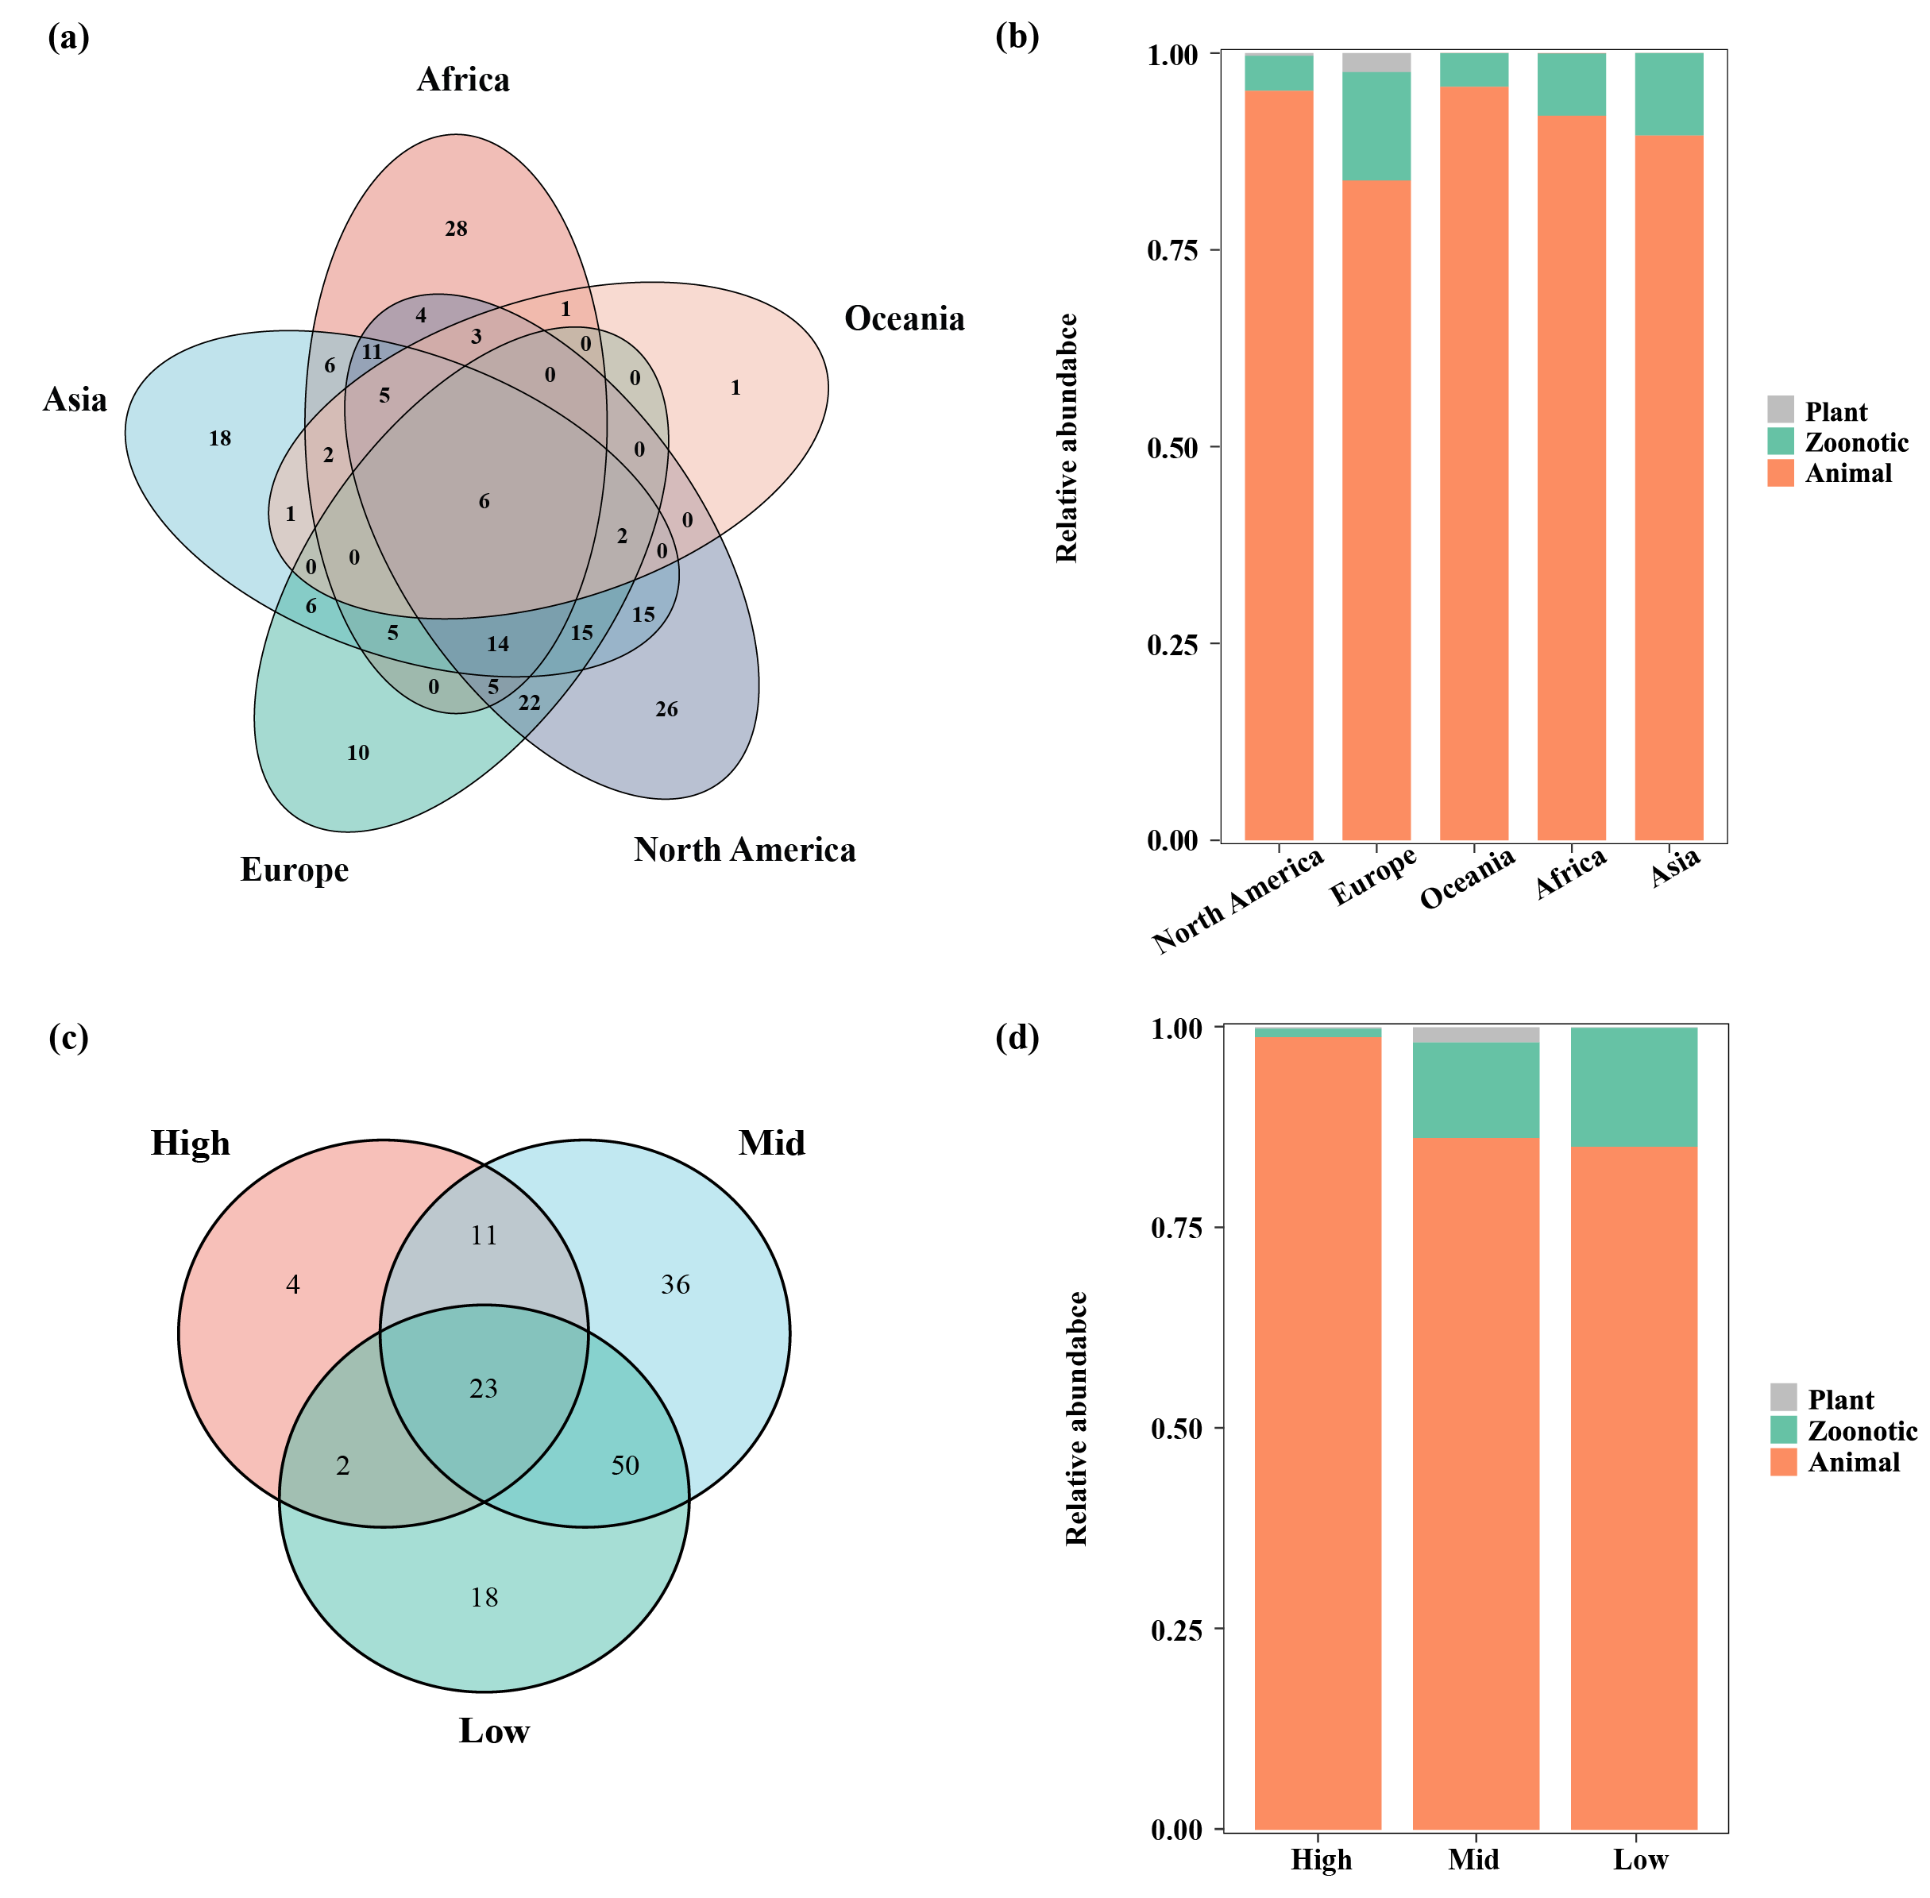

Fig. S7. Venn diagram of pathogenic bacteria interactions across continents and latitudes (a) (c). The relative abundance of zoonotic, animal, and plant pathogens in different continents and latitudes (b) (d).

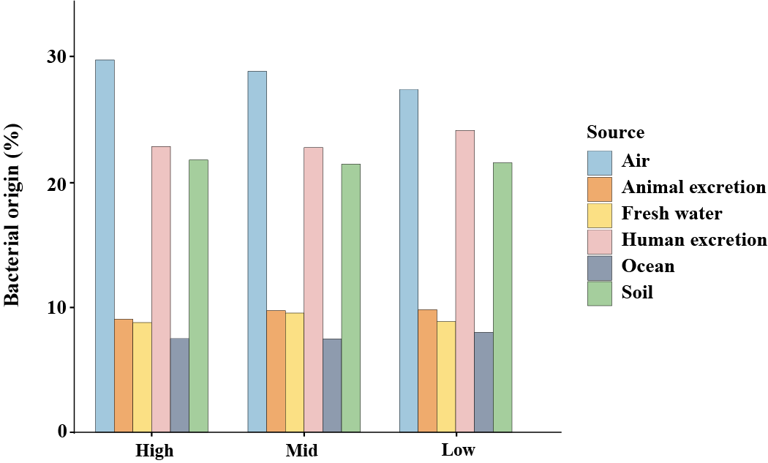

Fig. S8. Contributions of various environments to port water bacterial community, as determined by SourceTracker.

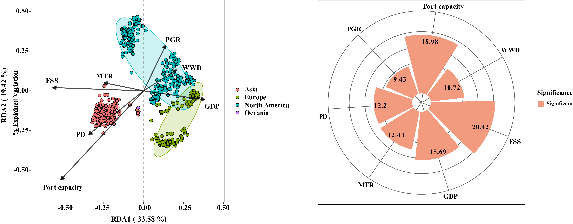
Fig. S9. The impacts of maritime activities (including Port capacity, MTI, FSS) and onshore activities (including WWD, GDP, PD, PGR) on port bacterial community.

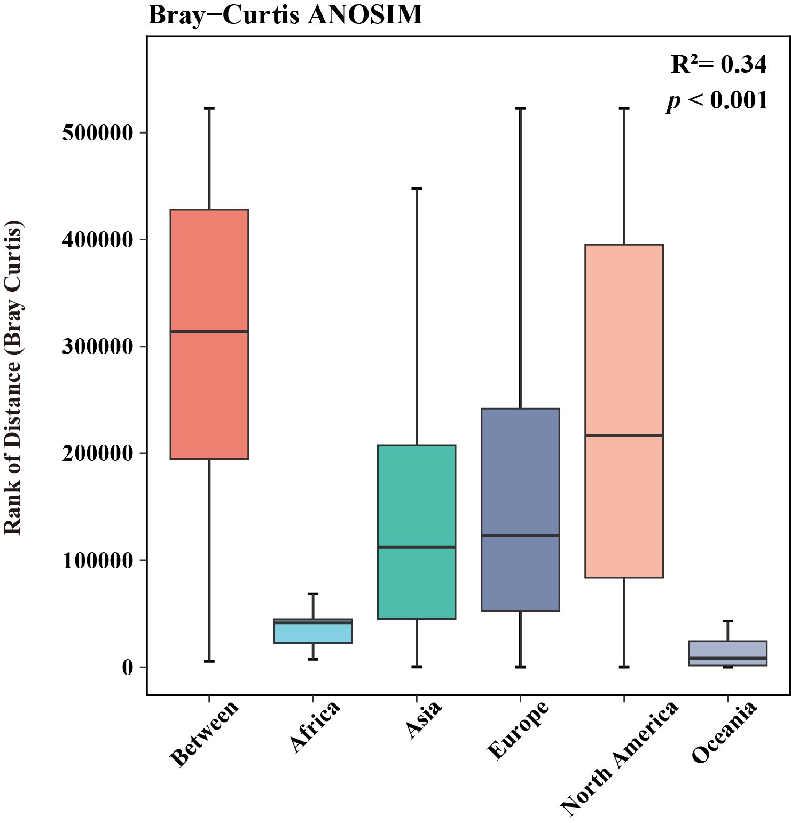

Fig. S10. ANOSIM of between-group and within-group differences.

References
      - Ghannam RB, Schaerer LG, Butler TM,Techtmann SM. 2020. Biogeographic Patterns in Members of Globally Distributed and Dominant Taxa Found in Port Microbial Communities. mSphere 5(1): e00481-19 https://doi.org/10.1128/mSphere.00481-19
      - Feng K, He Q, Peng X, Yang X, Du X, et al. 2025. Temperature and Biodiversity Regulate the Robustness of Plant–Microbe Networks in Natural Forests at Large Scale. Global Change Biology 31(7): e70335 https://doi.org/10.1111/gcb.70335
      - William AG, Claudia KG. 2019. Metabarcoding and machine learning analysis of environmental DNA in ballast water arriving to hub ports. Environment International 124: 312-319 https://doi.org/10.1016/j.envint.2018.12.038.
      - Williams R, Siboni N, King WL, Balaraju V, Bramucci A, et al. 2022. Latitudinal Dynamics of Vibrio along the Eastern Coastline of Australia. Water 14: 2510 https://doi.org/10.3390/w14162510

