Supporting information

Coupling mechanisms between cyanobacteria and antibiotic resistance genes in freshwater ecosystems

Yang Yuª, Zhiguang Niu^{a, *}, Yifan Zhaoª, Shuaiyi Li^{b, c}, Ying Zhangª, Chenchen Wang^{b, c, *}

ª School of Environmental Science & Engineering, Tianjin University, Tianjin 300350, China
^{b} School of Environmental and Municipal Engineering, Tianjin Chengjian University, Tianjin 300384, China
^{c} Tianjin Key Laboratory of Aquatic Science and Technology, Tianjin Chengjian University, Tianjin 300384, China
* Corresponding author:
E-mail addresses: wcc12122008@163.com (C. Wang), nzg@tju.edu.cn (Z. Niu).

Tel: +86 13820639453

Text S1. Literature Search Strategy
A literature search was conducted using the ISI Web of Science database. Based on the search terms listed in Table S1, a total of 28,781 publications related to cyanobacteria and 2,214 publications related to antibiotic resistance genes (ARGs) were retrieved. Among these, 43 studies addressed both cyanobacteria and ARGs simultaneously.

Text S2. Inclusion Criteria for Literature and Data
Titles and abstracts of the retrieved publications were screened individually. Studies focusing on experimental design, culture-based ARGs detection, or resistance mechanisms were excluded. Only original research articles investigating the occurrence of ARGs in natural environmental media and their association with cyanobacterial-related water quality were included. Review articles, secondary analyses, and duplicate reports were excluded. After screening, a total of 8,953 relevant studies were selected for further in-depth analysis, including 6,829 on cyanobacteria, 2,089 on ARGs, and 35 on the interaction between cyanobacteria and ARGs.

Table S1. Search criteria and Boolean operators applied to Web of Science databases
Group 1  (Cyanobacteria) | ("cyanobacteria" OR "blue-green algae" OR "HAB" OR "Chlorophyll a" OR "nutrient" OR "nitrogen")
Group 1  (ARGs) | ("antibiotic resistance gene" OR "antibiotic resistance bacteria" OR "antibiotic-resistant bacteria" OR "antimicrobial resistance" OR "antibiotic resistome" OR "ARGs")
AND
Group 2 | ("lake" OR "lagoon" OR "pond" OR "freshwater" OR " wetlands " OR "surface waters" OR "river" OR "stream")
AND NOT
Group 3 | ("shelf" OR "soil" OR "land" OR "sludge" OR "intestine" OR "human tract" OR "mesocosm" OR "microcosm" OR "aquaculture" OR "bench" OR "fouling" OR "sediment")
AND
Document Type
Group 4 | Article
Limit to years: 2014-01-01 to 2024-12-01

Table S2. Summary of Interaction Conclusions Between Cyanobacterial and ARGs.
Reference | Research Subjects |  | Conclusions
Reference | Cyanobacteria | ARGs | Conclusions
Critical roles of cyanobacteria as reservoir and source for antibiotic resistance genes | Synechococcus, Synechocystis, Anabaena,  Microcystis, Planktothrix, Raphidiopsis, Oscillatoria, Aphanizomenon | Sulfonamide, Tetracycline, Quinolone, β-lactam, | - sul1, strA, and strB were detected in Planktothrix.
Cyanobacteria mediate the dissemination of bacterial antibiotic resistance through conjugal transfer | Microcystis | Sulfonamide, Tetracycline | - Cyanobacteria reduced ARGs abundance by 2% to 18%.
Investigation of the antimicrobial susceptibility patterns of marine cyanobacteria in Bohai Bay: Cyanobacteria may be important hosts of antibiotic resistance genes in marine environment | Synechococcus, Synechocystis, Phormidium,  Oscillatoria, Planktothrix | Sulfonamide, Tetracycline, Multidrug, Aminoglycosides, β-lactam | - A positive correlation was observed between Cyanobacteria and sul2 and tetA.  - ARGs were detected in Synechocystis.
Cyanobacterial extracellular antibacterial substances could promote the spread of antibiotic resistance: impacts and reasons | Nodosilinea | Macrolide, Sulfonamide, Chloramphenicol, Quinolone, Aminoglycoside | - At low concentrations (0.01–0.1 μg·mL⁻¹), cyanobacterial extracellular substances (CES) promote the abundance of most ARGs.
Distribution characteristics of antibiotic resistance genes and microbial diversity in the inshore aquaculture area of Wenchang, Hainan, China | Cyanobacteria | Tetracycline, Fluoroquinolone, Sulfonamide, ChloramPhenicol, | - Cyanobacteria are potential hosts of ARGs.
Comprehensive insights into antibiotic resistance gene migration in microalgal-bacterial consortia: Mechanisms, factors, and perspectives | Cyanobacteria | ARGs | - Cyanobacteria facilitate the dissemination of ARGs.
Algae blooms with resistance in fresh water: Potential interplay between Microcystis and antibiotic resistance genes | Microcystis | ARGs | - Cyanobacteria facilitate the dissemination of ARGs.
Deciphering the role of cyanobacteria in water resistome: Hypothesis justifying the antibiotic resistance (phenotype and genotype) in Planktothrix genus | Planktothrix | Trimethoprim, Quinolone, β-lactam, Tetracycline, Streptomycin, Sulfonamide | - A strain was found to carry streptomycin resistance genes.
Distribution characteristics and controlling factors of typical antibiotics and antibiotic resistance genes in river networks in western area of Wangyu River, China | Cyanobacteria | Sulfonamide, Quinolones, Tetracycline, and Macrolide | - Cyanobacteria may inhibit sulfonamide.  - Quinolones are positively correlated with cyanobacteria (n = 56).
Short-Term Warming Induces Cyanobacterial Blooms and Antibiotic Resistance in Freshwater Lake, as Revealed by Metagenomics Analysis | Microcystis | Multidrug, Tetracycline, Peptide, Aminoglycoside, Carbapenem, Macrolide | - The interaction between Microcystis and ARGs is influenced by climatic conditions.  - Climate warming enhances cyanobacterial ARG promotion.
Mobile Genetic Elements Drive the Antibiotic Resistome Alteration in Freshwater Shrimp Aquaculture | Cyanobacteria | Multidrug, Vancomycin, Sulfonamide, Bacitracin, MLS | - Cyanobacteria facilitate the dissemination of ARGs.
Cyanobacterial blooms contribute to the diversity of antibiotic-resistance genes in aquatic ecosystems | Planktothrix, Microcystis | Aminoglycoside, β-lactam, Multidrug, Fluoroquinolone, Tetracycline, Vancomycin | - Cyanobacteria-mediated interactions between bacteria and fungi may be key factors influencing the abundance of ARGs during cyanobacterial blooms.  - Planktothrix secretes antifungal compounds that may promote the emergence and dissemination of ARGs.
Effects of eutrophication on the horizontal transfer of antibiotic resistance genes in microalgal-bacterial symbiotic systems | Cyanobacteria | ARGs | - Cyanobacteria are potential hosts of ARGs.
The antibiotic resistome of free-living and particle-attached bacteria under a reservoir cyanobacterial bloom | Cyanobacteria | Multidrug, β-lactam, Aminoglycoside | - The abundance and composition of ARGs respond differently to cyanobacterial blooms depending on microbial lifestyle.  - Cyanobacterial blooms exert a stronger influence on the composition of ARGs in particle-attached (PA) bacterial communities compared to free-living (FL) bacteria.
Distribution of Antibiotic Resistance Genes and Their Associations with Bacterial Communities and Water Quality in Freshwater Lakes | Cyanobacteria | Sulfonamides, Tetracyclines, Vancomycin, Streptogramin | - Cyanobacteria are negatively correlated with the vanA and vanR genes.  - The tetG gene is positively correlated with cyanobacteria.  - The interactions between cyanobacteria and ARGs are influenced by certain physicochemical factors and bacterial community composition.
Microbial succession and enrichment of antibiotic resistance genes during algal-bacterial biofilm purification of aquaculture wastewater | Cyanobacteria | Multidrug, Bacitracin, Aminoglycoside, Glycopeptid | - Cyanobacteria are potential hosts of ARGs.
Prevalence, source, and risk of antibiotic resistance genes in the sediments of Lake Tai (China) deciphered by metagenomic assembly: A comparison with other global lakes | Cyanobacteria  N=36 | Multidrug, MLS, Bacitracin, Quinolone, Mupirocin, Trimethoprim | - No specific conclusions were provided regarding the interactions between cyanobacteria and ARGs.
Antibiotic resistance genes and microcystins in a drinking water treatment plant | Microcystins (MCs) | β-lactam, Sulfonamide, MLS | - MCs can facilitate the dissemination of ARGs.
Beyond cyanotoxins: increased Legionella, antibiotic resistance genes in western Lake Erie water and disinfection-byproducts in their finished water | Microcystis | Sulfonamide, Tetracycline, Carbapenem | - Abundance of ARGs (tetQ and sul1) and mobile genetic elements (MGEs) was also significantly higher at the bloom site.
Mutual impacts and interactions of antibiotic resistance genes, microcystin synthetase genes, graphene oxide, and Microcystis aeruginosa in synthetic wastewater | Microcystis | Sulfonamide, Tetracycline | - Graphene oxide (GO) affects the abundance of Microcystis and ARGs; its presence within algal cells influences ARG abundance, thereby promoting their dissemination.
Antibiotic resistance genes in integrated surface ice, cryoconite, and glacier-fed stream in a mountain glacier in Central Asia | Phormidesmis | β-lactam, Multidrug, Glycopeptide, and MLS | - Cyanobacteria are potential hosts of ARGs.
Dynamic microbiome and mobile resistome are revealed in river biofilms from a multi-use watershed through long-read sequencing | Cyanobacteria | Multidrug, Glycopeptide, Bacitracins, β-lactam, Tetracycline, MLS, and Aminoglycosides | - Cyanobacteria are potential hosts of ARGs.  - Cyanobacteria facilitate the dissemination of ARGs.  - The roles of cyanobacteria in ARGs dynamics are not yet fully understood.
Insights into the microalgae-bacteria consortia treating swine wastewater: Symbiotic mechanism and resistance genes analysis | Cyanobacteria | ARGs | - Microalgae-bacteria consortia inhibit ARGs.
A watershed impacted by anthropogenic activities: Microbial community alterations and reservoir of antimicrobial resistance genes | Cyanobacteria  N=24 | β-lactam, Sulfonamide, Tetracycline, Aminoglycoside, Quinolone, MLS | - Cyanobacteria influence community composition, thereby affecting the distribution of ARGs.  - The effects of cyanobacteria on ARGs are not yet fully understood.
Occurrence and fate of antibiotics, antimicrobial resistance determinants and potential human pathogens in a wastewater treatment plant and their effects on receiving waters in Nanjing, China | Cyanobacteria | Fluoroquinolone, Sulfanilamide, Tetracycline, Chloramphenicol | - Cyanobacteria influence community composition, which in turn affects the distribution of ARGs.
Metagenomic insights into microbial community, functional annotation, and antibiotic resistance genes in Himalayan Brahmaputra River sediment, India | Cyanobacteria | Multidrug, Aminoglycoside, β-lactam, Fluoroquinolone, Rifampicin, Sulfonamide, and Tetracycline | - Further research is needed as the presence of ARGs in rivers indicates multiple antibiotic resistance genes associated with anthropogenic activities. With increasing reports of antibiotic resistance, it is imperative to properly regulate the discharge of untreated wastewater into rivers. Emphasis should be placed on investigating key microorganisms and ARGs to better understand their interactions within aquatic ecosystems and to promote sustainable management of river health.
Analysis of Bacterial Communities and Antibiotic Resistance Genes in the Aquaculture Area of Changli County | Cyanobacteria | Aminoglycoside, β-lactam | - ARGs influence changes in cyanobacterial community composition.
Removing high-strength lincomycin in pharmaceutical wastewater by a bacterial microalgae consortium co-immobilized filter | Cyanobacteria | ARGs | - Microalgae–bacteria consortia inhibit ARGs.
Identification of potential microbial risk factors associated with fecal indicator exceedances at recreational beaches | Cyanobacteria | β-lactam, Multidrug, Aminoglycoside, MLS, Tetracycline | - Further research is needed: study samples have shown the co-occurrence of cyanobacteria and ARGs.
Abundance and Diversity of Phages, Microbial Taxa, and Antibiotic Resistance Genes in the Sediments of the River Ganges Through a Metagenomic Approach | Microcystis | β-lactam, Multidrug, MLS, Fosmidomycin | - Further research is needed: the prevalence of ARGs varies among different microbial groups.

Table S3. Search criteria and Boolean operators applied to Web of Science databases
Mechanism category | Representative processes | Primary evidence level | Key references
Carrier | ARGs detected in cyanobacterial genomes, eDNA/iDNA | Laboratory / culture-based / molecular | [1],[2]
Carrier | Detection of ARGs (e.g., tet, sul) within cyanobacterial genomes | Metagenomic analysis/ Field observation | [3]
Carrier | Phage-mediated acquisition of ARGs by cyanobacterial taxa (e.g., Synechococcus, Phormidium) | Laboratory experiments | [4]
Carrier | ARGs detected in cultured cyanobacterial isolates from reservoirs | Culture-dependent PCR screening | [2]
Promoter | Enhanced HGT during blooms, QS regulation | Mesocosm / Field observation | [5],[6]
Promoter | Enrichment of ARG-hosting bacteria via cyanobacteria-derived dissolved organic matter | Experimental | [7]
Promoter | Co-occurrence of high ARG and MGE abundance in Microcystis-dominated blooms | Field observation | [6]
Inhibitor | Reduced ARGs abundance, plasmid suppression | Field observation/modeling | [8],[9]
Inhibitor | Stronger suppression of ARGs in particle-attached bacteria compared to free-living bacteria | Field observation | [8]
Inhibitor | Quantification of cyanobacteria-bacteria interference effects on ARG dynamics | Microbial interaction modeling | [9]
Feedback regulator | ARG-mediated cyanobacterial resilience | Experimental / Field observation | [10-15]
Feedback regulator | High antibiotic concentrations inhibit photosynthesis and cyanobacterial growth | Laboratory experiments | [8],[16], [17]
Feedback regulator | Antibiotic-resistant cyanobacteria outcompete susceptible algal species | Laboratory experiments | [14], [18], [19]

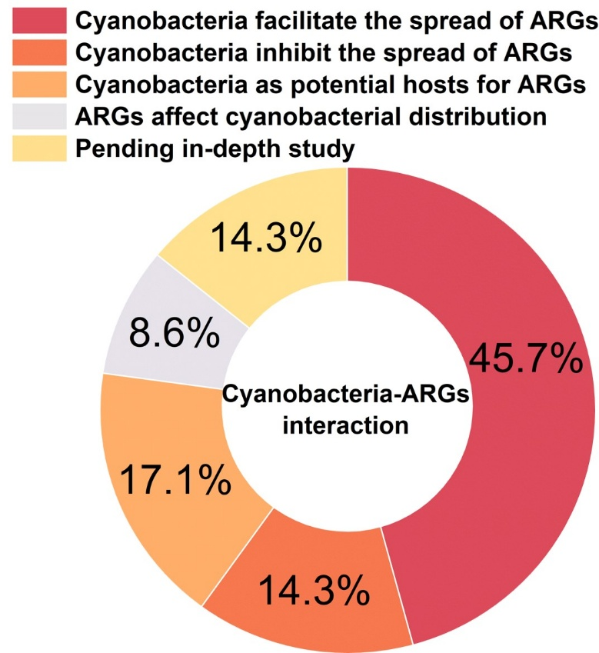
Fig.S1. Proportional breakdown of studies by interaction type between cyanobacteria and ARGs.
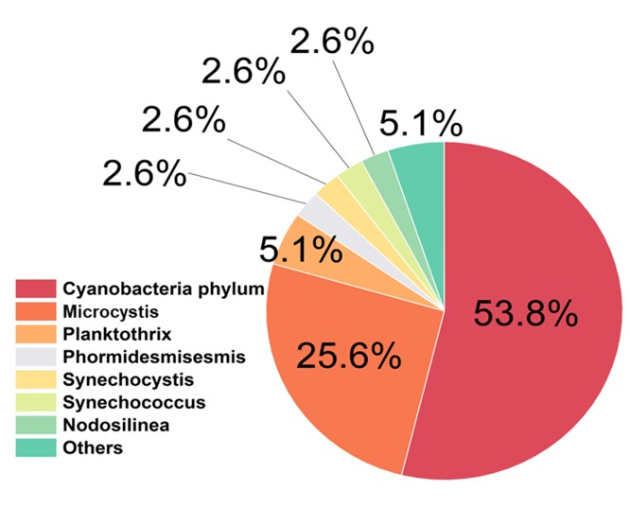
Fig.S2. Focus distribution of current studies on cyanobacteria-ARGs interactions across different taxonomic and mechanistic levels.

References
[1] Wang Z, Chen Q, Zhang J, Guan T, Chen Y, et al. 2020. Critical roles of cyanobacteria as reservoir and source for antibiotic resistance genes. Environment International 144:106034. https://doi.org/10.1016/j.envint.2020.106034
[2] Dias E, Oliveira M, Manageiro V, Vasconcelos V, Caniça M. 2019. Deciphering the role of cyanobacteria in water resistome: Hypothesis justifying the antibiotic resistance (phenotype and genotype) in Planktothrix genus. Science of The Total Environment 652:447-454. https://doi.org/10.1016/j.scitotenv.2018.10.167
[3] Al-Amoudi S, Razali R, Essack M, Amini MS, Bougouffa S, et al. 2016. Metagenomics as a preliminary screen for antimicrobial bioprospecting. Gene 594:248-258. Gene 594:248-258. https://doi.org/10.1016/j.gene.2016.09.021
[4] Kim M-J, Kang D, Lee G, Kim K, Kim J, et al. 2023. Interplays between cyanobacterial blooms and antibiotic resistance genes. Environment International 181. https://doi.org/10.1016/j.envint.2023.108268
[5] Yin Z, Zhou X, Kang J, Pei F, Du R, et al. 2022. Intraspecific and interspecific quorum sensing of bacterial community affects the fate of antibiotic resistance genes during chicken manure composting under penicillin G stress. Bioresource technology 347:126372. https://doi.org/10.1016/j.biortech.2021.126372
[6] Li W, Mao F, Te SH, He Y, Gin KY-H. 2021. Impacts of Microcystis on the dissemination of the antibiotic resistome in cyanobacterial blooms. ACS ES&T Water 1:1263-1273. https://doi.org/10.1021/acsestwater.1c00006
[7] Woodhouse JN, Kinsela AS, Collins RN, Bowling LC, Honeyman GL, et al. 2016. Microbial communities reflect temporal changes in cyanobacterial composition in a shallow ephemeral freshwater lake. The ISME journal 10:1337-1351. https://doi.org/10.1038/ismej.2015.218
[8] Guo Y, Liu M, Liu L, Liu X, Chen H, et al. 2018. The antibiotic resistome of free-living and particle-attached bacteria under a reservoir cyanobacterial bloom. Environment International 117:107-115. https://doi.org/10.1016/j.envint.2018.04.045
[9] Bao Y, Ruan Y, Wu J, Wang W-X, Leung KM, et al. 2023. Metagenomics-Based Microbial Ecological Community Threshold and Indicators of Anthropogenic Disturbances in Estuarine Sediments. Environmental science & technology 58:780-794. https://doi.org/10.1021/acs.est.3c08076
[10] Carpine R, Sieber S. 2021. Antibacterial and antiviral metabolites from cyanobacteria: their application and their impact on human health. Current Research in Biotechnology 3:65-81. https://doi.org/10.1016/j.crbiot.2021.03.001
[11] Liu Y, Zhang J, Gao B. 2020. Proteomic mechanisms for the stimulatory effects of antibiotics on Microcystis aeruginosa during hydrogen peroxide treatment. Chemosphere 247:125837. https://doi.org/10.1016/j.chemosphere.2020.125837
[12] Chen M-Y, Teng W-K, Zhao L, Hu C-X, Zhou Y-K, et al. 2021. Comparative genomics reveals insights into cyanobacterial evolution and habitat adaptation. The ISME journal 15:211-227. https://doi.org/10.1038/s41396-020-00775-z
[13] Zhang Y, Liu L, Liu Y, Chen L, Wang J, et al. 2024. Deciphering the natural and anthropogenic drivers on the fate and risk of antibiotics and antibiotic resistance genes (ARGs) in a typical river-estuary system, China. Journal of hazardous materials 480:136006. https://doi.org/10.1016/j.jhazmat.2024.136006
[14] Xu S, Jiang Y, Liu Y, Zhang J. 2021. Antibiotic-accelerated cyanobacterial growth and aquatic community succession towards the formation of cyanobacterial bloom in eutrophic lake water. Environmental Pollution 290:118057. https://doi.org/10.1016/j.envpol.2021.118057
[15] Wang Z, Chen Q, Zhang J, Xu H, Miao L, et al. 2024. Climate warming promotes collateral antibiotic resistance development in cyanobacteria. Water Research 256:121642. https://doi.org/10.1016/j.watres.2024.121642
[16] Kovalakova P, Cizmas L, McDonald TJ, Marsalek B, Feng M, et al. 2020. Occurrence and toxicity of antibiotics in the aquatic environment: A review. Chemosphere 251:126351.
[17] Singh A, Pratap SG, Raj A. 2024. Occurrence and dissemination of antibiotics and antibiotic resistance in aquatic environment and its ecological implications: a review. Environmental Science and Pollution Research 31:1-25. https://doi.org/10.1007/s11356-024-34355-x
[18] dos Santos Costa R, Quadra GR, de Oliveira Souza H, do Amaral VS, Navoni JA. 2021. The link between pharmaceuticals and cyanobacteria: a review regarding ecotoxicological, ecological, and sanitary aspects. Environmental Science and Pollution Research 28:41638-41650. https://doi.org/10.1007/s11356-021-14698-5
[19] Li JJ, Chao JJ, McKay RML, Xu RB, Wang T, et al. 2021. Antibiotic pollution promotes dominance by harmful cyanobacteria: A case study examining norfloxacin exposure in competition experiments. Journal of Phycology 57:677-688. https://doi.org/10.1111/jpy.13133

