Figure S1. Rarefaction curves for bacteria sequences in soil under different treatments, confirming adequate sequencing depth. Data are presented as mean ± standard errors (n = 3). CK: control; BC: biochar; FeBC: iron-loaded biochar; ONBC: oxygen-nanobubble-loaded biochar.
Figure S2. ﻿Effects of the ONBC and FeBC amendments on mean relative abundance of soil bacterial phyla in paddy soils. Data are mean of four replicates per treatment. CK: control; BC: biochar; FeBC: iron-loaded biochar; ONBC: oxygen-nanobubble-loaded biochar.
Figure S3. ﻿Effects of ONBC and FeBC amendments on mean relative abundance of soil bacterial classes in paddy soils. Data represent mean of four replicates per treatment. CK: control; BC: biochar; FeBC: iron-loaded biochar; ONBC: oxygen-nanobubble-loaded biochar.
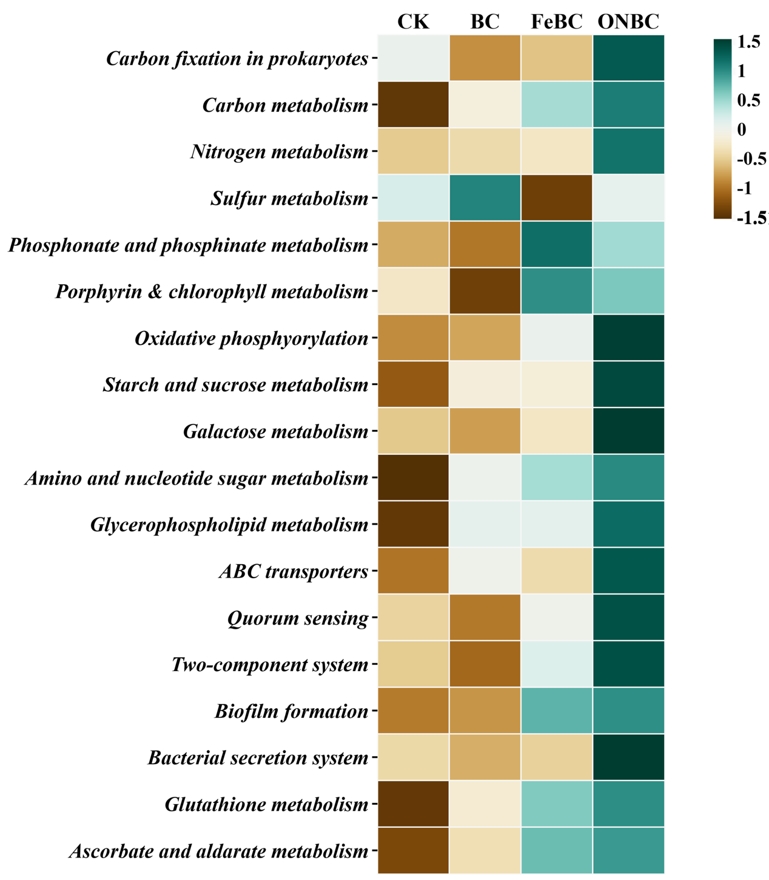
Figure S4. Heatmap of KEGG metabolic pathway abundance for the predicted functional potential of soil microbial communities in response to FeBC and ONBC amendments. Relative abundances are shown as z-score-normalized counts per million (CPM) values derived from metagenomic predictions. CK: control; BC: biochar; FeBC: iron-loaded biochar; ONBC: oxygen-nanobubble-loaded biochar.

Table S1. The basic physicochemical properties of BC, FeBC, and ONBC. BC: biochar; FeBC: iron-loaded biochar; ONBC: oxygen-nanobubble-loaded biochar. Values in Table S1 were obtained from independent measurements. The identical EC and CEC values for FeBC and ONBC were confirmed by checking the original data and are not typographical errors. These values are reported after rounding to two decimal places.
 | pH | EC (ms cm⁻¹) | CEC (cmol kg⁻¹) | C (%) | H (%) | N (%) | S (%)
BC | 9.99 | 1.75 | 10.9 | 52.32 | 1.96 | 0.17 | 1.29
FeBC | 2.26 | 2.02 | 14.65 | 48.72 | 1.84 | 0.19 | 1.45
ONBC | 10.07 | 2.02 | 14.65 | 50.01 | 1.8 | 0.18 | 1.29

Table S2. Sequential extraction procedure for Cd speciation analysis in paddy soil samples.
Fraction | Phase | Reagent | Extraction parameters | Soil/solution
EXC | Exchangeable | 1 M MgCl₂ | 1 h shaking, 25 °C | 1:8
CAR | Bound to carbonates | 1 M NaAc | 8 h shaking, 25 °C | 1:8
HOX | Bound to iron (Fe) and manganese (Mn) (hydr)oxides | 0.04 M NH₂OH·HCl | 4 h in water bath, 96 °C | 1:20
OM | Bound to organic matter | 0.02 M HNO₃ and 30% H₂O₂ (pH = 2) | 2 h in a water bath at 85 °C | 1:8
RES | Residual | HNO₃ + HCl | Microwave digestion | 1: 50

Table S3. Explanation and KO ID for genes responsible for microbial Cd stabilization.
Cd²⁺ stabilization pathway | Gene name | KO ID | Gene function
Cd²⁺ influx transporter | ZupT | K07238 | Cd²⁺ influx transporter
Cd²⁺ influx transporter | MntH | K03322 | Mn²⁺/Cd²⁺ co-transporter
Cd²⁺ efflux transporter | ZntA | K01534 | Cd²⁺ exporting ATPase
Cd²⁺ efflux transporter | CusA | K15726 | Heavy metal efflux system
Cd²⁺ efflux transporter | CusB | K07798 | Copper/cadmium efflux system
Cd²⁺ efflux transporter | CusC | K15725 | Heavy metal efflux system
Cd²⁺ detoxification | CueO | K14588 | Cuproxidase
Cd²⁺ detoxification | GshA | K01919 | Glutamate--cysteine ligase
Cd²⁺ detoxification | GshB | K01920 | Glutathione synthase
Cd²⁺ detoxification | GorA | K00383 | Glutathione reductase
Cd²⁺ sensing and binding | CadC | K21903 | Cadmium responsive transcriptional repressor
Cd²⁺ sensing and binding | GroEL | K04077 | Chaperonin GroEl
Cd²⁺ sensing and binding | DnaK | K04043 | Molecular chaperone

Table S4. Functional gene abbreviations and corresponding full names for C mineralization. Each gene abbreviation is linked to its enzyme classification (EC) number (if it has) and the KO ID. This table serves as a reference for interpreting genetic functions represented in Figure 6 and throughout the manuscript.

C mineralization | Abbreviation | Full name | EC number | KO ID
Polysaccharide degradation | celB | cellulase | 3.2.1.4 | K19357
Polysaccharide degradation | bglX | β-Glucosidase | 3.2.1.21 | K05349
Polysaccharide degradation | xynA | endo--1,4,-β-xylanase | 3.2.1.8 | K01181
Polysaccharide degradation | xynB | β-Xylosidase | ﻿3.2.1.37 | K01198
Polysaccharide degradation | amyA | α-Amylase | 3.2.1.1 | K01176
Polysaccharide degradation | pulA | pullulanase | 3.2.1.41 | K01200
Polysaccharide degradation | pel | pectate lyase | 4.2.2.2 | K01728
Polysaccharide degradation | pme | pectinesterase | 3.1.1.11 | K01051
Central carbon metabolism | hk | hexokinase | 2.7.1.1 | K00844
Central carbon metabolism | glk | glycokinase | 2.7.1.2 | K00845
Central carbon metabolism | pfkA | 6-phosphofructokinase | 2.7.1.11 | K00850
Central carbon metabolism | aceE | pyruvate dehydrogenase complex | 1.2.4.1 | K00163
Central carbon metabolism | gltA | citrate synthase | 2.3.3.1 | K01647
Central carbon metabolism | icd | isocitrate dehydrogenase | 1.1.1.42 | K00031
Central carbon metabolism | sucA | 2-Oxoglutarate dehydrogenase | 1.2.4.2 | K00164
Central carbon metabolism | sdhA | Succinate dehydrogenase | 1.3.5.1 | K00239
Central carbon metabolism | mdh | malate dehydrogenase | 1.1.1.37 | K00024
Lipid and fatty acid degradation | lip | triacylglycerol lipase | 3.1.1.3 | K01046
Lipid and fatty acid degradation | acd | acyl-CoA dehydrogenase | 1.3.8.6 | K00249
Lipid and fatty acid degradation | fadB | 3-Hydroxyacyl-CoA dehydrogenase | 1.1.1.157 | K00074
Lipid and fatty acid degradation | echA | Enoyl-CoA hydratase | 1.1.1.35 | K01692
Lipid and fatty acid degradation | atoB | Acetyl-CoA acetyltransferase | 2.3.1.9 | K00626
Aromatic compound degradation | catA | catechol 1,2-dioxygenase | 1.13.11.1 | K03381
Aromatic compound degradation | pcaG | protocatechuate 3,4-dioxygenase | 1.13.11.3 | K00448
Aromatic compound degradation | pcaH | protocatechuate 3,4-dioxygenase | 1.13.11.3 | K00449
Aromatic compound degradation | benA | Benzoate 1,2-dioxygenase | 1.14.12.10 | K05549
Aromatic compound degradation | benB | Benzoate 1,2-dioxygenase | 1.14.12.10 | K05550
Aromatic compound degradation | vanA | vanillate monooxygenase | 1.14.13.82 | K03862

Table S5. Functional gene abbreviations and corresponding full names for N mineralization. Each gene abbreviation is linked to its enzyme classification (EC) number (if it has) and the KO ID. This table serves as a reference for interpreting genetic functions represented in Figure 6 and throughout the manuscript.
N mineralization | Abbreviation | Full name | EC number | KO ID
Protein degradation | aprE | alkaline serine protease | 3.4.21.62 | K01342
Protein degradation | pepN | aminopeptidase N | 3.4.11.2 | K01256
Protein degradation | lasB | pseudolysin | 3.4.24.26 | K01399
Protein degradation | pepA | leucyl aminopeptidase | 3.4.11.1 | K01255
Protein degradation | nprE | bacillolysin | 3.4.24.28 | K01400
Protein degradation | npr | thermolysin | 3.4.24.27 | K08603
Deamination | mao | monoamine oxidase | 1.4.3.4 | K00274
Deamination | aoc2 | primary-amine oxidase | 1.4.3.21 | K00276
Deamination | gdhA | glutamate dehydrogenase | 1.4.1.4 | K00262
Deamination | sdaA | serine dehydratase | 4.3.1.17 | K01752
Deamination | LeuDH | leucine dehydrogenase | 1.4.1.9 | K00263
Deamination | ald | alanine dehydrogenase | 1.4.1.1 | K00259
Deamination | ansA | asparaginase | 3.5.1.1 | K01424
Deamination | aspA | aspartase | 4.3.1.1 | K01744
Amino sugars & chitin degradation | chiA | chitinase | ﻿3.2.1.14 | K01183
Amino sugars & chitin degradation | cda | ﻿chitin deacetylase | ﻿3.5.1.41 | K01452
Amino sugars & chitin degradation | nagZ | β-N-acetylhexosaminidase | ﻿3.2.1.52 | K01207
Amino sugars & chitin degradation | nagB | glucosamine-6-phosphate deaminase | 3.5.99.6 | K02564
Urea degradation | ureA | urease | 3.5.1.5 | K01430
Urea degradation | ureB | urease | 3.5.1.5 | K01429
Urea degradation | ureC | urease | 3.5.1.5 | K01428

Table S6. Functional gene abbreviations and corresponding full names for P mineralization. Each gene abbreviation is linked to its enzyme classification (EC) number (if it has) and the KO ID. This table serves as a reference for interpreting genetic functions represented in Figure 6 and throughout the manuscript.
P mineralization | Abbreviation | Full name | EC number | KO ID
Hydrolysis of organic P | phoA | alkaline phosphatase | 3.1.3.1 | K01077
Hydrolysis of organic P | phoD | alkaline phosphatase D | 3.1.3.1 | K01113
Hydrolysis of organic P | aphA | Acid phosphomonoesterase | 3.1.3.2 | K03788
Hydrolysis of organic P | phoN | acid phosphatase | 3.1.3.2 | K09474
Hydrolysis of organic P | ppa | inorganic pyrophosphatase | 3.6.1.1 | K01524
Phytase | phyA | 3-phytase | 3.1.3.8 | K01083
Phytase | appA | 4-phytase | 3.1.3.26 | K01093
Phytase | HisB | histidinol-phosphatase | 3.1.3.15B | K04486
Degradation of nucleic acids | ushA | 5′-Nucleotidase | 3.1.3.5 | K01081
Degradation of nucleic acids | yfbR | 5′-Nucleotidase | 3.1.3.89 | K06952
Degradation of nucleic acids | pde | phosphodiesterase | 3.1.4.1 | K01126
Degradation of nucleic acids | ppx1 | exopolyphosphatase | 3.6.1.11 | K01514
Phosphonate degradation | phnL | C-P lyase complex | 2.7.8.37 | K05780
Phosphonate degradation | phnI | C-P lyase complex | 2.7.8.37 | K06164
Phosphonate degradation | phnH | C-P lyase complex | 2.7.8.37 | K06165
Phosphonate degradation | phnG | C-P lyase complex | 2.7.8.37 | K06166
Phosphonate degradation | phnA | phosphonoacetate hydrolase | 3.11.1.2 | K19670
Phosphonate degradation | phnX | phosphonoacetaldehyde hydrolase | 3.11.1.1 | K05306
Regulation of P mineralization | phoB | PO₄³⁻ regulator response regulator | -- | K07657
Regulation of P mineralization | phoR | PO₄³⁻ regulator histidine kinase | -- | K07636
Regulation of P mineralization | phoU | PO₄³⁻ transport system protein | -- | K02039

Table S7. Functional gene abbreviations and corresponding full names for S-Fe-Mn redox. Each gene abbreviation is linked to its enzyme classification (EC) number (if it has) and the KO ID. This table serves as a reference for interpreting genetic functions represented in Figure 6 and throughout the manuscript.
S-Fe-Mn redox | Abbreviation | Full name | EC number | KO ID
S oxidation and reduction | aprA | adenylylsulfate reductase | 1.8.99.2 | K00394
S oxidation and reduction | aprB | adenylylsulfate reductase | 1.8.99.2 | K00395
S oxidation and reduction | dsrA | dissimilatory sulfite reductase | 1.8.1.22 | K11180
S oxidation and reduction | dsrB | dissimilatory sulfite reductase | 1.8.1.22 | K11181
S oxidation and reduction | sat | sulfate adenylyltransferase | 2.7.7.4 | K00958
S oxidation and reduction | tst | thiosulfate sulfurtransferase | 2.8.1.1 | K01011
S oxidation and reduction | sdo | sulfur dioxygenase | 1.13.11.18 | K17725
Fe oxidation and reduction | yqjH | ferric-chelate reductase (NADPH) | 1.16.1.9 | K07229
Fe oxidation and reduction | feR | ferric-chelate reductase (NADH) | 1.16.1.10 | K18915
Fe oxidation and reduction | fth1 | ferroxidase/ferritin heavy chain | 1.16.3.1 | K00522
Fe oxidation and reduction | bfr | ferroxidase/bacterioferritin | 1.16.3.1 | K03594
Fe oxidation and reduction | cp | ferroxidase/ceruloplasmin | 1.16.3.1 | K13624
Fe oxidation and reduction | fur | ferric uptake regulator | -- | K03711
Fe oxidation and reduction | sod2 | Fe-Mn superoxide dismutase | 1.15.1.1 | K04564
Fe oxidation and reduction | katE | catalase | 1.11.1.6 | K03781
Mn oxidation and reduction | mco | multicopper oxidase | 1.10.3.2 | K05909
Mn oxidation and reduction | moxA | manganese oxidase | 1.16.3.3 | K22348
Mn oxidation and reduction | mnxG | manganese oxidase | 1.16.3.3 | K22349
Mn oxidation and reduction | mcoA | manganese oxidase | 1.16.3.3 | K22350
Mn oxidation and reduction | ccoN | cytochrome c-type oxidase | -- | K00404
Mn oxidation and reduction | ccoO | cytochrome c-type oxidase | -- | K00405
Mn oxidation and reduction | ccoP | cytochrome c-type oxidase | -- | K00406
Mn oxidation and reduction | ccoQ | cytochrome c-type oxidase | -- | K00407
Mn oxidation and reduction | mntH | Mn transport protein | -- | K03322

