Supplementary materials for
Cadmium enhances biochar carbon sequestration in soils via cation bridging and microbial toxicity
Huayue Nie¹, Chang Shen¹, Xuliang Han¹, Zikai Lai¹, Mingwei Chen¹, Chenxiao Hu¹, Lanfang Han^{1,*}, Huan Tang ^{2,*}, Zhifeng Yang¹
¹Guangdong Basic Research Center of Excellence for Ecological Security and Green Development, Key Laboratory for City Cluster Environmental Safety and Green Development of the Ministry of Education, School of Ecology, Environment and Ocean, Guangdong University of Technology, Guangzhou 510006, China
²Key Laboratory of Northwest Water Resource, Environment and Ecology, MOE, Xi'an University of Architecture and Technology, Xi'an 710055, China
*Corresponding author. Email: hanlanfang@gdut.edu.cn

Text S1. Basic properties of the soil samples
Soil samples were collected from the plow layer (0–10 cm) of paddy fields in Anqing, Anhui province, China (30°36′N, 116°59′E). This area has a subtropical monsoon climate. The soil had a δ¹³C value of −22.97‰ and was yellow brown. Soil basic characteristics were detailed as follows: 0.064 mg kg⁻¹ Cd, 2.11 g kg⁻¹ SOC, total nitrogen (TN) 0.40 mg kg⁻¹, pH 5.13, clay 11.08%, silt 69.98%, and sand 18.94%.

Text S2. Gas sampling and calculation of the priming effect
A 20-mL gas sample was collected from the headspace of each bottle using a gas-tight locking syringe at 1, 3, 7, 14, 21, 30, 40, 50, and 60 days of incubation. The CO₂ release amounts from biochar and background carbon in the soil were distinguished based on δ¹³C isotope values. After sampling, synthetic air (80% N₂ + 20% O₂) was used to flush the bottles for 10 min to restore aerobic conditions^{[1]}. Then, a 20-mL sample of gas was extracted from the headspace of each sample to determine the initial concentration and δ¹³C value of CO₂. The CO₂ concentrations in the gas samples were measured using a gas chromatograph (GC-2014C, Shimadzu, Kyoto, Japan). δ¹³C isotope values were measured using a CO₂ stable isotope analyzer (G2201-I, Picarro, Santa Clara, CA, USA). The cumulative CO₂ emission, biochar-derived CO₂, native SOC-derived CO₂, and priming effect were computed using methods described in earlier work^{[2,3]}.
To elucidate the priming effects caused by biochar, it is crucial to differentiate between the CO₂ derived from native SOC and that from biochar. To achieve this, we calculated the CO₂ released from both biochar and SOC as follows (Amelung et al., 2008):
f _{BC} = (δ¹³CO_{2-Total} − δ¹³CO_{2-Control}) / (δ¹³CO_{2-BC} − δ¹³CO_{2-Control}) (1)
f _{BC} + f _{SOC} = 1 (2)
where the δ¹³CO_{2-Total} is the δ¹³C value of the total CO₂ from the biochar-treated soil; δ¹³CO_{2-Control} refers to the δ¹³C value of the CO₂ released from the soil without biochar; δ¹³CO_{2-BC} is the δ¹³C value of biochar; f _{BC} is the proportion of CO₂ derived from biochar to the total CO₂ emissions; and f _{SOC} is the proportion of CO₂ released by SOC in the biochar-treated soil.
The absolute priming effect (mg CO₂-C kg⁻¹ soil) was determined by subtracting the total CO₂ emissions from the control soil from the CO₂ emissions derived from SOC in the biochar-treated soil:
Priming effect = CO_{2-biochar} − CO_{2-Control} (3)
where CO_{2-biochar} represents the CO₂ emissions released from SOC in the biochar-treated soil (mg CO₂-C kg⁻¹ soil), while CO_{2-Control} represents the CO₂ emissions in the control group without biochar (mg CO₂-C kg⁻¹ soil). It should be mentioned that CO₂ emissions derived from biochar were excluded from the calculation of the absolute priming effect. This exclusion was necessary to ensure that the observed priming effects accurately reflect the changes in SOC mineralization, without being influenced by the additional CO₂ derived from biochar.

Text S3. Analysis of soil physical and biological properties
The distribution of the soil aggregates by size (<250 and 250–2000 μm) was assessed according to a previous method^{[4]}. Soil pH was determined using a pH meter after shaking the soil-water suspension (1:5, w/v) for 24 h. Bioavailable Cd in the soil was extracted with a 0.005 M diethylenetriaminepentaacetic acid (DTPA), 0.1 M triethanolamine (TEA), and 0.01 M CaCl₂ solution^{[5]}, followed by the analysis of the diluted filtrates using Inductively Coupled Plasma-Optical Emission Spectrometry (ICP-OES; ICAP-7400, ThermoFisher Scientific, USA).

Text S4. PLFA analysis
The composition of the microbial community was estimated by phospholipid fatty acids (PLFA): 3.0 g of freeze‐dried soil was extracted twice using 15 and 10 mL single‐phase chloroform/methanol/citrate buffer mixture (v/v/v = 1/2/0.8; pH = 4.0). The phospholipids were separated from neutral lipids and glycolipids using silicic acid columns (Supelco, Inc.), and then phospholipids were methylated to provide fatty acid methyl esters using mild alkaline methanolysis at 37 °C in a water bath. The PLFA methyl esters were separated and identified using a gas chromatograph (N6890; Agilent) fitted with a MIDI Sherlock microbial identification system (Version 4.5; MIDI). Methyl nonadecanoate fatty acid (19:0) was added as an internal standard before methylation. The concentration of PLFA was expressed as nmol g⁻¹ soil on a dry weight base. PLFA biomarkers of fungi (18:2ω6,9c and 18:1ω9c), Gram‐positive bacteria (G⁺‐bacteria, i14:0, i15:0, a15:0, i16:0, i17:0, and a17:0), Gram‐negative bacteria (G⁻-bacteria, 16:1ω7c, 16:1ω9c, 17:1ω8c, cy17:0, 18:1ω7c, and cy19:0), anaerobes (16:1ω7c), aerobes (18:1ω7c, 18:2ω6,9c), protozoa (18:3ω6c), psychrophilic bacteria (16:1ω7c, 18:1ω7c), and actinomycetes (10Me16:0, 10Me17:0, and 10Me18:0) were used to represent different microbial groups. The PLFA data were standardized to the mole percentages (mol%) of individual PLFA for the examination of the variation in microbial community structure in the soil.

Text S5. Sorption of DOC by biochar
To evaluate the effect of Cd on the adsorption of DOC by biochar, sorption experiments were conducted as follows. First, 50 mg of biochar was incorporated into 50 mL of a solution containing 200 mg L⁻¹ NaN₃ to suppress microbial activity. Subsequently, DOC was added to give a carbon concentration of 0, 3, 6, 10, or 15 mg L⁻¹ and the solution pH was adjusted to 7.0 using 0.1 M HCl and 0.1 M NaOH. The experiments included two treatments: with and without 0.2 mg L⁻¹ CdCl₂. This Cd concentration was chosen according to the Cd-to-biochar ratio of the “BC + High Cd” group. Following 48 h equilibration in the dark on a shaker, the mixtures were centrifuged at 4000 rpm for 5 min. The resulting supernatants were analyzed with a TOC analyzer (TOC-L, Shimadzu, Japan) to determine their DOC concentrations. Biochar-only controls and duplicate setups were employed to account for background leaching and ensure reproducibility, respectively. Finally, the data were fitted using the Freundlich adsorption isotherm model.

Table S1. The basic properties of the biochar used in this study
Property | Biochar
pH | 9.7
Total C (%) | 68.51
Total N (%) | 1.88
Total H (%) | 3.74
Total O (%) | 18.19
Atomic H/C | 0.66
Atomic O/C | 0.20
Atomic (O+N)/C | 0.22
δ¹³C (‰) | −13.44
DOC (g C kg⁻¹) | 1.49
SUVA₂₅₄ (L mg C⁻¹ m⁻¹) | 2.62
CEC (cmol kg⁻¹) | 34.27
Available P (g kg⁻¹) | 0.65
Available K (g kg⁻¹) | 34.31
SSA (m² g⁻¹) | 4.33
Pore volume (cm³ g⁻¹) | 0.011
Note that DOC means dissolved organic carbon; CEC, cation exchange capacity; SSA, specific surface area; SUVA₂₅₄, specific ultraviolet absorbance at 254 nm.

Table S2. Functional groups from the ¹³C NMR spectra of biochar.
 | Distribution (%) of C chemical shift (ppm) |  |  |  |  |  |  | Aromaticityª  (%)
Alkyl  0–45 |  | Methoxyl 45–63 | Carbohydrate  63–93 | Aryl  93–148 | O-Aryl  148–165 | Carboxyl  165–187 | Carbonyl  187-220 | Aromaticityª  (%)
18.89 |  | 4.11 | 6.32 | 58.81 | 6.17 | 2.80 | 2.91 | 68.91
ªAromaticity =100% × aromatic C (93–165 ppm) / [aromatic C (93–165 ppm) + aliphatic C (0–93 ppm)].

Table S3. Freundlich fitted parameters for adsorption isotherms of dissolved organic carbon by biochar samples.
Samples | K_{f} (mg^{1-n} L^{n} kg⁻¹) | n | R²
No-Cd | 1256 | 0.73 | 0.944
Cd | 3676 | 0.37 | 0.949
K_{f} and n are the Freundlich empirical constants indicative of sorption affinity and nonlinearity, respectively. “No-Cd” represents soils without Cd addition. “Cd” represents soils with Cd addition.

Table S4. The proportions of soil macro-aggregates and micro-aggregates in different treatments
Group | Macroaggregate (%) | Microaggregate (%)
No-Cd | 13.24 ± 3.04 c | 86.76 ± 3.04 a
Low-Cd | 13.36 ± 1.21 c | 86.64 ± 7.48 a
Medium-Cd | 12.10 ± 2.59 c | 87.90 ± 2.59 a
High-Cd | 13.97 ± 4.38 c | 86.03 ± 4.38 a
BC+No-Cd | 14.91 ± 1.92 c | 85.09 ± 1.92 a
BC+Low-Cd | 23.79 ± 3.60 b | 76.21 ± 3.60 b
BC+Medium-Cd | 25.36 ± 1.97 ab | 74.64 ± 1.97 bc
BC+High-Cd | 30.93 ± 0.91 a | 69.07 ± 0.91 c
Note: The data in the table are the mean ± standard deviation (n = 3). Different lowercase letters indicate significant differences among the treatment groups in the same column (p < 0.05). No-Cd, Low-Cd, Medium-Cd, and High-Cd represent the soils without Cd addition, with low Cd addition, with medium Cd addition, and with high Cd addition, respectively. BC+No-Cd, BC+Low-Cd, BC+Medium-Cd, BC+High-Cd represent the soils amended with biochar without Cd addition, with low Cd addition, with medium Cd addition, and with high Cd addition, respectively.

Table S5. The contents of microbial biomass carbon in bulk soils of different treatments
Group | MBC content (mg kg⁻¹)
No-Cd | 141.77 ± 36.42 a
Low-Cd | 150.21 ± 22.60 a
Medium-Cd | 138.36 ± 41.97 a
High-Cd | 140.00 ± 20.91 a
Note: The data in the table are the mean ± standard deviation (n = 3). Different lowercase letters indicate significant differences among the treatment groups in the same column (p < 0.05). No-Cd, Low-Cd, Medium-Cd, High-Cd represent the soils without Cd addition, with low Cd addition, with medium Cd addition, and with high Cd addition, respectively.

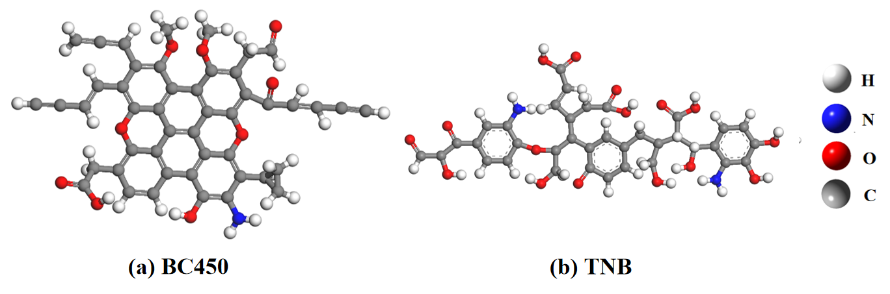
Figure S1. Molecular structure of the (a) Biochar-450 (BC450) and (b) Temple-Northeastern-Birmingham (TNB) model used in this work. C: gray, O: red, H: white, N: blue.
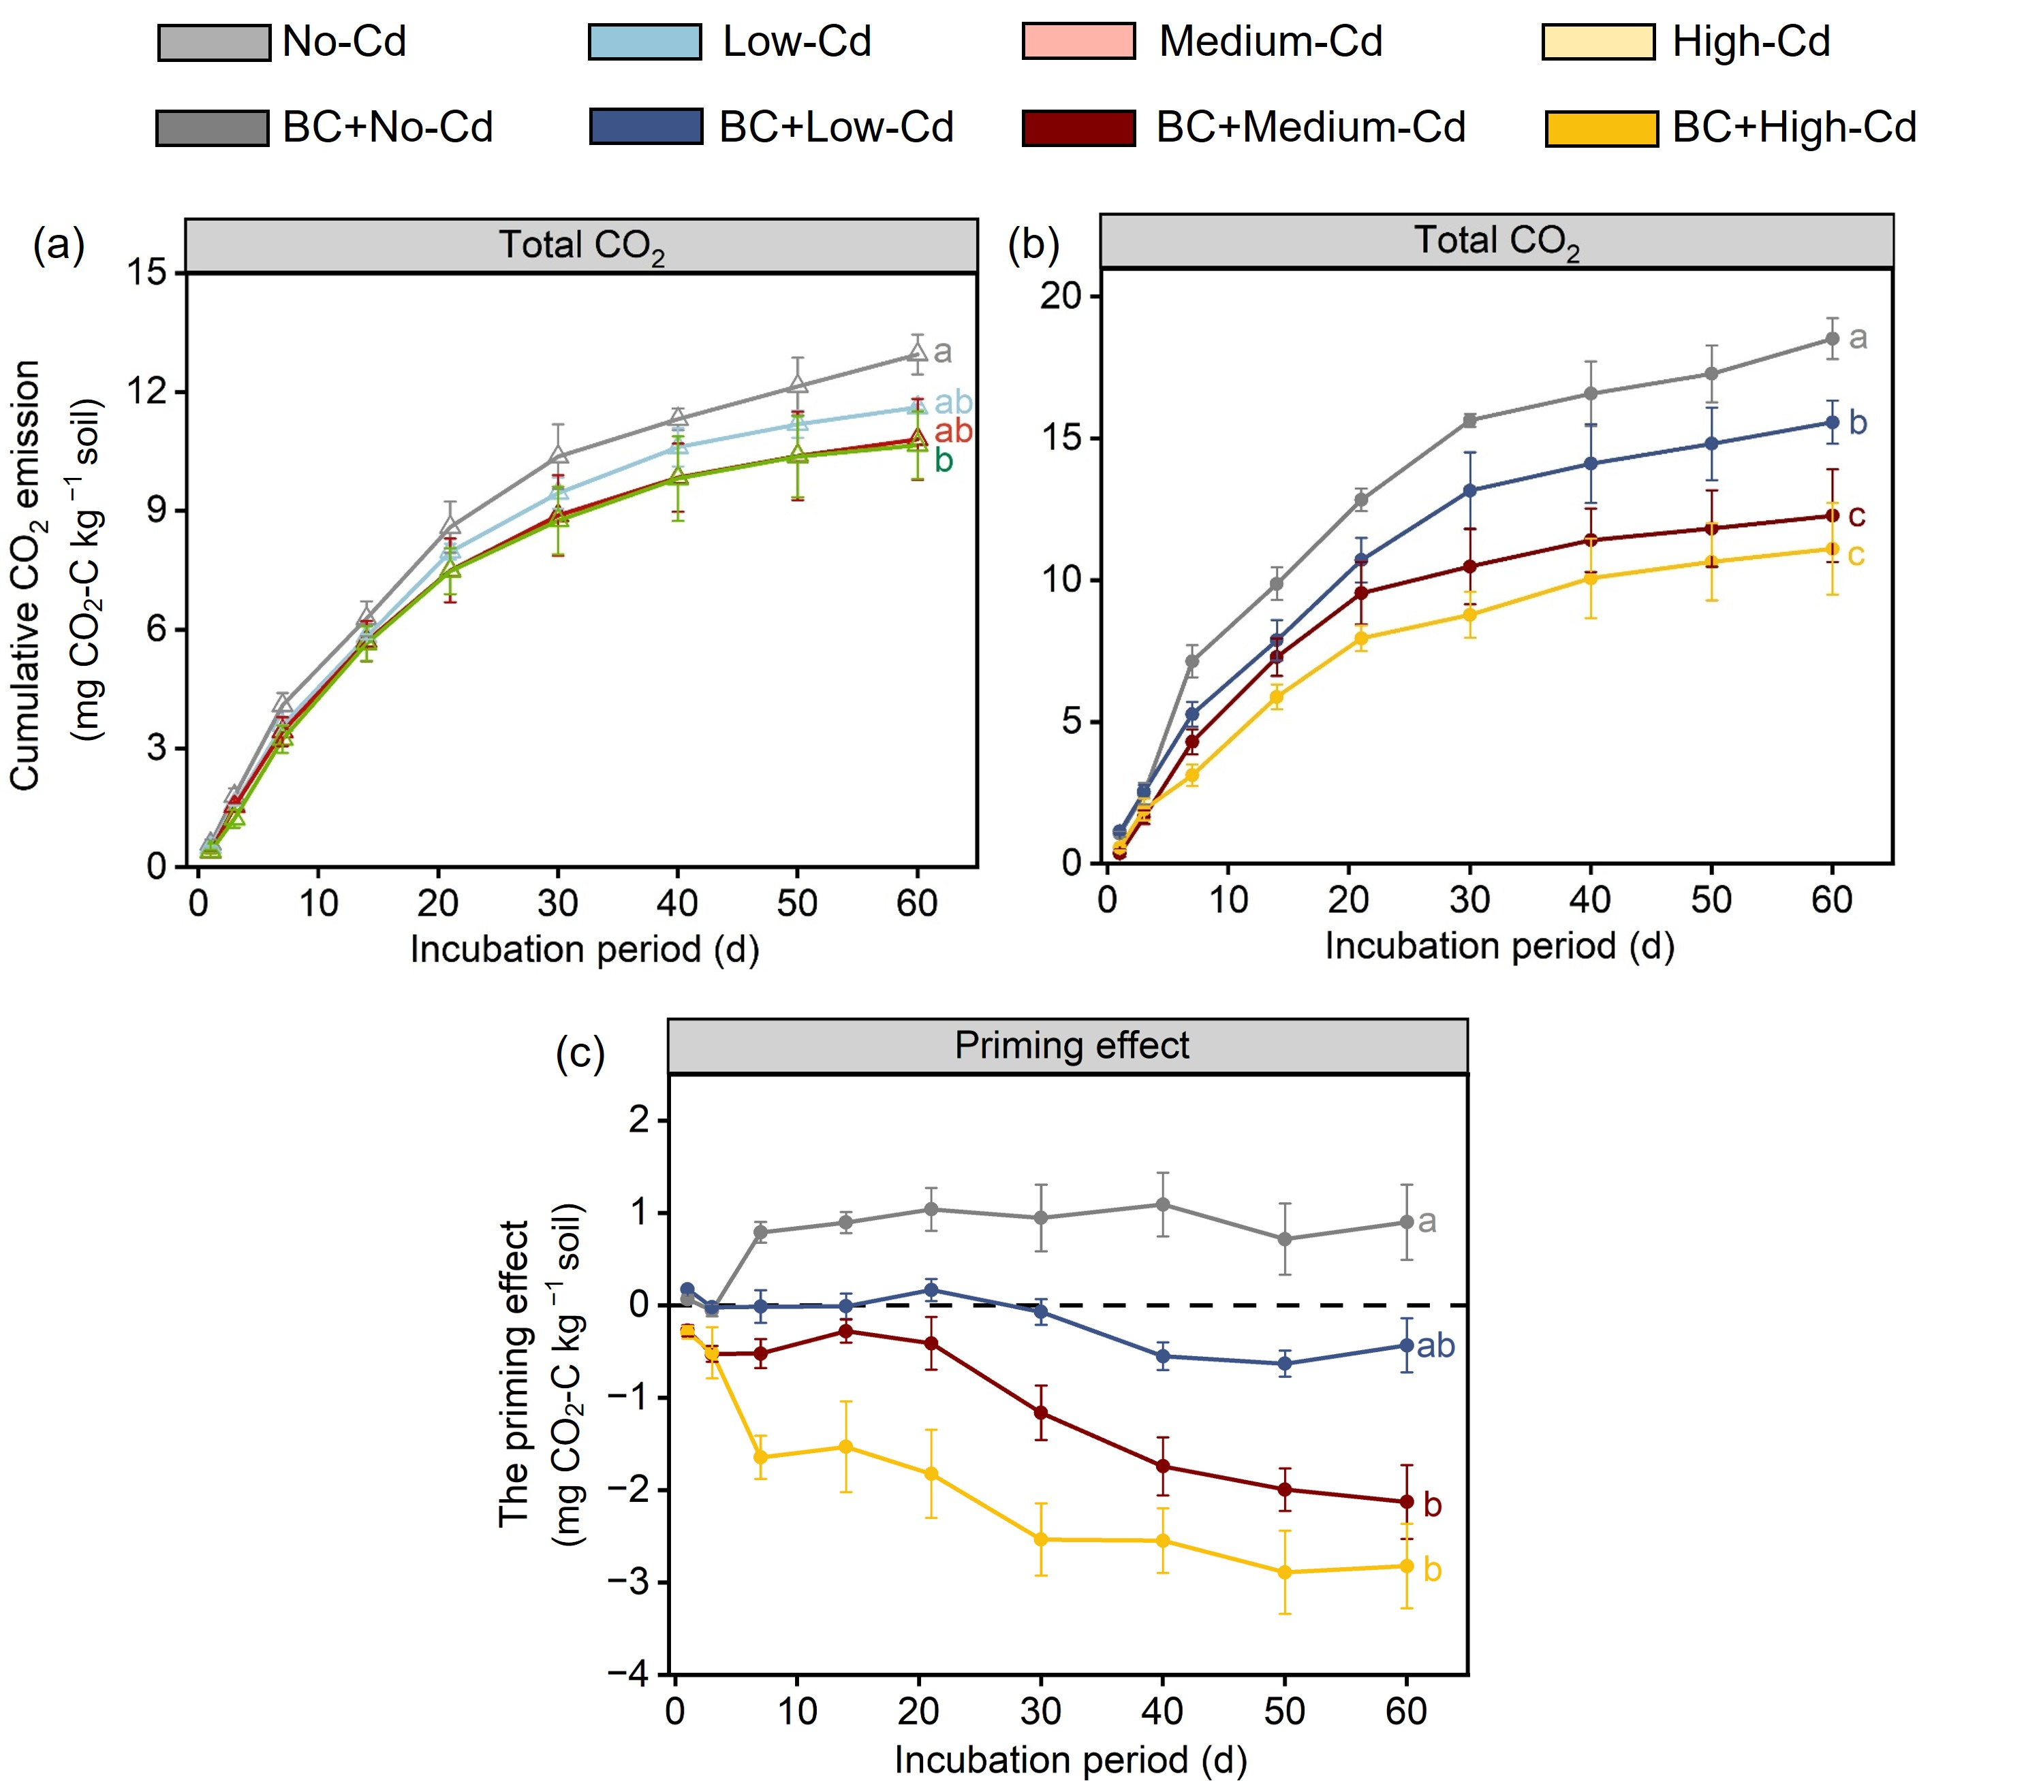
Figure S2. The cumulative amounts of total CO₂ evolved from soils without biochar components (a) and soils with the addition of biochar components (b). The priming effect of biochar on native SOC (c). No-Cd, Low-Cd, Medium-Cd, High-Cd represent the soils without Cd addition, with low Cd addition, with medium Cd addition, and with high Cd addition, respectively. BC+No-Cd, BC+Low-Cd, BC+Medium-Cd, BC+High-Cd represent the soils amended with biochar without Cd addition, with low Cd addition, with medium Cd addition, and with high Cd addition, respectively. Error bars indicate standard deviations (n = 3). Different lowercase letters indicate significant differences (p < 0.05).

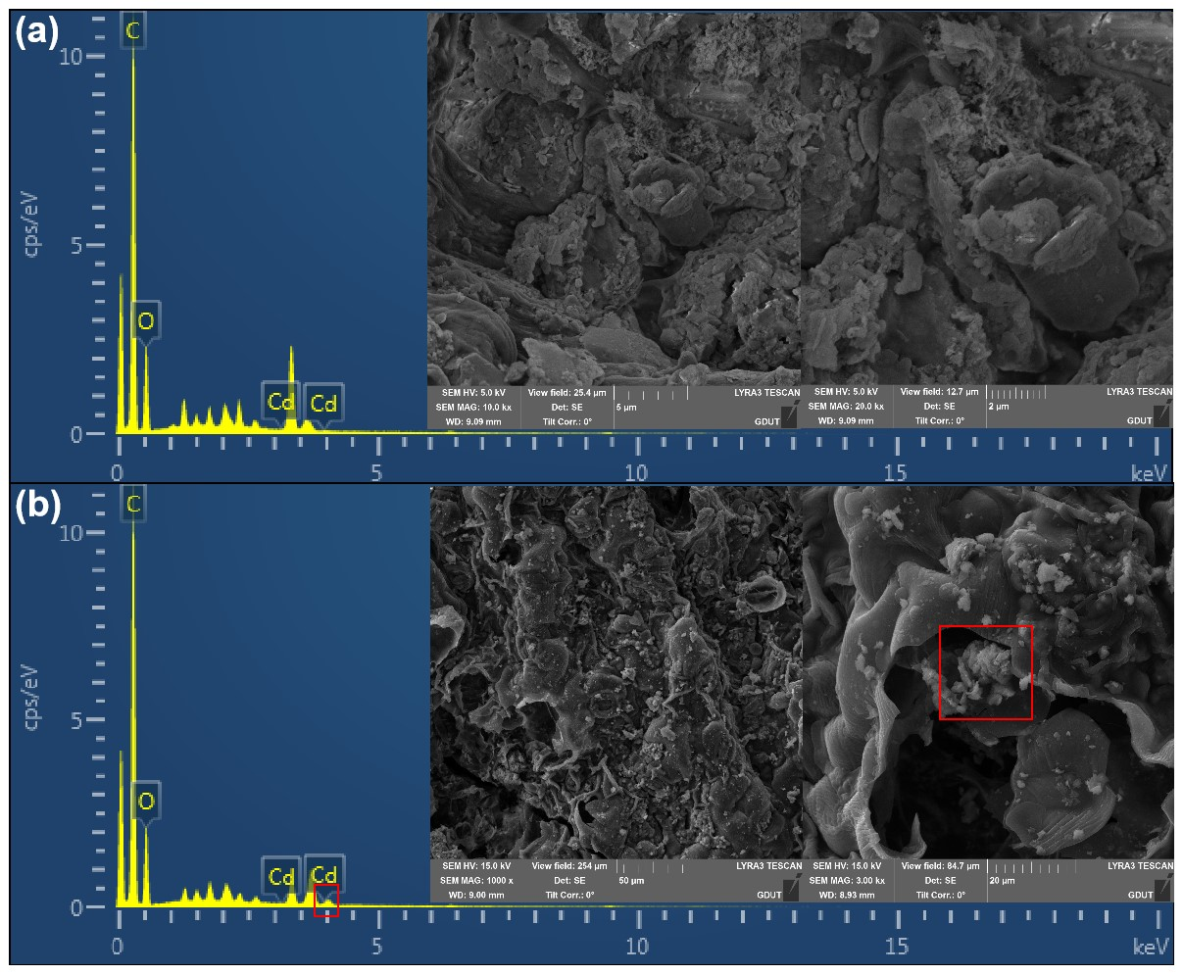
Figure S3. SEM morphology and EDS energy spectrum of biochar. The biochar samples are from the BC+No-Cd (a) and BC+High-Cd groups (b). The peaks of the Cd element and the suspected Cd crystalline structure on the surface of the biochar are marked in the red boxes.

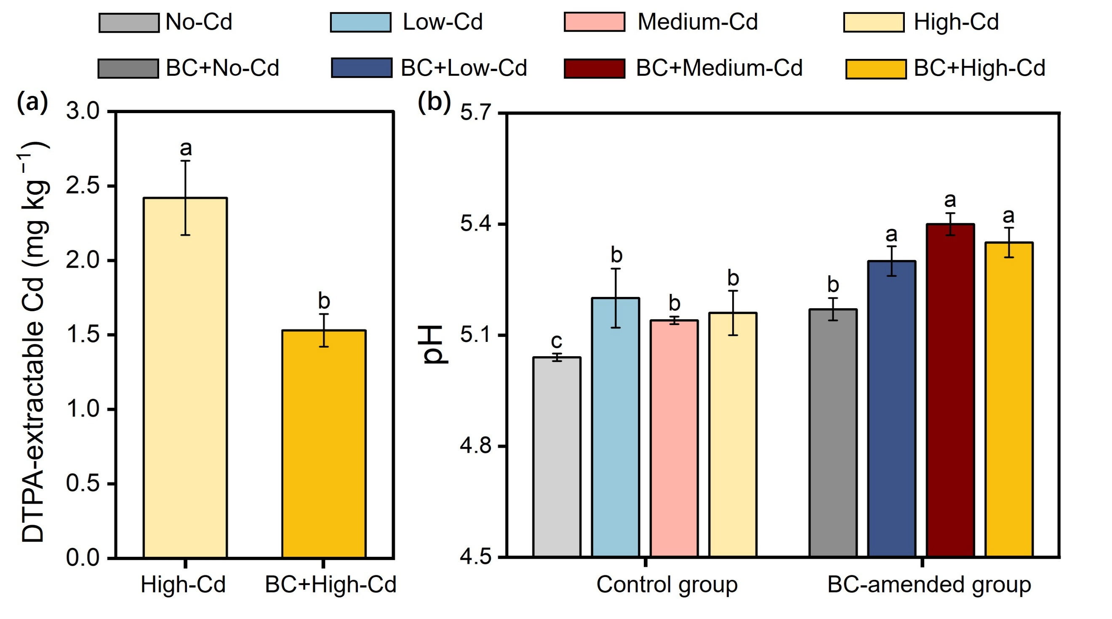 Figure S4. (a) The DTPA extractable Cd concentrations and (b) soil pH. No-Cd, Low-Cd, Medium-Cd, High-Cd represent the soils without Cd addition, with low Cd addition, with medium Cd addition, and with high Cd addition, respectively. BC+No-Cd, BC+Low-Cd, BC+Medium-Cd, BC+High-Cd represent the soils amended with biochar without Cd addition, with low Cd addition, with medium Cd addition, and with high Cd addition, respectively. Note that error bars represent standard errors of the means (n = 3); bars with different lowercase letters indicate significant differences (p < 0.05).

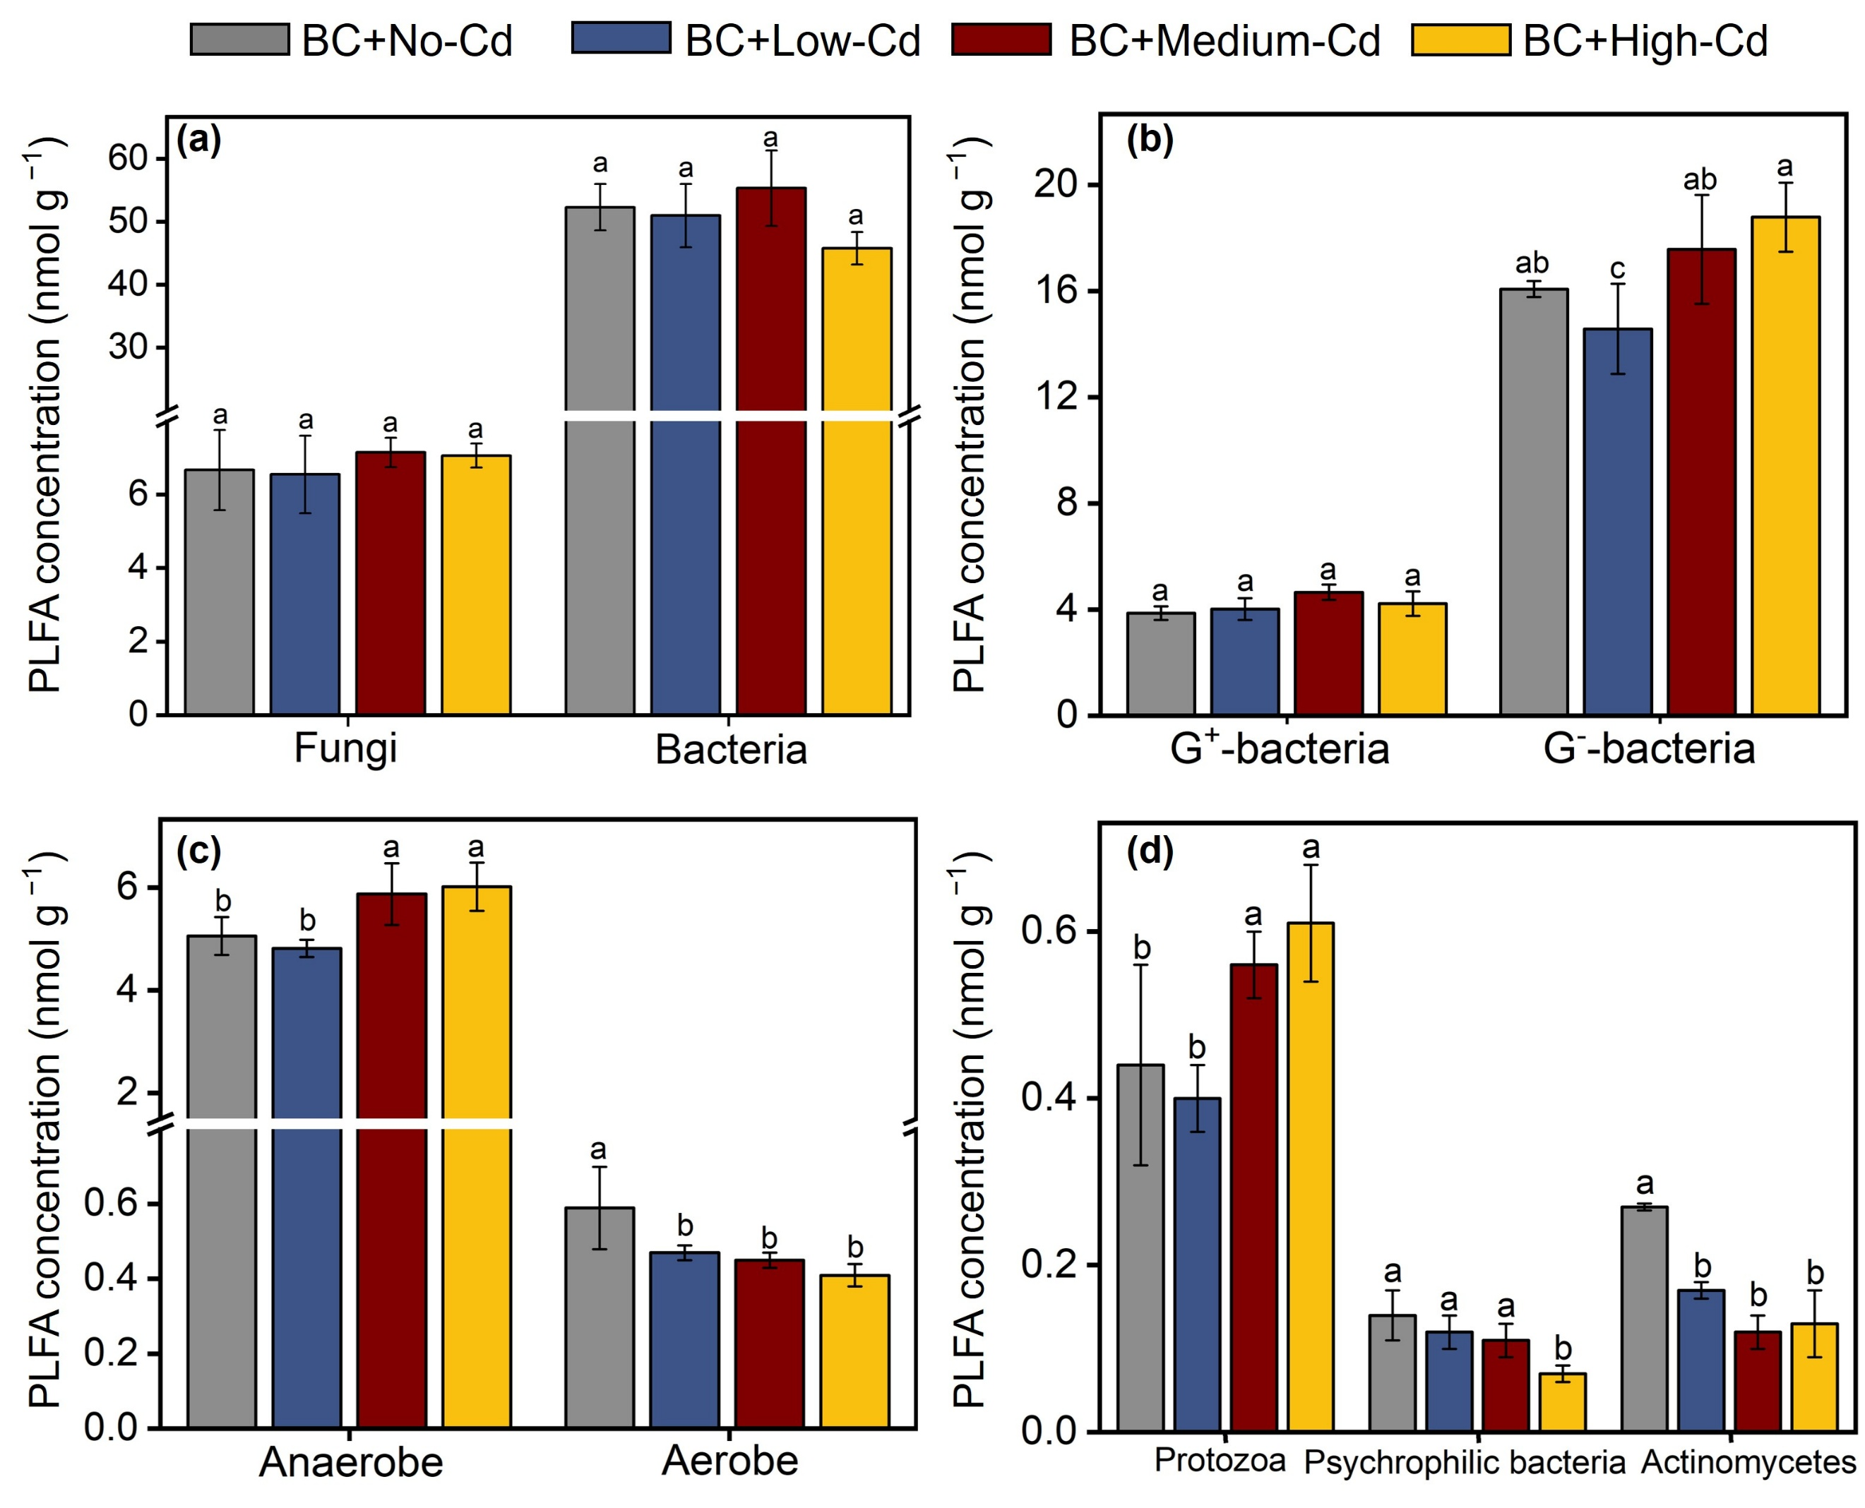
Figure S5. (a) Abundance of fungi and bacteria. (b) Abundance of Gram-positive bacteria (G⁺-bacteria) and Gram-negative bacteria (G⁻-bacteria). (c) Abundance of anaerobes and aerobes. (d) Abundance of protozoa, psychrophilic bacteria and actinomycetes. BC+No-Cd, BC+Low-Cd, BC+Medium-Cd, BC+High-Cd represent the soils amended with biochar without Cd addition, with low Cd addition, with medium Cd addition, and with high Cd addition, respectively. Note that error bars represent standard errors of the means (n = 3); bars with different lowercase letters indicate significant differences (p < 0.05).

References
[1] Chen L, Han L, Wang F, Chen Q, Huang H, et al. 2025. Polylactic acid microplastics induced negative priming and improved carbon sequestration via microbial processes in different paddy soils. Soil Biology & Biochemistry 201: 109653 https://doi.org/10.1016/j.soilbio.2024.109653
[2] Zhu X, Mao L, Chen B. 2019. Driving forces linking microbial community structure and functions to enhanced carbon stability in biochar-amended soil. Environment International 133: 105211 https://doi.org/10.1016/j.envint.2019.105211
[3] Han L, Liu B, Luo Y, Chen L, Ma C, et al. 2024. Quantifying the negative effects of dissolved organic carbon of maize straw-derived biochar on its carbon sequestration potential in a paddy soil. Soil Biology & Biochemistry 196: 109500 https://doi.org/10.1016/j.soilbio.2024.109500
[4] Elliott, E., T. 1986. Aggregate structure and carbon, nitrogen, and phosphorus in native and cultivated soils1. Soil Science Society of America Journal 50: 627 https://doi.org/10.2136/sssaj1986.03615995005000030017x
[5] Marković JP, Jović MD, Smičiklas ID, Aljivić-Ivanović MZ, Smiljanić SN et al. 2018. Estimation of cadmium uptake by tobacco plants from laboratory leaching tests. Journal of Environmental Science and Health Part a-Toxic/Hazardous Substances & Environmental Engineering 53: 352-361 https://doi.org/10.1080/10934529.2017.1401396

