Supplementary Material

Hierarchical Porous Biochar with Fe/Zn Co-activation Derived from Orange Waste: Enhanced Methylene Blue Adsorption and Mechanistic Insights

Lei Zhang ^{a,}*, Xin Liuª, Wenbo Liuª, Hongying Duª, Junkang Guoª*
ªSchool of Environmental Science and Engineering, Shaanxi University of Science & Technology, Xi’ an, 710021, PR China.

*Corresponding author:
Lei Zhang, School of Environmental Science and Engineering, Shaanxi University of Science ＆ Technology, Xi’ an, 710021, PR China
Email: zhanglei0954@126.com
Junkang Guo, School of Environmental Science and Engineering, Shaanxi University of Science ＆ Technology, Xi’ an, 710021, PR China
Email: junkangguo@sust.edu.cn
This document contains 3 figures (S1-8), 2 tables (S1-3)
Supplementary Fig. S1 SEM images showing the porous structures of (a) Fe/Zn-OPBC500 and (b) Fe/Zn-OPBC900.

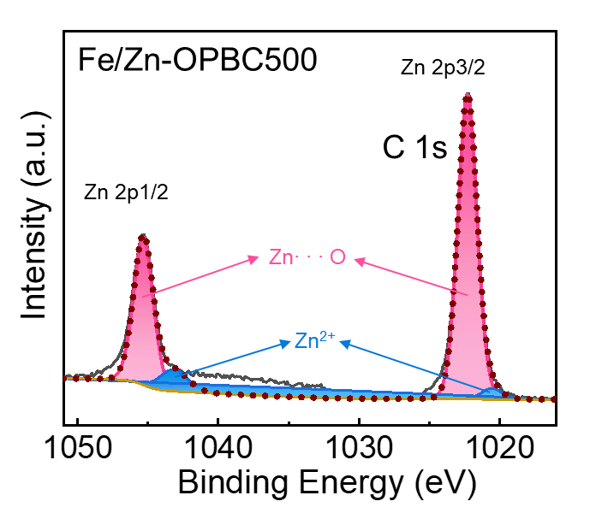
Supplementary Fig. S2 High-resolution XPS spectra of Zn 2p of for Fe/Zn-OPBC500.

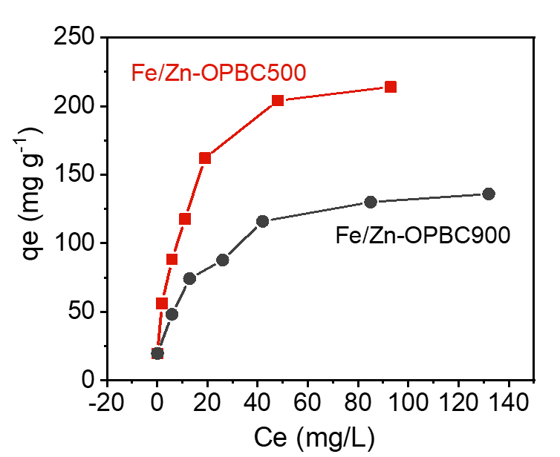
Supplementary Fig. S3 Effect of initial MB concentration on adsorption of Fe/Zn-OPBC500 and Fe/Zn-OPBC900.

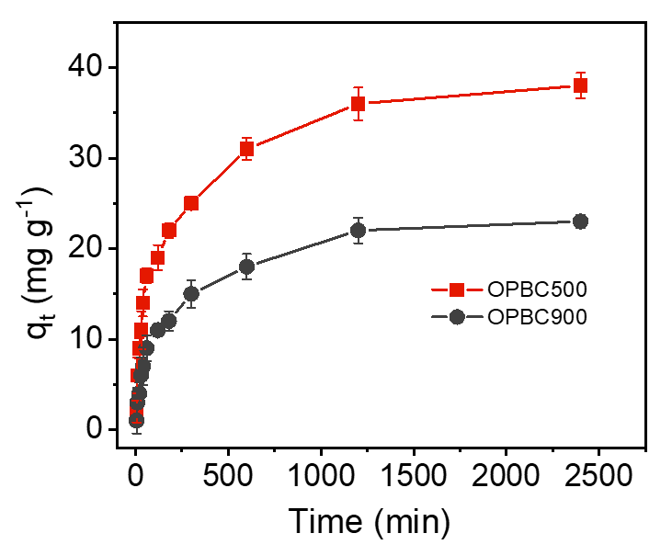
Supplementary Fig. S4 Effect of reaction time on adsorption of Fe/Zn-OPBC500 and Fe/Zn-OPBC900.

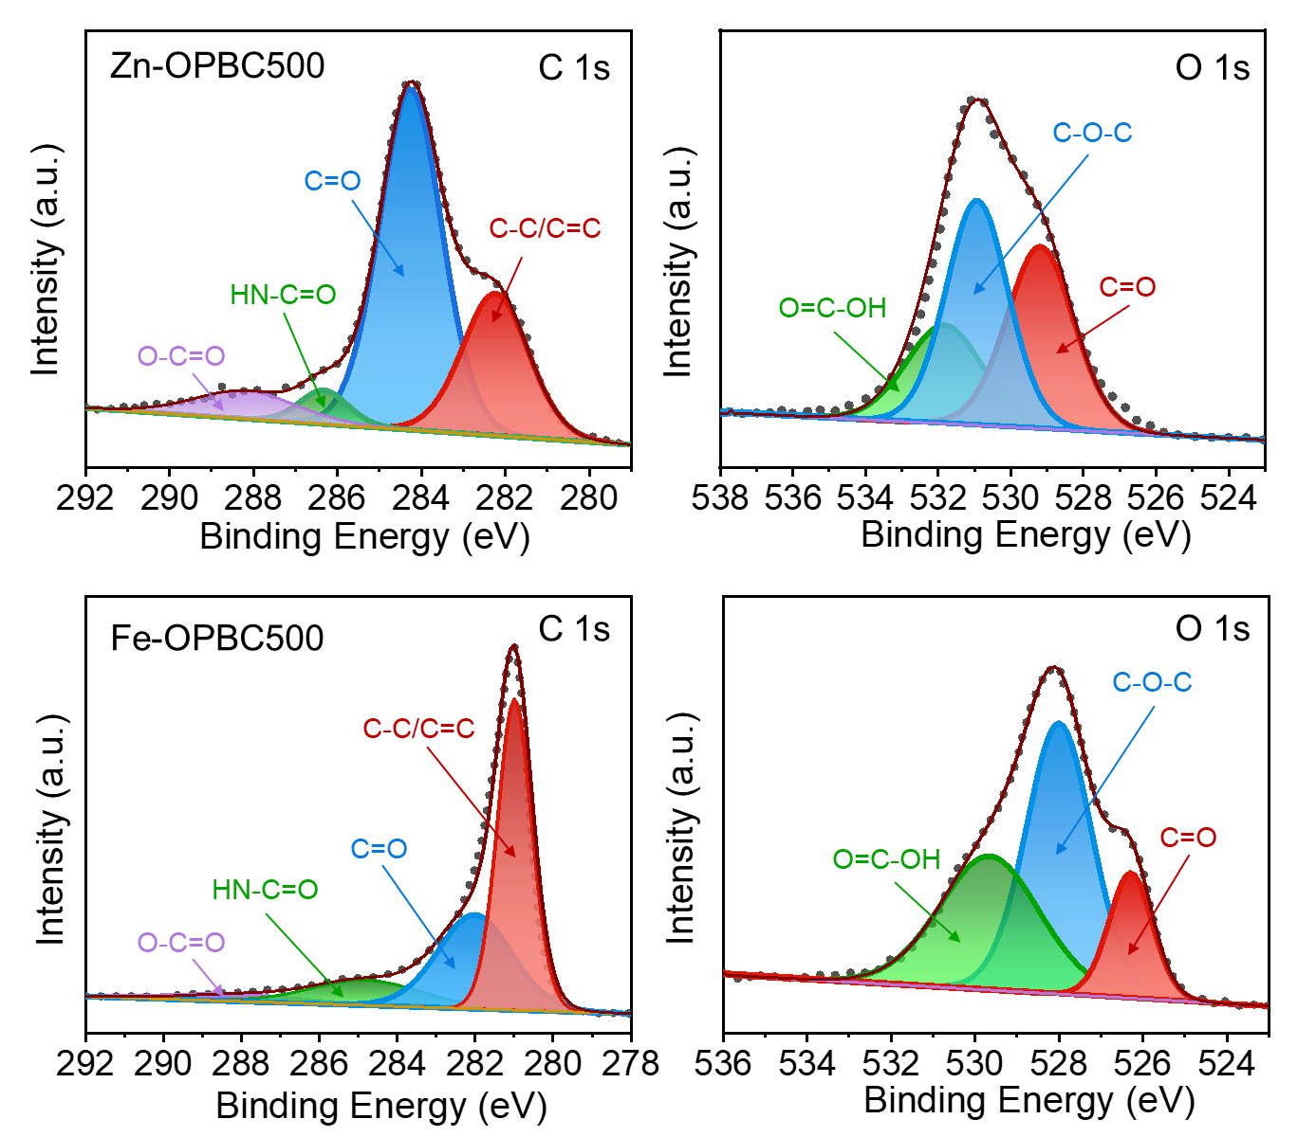
Supplementary Fig. S5 High-resolution XPS spectra of C1s and O1s for Zn-OPBC500 and Fe-OPBC500.

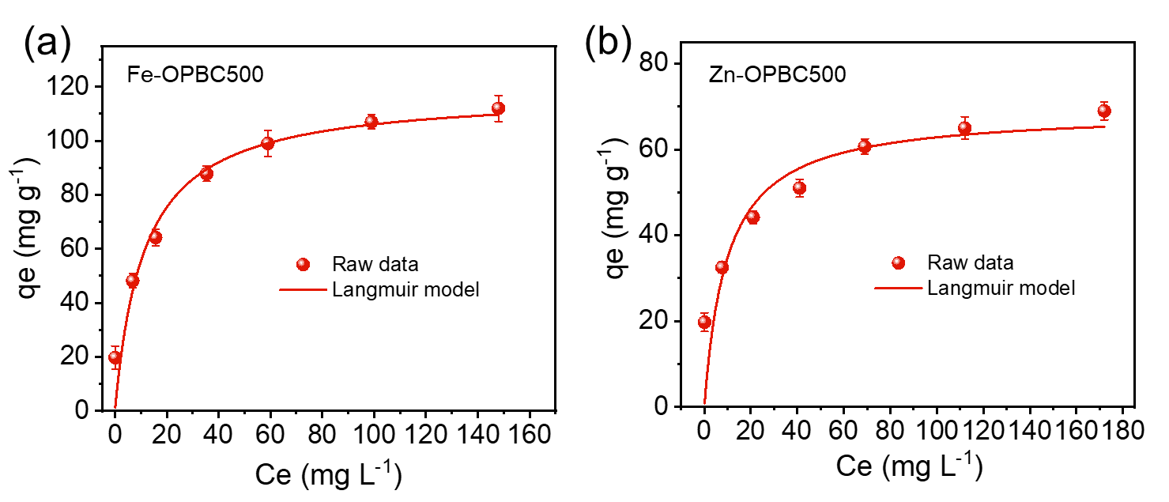
Supplementary Fig. S6 Nonlinear isotherm models for adsorption on Fe-OPBC500 and Zn-OPBC500.

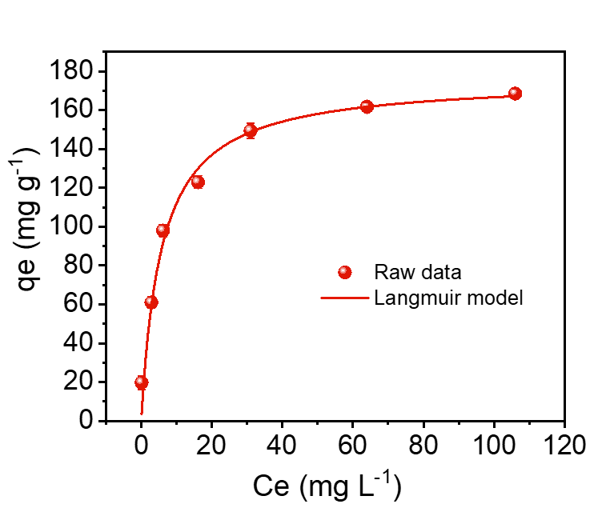
Supplementary Fig. S7 Nonlinear isotherm models for adsorption on Fe/Zn-OPBC700.

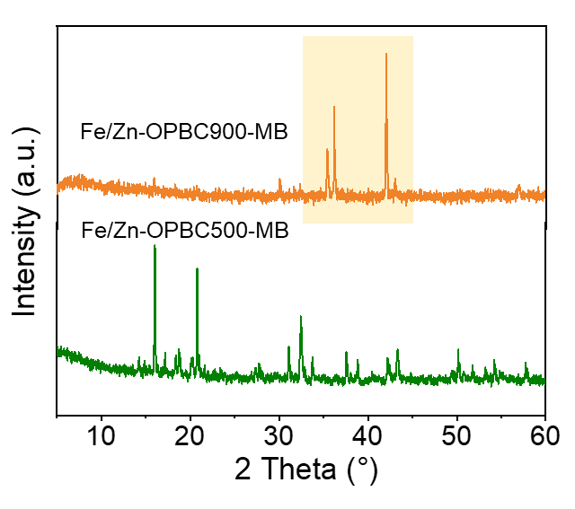
Supplementary Fig. S8 XRD patterns of Fe/Zn-OPBC500 and Fe/Zn-OPBC900 after the adsorption of MB.

Supplementary Table S1 Related parameters of Thermodynamic experiment
T (K) | K_{c} | ∆G_{θ} ( kJ mol⁻¹) | ∆H_{θ} (kJ mol⁻¹) | ∆S_{θ} (kJ mol⁻¹·K⁻¹)
298 | 1.4842 | –1.96 | 4.31 | 0.021
308 | 1.6516 | –2.13
318 | 1.9644 | –2.38

Supplementary Table S2 Specific distributions of C 1s and O 1s bonding states of Fe/Zn-OPBCs after MB adsorption
Sample | Percentage of area |  |  |  | Percentage of area
Sample | C–C  /C=C% | C=O% | HN–C=O% | O–C=O% | O=C–OH% | C–O–C % | C=O%
Fe/Zn-OPBC500 | 3.6 | 12.4 | 74.3 | 9.7 | 30.2 | 50.7 | 19.1
Fe/Zn-OPBC900 | 38.3 | 26.4 | 18.6 | 16.6 | 7.2 | 86.7 | 6.1

Supplementary Table S3. The adsorption capacity of various adsorbents towards MB in the literatures.
Adsorbent | Optimal pH | q_{e} (mg g⁻¹) | Reusability | References
Sewage sludge-derived biochar | 7 | 24.1 | 3 cycle reduced to ~60% | [1]
Ball mill-modified biochar | 8 | 50.27 | 4 cycle reduced to ~60% | [2]
Fe-modified lignin-based biochar | 7 | 200 | Remained 88.7% after five cycles | [3]
Activated reed-derived biochar | 6 | 77.35 | / | [4]
Chemically modified lychee seed biochar | 7 | 124.5 | / | [5]
Nano-silica biochar composites activated by KOH | 7 | 247.22 | 4 cycle reduced to 99.30 mg g⁻¹ | [6]
Hierarchical porous biochar with Fe/Zn co-activation | 7 | 237.53 | 7 cycles reduced to 113.24 mg g⁻¹ | This work

References
- Fan S, Wang Y, Wang Z, Tang J, Tang J, et al. 2017. Removal of methylene blue from aqueous solution by sewage sludge-derived biochar: Adsorption kinetics, equilibrium, thermodynamics and mechanism. Journal of Environmental Chemical Engineering 5: 601-611. https://doi.org/10.1016/j.jece.2016.12.019
- Wang J, Tan Y, Yang H, Zhan L, Sun G, et al. 2023. On the adsorption characteristics and mechanism of methylene blue by ball mill modified biochar. Scientific Reports 13: 21174. https://doi.org/10.1038/s41598-023-48373-1
- Sun Y, Wang T, Han C, Lv X, Bai L, et al. 2022. Facile synthesis of Fe-modified lignin-based biochar for ultra-fast adsorption of methylene blue: Selective adsorption and mechanism studies. ‌Bioresource Technology 344: 126186. https://doi.org/10.1016/j.biortech.2021.126186
- Wang Y, Zhang Y, Li S, Zhong W, Wei W. 2018. Enhanced methylene blue adsorption onto activated reed-derived biochar by tannic acid. Journal of Molecular Liquids 268: 658-666. https://doi.org/10.1016/j.molliq.2018.07.085
- Sahu S, Pahi S, Tripathy S, Singh SK, Behera A, et al. 2020. Adsorption of methylene blue on chemically modified lychee seed biochar: Dynamic, equilibrium, and thermodynamic study. Journal of Molecular Liquids 315: 113743. https://doi.org/10.1016/j.molliq.2020.113743
- Liu J, Lin Q, Gao J, Jia X, Cai M, et al. 2023. Adsorption properties and mechanisms of methylene blue and tetracycline by nano-silica biochar composites activated by KOH. Chemosphere 337: 139395. https://doi.org/10.1016/j.chemosphere.2023.139395

