Supplementary Information
Unraveling microbial ecological mechanisms of different modified biochars for sulfamethoxazole removal in various soils
Caicai Xie ª, Yuye Zhang ª, Tianci Tang ª, Siqi Tong ª, Ruonan Wang ª, Shichao Ma ª, Xiaohui Liu ^{a,*}, Fengmin Li ª, Changbing Ye ^{b}, Bin Zhao ^{b}, Ying Liu ^{c,*}
ª Key Laboratory of Marine Environment and Ecology, Ministry of Education and College of Environmental Science and Engineering, Ocean University of China, Qingdao 266100, China.
^{b} College of Chemical and Environmental Engineering, Yuxi Normal University, Yuxi 653100, China.
^{c} School of Environment and Geography, Shandong Key Laboratory of Synergistic Control of Complex Mult-Media Pollution, Shandong Key Laboratory of Polymeric Materials Recycling and Upcycling, Qingdao University, Qingdao 266071, China.

* Corresponding authors: lxh7786@ouc.edu.cn (Xiaohui Liu); liuying8990@qdu.edu.cn (Y. Liu)

Contains
Number of Text in SI: 3
Number of Table in SI: 8
Number of Figure in SI: 5

Texts
Text S1 Detailed methods for DOM extraction, 3D fluorescence measurement, and PARAFAC model validation.
Text S2 Detailed protocols for soil enzyme activity assays.
Text S3 SMX extraction, purification, and instrumental analysis.

Tables
Table S1 Theoretical comparison of H₃PO₄-, CTAB-, and FeCl₃-modified biochars in terms of surface charge, pore structure, hydrophobicity, and dominant SMX adsorption mechanisms.
Table S2 Physical and chemical properties of the tested soil.
Table S3 Experimental design and grouping.
Table S4 Physicochemical properties of biochar before and after modification.
Table S5 Spectral characteristics of four fluorescence components
Table S6 The α diversity index of microbial community.
Table S7 Test for Dispersion Within OTU Data Groups.
Table S8 Topological parameters of three ecological molecular networks.

Figures
Fig. S1 SEM images at high magnification (10.0 k).
Fig. S2 Fluorescence components and wavelengths based on the PARAFAC model. (C1: UVA humic-like, C2: visible humic-like, C3: fulvic-like, C4: tryptophan-like)
Fig. S3 Percentage of maximum fluorescence intensity of each component
Fig. S4 Microbial community composition and relative abundance at the genus level.
Fig. S5 Genus-level differential abundance assessed by ANCOM-BC2.

Text S1 Detailed methods for DOM extraction, 3D fluorescence measurement, and PARAFAC model validation.
Soil DOM was extracted by the water extraction method. Freeze-dried soil was mixed with ultrapure water at a soil-to-water ratio of 1:30 (mass-to-volume) in a brown polyethylene bottle. The mixture was shaken at 200 rpm and 25 °C for 24 h in the dark. After shaking, the suspension was centrifuged at 10,000 rpm for 10 min at 4°C. The supernatant was filtered through a 0.45 μm cellulose acetate membrane, and the filtrate was stored at 4 °C in the dark before analysis. The DOC concentration was determined using a TOC analyzer.
Before EEM measurement, all DOM solutions were diluted with ultrapure water to a uniform DOC concentration of 10 mg·L⁻¹, and the pH was adjusted to 8.0 ± 0.05 using 0.5 M HCl and NaOH. The EEM measurement parameters are described in Section 2.4 of the main text.
PARAFAC modeling was performed using the DOMFluor toolbox in MATLAB 2019. Rayleigh and Raman scattering were corrected using DOMFluor commands. Outliers were identified and removed based on leverage and residual analysis. The model was validated by split-half validation and residual analysis. The number of fluorescent components was determined by iterative fitting, core consistency diagnostics, and random initialization. The final model was confirmed by comparing split-half validation results, and the maximum fluorescence intensity (F_{max}) of each component was used to estimate its relative contribution.

Text S2 Detailed protocols for soil enzyme activity assays.
Sucrose invertase uses sucrose as its substrate, the concentration range of the standard curve is 5, 10, 15, 20, 25, and 30 mg·L⁻¹. Place 2.0 g of dry soil in a 50-mL conical flask, add 15 mL of 8% sucrose solution, 5 mL of pH 5.5 phosphate buffer, and 1 mL of toluene; mix well and incubate at 37 °C for 24 h. After incubation, remove the supernatant, add 3,5-dinitrosalicylic acid reagent, heat in a boiling water bath for 5 min, cool with tap water for 3 min, adjust the volume, and measure the amount of glucose produced at a wavelength of 508 nm.
Urease uses urea as a substrate, the concentration range of the standard curve is 0.2, 0.6, 1.0, 1.4, 1.8, 2.2, and 2.6 mg·L⁻¹. Weigh 2.0 g of dry soil into a 50-mL conical flask, add 0.4 mL of toluene, and let stand for 15 min; then add 4 mL of a 10% urea solution and 8 mL of citrate buffer (pH 6.7), and incubate at 37 °C for 24 h. After incubation, remove the supernatant, add sodium phenolate and sodium hypochlorite solutions, allow the color to develop for 20 min, adjust the volume to the mark, and measure the amount of ammonium nitrogen produced at a wavelength of 578 nm.
Phosphatase uses disodium phenylphosphate as a substrate, the concentration range of the standard curve is 0.2, 0.5, 1.0, 1.5, 2.0, 2.5, and 3.0 mg·L⁻¹. Weigh 2.0 g of dry soil into a 50-mL conical flask, add 0.4 mL of toluene and 8 mL of 0.5% disodium phenylphosphate solution, and incubate at a constant temperature of 37 °C for 24 h. After incubation, collect the filtrate, add ammonium chloride–ammonium hydroxide buffer, a 2% 4-aminoantipyrine solution, and an 8% potassium ferricyanide solution, and measure the amount of phenol produced at a wavelength of 510 nm within 15 min.

Text S3 SMX extraction, purification, and instrumental analysis
Soil samples were freeze-dried, ground, and passed through a 100-mesh sieve. An aliquot of 1.0 g of soil was weighed into a 50 mL centrifuge tube and spiked with 10 ng of internal standard. Then, 15 mL of EDTA-Mcllvaine solution (37.2 g EDTA-2Na, 27.5 g Na₂HPO₄, and 12.9 g citric acid dissolved in 1 L ultrapure water, pH 4 ± 0.05) and 15 mL of acetonitrile were added. The mixture was vortexed, shaken at 200 rpm for 10 min, ultrasonicated for 15 min, and centrifuged at 8,000 rpm for 10 min. The supernatant was collected, and the extraction was repeated three times. The combined extracts were evaporated to near dryness at 40 °C, redissolved in ultrapure water to 300 mL, adjusted to pH 3 ± 0.05 with 1 mol·L⁻¹ HCl, and supplemented with 0.5 g Na₂EDTA.
A SAX-HLB tandem cartridge was activated with 10 mL of methanol followed by 10 mL of ultrapure water. The extract was loaded onto the cartridge at a flow rate of 3–5 mL·min⁻¹ . The cartridge was washed with 10 mL of ultrapure water and 10 mL of 5% methanol, and then eluted with 6 mL of methanol followed by 6 mL of 5% ammonia in methanol. The eluate was evaporated to near dryness at 40 °C, redissolved in 1 mL of methanol, filtered through a 0.22 μm organic membrane, and transferred to a 2 mL vial for analysis.
The analysis was performed on an HPLC-MS/MS system (8040, Shimadzu, Japan) equipped with an InertSustain C18 column (150 mm × 4.6 mm, 5 μm, Tokyo, Japan). The mobile phase consisted of A (methanol:acetonitrile = 1:1) and B (0.3% formic acid and 0.1% ammonium formate) at a ratio of 7:3. The flow rate was 1 mL·min⁻¹, and the injection volume was 10 μL. Isocratic elution was used, and detection was performed in positive electrospray ionization mode (ESI+). The average recovery rate of SMX was 80.48%, with a relative standard deviation of 2.16%, a limit of detection of 0.08 ng·g⁻¹, and a limit of quantification of 0.25 ng·g⁻¹.

Table S1. Theoretical comparison of H₃PO₄-, CTAB-, and FeCl₃-modified biochars in terms of surface charge, pore structure, hydrophobicity, and dominant SMX adsorption mechanism.
Modifier | Surface charge | Pore structure | Hydrophobicity | Dominant SMX adsorption mechanism
H₃PO₄ | Deprotonation at ambient pH increases negative surface charge; strongly pH-dependent | Promotes the development of micropores and mesopores, increasing specific surface area and adsorption sites; excess phosphoric acid may block some micropores | Increased polar groups enhance hydrophilicity | Hydrogen bonding, surface complexation, π–π interactions, pore filling
CTAB | Increased positive charge density | Surfactant etching and templating may increase porosity and pore size; long chains may cover part of the surface | Long alkyl chains markedly increase hydrophobicity | Hydrophobic partitioning, electrostatic attraction, π–π interactions
FeCl₃ | Increased positive charge density under acidic to neutral conditions; introduces variable-charge sites | Deposition of iron oxide particles may reduce porosity but increases surface roughness and reactive sites | Iron oxide surfaces are rich in hydroxyl groups and relatively hydrophilic, but polarity and charge are altered | Surface complexation, electrostatic attraction, ligand exchange, hydrogen bonding

Table S2. Physical and chemical properties of the tested soil
Sample ID | Sampling area | Soil type | Parent material | pH | TOC (g·kg⁻¹)
B | Heilongjiang Province, China | Mollisol | Clayey sediment of loess-like origin | 6.51 ± 0.02 | 2.39 ± 0.01
Y | Shandong Province, China | Fluvisol | Alluvial deposits with mollisol characteristics | 6.82 ± 0.03 | 2.69 ± 0.02
R | Hainan Province, China | Ferralsol | Granite weathered materials | 5.73 ± 0.03 | 1.47 ± 0.01

Table S3. Experimental design and grouping
Group | Soil | Antibiotics | Biochar
CKB | Black soil 60 g | NA | NA
CKY | Fluvo-aquic soil 60 g | NA | NA
CKR | Latosol 60 g | NA | NA
BA | Black soil 60 g | 1.2 µg SMX | NA
YA | Fluvo-aquic soil 60 g | 1.2 µg SMX | NA
RA | Latosol 60 g | 1.2 µg SMX | NA
BCA1 | Black soil 60 g | 1.2 µg SMX | 0.6 g C1
BCA2 | Black soil 60 g | 1.2 µg SMX | 0.6 g C2
BCA3 | Black soil 60 g | 1.2 µg SMX | 0.6 g C3
YCA1 | Fluvo-aquic soil 60 g | 1.2 µg SMX | 0.6 g C1
RCA1 | Latosol 60 g | 1.2 µg SMX | 0.6 g C1

Table S4. Physicochemical properties of biochar before and after modification
Biochar | pH | C  /wt% | N  /wt% | O  /wt% | P  /wt% | Fe  /wt% | Si  /wt% | Ca  /wt%
Original biochar | 7.14 | 45.23 | 0.68 | 42.90 | 0.04 | 0.70 | 10.13 | 0.31
C1 | 2.88 | 69.38 | 5.56 | 16.49 | 0.98 | 0.44 | 6.92 | 0.23
C2 | 6.79 | 64.05 | 3.04 | 25.48 | 0.20 | 1.68 | 3.89 | 1.67
C3 | 3.11 | 46.48 | 0.06 | 12.25 | 0.06 | 2.84 | 38.26 | 0.05

Table S5. Spectral characteristics of four fluorescence components
Component | Type | Ex/nm | Em/nm
C1 | UV/Vis humic acids | 200–315 | 315–500
C2 | Visible humic acids | 315–450 | 420–600
C3 | Fulvic acid derivatives | 200–420 | 375–500
C4 | Tryptophan-like compounds | 200–260 | 250–320

Table S6. The α diversity indices of the microbial community
Group |  | Shannon | Simpson | ACE | Chao1 | Coverage
CK | CKB | 3.796 ± 0.085 | 0.052 ± 0.010 | 469.7 ± 63.44 | 474.36 ± 46.20 | 0.997
CK | CKR | 2.886 ± 0.106 | 0.116 ± 0.008 | 280.17 ± 58.26 | 282.07 ± 56.16 | 0.999
CK | CKY | 3.795 ± 0.022 | 0.045 ± 0.001 | 344.74 ± 19.56 | 346.55 ± 20.44 | 0.998
Soil + SMX | BA | 3.701 ± 0.445 | 0.063 ± 0.043 | 571.22 ± 137.9 | 584.13 ± 142.74 | 0.996
Soil + SMX | RA | 4.201 ± 1.31 | 0.102 ± 0.077 | 1000.8 ± 571.3 | 1003.9 ± 429.7 | 0.997
Soil + SMX | YA | 3.306 ± 0.340 | 0.085 ± 0.026 | 833.87 ± 274.48 | 643.7 ± 184.89 | 0.995
Soil + SMX + biochar | BCA1 | 3.483 ± 0.137 | 0.13 ± 0.09 | 402.37 ± 124.3 | 415.6 ± 97.56 | 0.998
Soil + SMX + biochar | BCA2 | 3.886 ± 0.362 | 0.049 ± 0.022 | 437.08 ± 122.37 | 439.17 ± 84.37 | 0.998
Soil + SMX + biochar | BCA3 | 4.017 ± 0.477 | 0.032 ± 0.012 | 415.1 ± 180.45 | 442.78 ± 129.82 | 0.997
Soil + SMX + biochar | RCA1 | 3.275 ± 1.889 | 0.097 ± 0.025 | 336.54 ± 53.14 | 331.43 ± 81.02 | 0.998
Soil + SMX + biochar | YCA1 | 3.084 ± 0.243 | 0.141 ± 0.022 | 328.73 ± 119.36 | 334.89 ± 91.72 | 0.999

Table S7. Test for dispersion within OTU data groups
Group | Average distance to median
BA | 0.10107
BCA1 | 0.09335
BCA2 | 0.09844
BCA3 | 0.09660
CKB | 0.14113
CKR | 0.05822
CKY | 0.07350
RA | 0.31528
RCA1 | 0.21796
YA | 0.05842
YCA1 | 0.05189
Note: The results of the permutation test for homogeneity of variance in a multivariate analysis were F = 1.3165, p = 0.26 (999 permutations).

Table S8. Topological parameters of three ecological molecular networks
Parameter | A | C1 | CA1
Model threshold | 0.999 | 0.95 | 0.999
Average degree | 9.838 | 3.105 | 4.803
Node number | 321 | 114 | 376
Connections | 1,579 | 177 | 903
R² | 0.735 | 0.765 | 0.76
Mean connectivity | 9.838 | 3.105 | 4.803
Average aggregation coefficient | 0.125 | 0.228 | 0.231
Average path length | 2.984 | 4.254 | 4.918
Number of modules  (Network modularity) | 7  (0.337) | 23  (0.816) | 18  (0.685)
Network density | 0.031 | 0.027 | 0.013
Connectivity | 0.972 | 0.901 | 0.989
Transmissibility | 0.152 | 0.536 | 0.32
Positive connectivity | 1,425 (90.2%) | 162 (91.5%) | 527 (58.4%)
Negative connectivity | 154 (9.8%) | 15 (8.5%) | 376 (41.6%)

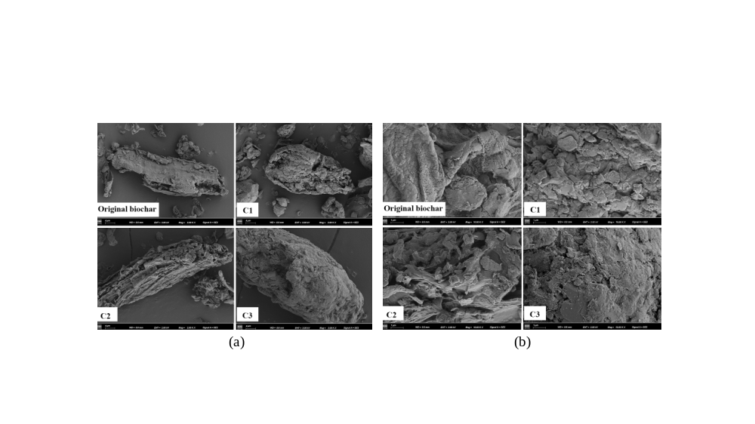

Fig. S1 SEM images at high magnification (10.0 k).

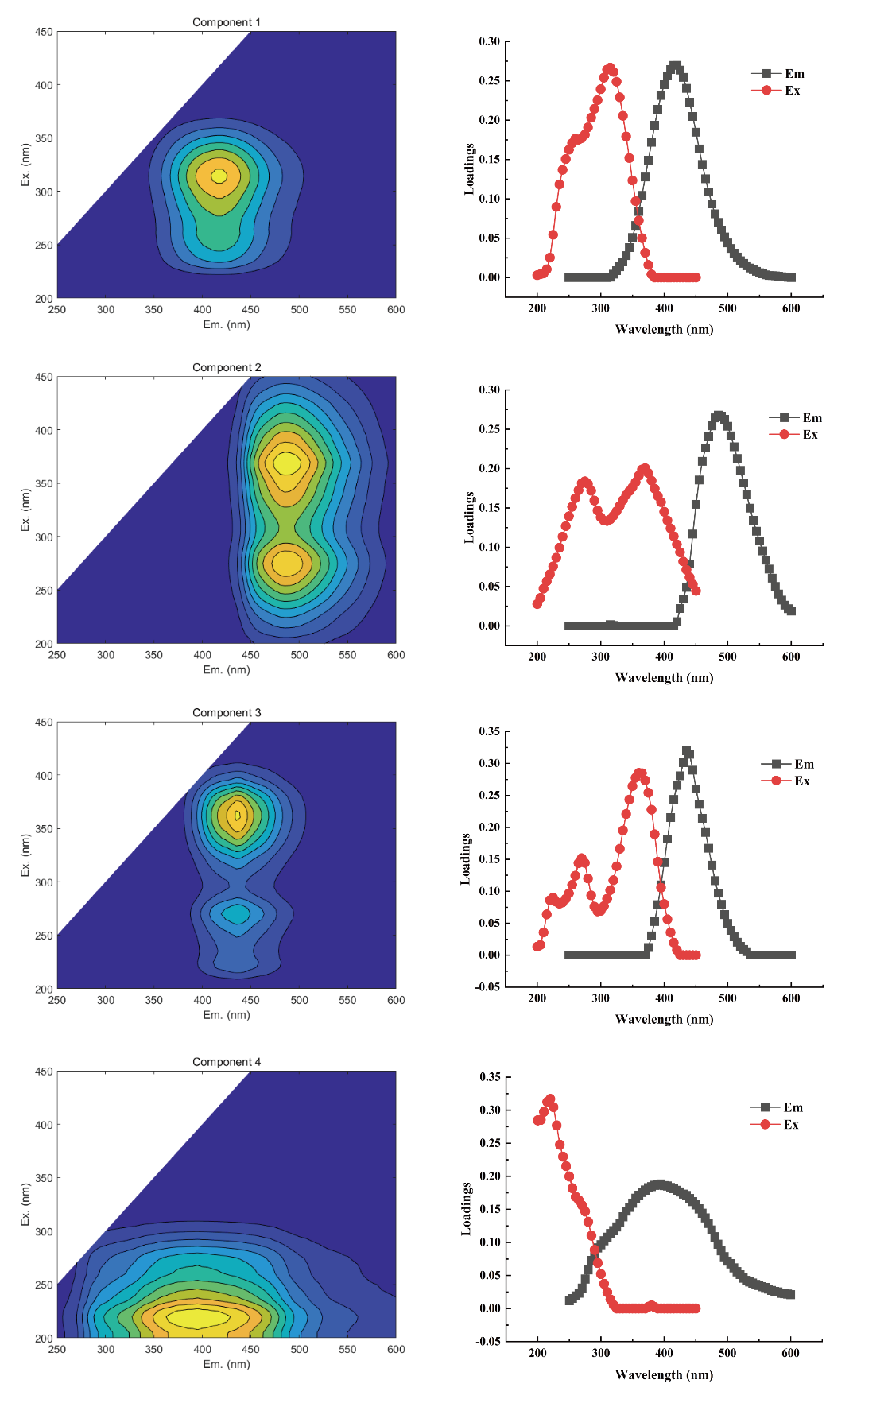

Fig. S2 Fluorescence components and wavelengths based on the PARAFAC model. (C1: UVA humic-like, C2: visible humic-like, C3: fulvic-like, C4: tryptophan-like)

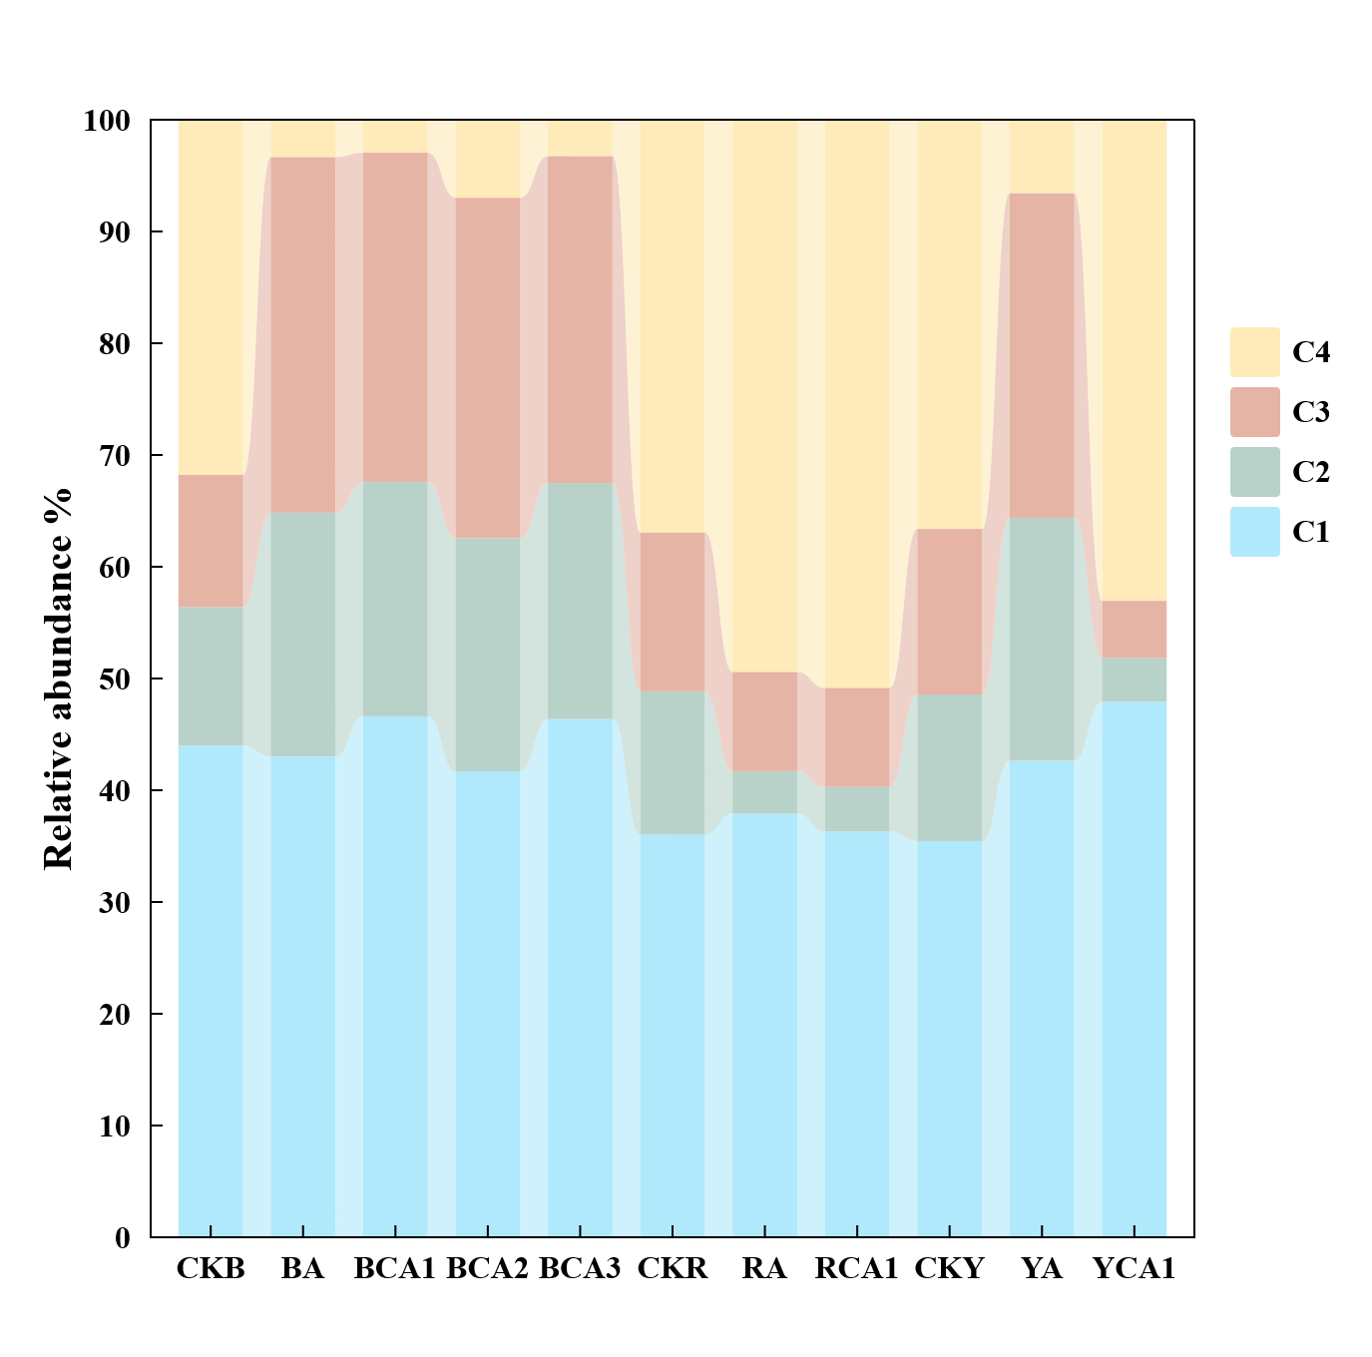

Fig. S3 Percentage of maximum fluorescence intensity of each component.

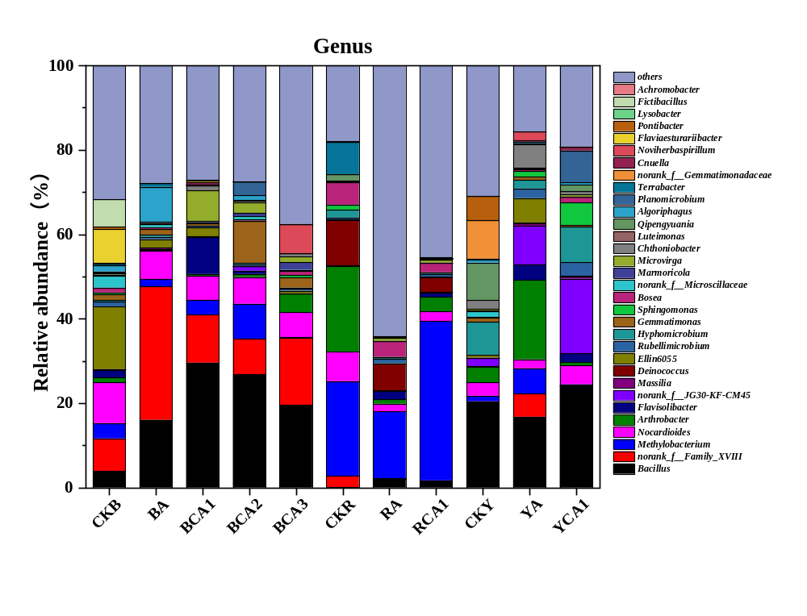

Fig. S4 Microbial community composition and relative abundance at the genus level.

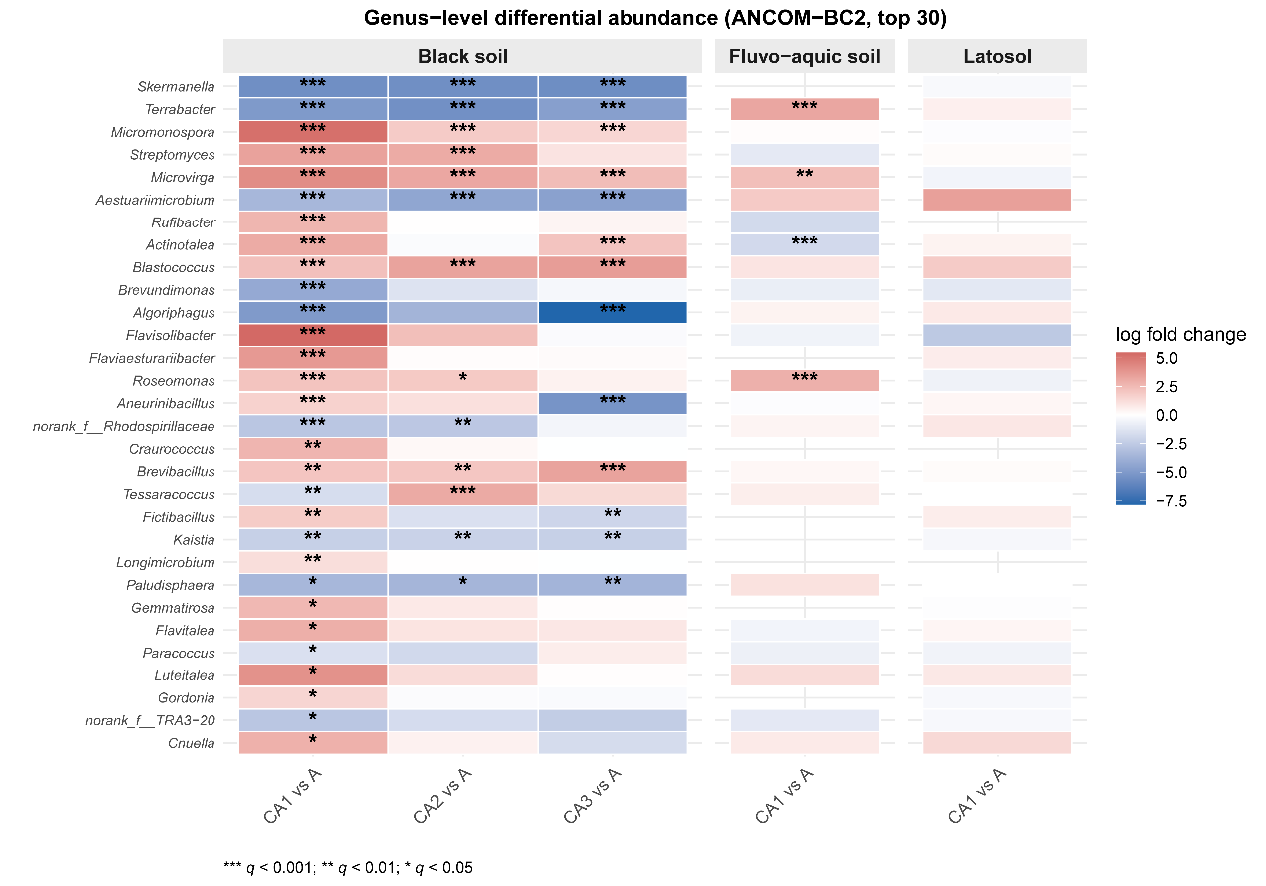

Fig. S5 Genus-level differential abundance assessed by ANCOM-BC2.

