Differences in soil organic carbon among soil layers caused by microbial necromass carbon accumulation under different tillage and carbon input

Ximing Liu^{1,2}, Chang Zhang^{1,2}, Xiaolin Li², Song Cheng², Jinyao Yan², Jingchao Yuan², Jianzhao Liu², Yao Liang²，Jingkun Lu², Wei Fan^{2*}, Hongguang Cai^{2*}

¹ College of Resources and Environment, Jilin Agricultural University, Changchun 130118, Jilin, People’s Republic of China;
² Institute of Agricultural Resources and Environment, Jilin Academy of Agricultural Sciences, Changchun 130033, Jilin, People’s Republic of China

*Correspondence:Wei Fan (isfanwei@foxmail.com)
Hongguang Cai (caihongguang1981@163.com)

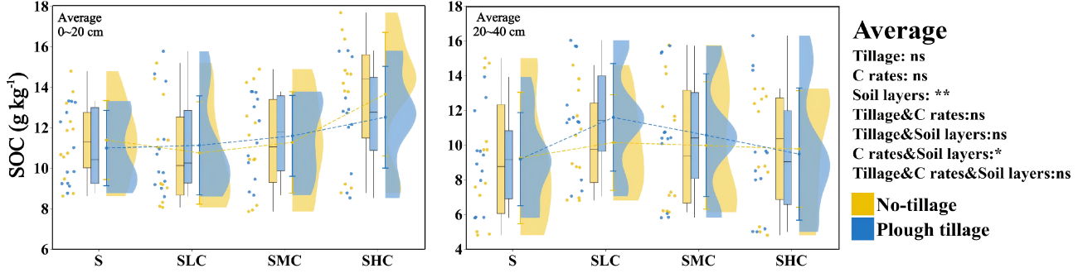
Fig.S1 Effects of tillage and carbon input on SOC. The scatters in the figure represent the measured values of each test point. The boundaries of the box plot are the first quartile and the third quartile, respectively. The horizontal lines in the box represent the median, and the vertical lines in the box plot are the first quartile-1.5 IQR and the third quartile + 1.5 IQR. The irregular figure on the right side represents the density distribution of the measured value, the dot represents the average value, the line segment at both ends of the dot represents the standard deviation, and the line between the dots represents the change trend of the measured value between the treatments.Main effects of single factors and their interactive effects are displayed for Tillages : Tillage methods ; C Rates : Carbon input ; Significance levels:**, P < 0.01; *, P < 0.05; ns, not significant at P > 0.05 level.

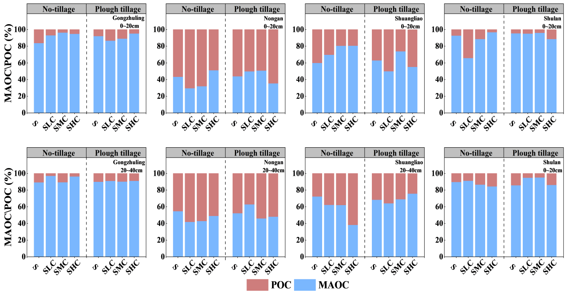
Fig.S2 The ratio of mineral-bound organic carbon to particulate organic carbon
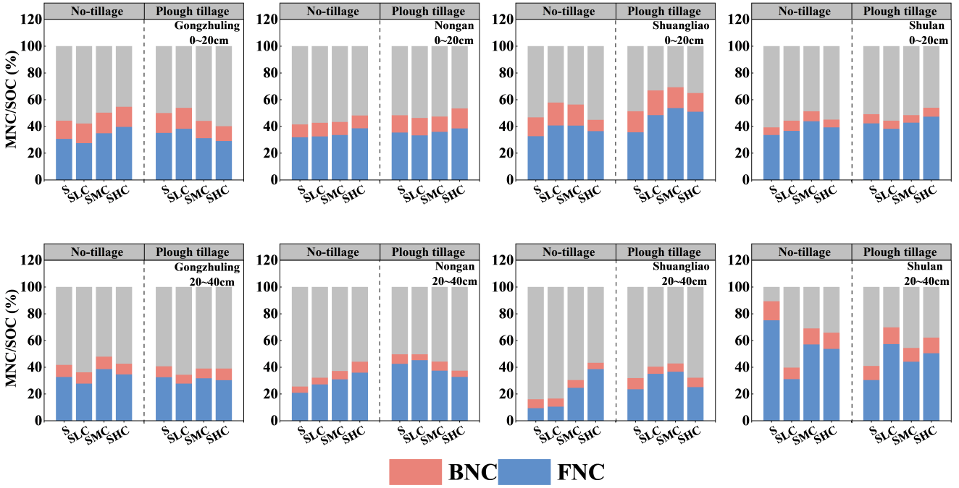
Fig.S3 The proportion of microbial residue carbon in soil organic carbon

Table S1 Effects of tillage and carbon input on soil physical and chemical properties in each experimental site
Sites | Soil  layers | Tillages | C Rates | Bulk density  g cm⁻³ | EC  μs cm⁻¹ | pH | TN  g kg⁻¹ | TP  g kg⁻¹ | TK  g kg⁻¹ | CBH  μmol d⁻¹ g⁻¹ | AG  μmol d⁻¹ g⁻¹ | BG  μmol d⁻¹ g⁻¹ | XY  μmol d⁻¹ g⁻¹
Gongzhuling | topsoil | NT | S | 1.41 a | 84.33 b | 5.99 a | 0.56 c | 0.74 ab | 12.93 a | 44.58 b | 18.26 c | 50.46 c | 40.12 b
Gongzhuling | topsoil | NT | SLC | 1.38 b | 85.07 b | 6.00 a | 0.60 c | 0.79 a | 12.43 a | 51.79 a | 21.47 b | 66.24 b | 40.10 b
Gongzhuling | topsoil | NT | SMC | 1.39 b | 93.30 b | 5.83 ab | 0.69 b | 0.76 ab | 11.77 a | 51.44 a | 22.03 b | 70.18 b | 25.62 a
Gongzhuling | topsoil | NT | SHC | 1.42 a | 122.60 a | 5.49 b | 0.84 a | 0.67 b | 11.97 a | 51.64 a | 24.83 a | 84.40 a | 26.08 a
Gongzhuling | topsoil | PT | S | 1.33 a | 82.67 a | 6.02 b | 0.51 c | 0.70 c | 12.07 b | 52.32 b | 24.35 a | 69.66 b | 30.52 b
Gongzhuling | topsoil | PT | SLC | 1.33 a | 81.87 a | 6.03 b | 0.65 b | 0.79 b | 10.70 b | 57.74 ab | 16.49 b | 80.96 a | 35.45 a
Gongzhuling | topsoil | PT | SMC | 1.32 a | 72.43 b | 6.28 a | 0.71 b | 0.94 a | 14.00 a | 56.26 ab | 22.22 a | 75.44 ab | 26.85 c
Gongzhuling | topsoil | PT | SHC | 1.32 a | 83.63 a | 6.00 b | 0.84 a | 0.83 b | 11.60 b | 63.38 a | 18.11 b | 72.81 b | 34.70 a
Gongzhuling | subsoil | NT | S | 1.53 a | 71.80 a | 6.30 b | 0.58 c | 0.88 a | 13.57 a | 71.52 b | 30.77 a | 43.39 b | 50.88 a
Gongzhuling | subsoil | NT | SLC | 1.49 b | 70.00 a | 6.37 b | 0.63 bc | 0.45 c | 12.17 b | 71.49 b | 17.05 c | 50.73 a | 37.89 b
Gongzhuling | subsoil | NT | SMC | 1.47 c | 72.00 a | 6.30 b | 0.67 b | 0.47 c | 11.90 b | 75.66 ab | 20.32 b | 42.07 b | 46.22 b
Gongzhuling | subsoil | NT | SHC | 1.53 a | 71.33 a | 7.05 a | 0.79 a | 0.69 b | 11.97 b | 81.69 a | 16.79 c | 55.74 a | 46.22 b
Gongzhuling | subsoil | PT | S | 1.42 a | 72.00 a | 7.05 a | 0.44 c | 0.54 a | 12.33 ab | 65.22 a | 13.49 b | 83.07 a | 30.25 b
Gongzhuling | subsoil | PT | SLC | 1.42 a | 66.37 a | 6.64 b | 0.59 b | 0.48 ab | 11.57 b | 69.21 a | 19.11 a | 83.07 a | 38.62 a
Gongzhuling | subsoil | PT | SMC | 1.41 a | 72.00 a | 6.29 c | 0.70 a | 0.43 b | 11.50 b | 66.25 a | 16.64 a | 59.40 c | 26.50 b
Gongzhuling | subsoil | PT | SHC | 1.42 a | 72.43 a | 6.31 c | 0.75 a | 0.52 a | 13.20 a | 68.08 a | 18.95 a | 69.92 b | 21.46 c
Nongan | topsoil | NT | S | 1.44 b | 144.47 c | 8.21 a | 1.07 c | 0.95 a | 13.80 a | 38.87 c | 15.62 b | 138.25 b | 40.76 a
Nongan | topsoil | NT | SLC | 1.49 a | 171.30 b | 8.09 b | 1.13 bc | 0.94 a | 13.63 a | 42.55 c | 17.14 b | 129.72 b | 43.31 a
Nongan | topsoil | NT | SMC | 1.48 a | 169.30 b | 8.10 b | 1.15 b | 0.94 a | 8.40 b | 55.35 b | 18.85 b | 134.46 b | 37.88 a
Nongan | topsoil | NT | SHC | 1.48 a | 186.70 a | 8.00 c | 1.28 a | 0.79 b | 13.17 a | 76.19 a | 29.02 a | 152.01 a | 41.53 a
Nongan | topsoil | PT | S | 1.45 a | 169.93 b | 8.09 ab | 0.84 c | 1.33 a | 15.10 a | 60.45 b | 16.40 b | 146.32 c | 32.41 a
Nongan | topsoil | PT | SLC | 1.40 b | 152.70 c | 8.18 ab | 0.87 bc | 0.99 c | 12.97 b | 61.34 ab | 15.52 b | 175.72 b | 34.81 a
Nongan | topsoil | PT | SMC | 1.41 b | 150.67 c | 8.35 a | 0.95 b | 1.13 b | 15.73 a | 65.23 ab | 16.76 b | 109.15 c | 35.18 a
Nongan | topsoil | PT | SHC | 1.42 b | 203.40 a | 7.90 b | 1.08 a | 1.16 b | 14.20 ab | 74.63 a | 26.85 a | 224.08 a | 30.27 a
Nongan | subsoil | NT | S | 1.51 a | 139.60 b | 8.25 a | 0.77 a | 0.43 c | 12.67 a | 59.17 b | 17.96 b | 43.06 c | 18.14 c
Nongan | subsoil | NT | SLC | 1.44 c | 166.10 a | 8.11 b | 0.78 a | 0.61 b | 9.37 c | 72.20 a | 21.73 a | 79.45 a | 43.74 a
Nongan | subsoil | NT | SMC | 1.46 b | 169.83 a | 8.09 b | 0.82 a | 0.79 a | 12.97 a | 75.37 a | 22.63 a | 53.85 b | 43.79 a
Nongan | subsoil | NT | SHC | 1.46 b | 166.67 a | 8.11 b | 0.81 a | 0.45 c | 11.17 b | 71.28 a | 24.29 a | 79.45 a | 36.97 b
Nongan | subsoil | PT | S | 1.50 a | 148.53 d | 8.17 a | 0.83 bc | 0.70 ab | 12.83 a | 55.75 b | 24.70 a | 136.62 a | 24.96 c
Nongan | subsoil | PT | SLC | 1.45 b | 188.53 a | 7.99 d | 0.74 c | 0.75 a | 12.97 a | 67.27 a | 20.51 b | 133.51 a | 44.36 b
Nongan | subsoil | PT | SMC | 1.46 b | 174.33 b | 8.02 c | 0.87 b | 0.67 b | 10.40 b | 66.85 a | 13.95 c | 78.39 b | 56.51 a
Nongan | subsoil | PT | SHC | 1.43 c | 163.43 c | 8.14 b | 1.11 a | 0.72 ab | 12.77 a | 60.44 ab | 20.63 b | 129.65 a | 55.62 a
Shuangliao | topsoil | NT | S | 1.34 a | 234.00 a | 7.95 c | 0.84 b | 1.22 a | 11.90 a | 67.21 b | 20.17 a | 55.67 c | 40.39 a
Shuangliao | topsoil | NT | SLC | 1.33 ab | 143.10 b | 8.15 b | 0.87 b | 0.87 b | 11.40 a | 73.28 b | 20.42 a | 61.98 c | 40.68 a
Shuangliao | topsoil | NT | SMC | 1.32 b | 158.97 b | 7.97 c | 0.83 b | 0.82 b | 11.57 a | 74.15 b | 21.47 a | 88.61 b | 28.91 b
Shuangliao | topsoil | NT | SHC | 1.34 a | 147.10 b | 8.39 a | 1.14 a | 1.24 a | 11.90 a | 82.87 a | 20.45 a | 126.02 a | 31.59 b
Shuangliao | topsoil | PT | S | 1.33 b | 173.00 b | 7.16 c | 0.82 a | 1.26 a | 12.63 a | 58.60 c | 20.91 a | 58.26 c | 35.56 c
Shuangliao | topsoil | PT | SLC | 1.33 b | 161.17 b | 8.21 a | 0.77 ab | 1.09 b | 8.93 c | 63.54 c | 13.79 b | 82.95 b | 43.35 b
Shuangliao | topsoil | PT | SMC | 1.35 a | 173.70 b | 8.27 a | 0.72 b | 0.99 bc | 12.53 a | 91.92 a | 13.24 b | 83.22 b | 24.10 d
Shuangliao | topsoil | PT | SHC | 1.31 c | 229.67 a | 8.05 b | 0.71 b | 0.95 c | 11.63 b | 82.14 b | 18.37 a | 87.79 a | 48.88 a
Shuangliao | subsoil | NT | S | 1.34 d | 156.07 a | 8.28 b | 0.62 c | 0.55 b | 12.33 a | 62.82 c | 20.02 b | 69.09 c | 43.51 b
Shuangliao | subsoil | NT | SLC | 1.41 a | 163.50 a | 8.10 c | 0.73 b | 0.44 c | 10.93 b | 72.58 b | 24.31 a | 80.89 b | 35.79 c
Shuangliao | subsoil | NT | SMC | 1.39 b | 158.93 a | 8.12 c | 0.77 b | 0.23 d | 12.47 a | 73.63 b | 22.19 ab | 121.06 a | 51.72 a
Shuangliao | subsoil | NT | SHC | 1.36 c | 167.20 a | 8.41 a | 0.88 a | 0.61 a | 10.70 b | 88.37 a | 15.98 c | 115.31 a | 42.35 b
Shuangliao | subsoil | PT | S | 1.37 a | 183.60 b | 7.42 b | 0.75 a | 0.43 b | 12.70 b | 71.72 b | 25.45 a | 60.56 b | 50.93 a
Shuangliao | subsoil | PT | SLC | 1.35 b | 177.60 b | 8.23 a | 0.66 b | 0.74 a | 8.03 c | 75.17 b | 19.34 c | 67.13 a | 42.78 b
Shuangliao | subsoil | PT | SMC | 1.35 b | 183.83 b | 8.31 a | 0.57 c | 0.73 a | 12.53 b | 74.55 b | 21.63 b | 55.47 c | 41.51 b
Shuangliao | subsoil | PT | SHC | 1.35 b | 251.43 a | 8.31 a | 0.72 ab | 0.75 a | 15.20 a | 82.16 a | 18.04 c | 62.22 b | 44.01 b
Shulan | topsoil | NT | S | 1.43 a | 102.87 b | 5.11 a | 0.61 c | 1.09 c | 14.53 a | 52.47 b | 22.04 a | 51.84 c | 50.90 a
Shulan | topsoil | NT | SLC | 1.37 c | 107.33 a | 4.83 b | 0.77 b | 1.39 a | 11.20 b | 70.57 a | 14.89 b | 61.76 b | 46.08 bc
Shulan | topsoil | NT | SMC | 1.36 c | 106.97 a | 4.86 b | 0.88 a | 1.29 ab | 11.40 b | 76.93 a | 11.78 c | 50.56 c | 43.75 c
Shulan | topsoil | NT | SHC | 1.40 b | 100.90 c | 5.20 a | 0.91 a | 1.26 b | 11.77 b | 69.51 a | 10.75 d | 87.68 a | 49.05 ab
Shulan | topsoil | PT | S | 1.37 a | 105.50 a | 4.97 b | 1.01 c | 1.26 b | 15.43 a | 76.24 b | 19.70 b | 50.88 b | 42.71 b
Shulan | topsoil | PT | SLC | 1.31 c | 86.33 c | 5.33 a | 1.14 b | 1.56 a | 8.40 c | 77.14 b | 17.38 c | 60.16 b | 20.29 c
Shulan | topsoil | PT | SMC | 1.34 b | 96.27 b | 5.35 a | 1.13 b | 1.51 a | 15.03 a | 90.92 a | 20.38 ab | 60.80 b | 23.62 c
Shulan | topsoil | PT | SHC | 1.34 b | 93.00 bc | 5.45 a | 1.28 a | 1.13 c | 13.20 b | 99.46 a | 22.43 a | 72.96 a | 49.92 a
Shulan | subsoil | NT | S | 1.60 a | 91.00 b | 5.51 b | 0.48 b | 0.71 b | 15.67 a | 59.63 b | 7.37 d | 47.36 a | 29.19 b
Shulan | subsoil | NT | SLC | 1.42 d | 100.83 a | 5.20 c | 0.55 a | 0.31 c | 12.03 b | 93.01 a | 31.40 a | 29.20 c | 20.34 c
Shulan | subsoil | NT | SMC | 1.45 c | 70.60 c | 5.93 a | 0.55 a | 0.94 a | 12.70 b | 93.87 a | 22.73 b | 37.84 b | 39.63 a
Shulan | subsoil | NT | SHC | 1.55 b | 75.77 c | 5.83 a | 0.59 a | 0.65 b | 14.97 a | 101.44 a | 12.75 c | 38.00 b | 41.00 a
Shulan | subsoil | PT | S | 1.50 a | 98.30 a | 5.29 d | 0.49 b | 0.54 b | 15.13 a | 58.54 c | 21.77 a | 40.00 b | 31.53 c
Shulan | subsoil | PT | SLC | 1.46 b | 90.57 b | 5.52 c | 0.54 a | 0.63 a | 15.47 a | 72.16 b | 20.47 a | 52.72 a | 37.86 b
Shulan | subsoil | PT | SMC | 1.44 c | 84.87 c | 5.65 b | 0.57 a | 0.55 b | 12.17 b | 75.34 b | 21.12 a | 41.76 b | 36.80 bc
Shulan | subsoil | PT | SHC | 1.44 c | 79.53 d | 5.76 a | 0.45 b | 0.25 c | 15.60 a | 85.65 a | 11.27 b | 51.28 a | 52.30 a
ANOVA
Tillage |  |  |  | ** | ns | ns | ns | * | * | ns | ns | ns | ns
C rate |  |  |  | ns | ns | ns | ** | ns | ** | ** | ns | ** | ns
Depth |  |  |  | ** | ns | ns | ** | ** | ns | ** | ns | ** | *
Tillage × C rate |  |  |  | ns | ns | ns | ns | ns | ** | ns | * | ns | *
Tillage × Depth |  |  |  | ns | ns | ns | ns | ns | ns | ** | ns | ns | *
C rate × Depth |  |  |  | ns | ns | ns | ns | ns | ns | * | ** | ns | **
Tillage × C rate × Depth |  |  |  | ns | ns | ns | ns | ns | ** | ** | ns | ns | *
The lowercase letters after the number indicate the significant difference between the treatments. NT: No-tillage; PT: Plough tillage; Main effects of single factors and their interactive effects are displayed for Tillages: tillage methods; C Rates: Carbon input; Significance levels:**, P< 0.01; *, P< 0.05; ns, not significant at P> 0.05 level.
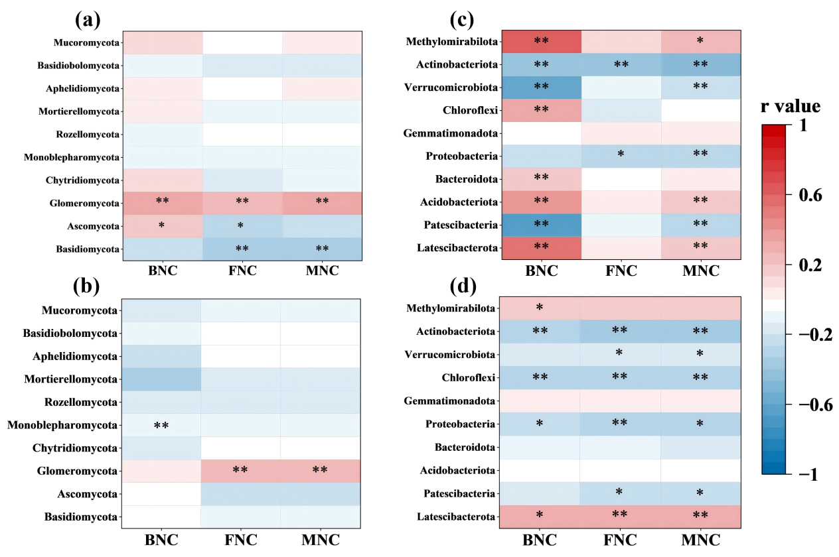
Fig.S4 The person correlation between fungal phylum level and residual carbon in topsoil ( a ) and subsoil ( b ), the person correlation between bacterial phylum level and residual carbon in topsoil ( c ) and subsoil ( d ), * indicates that the correlation between the two reaches a significant level ( P < 0.05 ), * * indicates that the correlation between the two reaches a significant level ( P < 0.01 ).
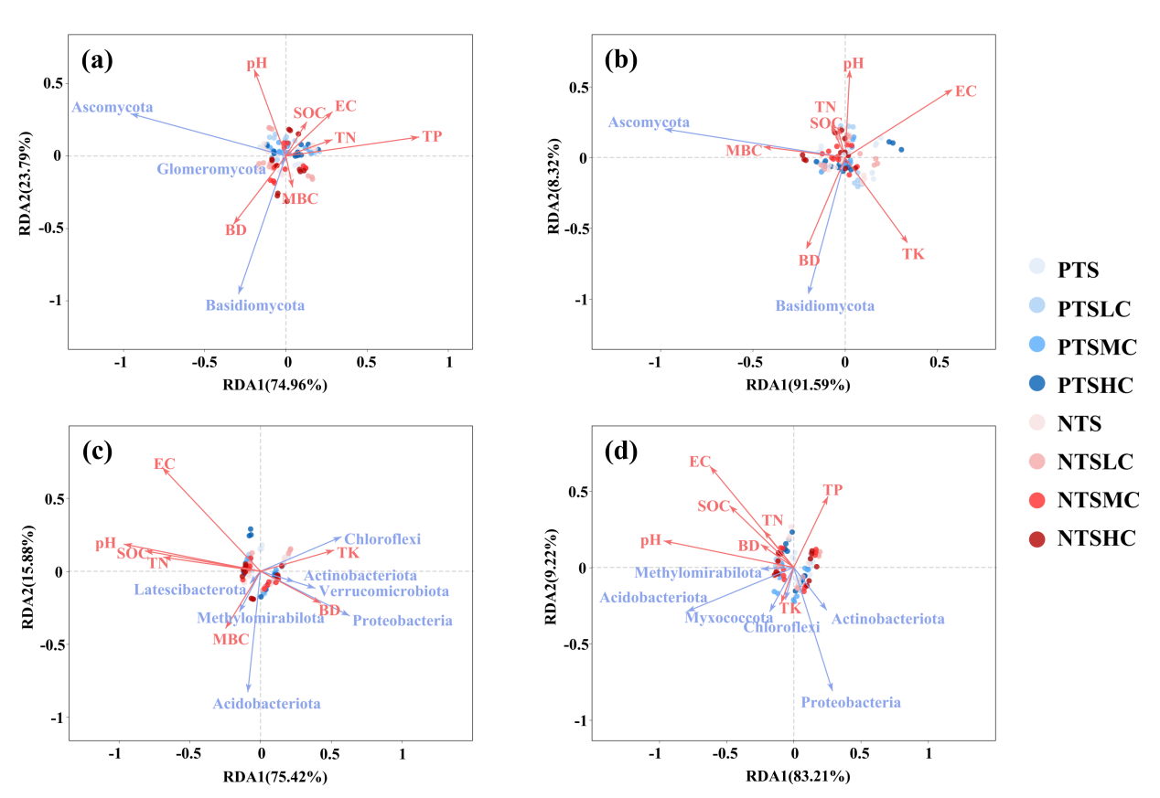
Fig.S5 RDA analysis of fungal phylum level and environmental factors in topsoil ( a ) and subsoil ( b ), and RDA analysis of bacterial phylum level and environmental factors in topsoil ( c ) and subsoil ( d ).
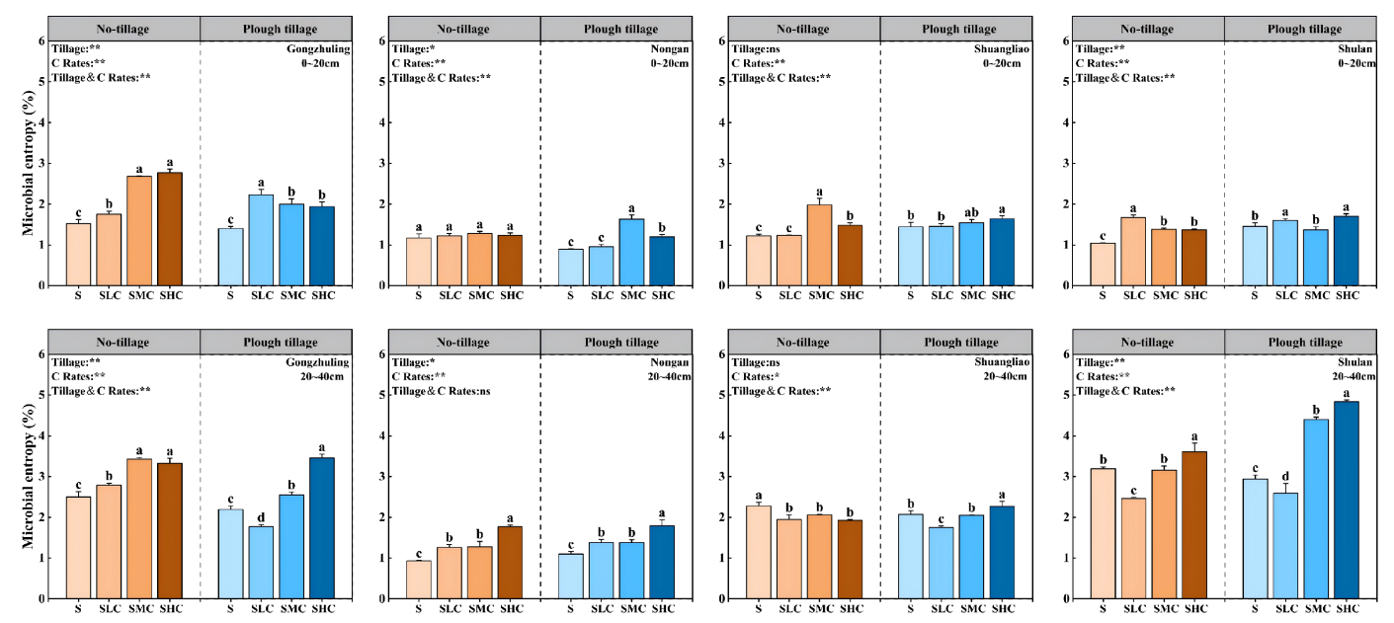
Fig.S6 Effects of tillage and carbon input on microbial entropy. The significant differences between different treatments were represented by letters (P < 0.05, n=3), and the error line represented the standard deviation of the mean values of different treatments. The main effects of single factors and their interactive effects are displayed for Tillages: Tillage methods; C Rates: Carbon input; Significance levels:**, P< 0.01; *, P< 0.05; ns, not significant at P> 0.05 level.

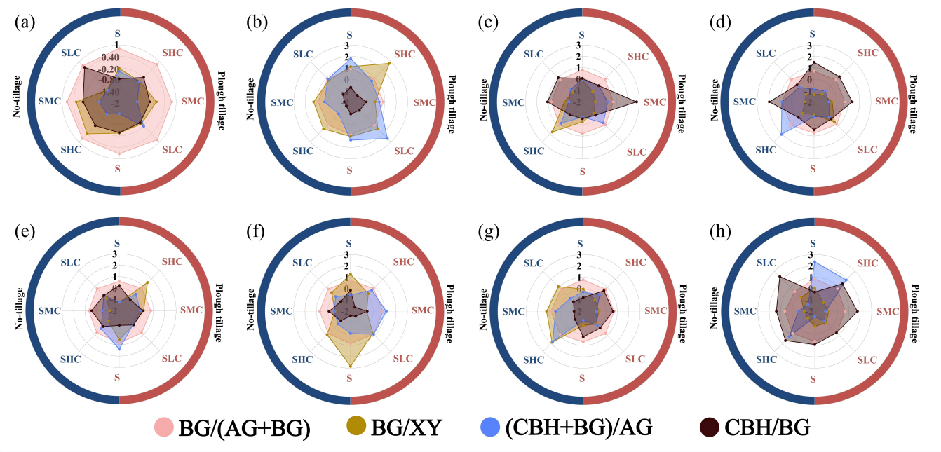
Fig.S7 The enzyme activity ratios of topsoil (a-d) and subsoil (e-h) in Gongzhuling, Nongan, Shuangliao and shulan.
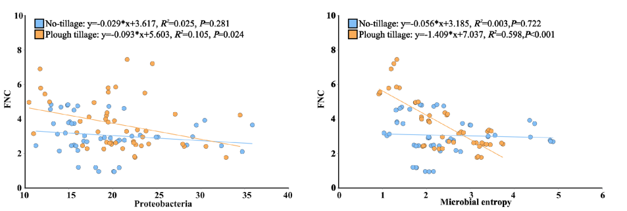
Fig.S8 Linear regression of FNC with Proteobacteria relative abundance and microbial entropy under different tillage in subsoil

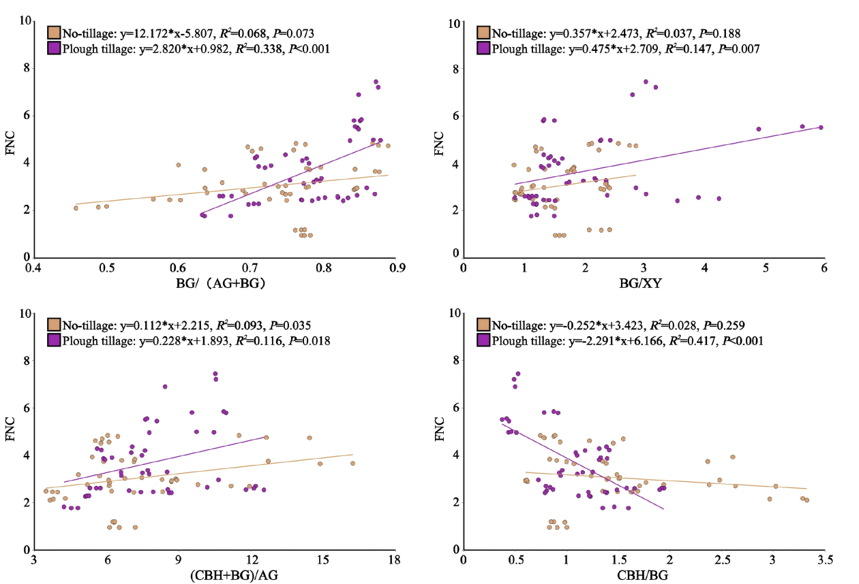
Fig.S9 Linear regression of enzyme activity ratio and FNC under different tillage methods in subsoil
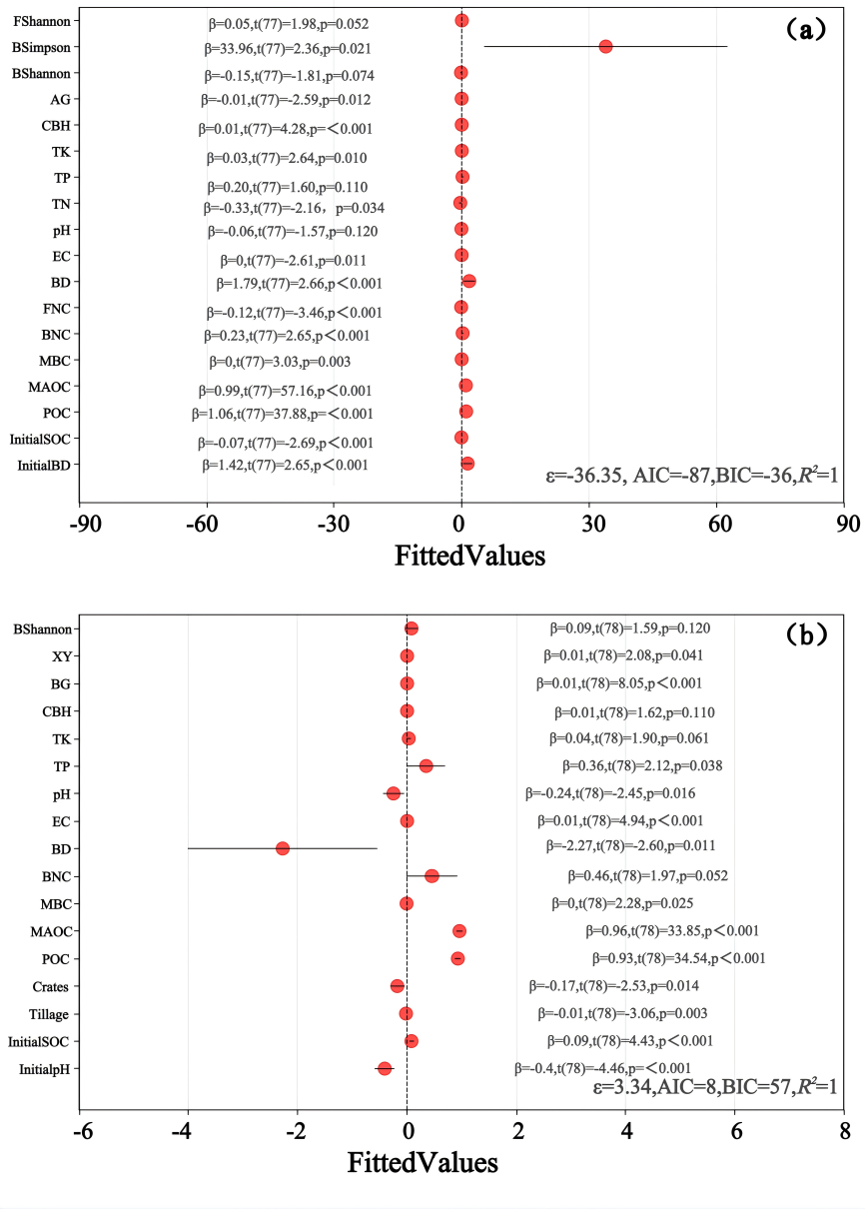
Fig.S10 Multiple linear regression analysis of all variables in topsoil(a) and subsoil(b) on SOC

