Supporting Information for
Synergistic Photocatalysis of BiOCl/MXene Activates Peroxymonosulfate for Enhanced Fulvic Acid Degradation: Performance and Mechanism Insights

Chenglong Sun¹, Chunyan Yang^{3, *}, Guie Li¹, Qiu Yang¹, Changhong Zhan², Guangshan Zhang^{1,2,*}

¹ Qingdao Engineering Research Center for Rural Environment, College of Resources and Environment, Qingdao Agricultural University, Qingdao 266109, PR China
² Harbin Institute of Technology (Weihai) Qingdao Research Institute, Qingdao 266109, PR China
³ College of Architecture and Environment, Sichuan University, Chengdu 610207, PR China

* Corresponding author. Tel: 86-532-58957461, Fax: 86-532-58957461
E-mail addresses: gszhang@qau.edu.cn; cyyanghit@163.com

This supplementary information (SI) contains the following parts:
- Chemicals (Text S1).
- Fabrication of BiOCl/MXene (Text S2).
- Characterization (Text S3).
- Evaluation of catalytic performance (Text S4).
- Analytical methods (Text S5-S6).
- Photocatalysis-PMS synergistic effect (Text S7).
- Fabrication of BiOCl/MXene (Fig. S1).
- Photochemical reactor (Fig. S2)
- Photocatalysis-PMS synergistic effect (Fig. S3).
- Influence and Optimization of Reaction Conditions (Fig. S4).
- Reusability and Universality (Fig. S5).
- Band structure and charge separation efficiency (Fig. S6).
- Proposed synergistic mechanism (Fig. S7).
- Aromaticity Loss and Mineralization (Fig. S8).

S1. Chemicals
Text S1.
All chemical reagents used in this study were of analytical grade, including bismuth nitrate (Bi(NO₃)₃·5H₂O), ethylene glycol (EG), potassium chloride (KCl), nitric acid (HNO₃), sodium hydroxide (NaOH), furfuryl alcohol (FFA), sodium carbonate (Na₂CO₃), and sodium sulfate (Na₂SO₄), all of which were purchased from Sinopharm Chemical Reagent Co., Ltd. (China). MXene was obtained from Beijing Beike New Materials Technology Co., Ltd. (China). Fulvic acid (FA, the main component of humic acid (HA), with FA content ≥ 90%), p-benzoquinone (p-BQ), diuron (DUR), sulfamethazine (SMR), rhodamine B (RhB), p-nitrophenol (PNP), and bisphenol A (BPA) were purchased from Shanghai Macklin Biochemical Technology Co., Ltd. (China). Tert-butanol (TBA) was acquired from Xilong Scientific Co., Ltd. (China). Disodium ethylenediaminetetraacetate (EDTA-2Na), sodium chloride (NaCl), and methylene blue (MB) were purchased from Tianjin BASF Chemical Co., Ltd. (China). Sodium nitrate (NaNO₃) was obtained from Tianjin Beilian Fine Chemical Development Co., Ltd. (China), and sodium dihydrogen phosphate (NaH₂PO₄) was purchased from Tianjin Dingshengxin Chemical Co., Ltd. (China). All the aforementioned reagents were of analytical grade. Unless otherwise specified, deionized water (DI) was used throughout the experiment.

S2. Fabrication of BiOCl/MXene
Text S2.
MXene:MXene was synthesized via the hydrofluoric acid (HF) etching method. Typically, 2 g of titanium aluminum carbide (Ti₃AlC₂) powder was added into a polytetrafluoroethylene (PTFE) beaker containing 40 mL of HF solution (mass fraction > 40%), followed by continuous stirring at room temperature for 24 h. After the reaction, the mixed solution was subjected to centrifugation treatment. Subsequently, the centrifuged solid was repeatedly washed with deionized water via ultrasonic centrifugation (US centrifugation) until the pH value of the supernatant reached 6. Finally, the obtained precipitate was dried overnight in a vacuum environment at 60℃, yielding the MXene material.
BiOCl/MXene: 0.97 g of bismuth nitrate pentahydrate was weighed and dissolved in 30 mL of ethylene glycol solution in a beaker, denoted as Solution A. 0.30 g of potassium chloride and a certain amount of MXene were weighed and dissolved in 10 mL of deionized water in a beaker, denoted as Solution B. After each was ultrasonicated for 15 minutes, Solution B was slowly added to Solution A, and ultrasonic treatment was continued for another 15 minutes to obtain a mixed solution. The solution was transferred to a high-temperature autoclave, and the reaction conditions were set as follows: reaction time 10 h and reaction temperature 160 ℃. After the reaction was completed and cooled to room temperature, the resulting catalyst was taken out and washed with deionized water and absolute ethanol respectively for 3 times, with the washing process being 1 time with distilled water, 3 times with ethanol, and 2 times with distilled water. Finally, the material was placed in a vacuum oven and dried at 60 °C for 4 hours to obtain the BiOCl/MXene composite material.

S3. Characterization
Text S3.
The surface morphology of the catalyst was analyzed using a scanning electron microscope (SEM, Model Zeiss sigma500), and its microscopic morphology was observed via a transmission electron microscope (TEM, Model HF5000). The crystal structure of the catalyst was characterized by an X-ray diffractometer (XRD, Model D8 ADVANCE, Bruker, Germany). The specific surface area of the catalyst was determined using a Brunauer-Emmett-Teller (BET) surface area analyzer (Model Micromeritics 2460). Additionally, the elemental composition of the photocatalyst was tested using an X-ray photoelectron spectrometer (XPS, Model Thermo ESCALAB nexsa G2).

S4. Evaluation of catalytic performance
Text S4.
In the experiment of FA degradation via photocatalytic activation of PMS by BiOCl/MXene, a 300 W xenon lamp was used to simulate a visible light source (wavelength range: 400 nm ≤ λ ≤ 780 nm, light intensity: 296 mW/cm²). 100 mL of FA solution was placed in a reaction dish, which was then put into the reactor. A quantitative amount of BiOCl/MXene photocatalyst and PMS were added to the solution. The light source was turned on, and samples were taken every 5 minutes. The collected samples were filtered through a 0.45 μm filter membrane, and their absorbance was quickly measured using an ultraviolet-visible spectrophotometer. The concentration and removal rate of humic acid were calculated via a standard curve.

S5. Analytical methods
Text S5.
The spectral acquisition parameters were precisely set as follows: the scanning speed was 12000 nm/min, the excitation wavelength (Ex) range was 220.0–450 nm, the emission wavelength (Em) range was 280.0–550 nm, and the sampling interval for both excitation and emission wavelengths was 5.0 nm. To eliminate solvent background interference, the blank spectrum of deionized water was collected under the same measurement conditions and used for zero-point correction of the 3D-EEM spectrum.
Text S6.
The optical properties of the photocatalyst were detected using an ultraviolet-visible spectrophotometer (UV-Vis, Model V-3900, Hitachi, Japan). The photoelectrochemical performance tests were mainly conducted with an electrochemical workstation (Model CHI660E, Chenhua Instruments, Shanghai, China). The main active species during the photocatalytic reaction were detected by an electron paramagnetic resonance (EPR) spectrometer (Model Bruker A300, Bruker, Germany). The intermediate products of fulvic acid (FA) degradation were analyzed via a high-performance liquid chromatography-quadrupole time-of-flight mass spectrometer (HPLC-QTOF-MS, Model 6545 XT, Agilent Technologies, USA).

S6. Photocatalysis-PMS synergistic effect
Text S7.
In the preparation of BiOCl/MXene composite catalysts, the optimization of synthesis process parameters is a core step for accurately regulating their microstructure and catalytic performance. In this study, the single-factor variable method was employed to systematically conduct optimization experiments. First, to clarify the effect of synthesis temperature on catalyst performance, the synthesis time and MXene dosage were fixed, and a synthesis temperature gradient of 120℃, 140℃, 160℃, 180℃, and 200℃ was set. The core evaluation index was the degradation rate of formaldehyde (FA, initial concentration: 100 mg/L) by the catalyst after 30 min of reaction. Based on this, 160℃ was identified as the optimal synthesis temperature. Subsequently, at 160℃, the MXene dosage was fixed, and a time gradient of 4 h, 6 h, 8 h, 10 h, and 12 h was established. As the synthesis time prolonged, the FA degradation rate first increased and then stabilized, leading to the determination of 10 h as the optimal synthesis time. Finally, under the conditions of 160℃ and 10 h, a MXene dosage gradient of 5 wt%, 10 wt%, 15 wt%, 20 wt%, and 25 wt% was set (based on the mass of BiOCl). Through performance testing, 15 wt% was confirmed as the optimal MXene dosage.

S7. Fabrication of BiOCl/MXene
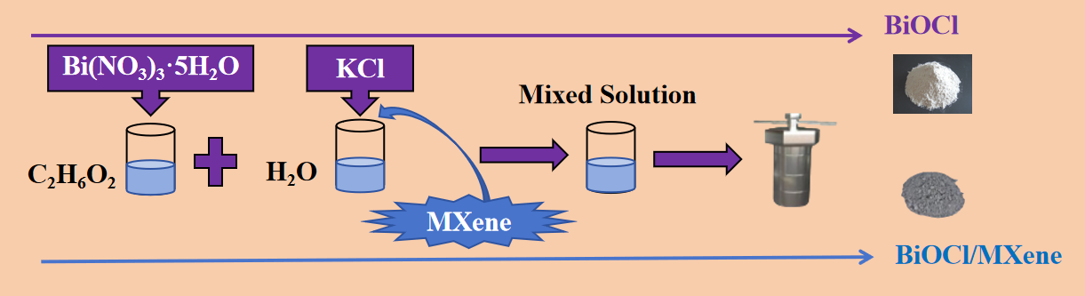
Fig.S1 Schematic diagram of the material synthesis route.

S8. Photochemical reactor
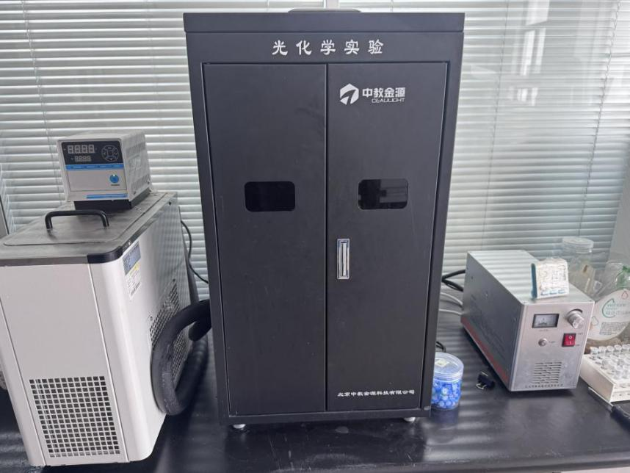
Fig.S2 Schematic Diagram of the Photocatalytic PMS Activation Reactor.

S9. Photocatalysis-PMS synergistic effect
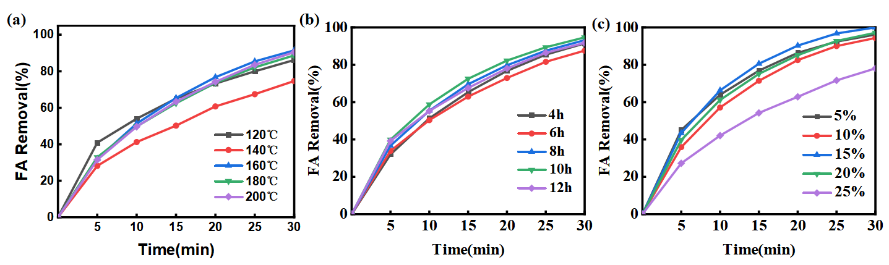
Fig.S3 (a) Different temperatures, (b) different synthesis times, and (c) different MXene dosages on FA degradation experiment.

S10. Influence and Optimization of Reaction Conditions
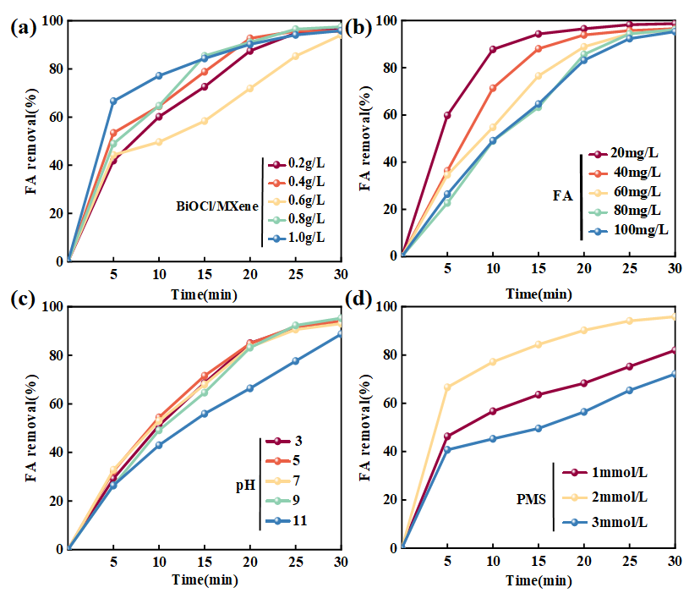
Fig.S4 (a) Catalyst dosage, (b) initial FA solution concentration, (c) solution pH value, and (d) PMS dosage on FA degradation experiment.

S11. Reusability and Universality
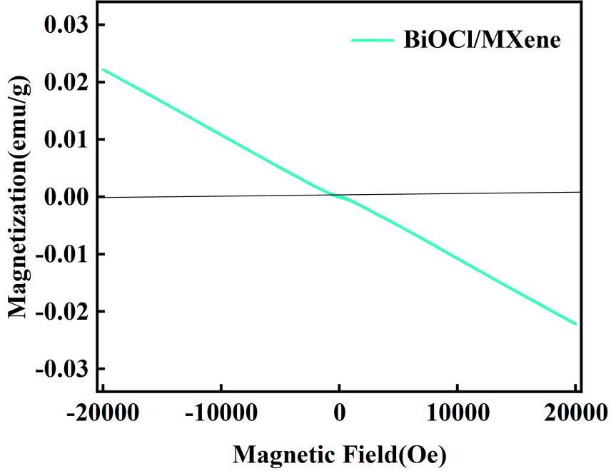
Fig.S5 BiOCl/MXene Hysteresis Loop Figure.

S12. Band structure and charge separation efficiency
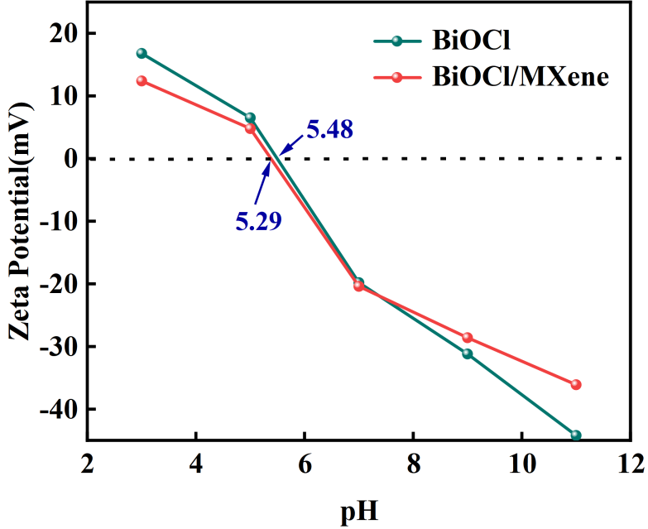
Fig.S6 Relationship between Zeta Potential and pH of Different Materials.

S13. Proposed synergistic mechanism
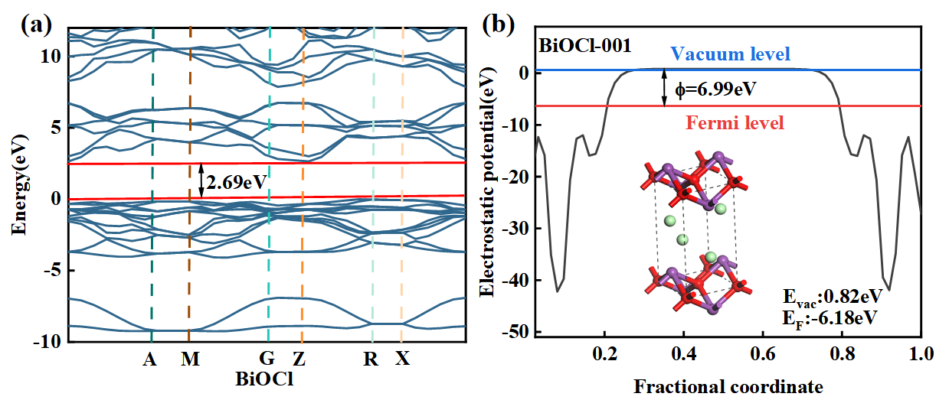
Fig.S7 (a) Band structure and (b) calculated work function of BiOCl.

S14. Aromaticity Loss and Mineralization
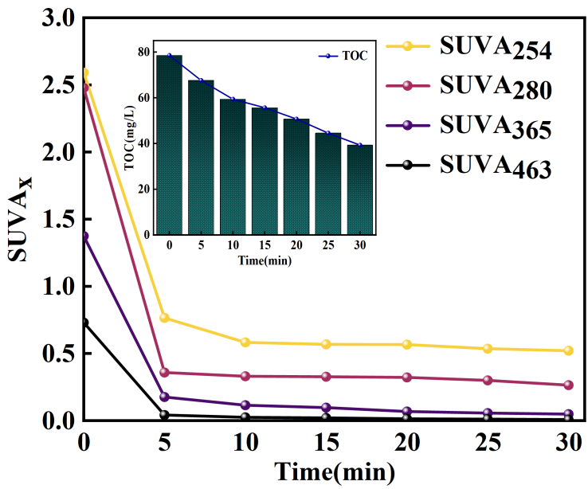
Fig.S8 Specific Ultraviolet Absorbance (SUVA) Series Indicators and Total Organic Carbon (TOC) Variations with Inset of TOC Changes During FA Degradation Process.

