Fungi serve as novel biological factor for enrichment resistance genes in facultative composting as exhibited by fungal gradient experiments
Yan Yang ª, Jiani Wang ª, Nana Wei ^{b, c}, Kaishu Luo ª, Xia Gao ª, Guoxue Li ª, Si Li ª, Yuezhen Tian ^{b*}, Jing Yuan ^{a*}
ª Beijing Key Laboratory of Farmland Soil Pollution Prevention and Remediation, College of Resources and Environmental Sciences, China Agricultural University, Beijing 100193, China
^{b} Xinjiang Key Laboratory of Genetics, Breeding and Reproduction of Fine-Wool Sheep, Institute of Animal Science, Xinjiang Academy of Animal Science, Urumqi 830011, China
^{c} College of Animal Science, Xinjiang Agricultural University, Urumqi 830052, China
* Corresponding author: Jing Yuan (jingyuan@cau.edu.cn)
Yuezhen Tian (tian306656637@126.com)
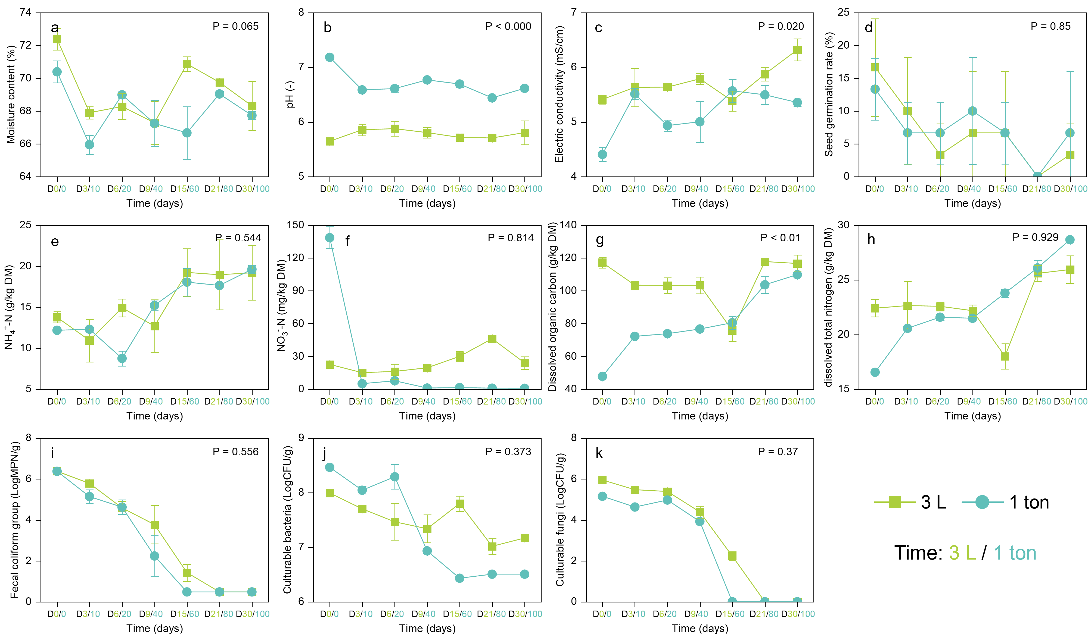
Fig. S1. Comparison of physicochemical parameters and culturable microbial counts between the 3-L and 1-ton composting systems. (a) Moisture content, (b) pH, (c) Electrical conductivity, (d) Seed germination rate, (e) NH₄⁺-N, (f) NO₃⁻-N, (g) Dissolved organic carbon, (h) Dissolved total nitrogen, (i) Fecal coliforms, (j) Culturable bacteria, (k) Culturable fungi. The left side of the x‑axis (green) represents the 3‑L system, and the right side (blue) represents the 1‑ton system.
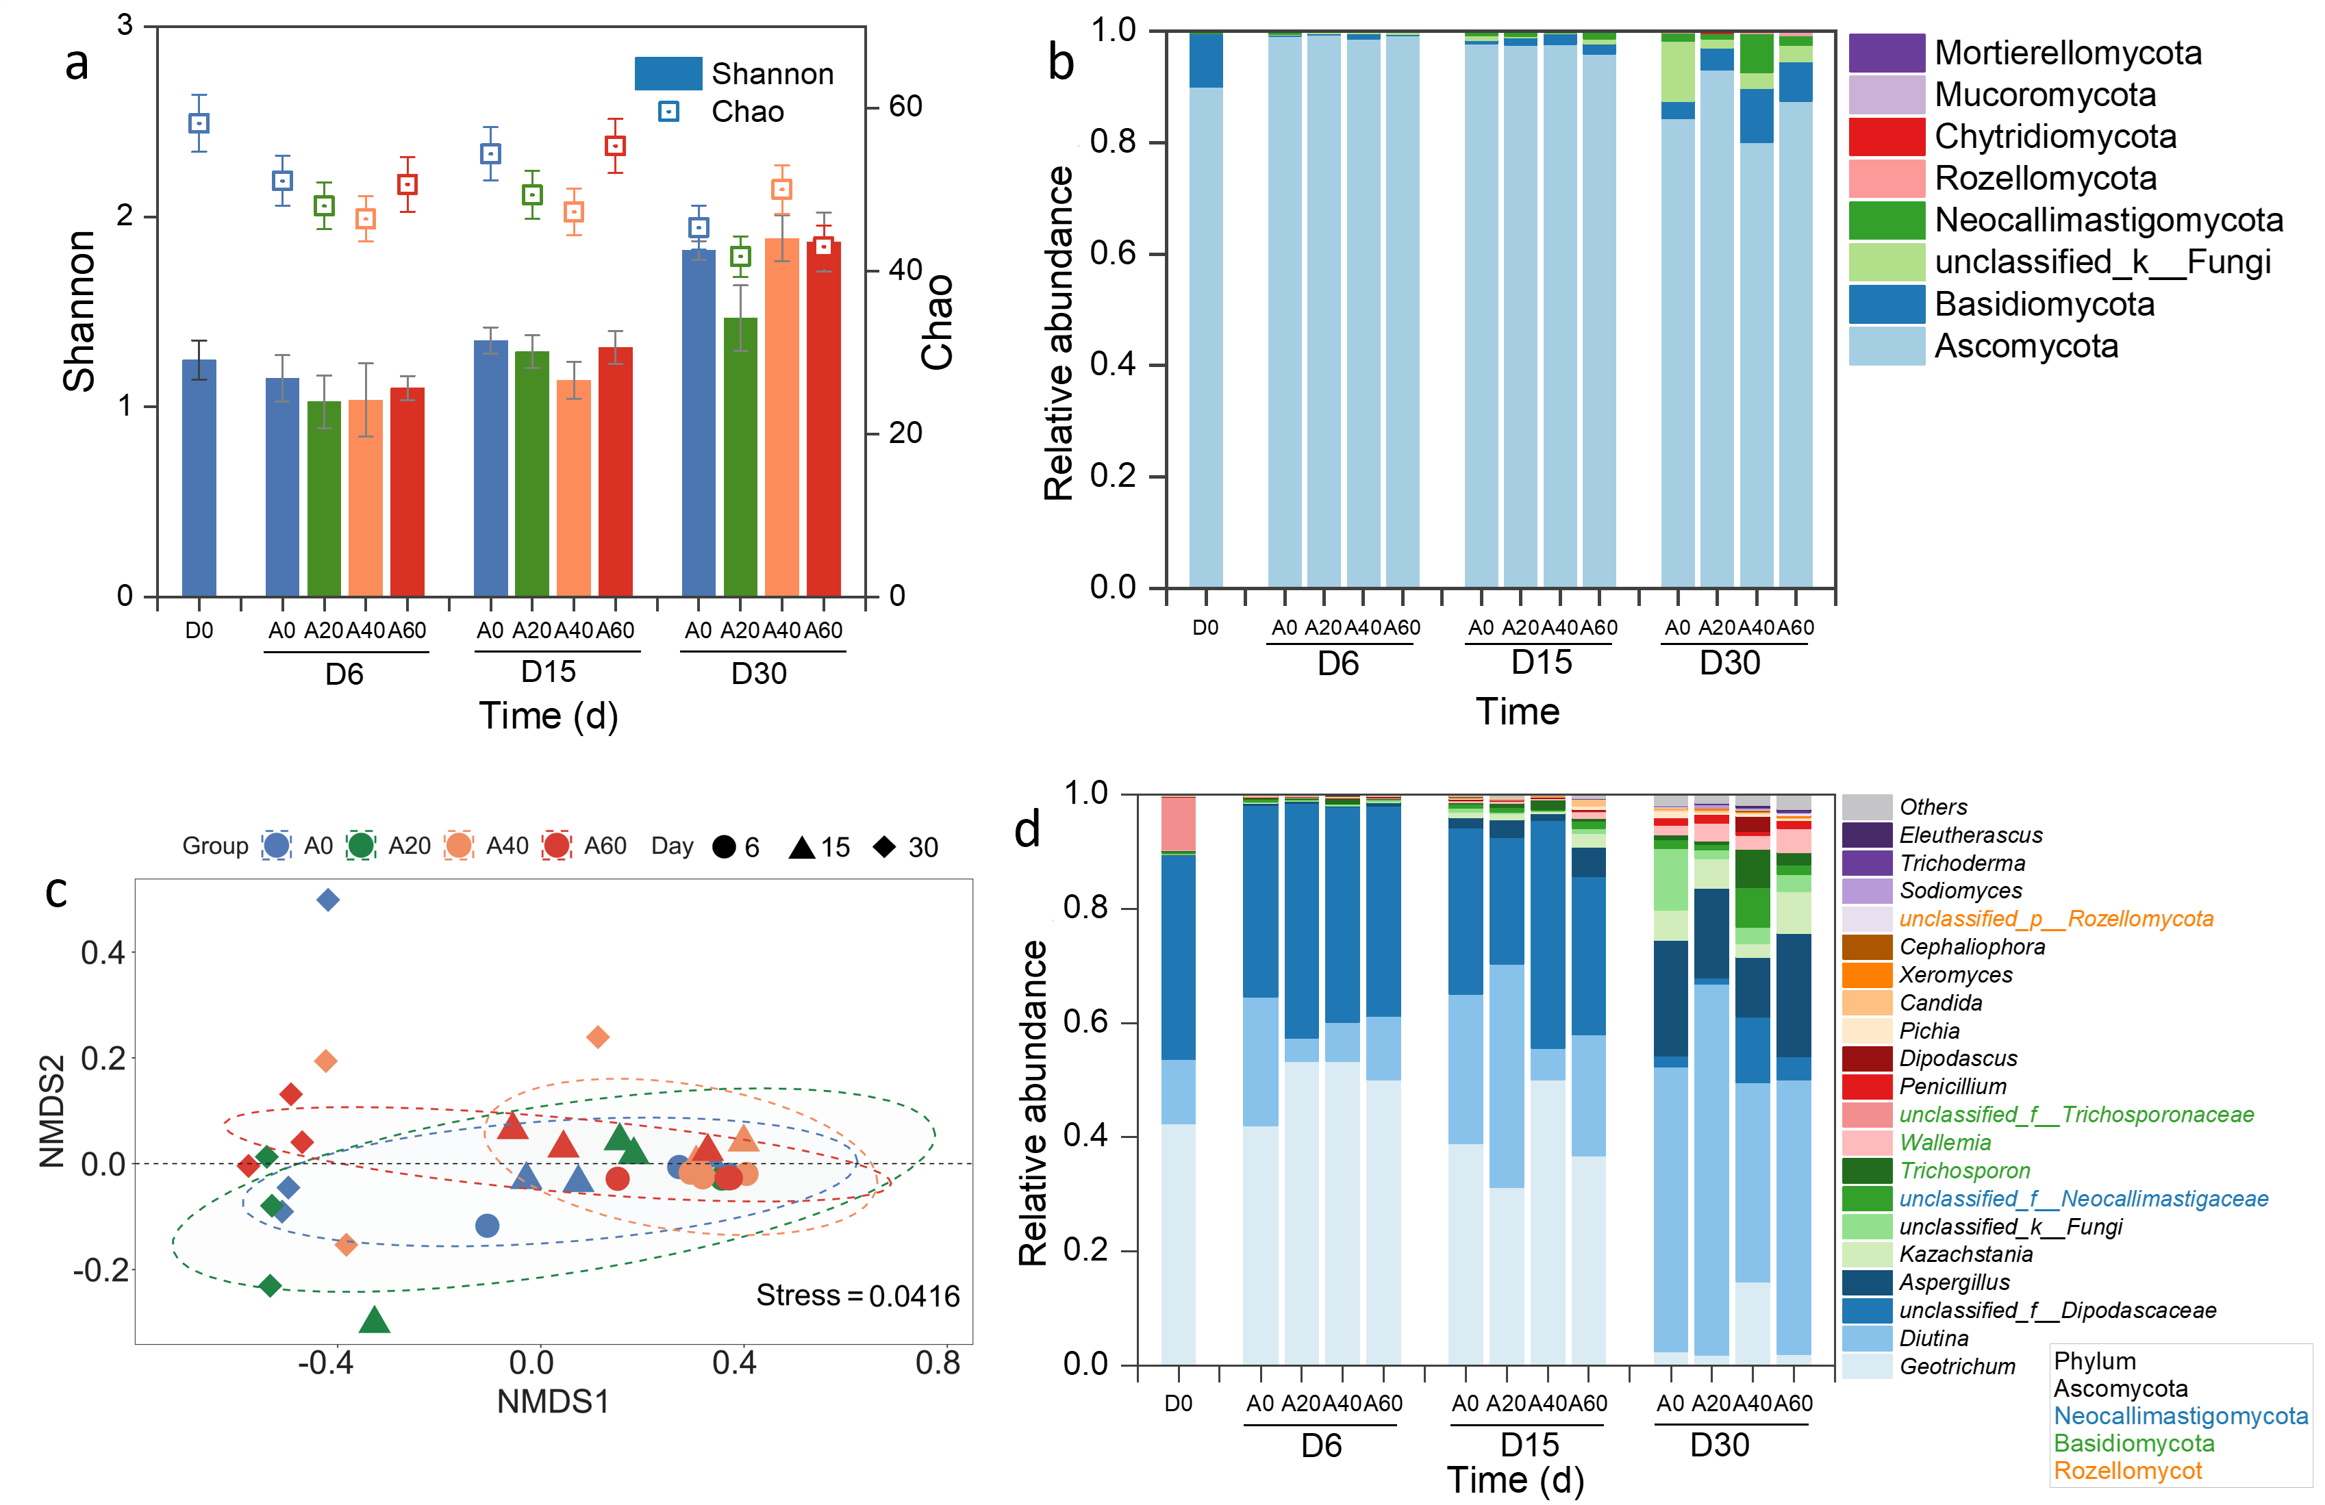
Fig. S2. The variation fungal composition during different fungal gradient facultative composting. Variations in fungal alpha (Shannon and Chao indices) (a) and beta (c) diversity. The fungal community structure at the phylum (b) and genus (d) level.
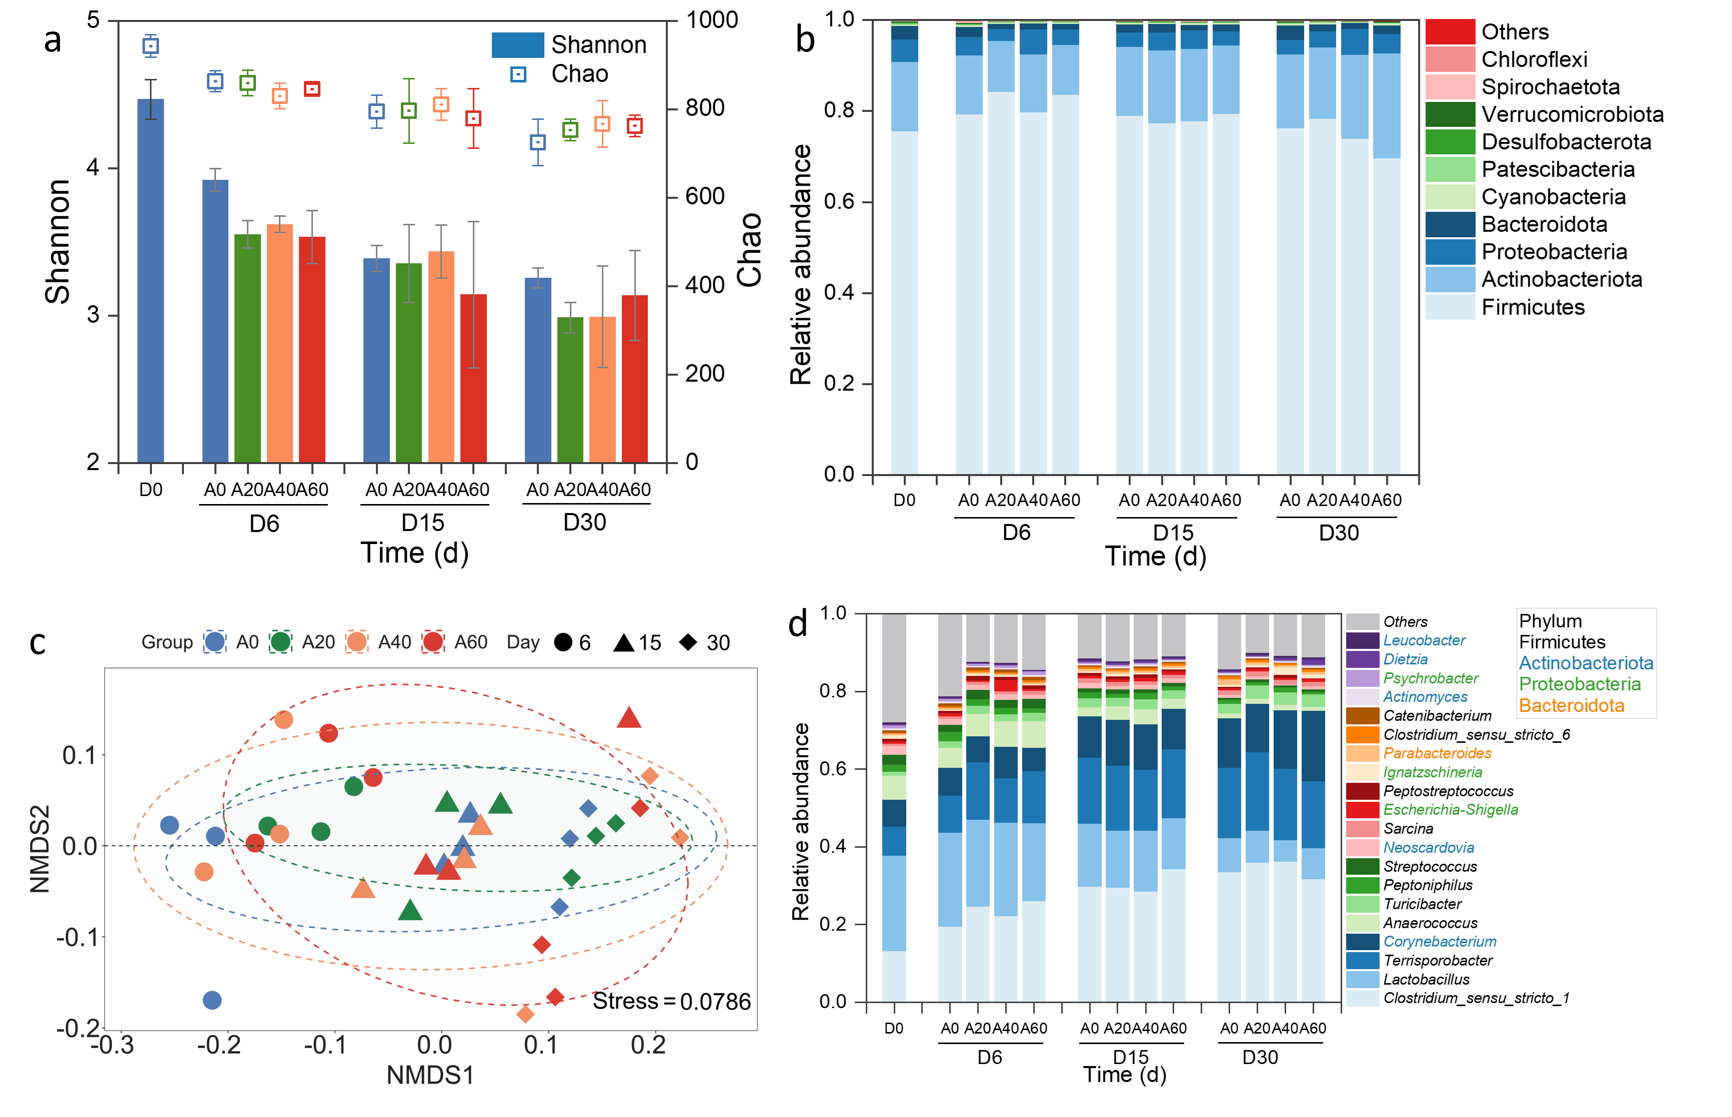
Fig. S3. The variation bacterial composition during different fungal gradient facultative composting. Variations in bacterial alpha (Shannon and Chao indices) (a) and beta (c) diversity. The bacterial community structure at the phylum (b) and genus (d) level.
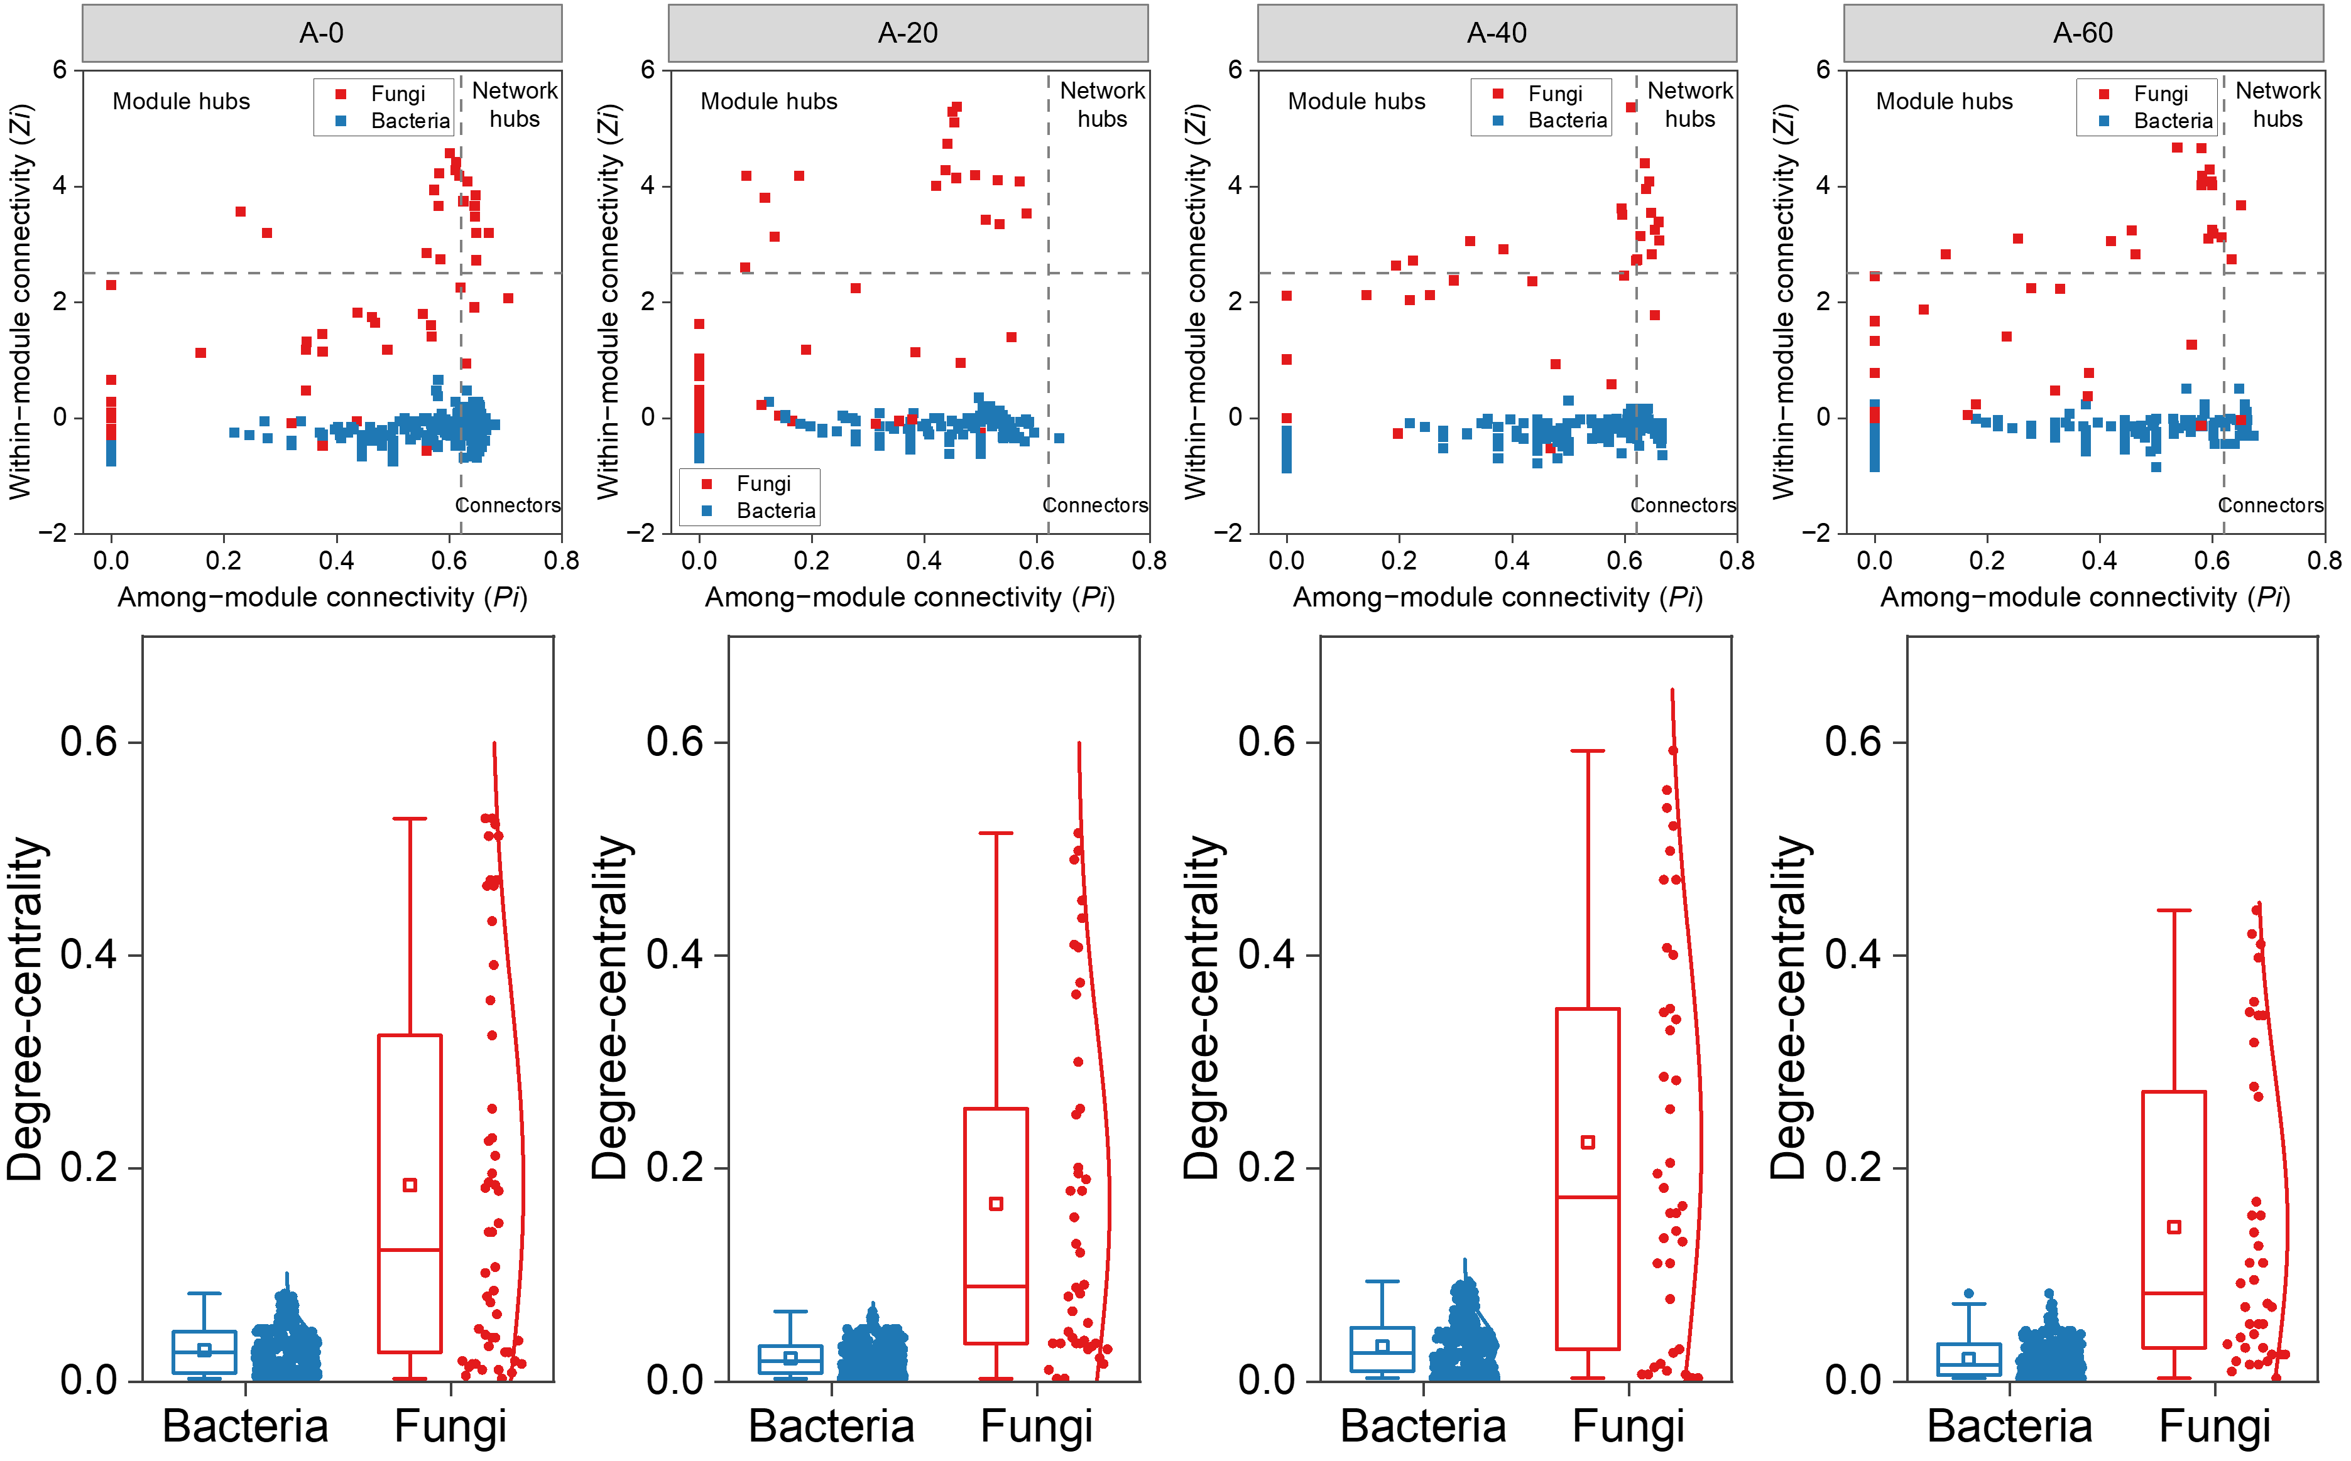
Fig. S4. The Zi-Pi plots and degree-centrality of OTUs based on the fungal and bacterial networks topology in different fungal gradient facultative composting.

Table S1 Topological features of the microbial community networks in different fungal gradient facultative composting.
Network Indexes | Fungal networks |  |  |  | Bacterial networks
Network Indexes | A0 | A20 | A40 | A60 | A0 | A20 | A40 | A60
Total nodes | 74 | 72 | 75 | 79 | 408 | 306 | 269 | 295
Total edges | 517 | 433 | 281 | 422 | 582 | 344 | 308 | 324
Positive edges | 112 | 93 | 68 | 53 | 409 | 236 | 260 | 260
Negative edges | 405 | 340 | 213 | 369 | 173 | 108 | 48 | 64
P/N ratio | 0.28 | 0.27 | 0.32 | 0.14 | 2.36 | 2.19 | 5.42 | 4.06
Average path length | 2.08 | 2.01 | 2.17 | 2.06 | 2.76 | 1.70 | 1.75 | 1.68
Centralization degree | 6.99 | 6.01 | 3.75 | 5.34 | 1.43 | 1.13 | 1.15 | 1.10
Clustering coefficient | 0.19 | 0.15 | 0.13 | 0.12 | 0.05 | 0.04 | 0.05 | 0.05
Diameter | 4.00 | 4.00 | 5.00 | 6.00 | 8.00 | 5.00 | 6.00 | 6.00
Modularity | 0.28 | 0.28 | 0.40 | 0.25 | 0.78 | 0.86 | 0.79 | 0.86

Table S2 Topological features in cross‐kingdom co‐occurrence networks of the bacterial-fungal associations in different fungal gradient facultative composting.
Network Indexes | A0 | A20 | A40 | A60
Total nodes | 363 | 363 | 297 | 314
Bacterium node | 313 | 322 | 259 | 274
Fungi node | 50 | 43 | 38 | 40
Total edges | 3350 | 2550 | 2540 | 1825
Positive edges | 1606 | 1319 | 1330 | 840
Negative edges | 1744 | 1231 | 1210 | 985
P/N ratio | 0.92 | 1.07 | 1.10 | 0.85
Average path length | 2.81 | 2.90 | 2.60 | 3.82
Centralization degree | 9.22 | 14.04 | 8.55 | 5.81
Diameter | 8.00 | 8.00 | 8.00 | 8.00
Modularity | 0.19 | 0.26 | 0.20 | 0.27

